Supplementary Materials

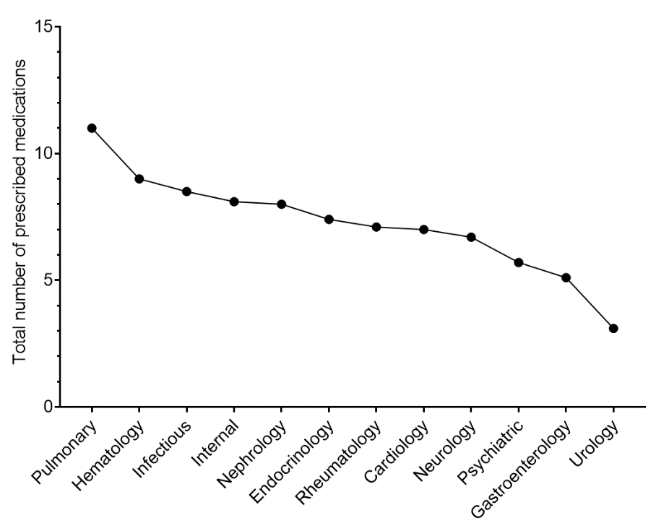
Figure SM_1: Total number of prescribed medications over each specialty care unit.

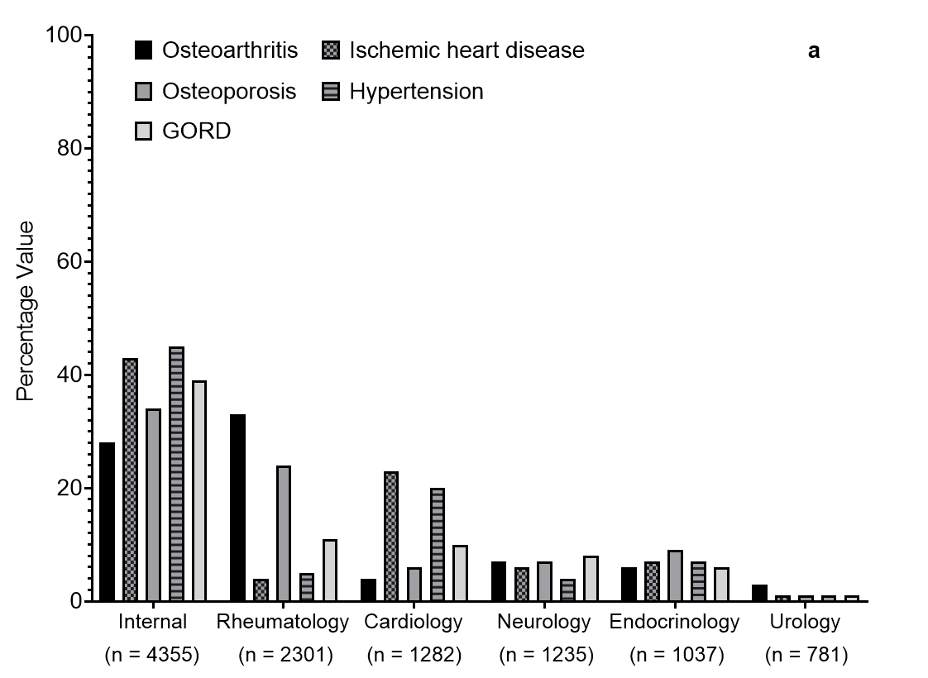 | 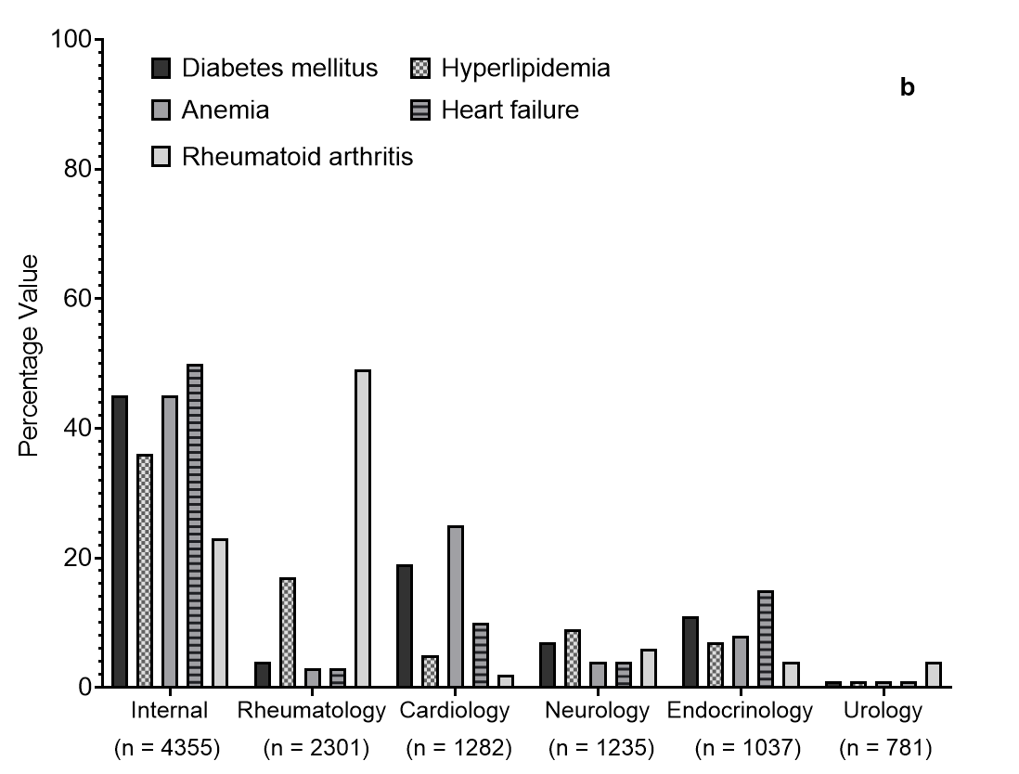
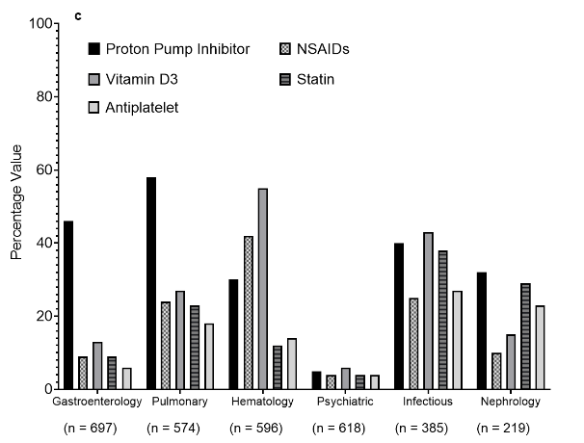 | 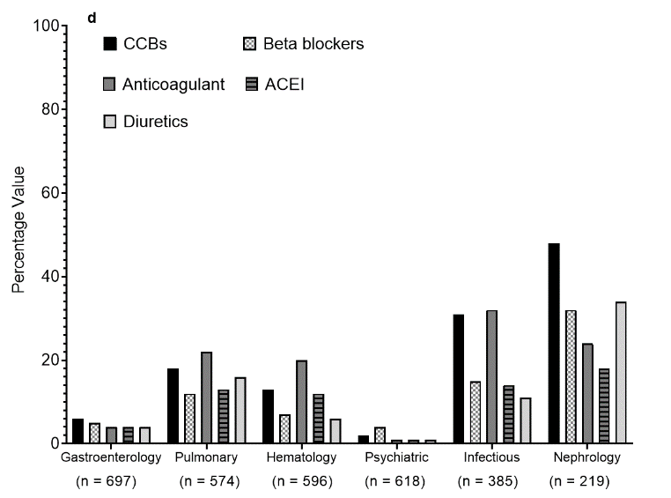
Figure SM_2: (a) and (b) show the prevalence of common recorded comorbidities presented in the different specialty care units. (c) and (d) show the most commonly prescribed medication classes in the different specialty care units. Data presents the percentage value of the referenced group.

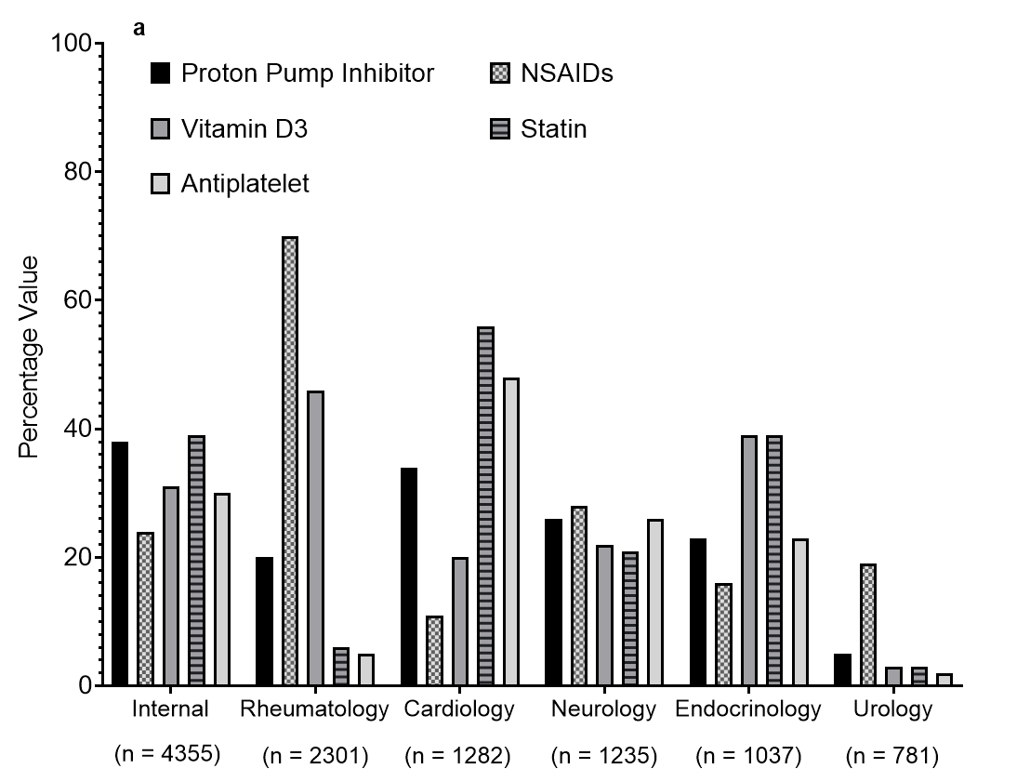 | 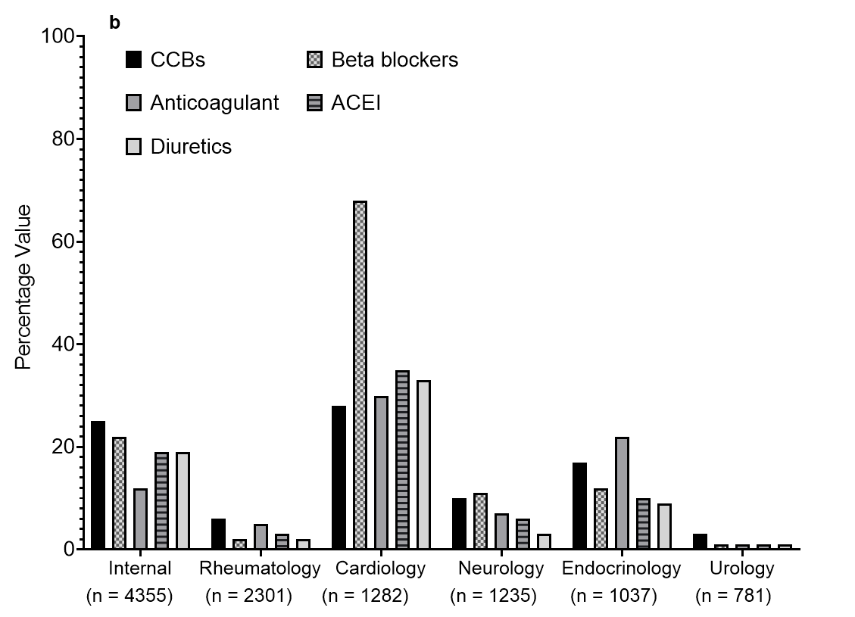
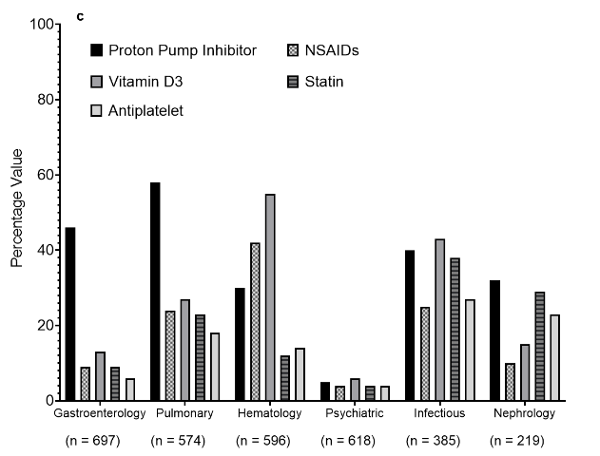 | 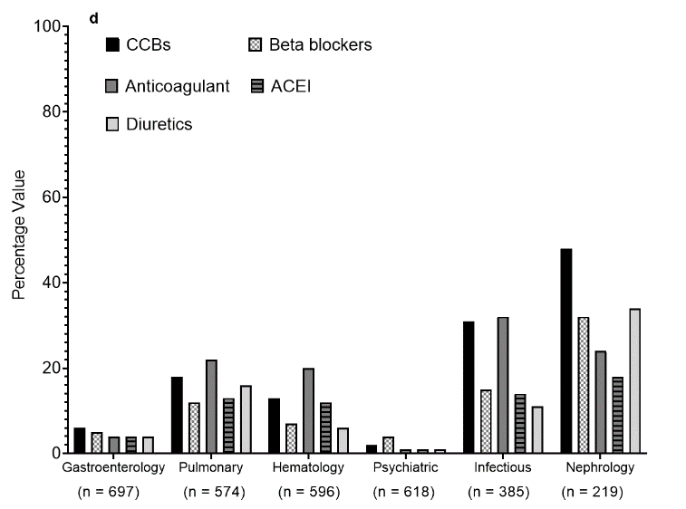
Figure SM_3: Common recorded medications prescribing prevalence based on each clinic specialty. Data presents percentage value of the referenced group. NSAIDs = Non-Steroidal Anti-Inflammatory Drugs, CCBs = Calcium Channel Blockers, ACEIs = Angiotensin Converting Enzyme Inhibitors.

Table SM_1: Common recorded morbidities among the cohort classified based on age group. GORD = Gastroesophageal reflux disease
Comorbidity | Total Patients | Middle-aged Adults | Older Adults | P-value
 | n = 14081 | n = 9722 | n = 4359
Osteoarthritis, n (%) | 5262 (37) | 3793 (40) | 1469 (34) | < 0.001
Ischemic heart disease, n (%) | 4783 (34) | 2543 (26) | 2240 (51) | < 0.001
Osteoporosis, n (%) | 4616 (33) | 3225 (33) | 1391 (32) | 0.1
Hypertension, n (%) | 4279 (30) | 2233 (23) | 2046 (47) | < 0.001
GORD, n (%) | 4209 (30) | 2568 (26) | 1641 (38) | < 0.001
Hyperlipidaemia, n (%) | 3738 (27) | 1877 (19) | 1861 (43) | < 0.001
Anaemia, n (%) | 3726 (27) | 2649 (27) | 1077 (25) | 0.002
Heart failure, n (%) | 3549 (25) | 1912 (19) | 1737 (40) | < 0.001
Diabetes mellitus, n (%) | 2993 (21) | 1578 (16) | 1415 (33) | < 0.001
Rheumatoid arthritis, n (%) | 2970 (21) | 2312 (24) | 658 (15) | < 0.001

Table SM_2: Prevalence of medications prescribing among the cohort classified based on the age groups. Medications were presented by the first level order as per the anatomical therapeutic classification.
Medication Class | Total cohort | Middle aged adults | Older adults | P-value
 | n = 14081 | n = 9722 | n = 4359
Alimentary and metabolism, n (%) | 8043 (57) | 5150 (53) | 2893 (66) | < 0.001
Musculo-skeletal system, n (%) | 6782 (48) | 4892 (50) | 1890 (43) | < 0.001
Nervous system, n (%) | 6528 (46) | 4644 (48) | 1884 (43) | < 0.01
Blood and blood forming organs, n (%) | 5943 (42) | 3687 (38) | 2256 (52) | < 0.001
Cardiovascular system, n (%) | 5880 (42) | 3251 (33) | 2629 (60) | < 0.001
Systemic hormonal preparation, n (%) | 2081 (15) | 1430 (15) | 651 (15) | 0.7
Antineoplastic and immunomodulating agents, n (%) | 1506 (11) | 1307 (13) | 199 (5) | < 0.001
Genito urinary system and sex hormones, n (%) | 1417 (10) | 684 (7) | 733 (17) | <0.001
Respiratory system, n (%) | 1457 (10) | 892 (9) | 565 (13) | < 0.001
Anti-infective for systemic use, n (%) | 1372 (10) | 916 (9) | 456 (11) | 0.06
Sensory organs, n (%) | 643 (5) | 349 (4) | 294 (7) | < 0.001
Dermatological, n (%) | 427 (3) | 253 (3) | 174 (4) | < 0.001
Various, n (%) | 219 (2) | 108 (1) | 111 (3) | < 0.001
Antiparasitic products, insecticides and repellents, n (%) | 127 (1) | 104 (1) | 23 (0.5) | 0.002

Table SM_3: Prevalence of medications prescribing among cohort classified based on the age groups. Medications were presented based on their therapeutics class. NSAIDs = non-steroidal anti-inflammatory drugs, ACEIs = Angiotensin converting enzyme inhibitors.
Medication Class | Total cohort | Middle aged adults |  | Older adults | P-value
 | n = 14081 | n = 9722 |  | n = 4359
Proton pump inhibitors, n (%) | 4209 (30) | 2568 (26) |  | 1641 (38) | < 0.001
NSAIDs, n (%) | 4059 (30) | 3012 (31) |  | 1047 (24) | < 0.001
Vitamin D, n (%) | 4178 (30) | 2985 (31) |  | 1193 (27) | < 0.001
Statin, n (%) | 3711 (26) | 1856 (19) |  | 1855 (43) | < 0.001
Antiplatelet, n (%) | 3018 (21) | 1423 (15) |  | 1595 (37) | < 0.001
Calcium channel blockers, n (%) | 2358 (17) | 1181 (12) |  | 1177 (27) | < 0.001
Beta blockers, n (%) | 2417 (17) | 1187 (12) |  | 1230 (28) | < 0.001
Anticoagulants, n (%) | 1770 (13) | 971 (10) |  | 799 (18) | < 0.001
ACEIs, n (%) | 1783 (13) | 977 (10) |  | 806 (19) | < 0.001
Diuretics, n (%) | 1737 (12) | 729 (8) |  | 1008 (23) | < 0.001

