

Supplementary Figure 1 Global map of the ASIR (A) and ASDR (B) of cervical cancer from 1990 to 2019. ASIR, age-standardized incidence rate. ASDR, age-standardized death rate.

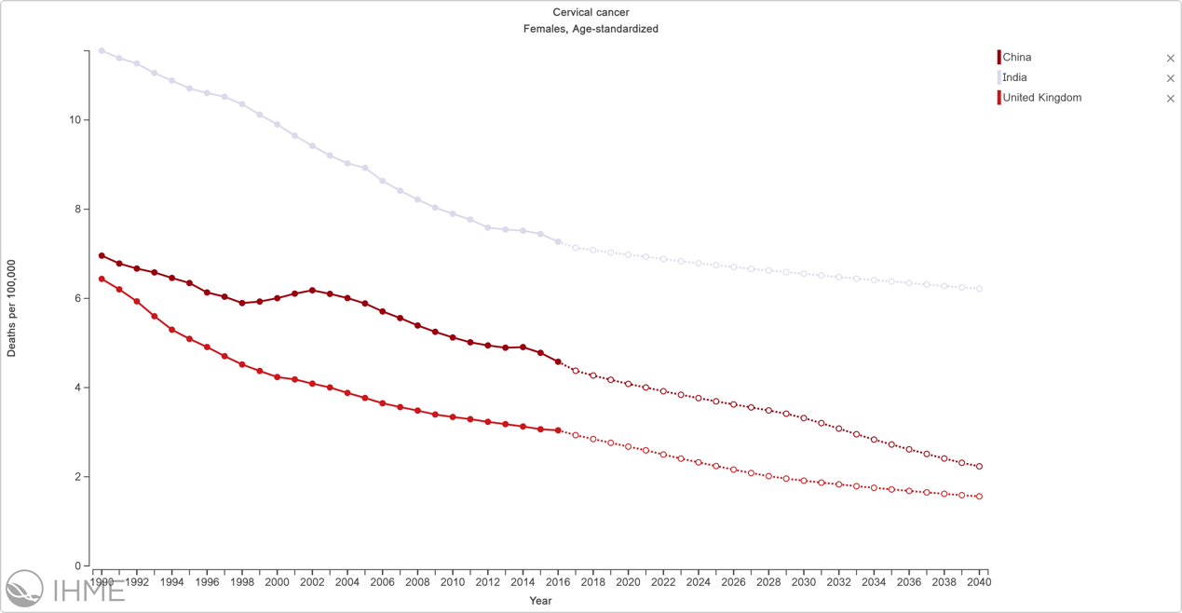

Supplementary Figure 2 The change trends of the ASDR from 1990 to 2040 in China, India and the UK.