# Supplementary Figures

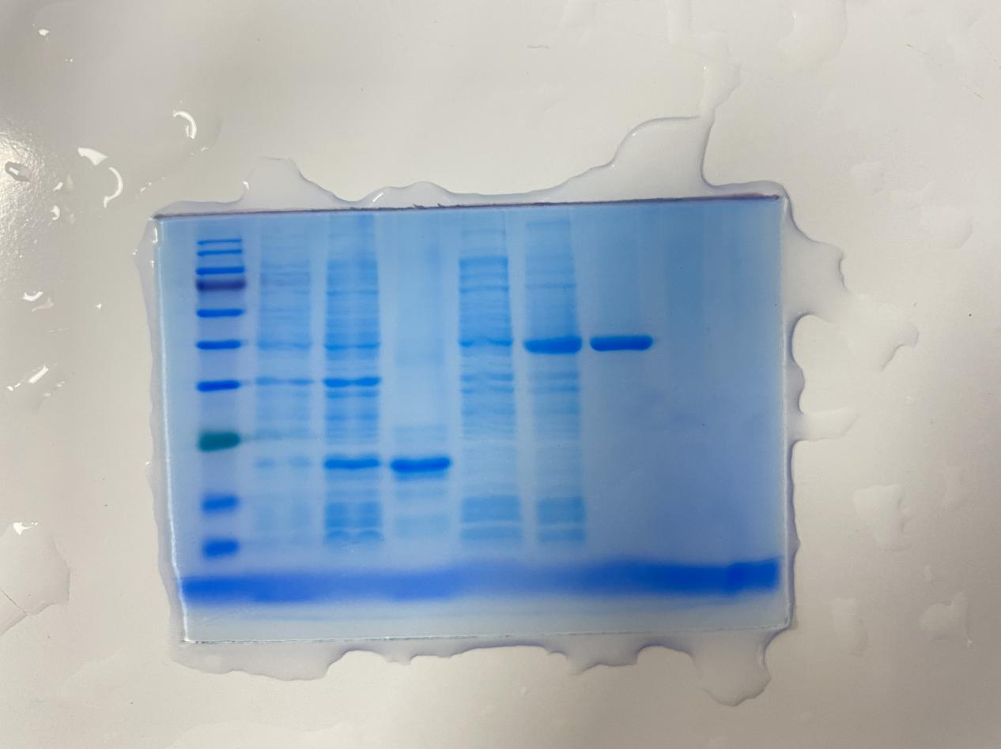

**M 1 2 3 4 5 6**

This SDS-PAGE assay result is the original image of Fig 3B. Lane M: protein molecular weight marker (10-180kDa); Lane 1:. Uninduced pET-32a protein; Lane 2. Induced pET-32a protein; Lane 3. Purified Trx protein; Lane 4. Uninduced protein of pET-32a-MsIFN-γ; Lane 5. Induced pET-32a-MsIFN-γ protein; Lane 6: Purified MsIFN-γ protein.

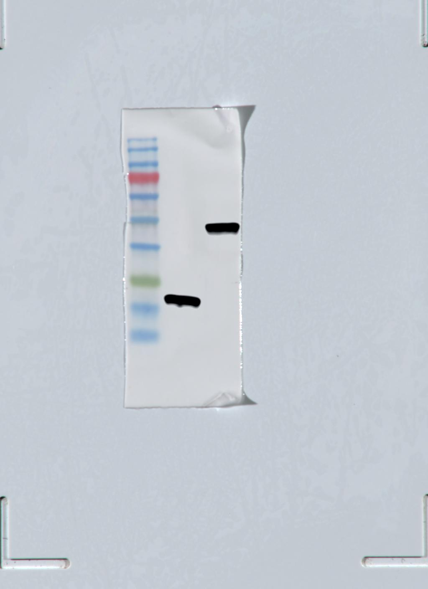

**M 1 2**

This WB assay result is the original image of Fig 1B. M: Standard protein molecular weight Maker; 1. Purified Trx protein; 2. Purified rMsIFN-γ protein.