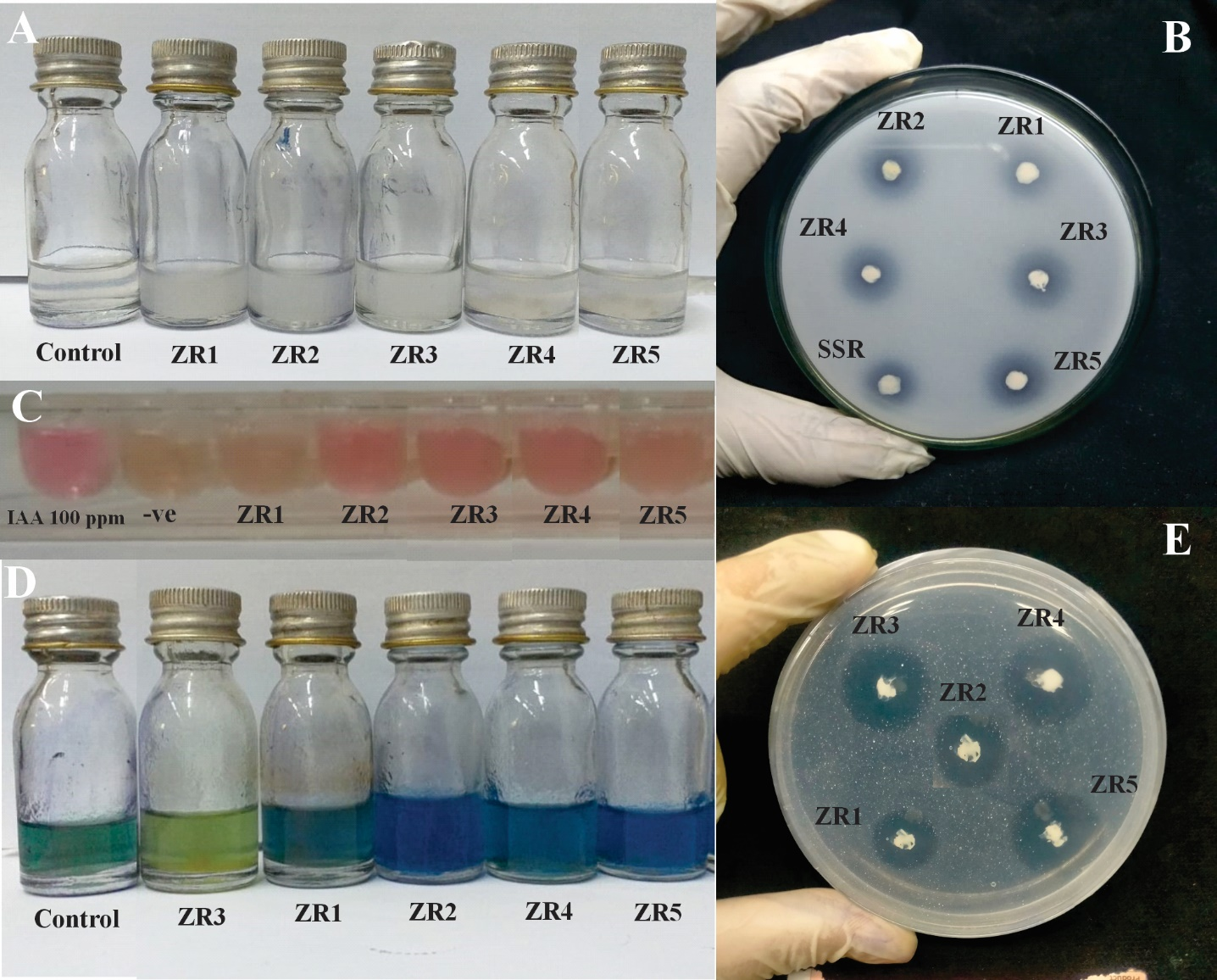

**Figure S1: Plant Growth Promoting Attributes of PSB**

A: ACC deaminase activity B: P solubilization C: IAA production D: Growth in NFM vials E: Zinc solubilization

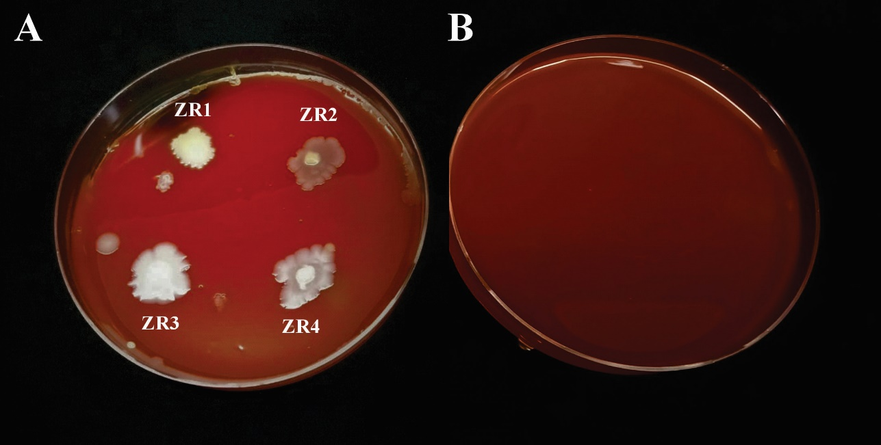

**Figure S2: Blood Agar test for Biosafety assessment**

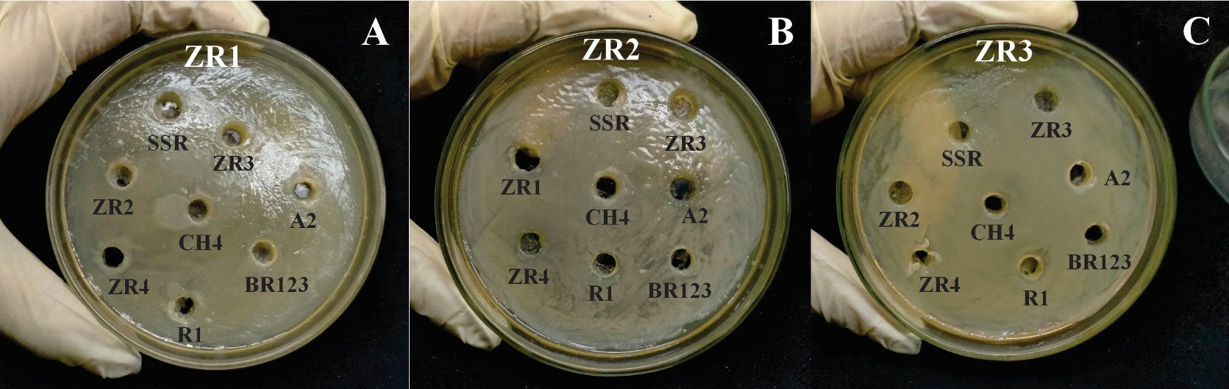

**Figure S3: Compatibility test of PSB for Consortium Development**

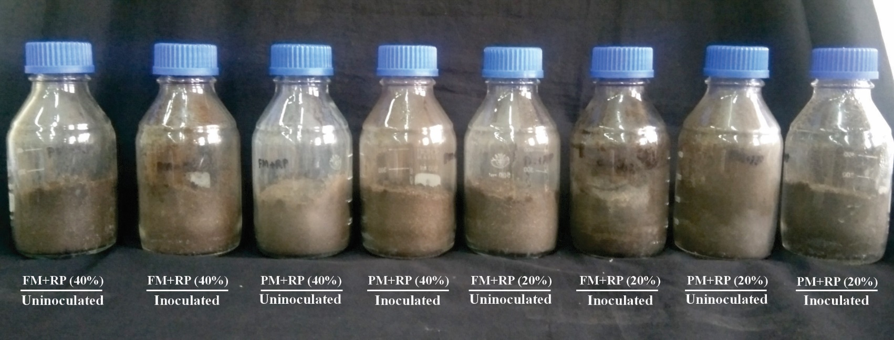

**Figure S4: Setup of microcosm bottles**