Table S1: Physiochemical properties of wheat rhizospheric soils collected for bacterial isolations from different sites of South Punjab, Pakistan.
Sample no. | District | Coordinates | pH | EC  (dS m⁻¹) | Organic  Matter (%) | Available P (mg kg⁻¹) | Exch. K  (mg kg⁻¹)
1 | Islamabad (Site 1) | 33.591068, 73.321415 | 7.99 | 1.49 | 0.71 | 1.00 | 390
2 | Bagh | 34.029349, 73.754826 | 7.73 | 0.95 | 0.65 | 17.40 | 454
3 | Islamabad (Site 2) | 33.566515, 73.272147 | 8.02 | 2.00 | 0.58 | 9.50 | 400
4 | Rawalpindi | 33.608787, 73.429849 | 7.87 | 0.99 | 0.68 | 13.85 | 218
5 | Bahawalnagar (Site 1) | 29.348194, 72.995185 | 7.84 | 0.25 | 0.41 | 6.25 | 154
6 | Multan (Site 1) | 30.268453, 71.415518 | 7.91 | 0.28 | 0.38 | 12.95 | 184
7 | Muzzafargarh | 30.282401, 71.391901 | 8.47 | 0.32 | 0.38 | 18.20 | 280
8 | Multan (Site 2) | 30.246454, 71.480404 | 7.83 | 0.31 | 0.15 | 5.95 | 134
9 | Bahawalnagar (Site 2) | 29.321651, 72.875404 | 7.92 | 0.34 | 0.59 | 20.45 | 176
10 | Sialkot | 32.429799, 74.609782 | 7.62 | 0.71 | 0.38 | 16.65 | 212
11 | Jhang (Site 1) | 31.320934, 72.599428 | 7.80 | 0.42 | 0.35 | 4.45 | 212
12 | Jhang (Site 2) | 31.288285, 72.366462 | 7.93 | 0.23 | 0.50 | 32.10 | 180
13 | Mankera (Site 1) | 31.346443, 71.682785 | 8.20 | 0.12 | 0.18 | 7.45 | 116
14 | Mankera (Site 2) | 31.276066, 71.714639 | 8.00 | 0.13 | 0.48 | 9.60 | 136

Table S2: Morpho-physiological characterization of P solubilizing bacteria
 |  |  | Colony Morphology |  | Cell Morphology
Strains | Phosphate Solubilizing Bacteria | Accession numbers | Colony Characteristics | Picture | Shape | Motility | Gram Staining | Cell Picture
ZR1 | Pantoea cypripedii | OR272290 | Circular, Pale white, Raised, Smooth | 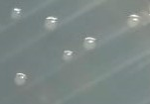 | Rods | + | - | 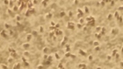
ZR2 | Lysinibacillus fusiformis | OR272301 | Circular, White, Raised, Smooth and Shiny | 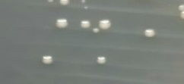 | Rods | - | - | 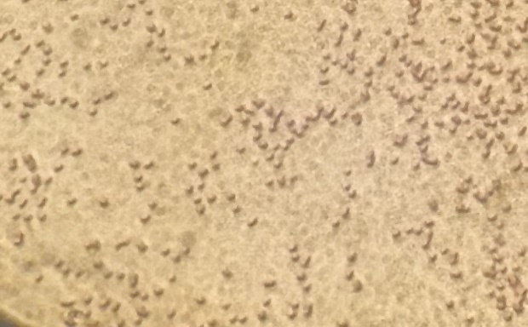
ZR3 | Enterobacter quasihormaechei | OR272303 | Off-White, Flat, Irregular-edged colonies. | 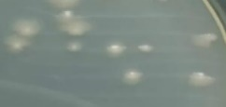 | Rods | ++ | - | 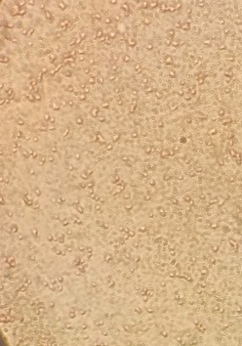
ZR4 | Klebsiella pneumoniae | OR272305 | Circular, Creamy White, Convex, Raised, Smooth, Shiny, Sticky colonies | 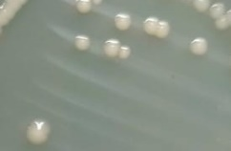 | Small Rods | - | - | 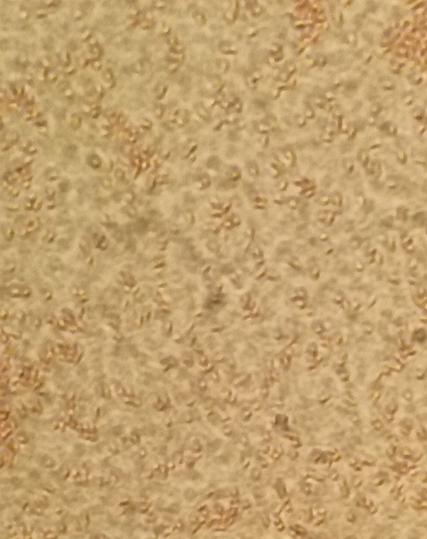
ZR5 | Klebsiella quasivariicola | OR272306 | Circular, White, Entire, Flat, Smooth, Sticky colonies | 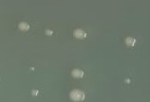 | Small Rods | - | - | 