# Data availability

The mitogenome sequence is available in nucleotide database of GenBank (https://www.ncbi.nlm.nih.gov/nucleotide/) with accession numbers: OR680716.1 (plastome) and OR680718.1 (mitogenome). The sequencing reads used for mitogenome assembly in this study have been released on the NCBI with those accession numbers: PRJNA1031331 (BioProject); SAMN37933744 (BioSample) and SRR26513849, SRR26513847 and SRR26513848 (SRA).

**Figure S1 The Sanger sequencing results of eight paths in the mitogenome of *A. odorata.***

**Figure S1A-H** represent the Sanger sequencing results for each of the eight paths, The sequencing results are expected and verify the reality of these eight paths.

**A**

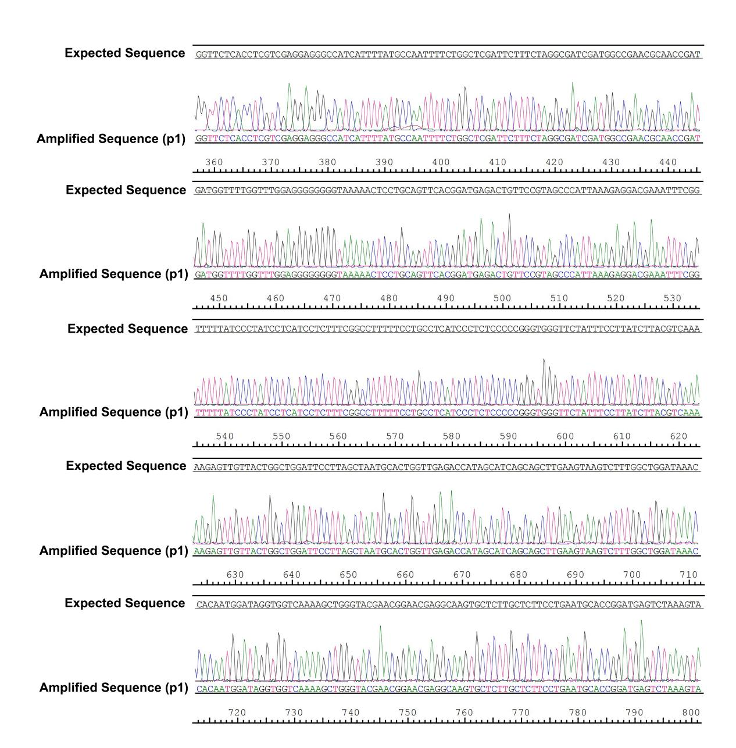

**B**

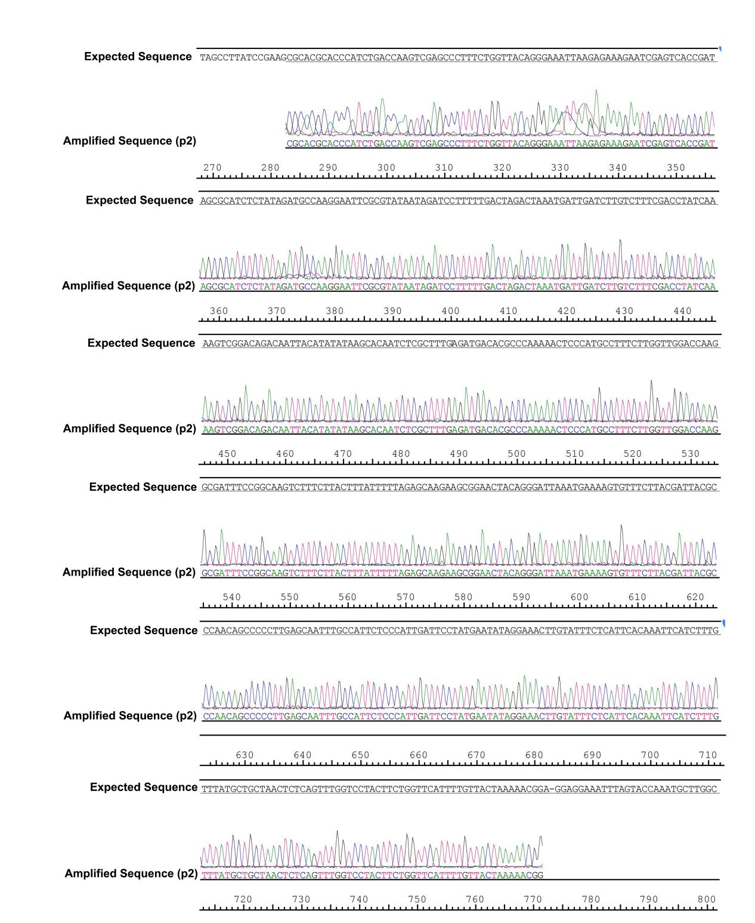

**C**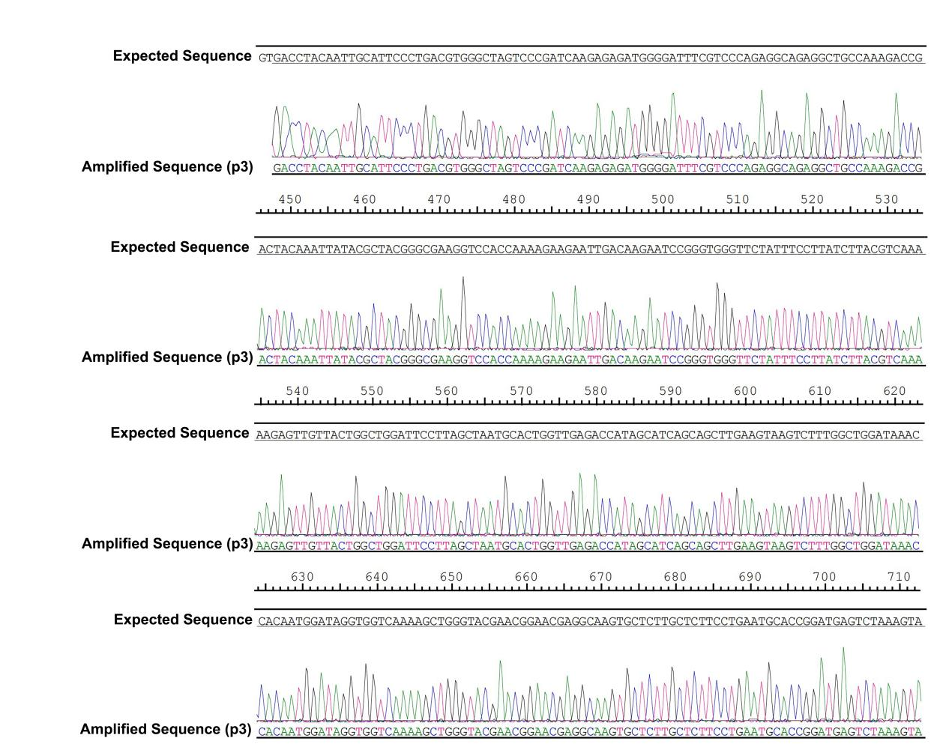

**D**

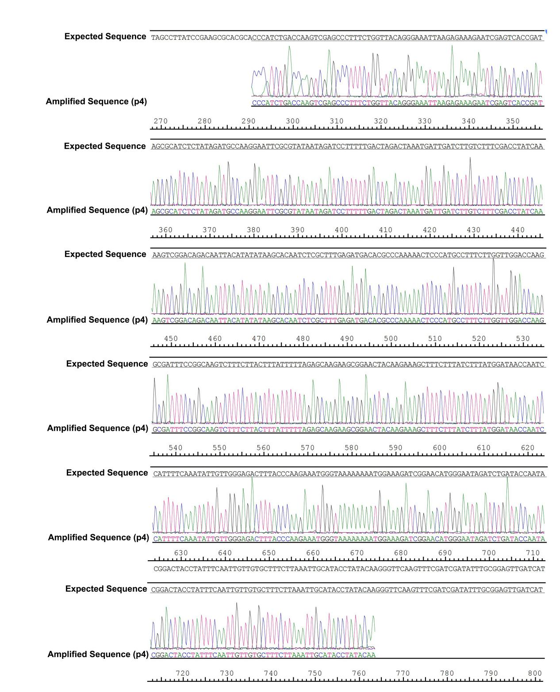

**E**

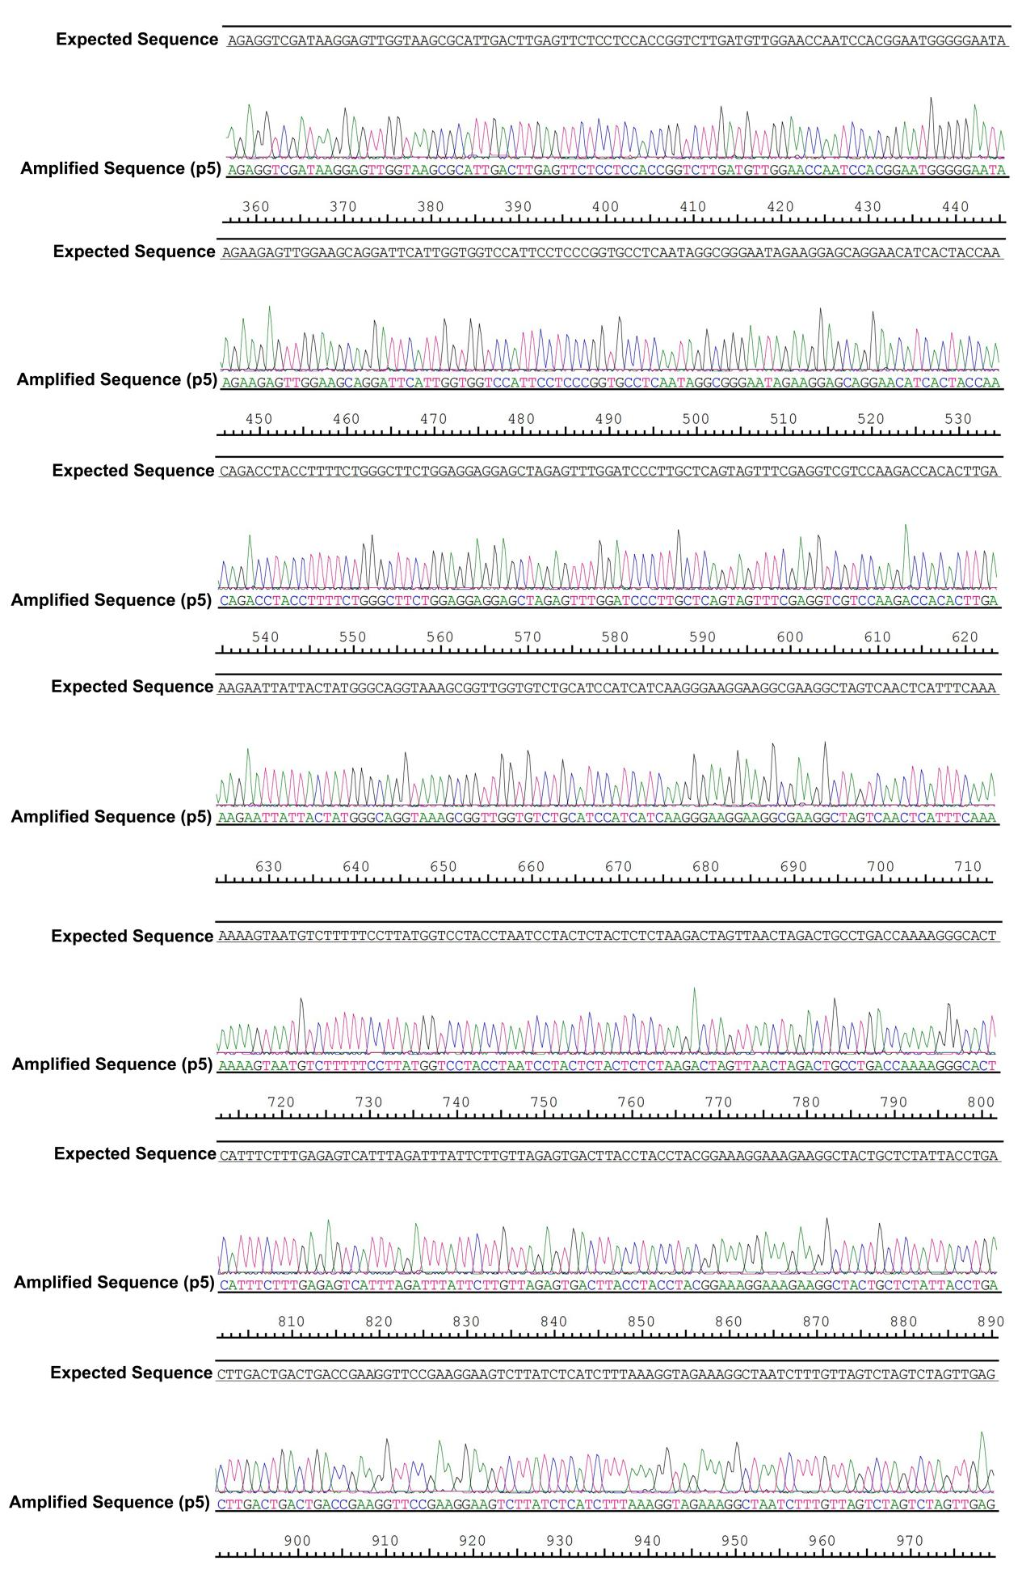

**F**

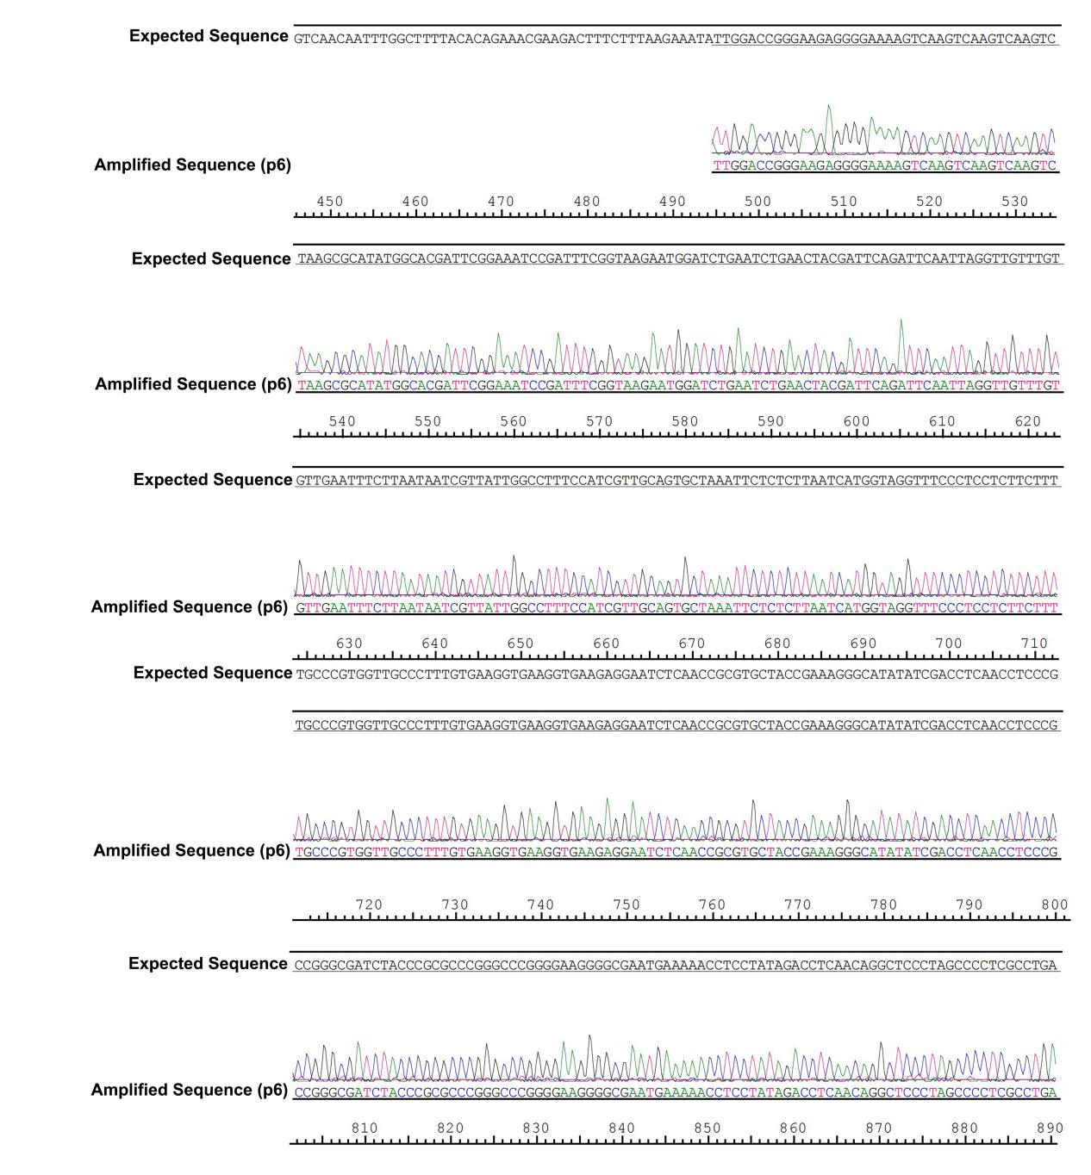

**G**

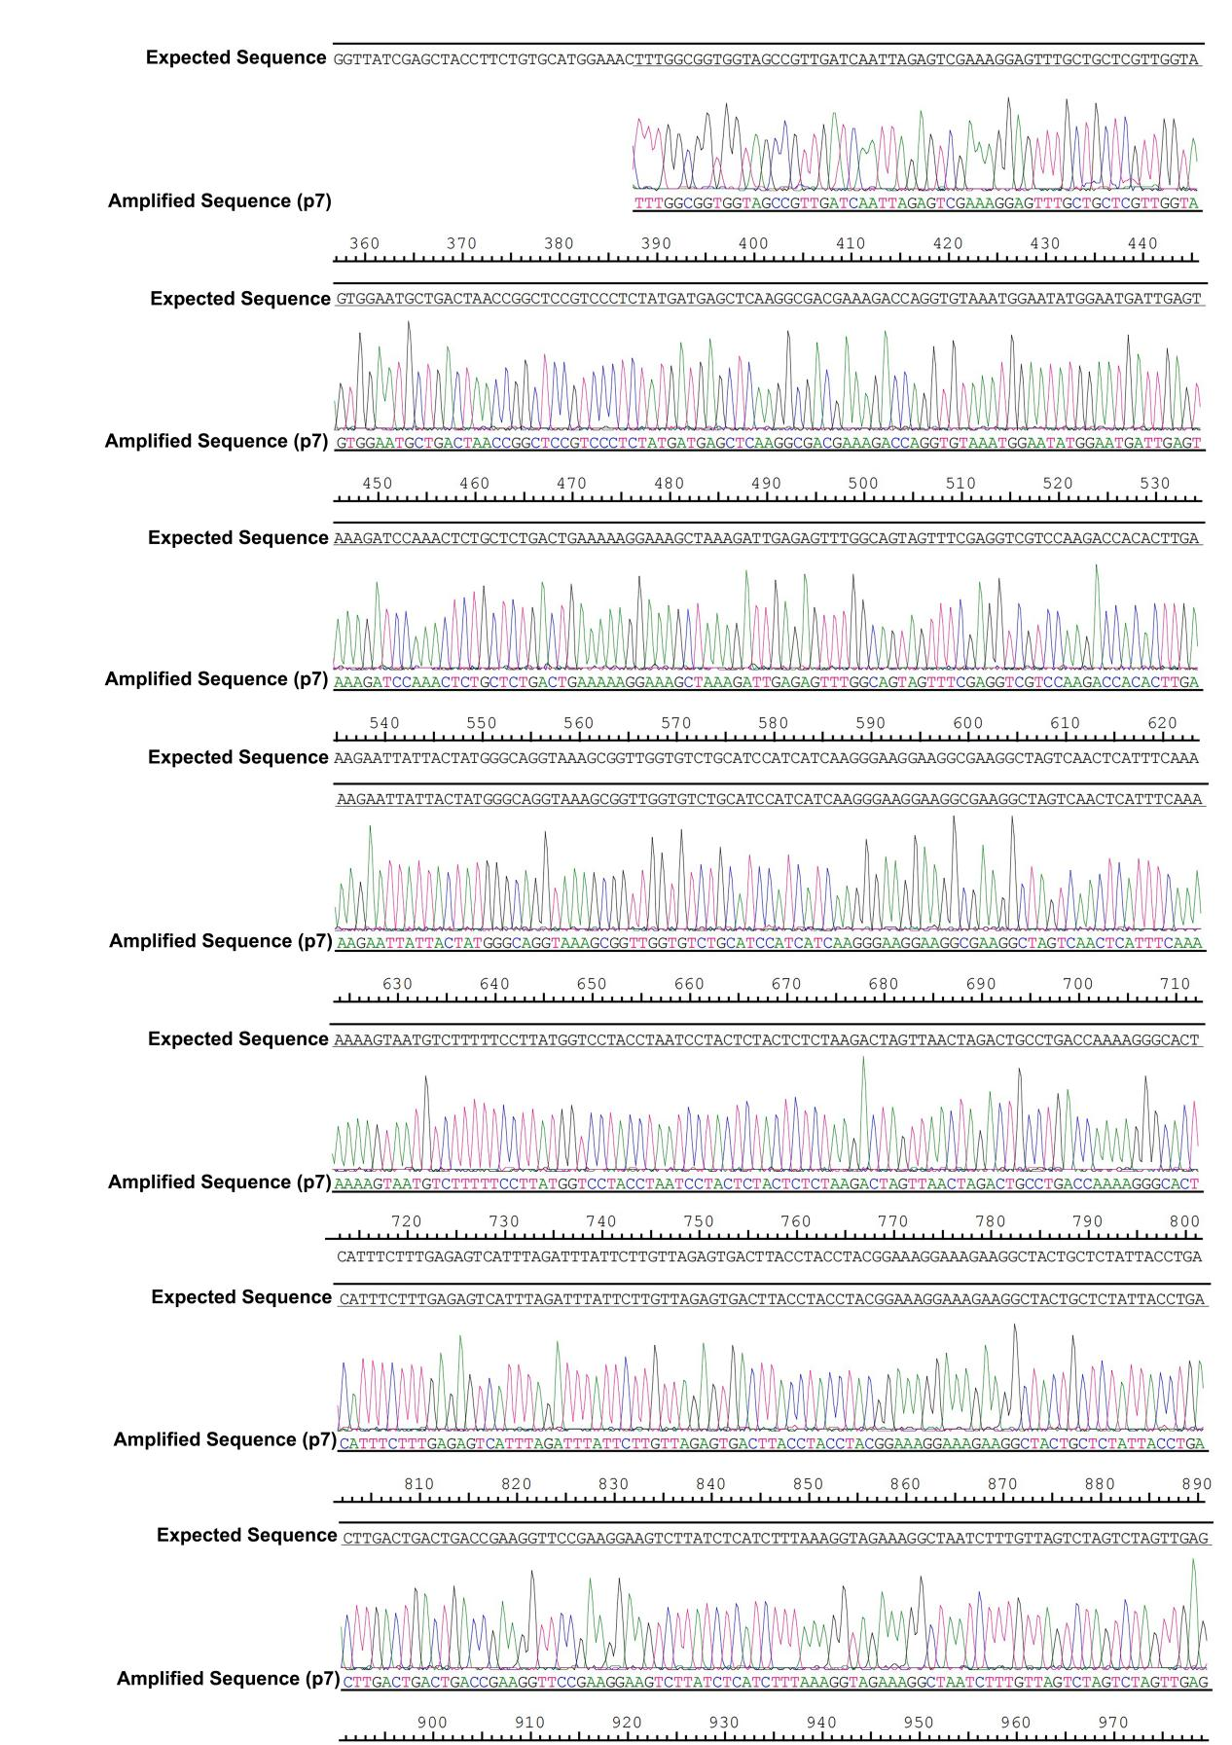

**H**

