Table S1
Webcam Parameter List
Webcam Picture | Parameter | Value
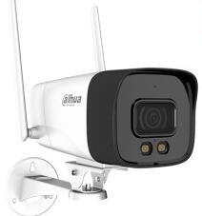 | Resolution | 1080P/2K
 | Networking Method | Wi-Fi/WLAN
 | Focal length | 6mm
 | Storage Method | Memory Card / Cloud Storage / Hard Disk
 | Waterproof rating | IP67

