Supplementary Material

Evaluation of the possibility of enhancing skin absorption of other active ingredients of exopolysaccharides
It was investigated whether exopolysaccharides produced from the phycobiliprotein production-enhancing mutant enhance the skin absorption rate of other active ingredients. Adenosine (1.98% w/w), one of the representative skin active ingredients, was used as an indicator, and an experiment was conducted with an aqueous solution with and without 0.01% (w/w) EPS. A skin penetration device (FDC-6T, Logan, USA) was utilized, and the relative humidity of the device was maintained at 30-50% during the test. The Strat-M membrane (transdermal diffusion test model, USA; filter diameter 25 mm, thickness 300 μm) was washed in phosphate-buffered saline (PBS) for 3-5 mins before being secured atop the receptor chamber, which was then filled with PBS. The temperature of the PBS was maintained at 32 ± 1 °C. Subsequently, 0.5 mL of the sample was uniformly applied to the membrane (applied area: 0.64 cm2), and after a set period, 0.3 mL of PBS in the receptor chamber was collected and quantitatively analyzed via high performance liquid chromatography. The skin permeability was assessed by calculating the amount of the target ingredient (adenosine) detected in the receptor chamber relative to the amount of the target ingredient in the applied test substance.

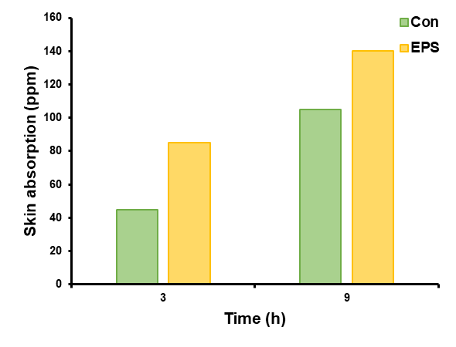
Supplementary Figure 1. Evaluation of skin absorption enhancement potential of other active ingredients of exopolysaccharides (EPS) produced from the strain PPE. ‘Con’ refers to the control without EPS, and ‘EPS’ refers to the sample containing 0.1% (w/w) EPS. Adenosine, at a concentration of 1.98% (w/w), was used as an indicator for skin active ingredients.

