Supplementary Material

# Supplementary Figures

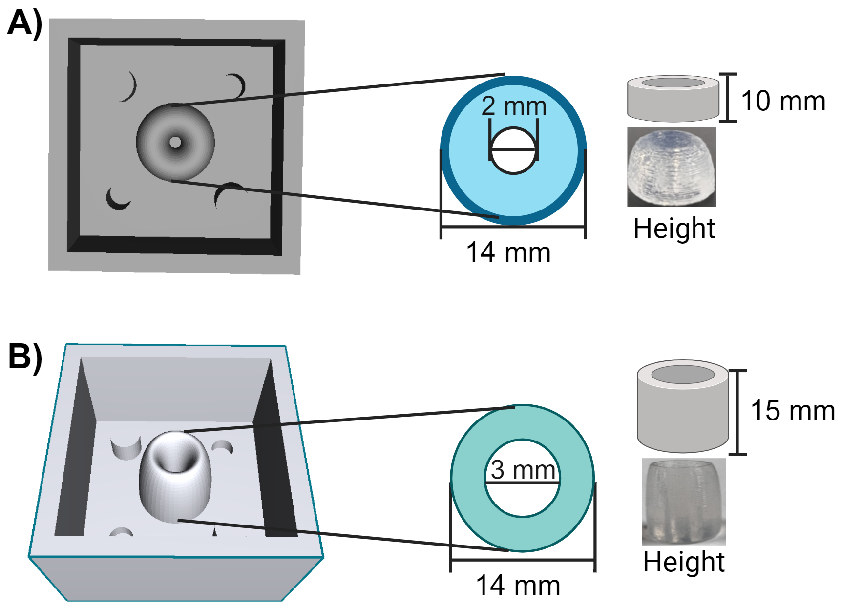

**Supplementary Figure 1.** **SolidWorks designed of the outside molds.** (**A**) The first mold had a thickness of 10mm with an outside diameter of 14 mm and inside diameter of 2 mm. (**B**) The second mold had a thickness of 15 mm with an outside diameter of 14 mm and inside diameter of 3 mm. Schemes created in BioRender.com.

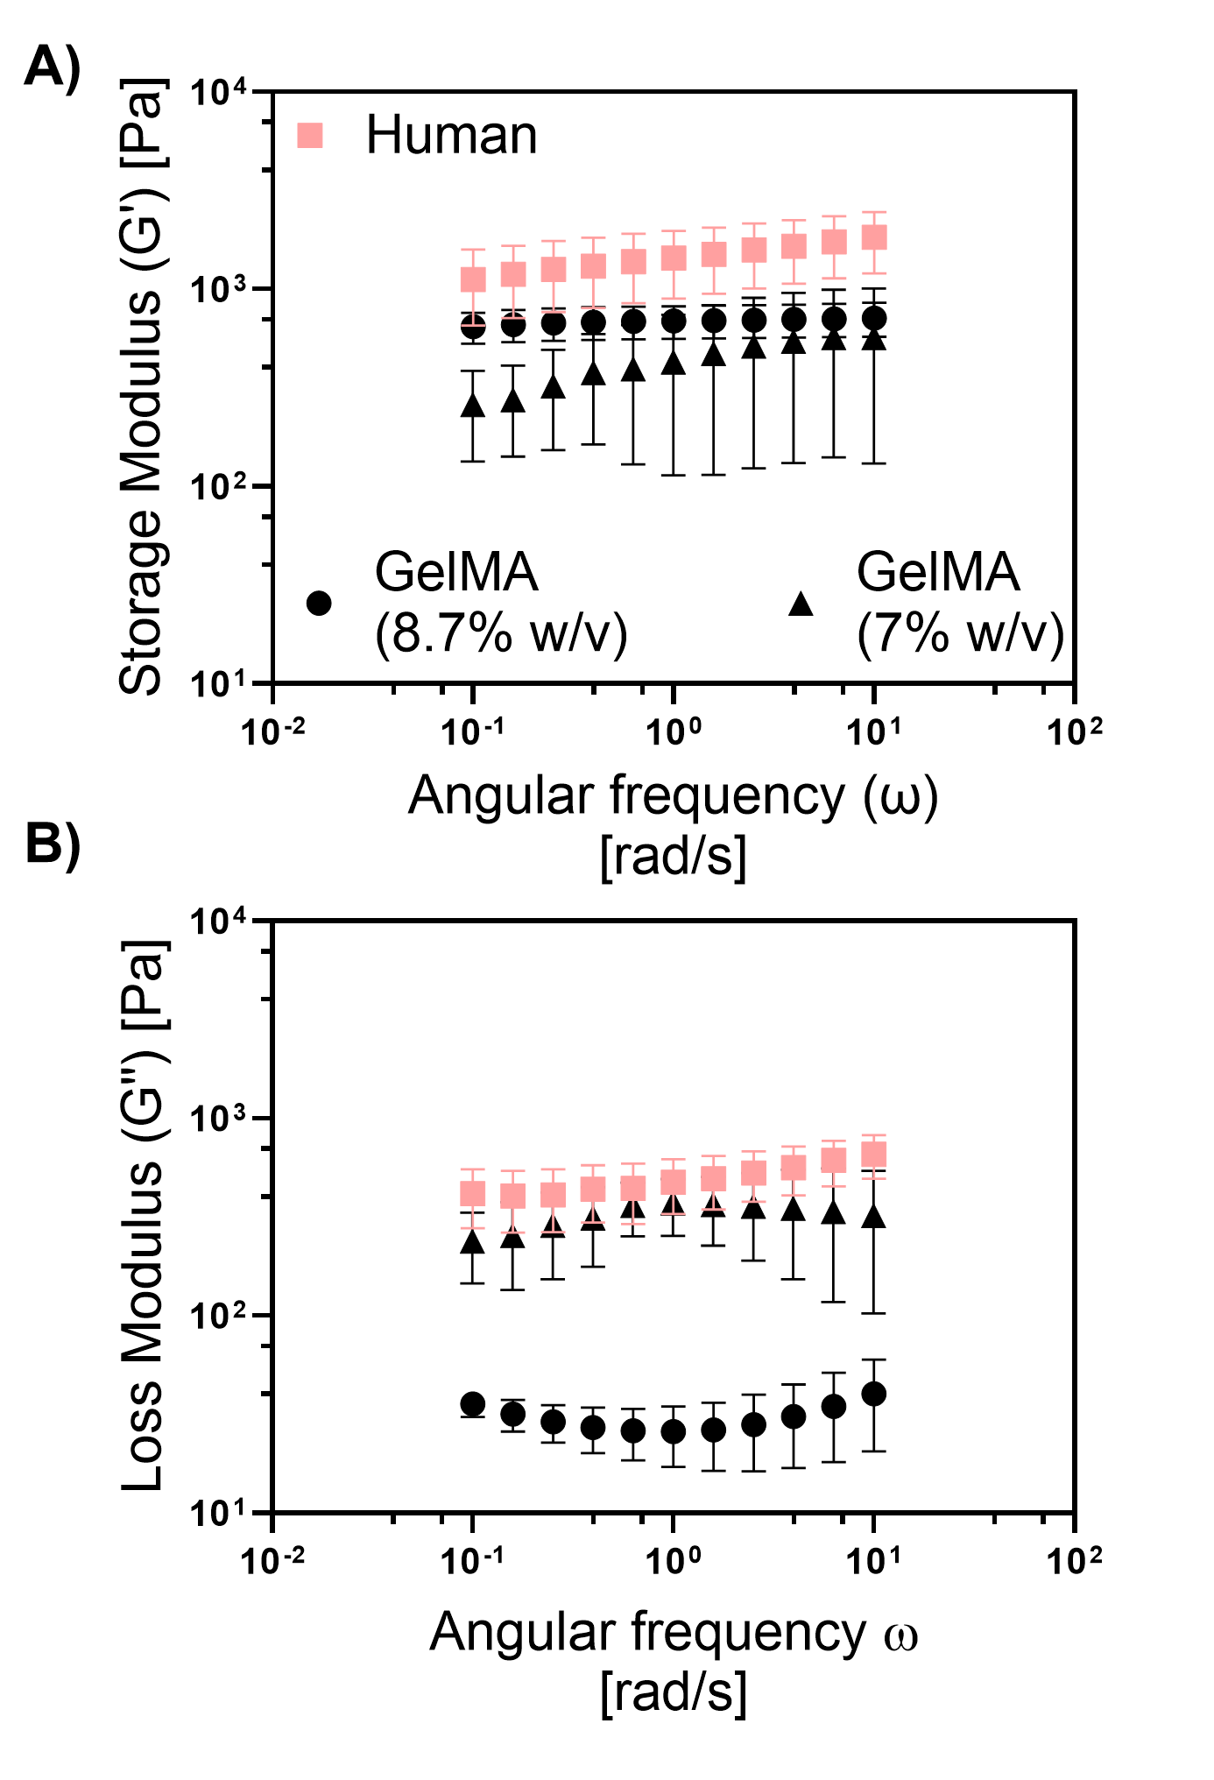

**Supplementary Figure 2.** Comparison of the viscoelastic properties between GelMA and human cervix. **(A)** storage and **(D)** loss modulus. Frequency sweeps were conducted from 0.1 to 100 rad/sec within the linear viscoelastic (LVE) region at a constant strain amplitude of 5%, and temperature of 37°C. Human cervix samples were stored in 10% PBS and incubated at 37°C for 1 hour before experiments. GelMA hydrogels were crosslinked with LAP using a 405 nm UV light source for about 1 min, then hydrogels were incubated at 37°C for 1hour prior measurement. Data represent the mean ± SD (n = 5).

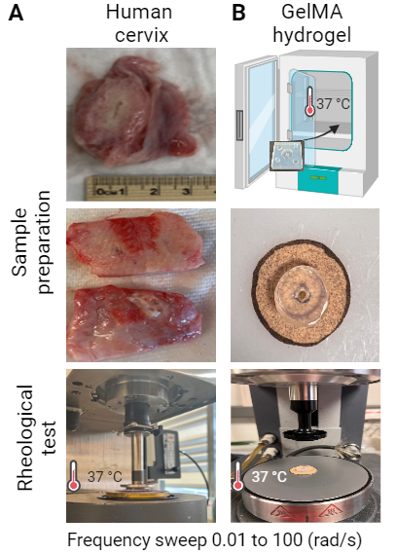

**Supplementary Figure 3.** **Rheological comparison between the human cervix and GelMa hydrogel.** (**A**) Representation of human sample processing for rheometric test. Human samples were dissected to remove excess fat and residual tissue and cut so that they fit the 25mm circular plate (**B**). Schematic representation of sample preparation and images of GelMA (8.7%w/v) before the rheometric test. Diagram created in BioRender.com.

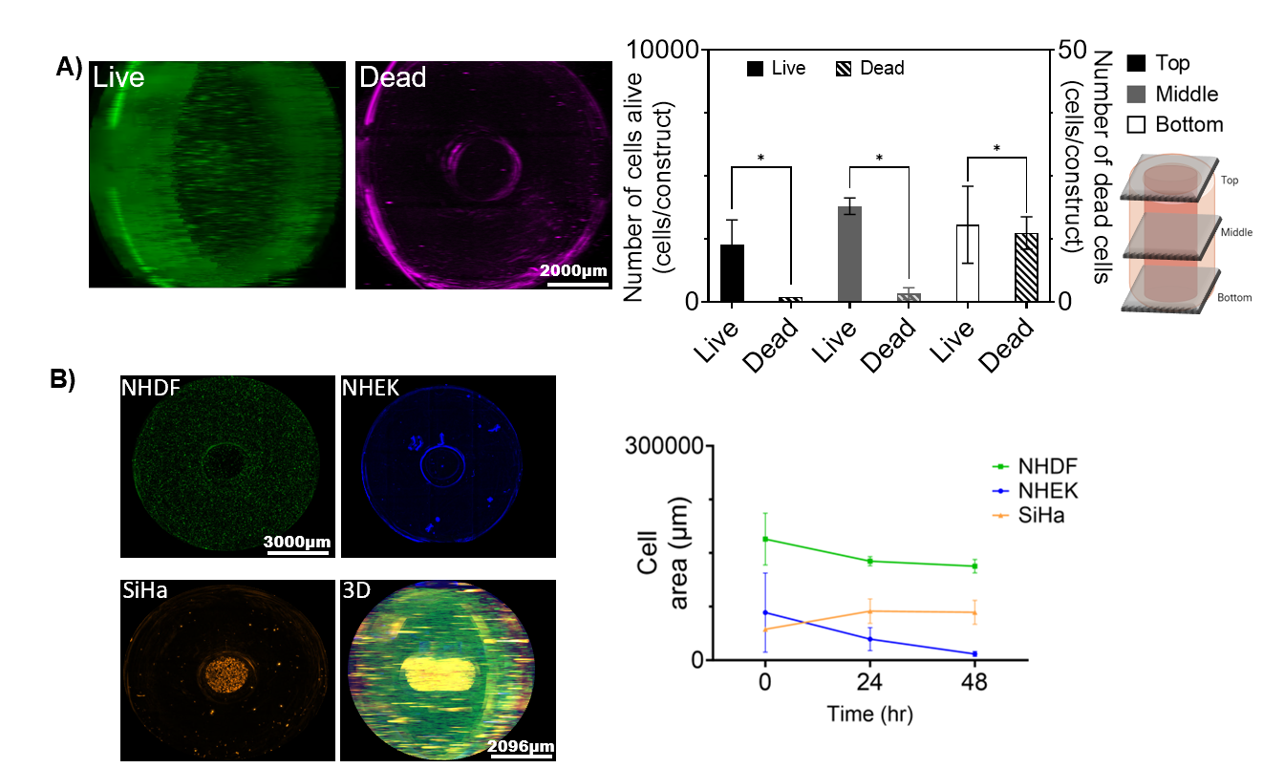

**Supplementary Figure 4. Cell response in 3D *in vitro* model with 15 mm thickness. (A)** Cell viability and (**B**) Cell area were assessed in 3D *in vitro* model with 15 mm thickness. Representative images of live in green and dead cells in magenta after 48 hours of culture. The number of live and dead cells in the 3D construct at 48 hours was quantified in the top, middle and bottom layers of the 3D model. The top, middle and bottom layers were defined based on the z-stacks position. Top layer corresponded to the images at the z-stack =1280-1080 µm, the middle layer the z-stack= 720-540 µm, and the bottom layer were at a z-stack =0-360 µm. Distance between z-stack layers was defined as 180 μm. (**B**) Representative images of the three cell lines (NHDF, NHEK, and SiHa) after 48 hours of co-culture in the 3D model. The cell area of each cell line was quantified at every time point. Images were taken every 24 hours for 48 hours. A montage of 4x5 (rows x columns) with 9 z-stacks was taken to capture the 3D model. The sample thickness was 1280 µm Live-dead assay constructs were stained with a solution of calcein and propidium iodide after 48 hours of cocultured. Cell area was tracked by staining NHDF cells with CellTracker Green CMFDA (C7025), SiHa were tracked using CellTracker Red CMTPX (C34552), and NHEK cells with CellTracker Blue CMF2HC (C12881). Images were created using Gen5 V3.14 software, and post analysis was done in Gen5 and ImageJ. The data represent the mean ± SD (n = 4). \**p* < 0.05, analyzed using 2-Way ANOVA with Tukey post-test.

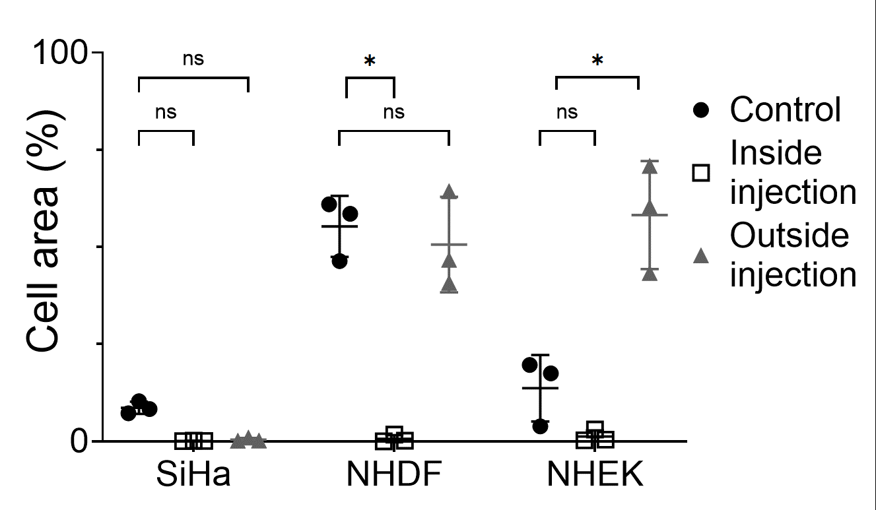

**Supplementary Figure 5. Changes in cell area after treatment with EC-ethanol injection.** Cell area was compared among the three cell lines co-cultured in the 3D model post injection at 48h. Control group had only culture media. Cell area was quantified using Fiji ImageJ. Images were created and processed with Gen5 V3.14 software. 2D z-projection was created using Fiji ImageJ and was used to quantify the percentage of cells where the EC-ethanol was injected and compared to the area in the outside. Cell area was tracked by staining NHDF cells with CellTracker Green CMFDA (C7025), SiHa were tracked using CellTracker Red CMTPX (C34552), and NHEK cells with CellTracker Blue CMF2HC (C12881). The percentage of cell area was measured as the area covered by each cell line compared to the total area of the well. * *p* <0.05, compared to the EC-ethanol group. Two-way ANOVA with Sidak post-test. Data represent the mean ± SD (n = 4).

All the images are available on the Fogg Lab GitHub (https://github.com/fogg-lab/Cervical-Dysplasia). The datasets generated during and analyzed during the current study are available from the corresponding author upon reasonable request.