Supplementary Material

Supplementary Figures and Tables

Supplementary Figures
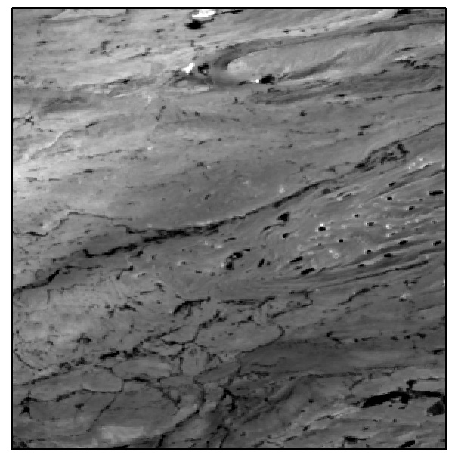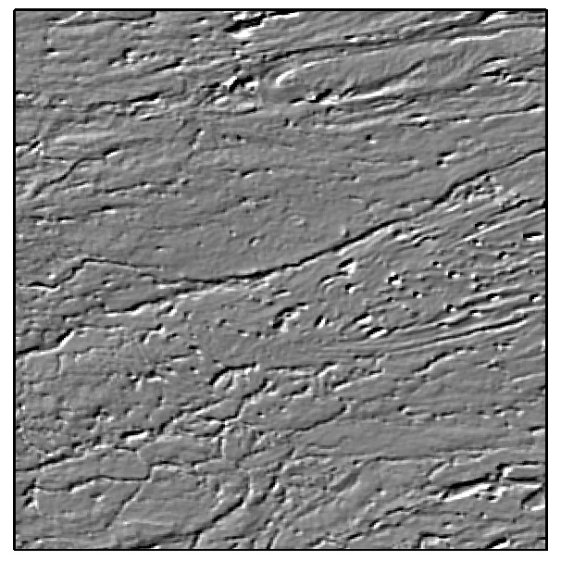
Supplementary Figure 1. (A) before NE-oriented convolutional filtering enhancement (B) after NE-oriented convolutional filtering enhancement

Supplementary Tables
Supplementary Table 1. Brief information on remote sensing data acquisition
Data source | Acquisition time | Acquisition source | Number
Landsat 8 OLI | 20140822 | Geospatial Data Cloud (GDC) https://www.gscloud.cn/search | LC81440352014234LGN00
Sentinel-2 | 20210920 | ESA https://dataspace.copernicus.eu/ | S2A_MSIL2_20210920T050701_N9999_R019_T44SQF_20230419T105427.SAFE
 | 20210930 |  | S2A_MSIL2_20210930T050701_N0500_R019_T44SPF_20230120T015615.SAFE
 | 20200930 |  | S2B_MSIL2_20200930T050659_N0500_R019_T44SPE_20230503T003341.SAFE
 | 20200930 |  | S2B_MSIL2_20200930T050659_N0500_R019_T44SQE_20230503T003341.SAFE
ASTER | 20010920 | USGS https://earthexplorer.usgs.gov/ | AST_L1T_00309202001052158_20150419175419_5966
GF-6 | 20210727 | Catalog of Ecological Red Line Data Resources | GF6_PMS_E83.1_N35.8_20210727_L5A_1120126560
 | 20190907 |  | GF6_PMS_E83.3_N35.8_20190907_L5A_1119920218
 | 20211205 |  | GF6_PMS_E83.4_N36.5_20211205_L5A_1120163826
 | 20210918 |  | GF6_PMS_E84.0_N36.5_20210918_L5A_1120142839

Supplementary Table 2. Landsat 8 OLI and Sentinel-2 data band parameters
Bands | Landsat 8 OLI |  |  |  | Sentinel-2A | Sentinel-2B
 | Numbers | wavelength/μm | resolution/m | Numbers | wavelength/μm | wavelength/μm | resolution/m
Visible and near infrared (VNIR) | 1 | 0.433-0.453 | 30 | 1 | 0.412-0.456 | 0.411-0.456 | 60
 | 2 | 0.450-0.515 | 30 | 2 | 0.456-0.533 | 0.456-0.532 | 10
 | 3 | 0.525-0.600 | 30 | 3 | 0.538-0.583 | 0.536-0.582 | 10
 | 4 | 0.630-0.680 | 30 | 4 | 0.646-0.684 | 0.646-0.685 | 10
 | 8 | 0.500-0.680 | 15 | 5 | 0.695-0.714 | 0.694-0.714 | 20
 | 5 | 0.845-0.885 | 30 | 6 | 0.731-0.749 | 0.730-0.748 | 20
 |  |  |  | 7 | 0.769-0.797 | 0.766-0.794 | 20
 |  |  |  | 8 | 0.760-0.907 | 0.774-0.907 | 10
 |  |  |  | 8A | 0.837-0.881 | 0.840-0.880 | 20
 |  |  |  | 9 | 0.932-0.958 | 0.930-0.957 | 60
Short wave infrared (SWIR) | 9 | 1.360-1.390 | 30 | 10 | 1.337-1.412 | 1.339-1.415 | 60
 | 6 | 1.560-1.660 | 30 | 11 | 1.539-1.682 | 1.538-1.679 | 20
 | 7 | 2.100-2.300 | 30 | 12 | 2.078-2.320 | 2.065-2.303 | 20

Figures
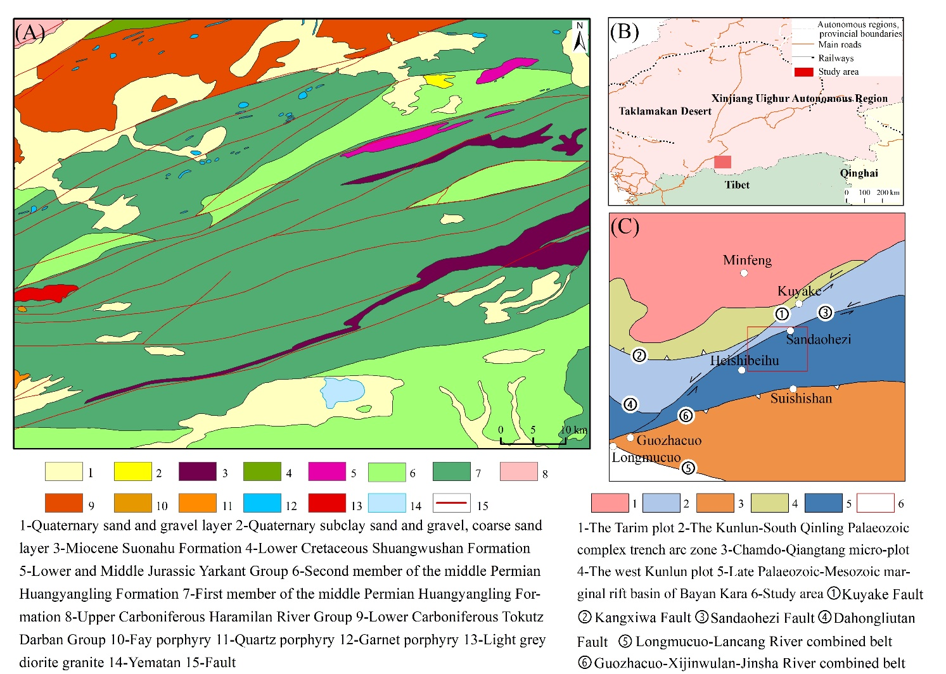
Figure 1 (A) Geological map of Huangyangling (According to the Xinjiang Minfeng County Wolonggang-Huifengkou Antimony Mine Preliminary Geological Report, 2011); (B) Geographic location of Huangyangling (According to the Xinjiang Minfeng Huangyangling Antimony Mine Investigation Report, 2009, modified); (C) Geotectonic subdivision of Huangyangling (According to the Xinjiang Minfeng Huangyangling Antimony Mine Investigation Report, 2009, modified)
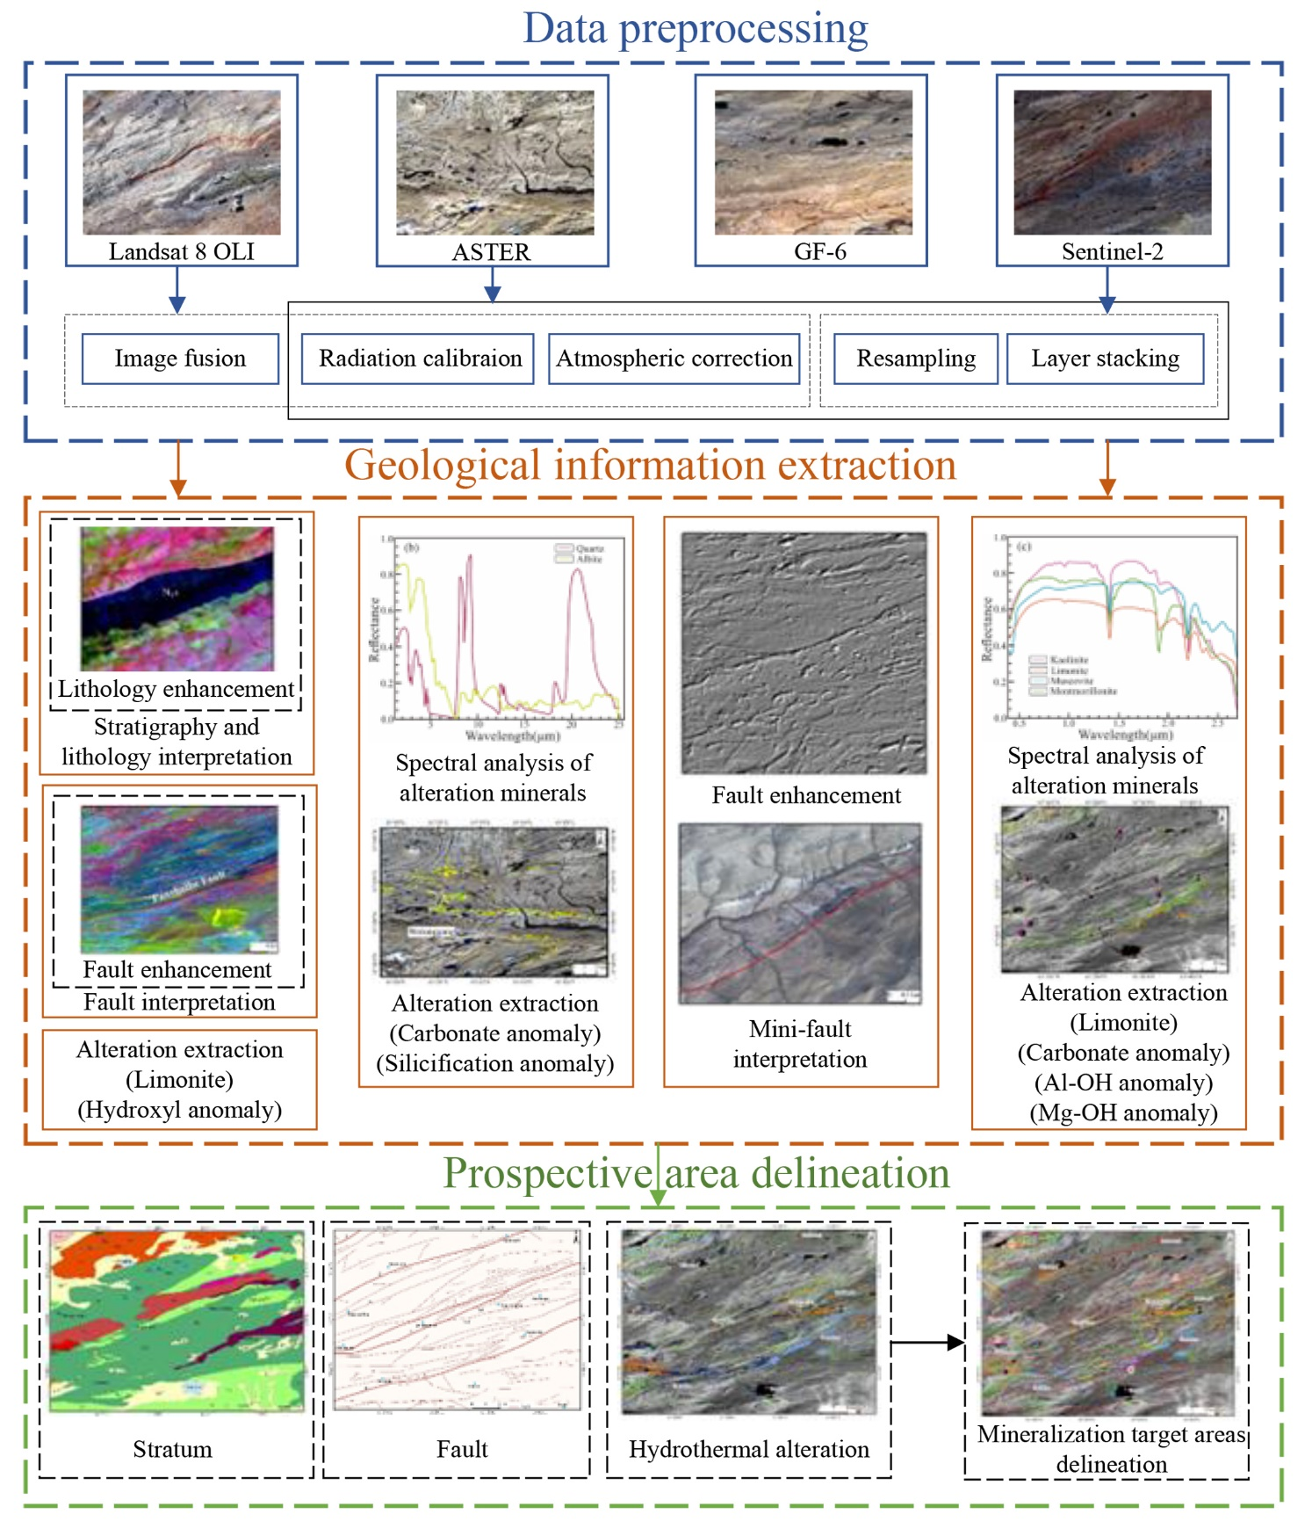
Figure 2 The workflow of this study
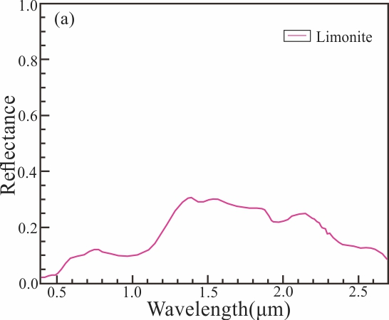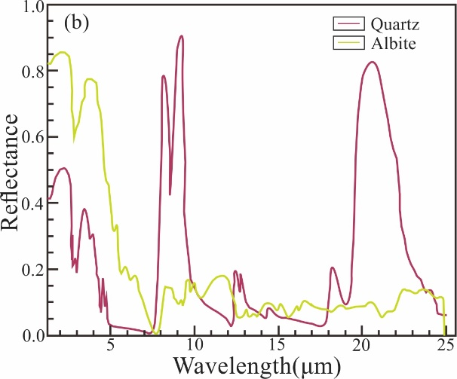
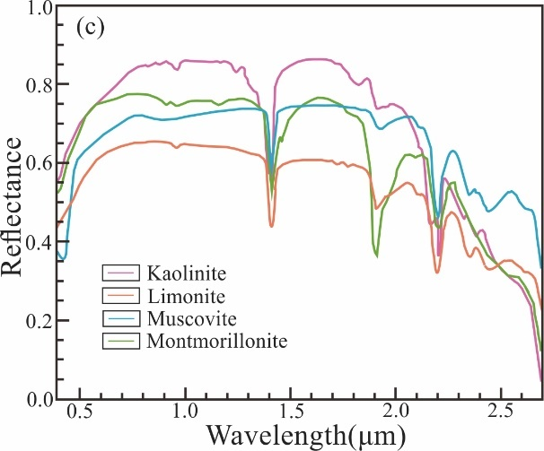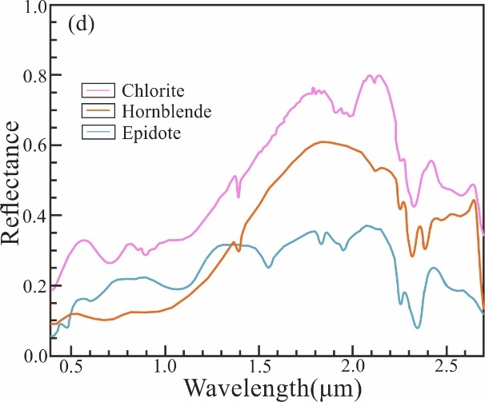
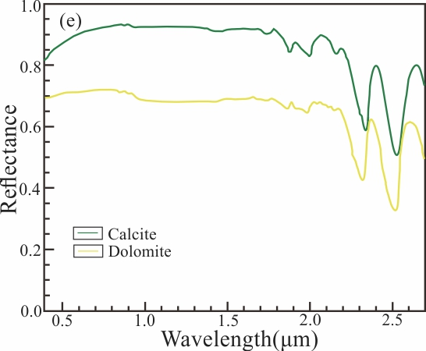
Figure 3 Typical alteration mineral spectral curves (from USGS spectral library) (a) Limonite; (b) Silicification minerals; (c) Al-OH minerals; (d) Mg-OH minerals; (e) Carbonate minerals
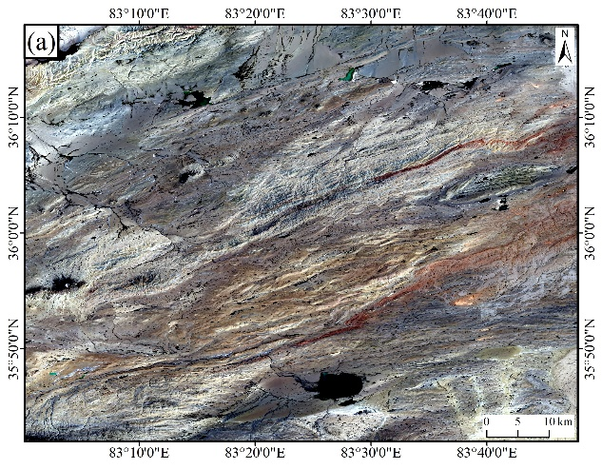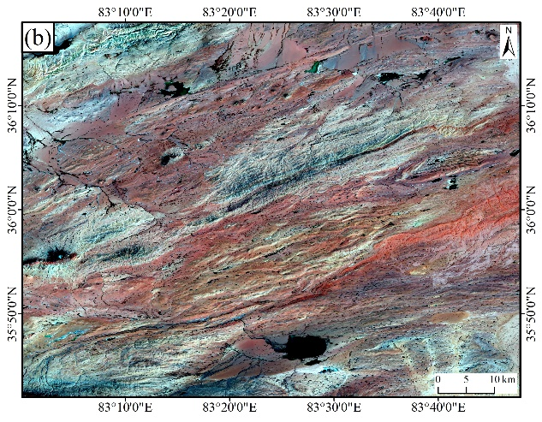
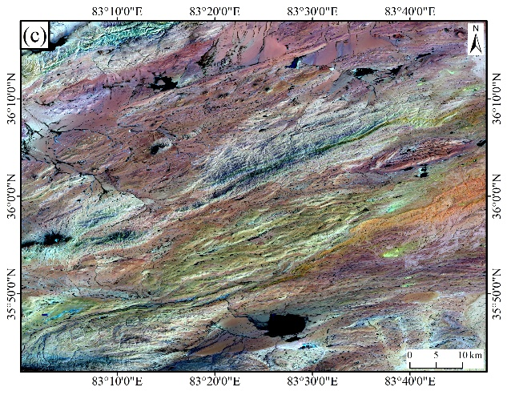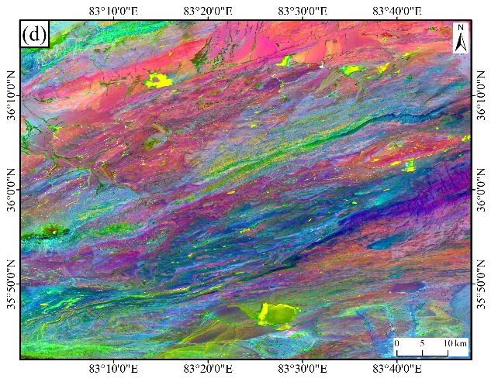
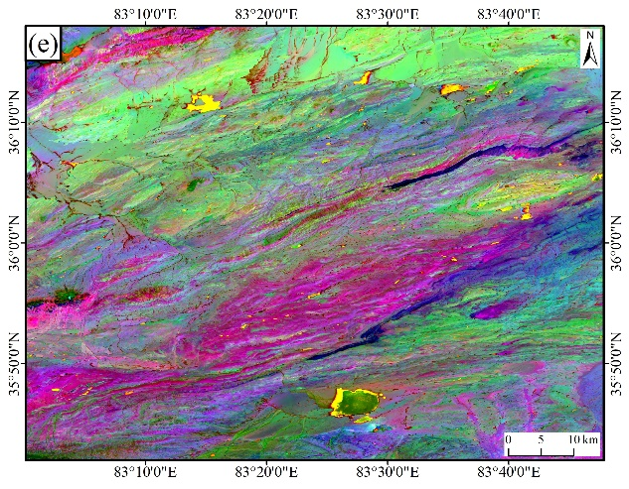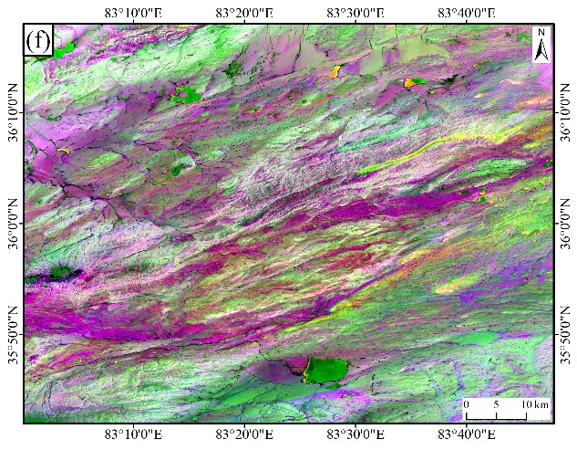
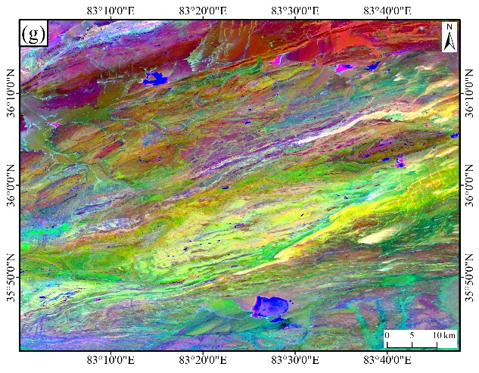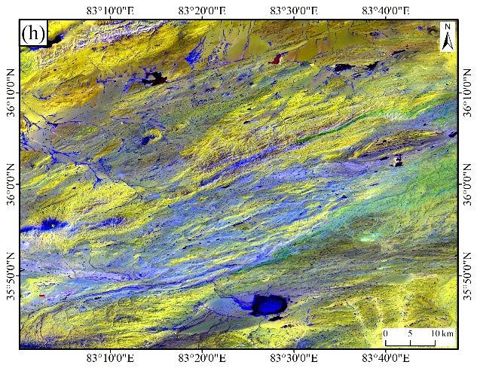
Figure 4 Lithology information enhancement using Landsat 8 data (a) B4(R)B3(G)B2(B); (b) B6(R)B3(G)B2(B); (c) B7(R)B5(G)B2(B); (d) PC3(R)PC2(G)PC1(B); (e) PC5(R)PC3(G)PC1(B); (f) IC6(R)IC3(G)B1(B); (g) IC6(R)MNF2(G)MNF1(B); (h) B3(R)B5(G)B6/B7(B)
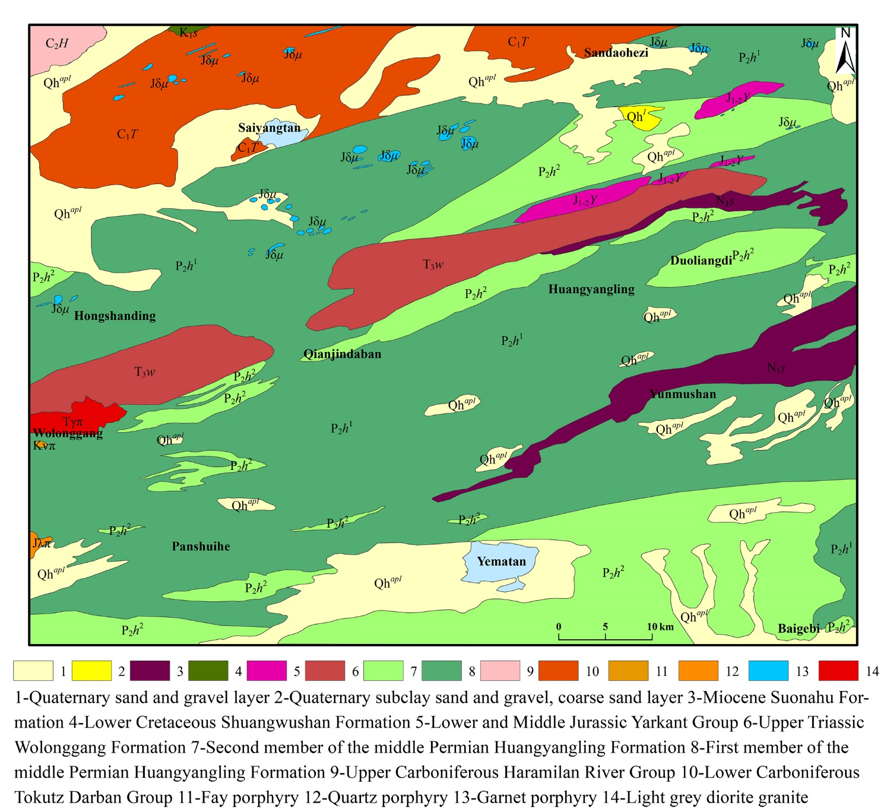
Figure 5 Remote sensing interpretation of stratigraphy and lithology
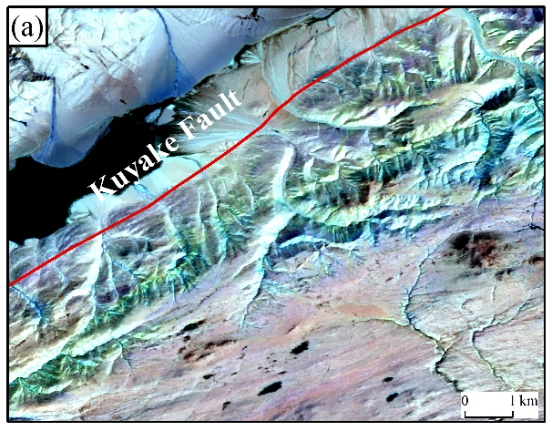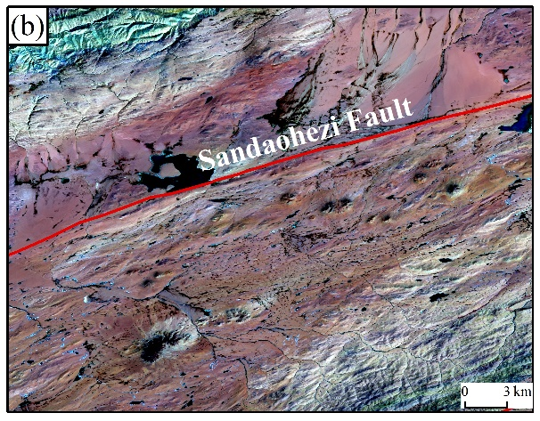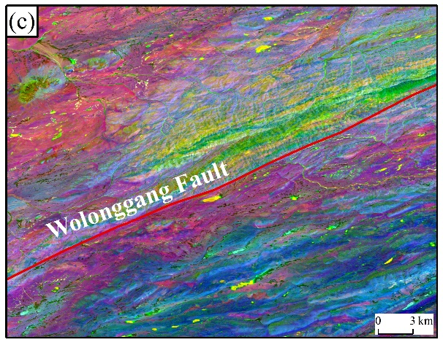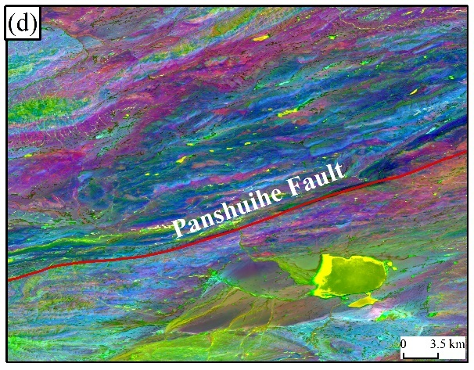
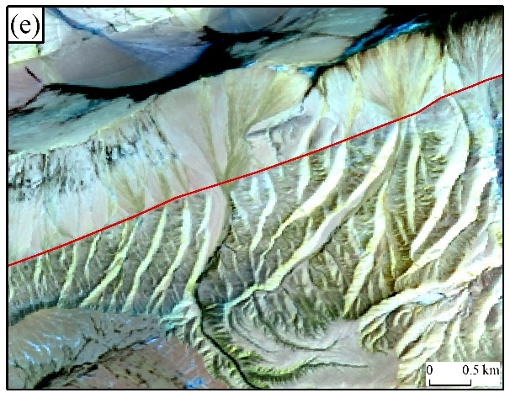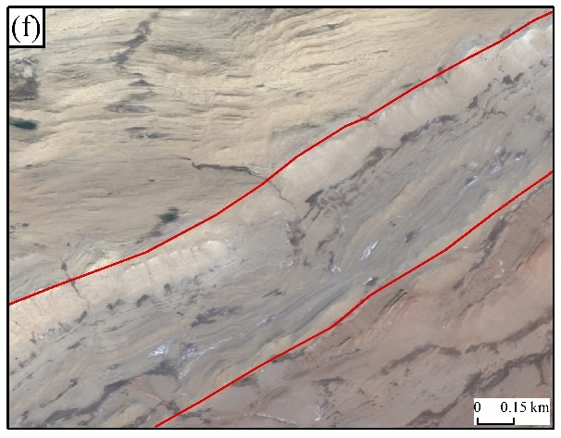
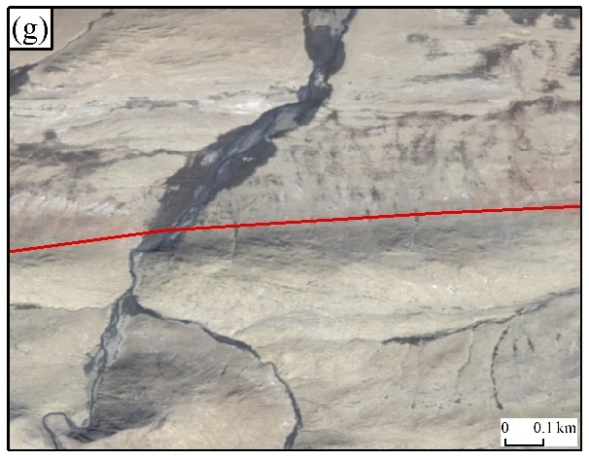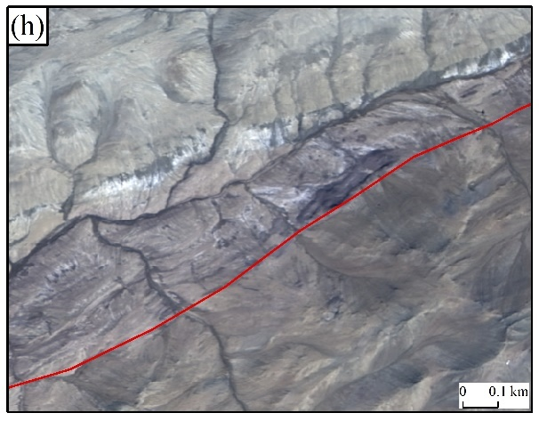
Figure 6 Fault interpretation flags (a) Landsat 8 B7(R)B5(G)B2(B); (b) Landsat 8 B7(R)B5(G)B2(B); (c) Landsat 8 PC3(R)PC2(G)PC1(B); (d) Landsat 8 PC3(R)PC2(G)PC1(B); (e) Landsat 8 B7(R)B5(G)B2(B); (f) GF-6 B3(R)B2(G)B1(B); (g) GF-6 B3(R)B2(G)B1(B);(h) GF-6 B3(R)B2(G)B1(B)
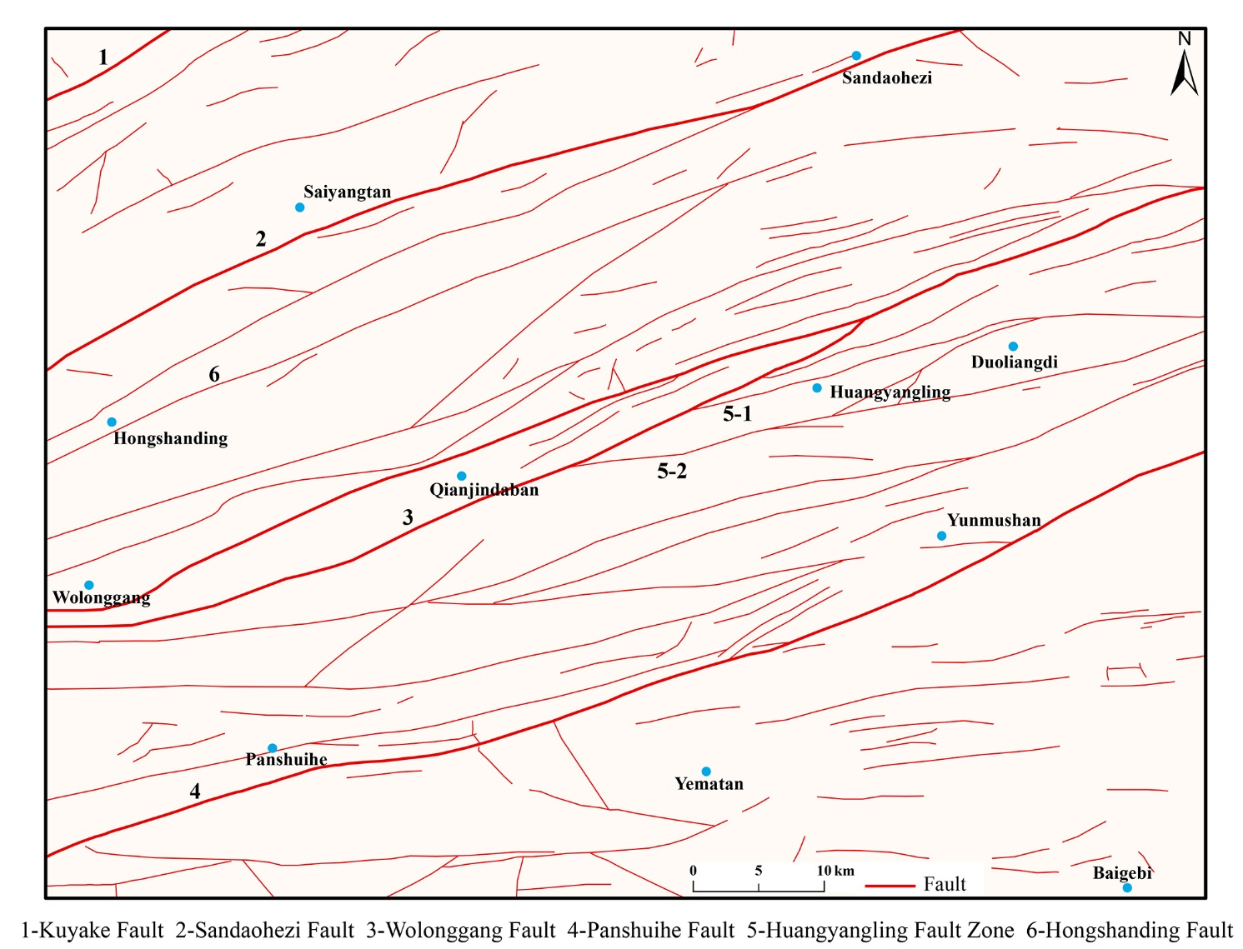
Figure 7 Remote sensing interpretation of lineaments

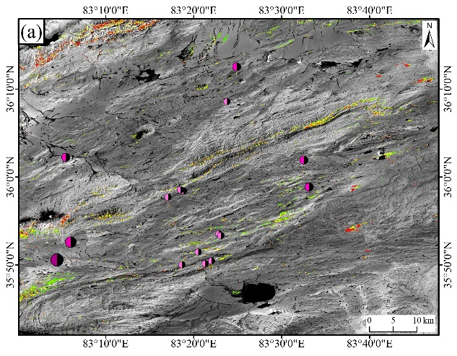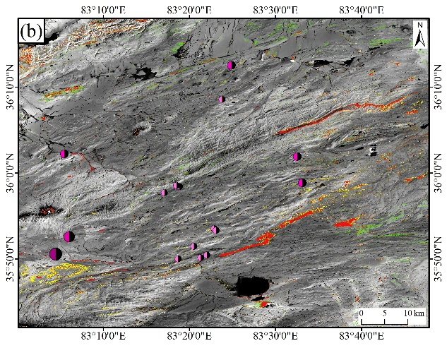
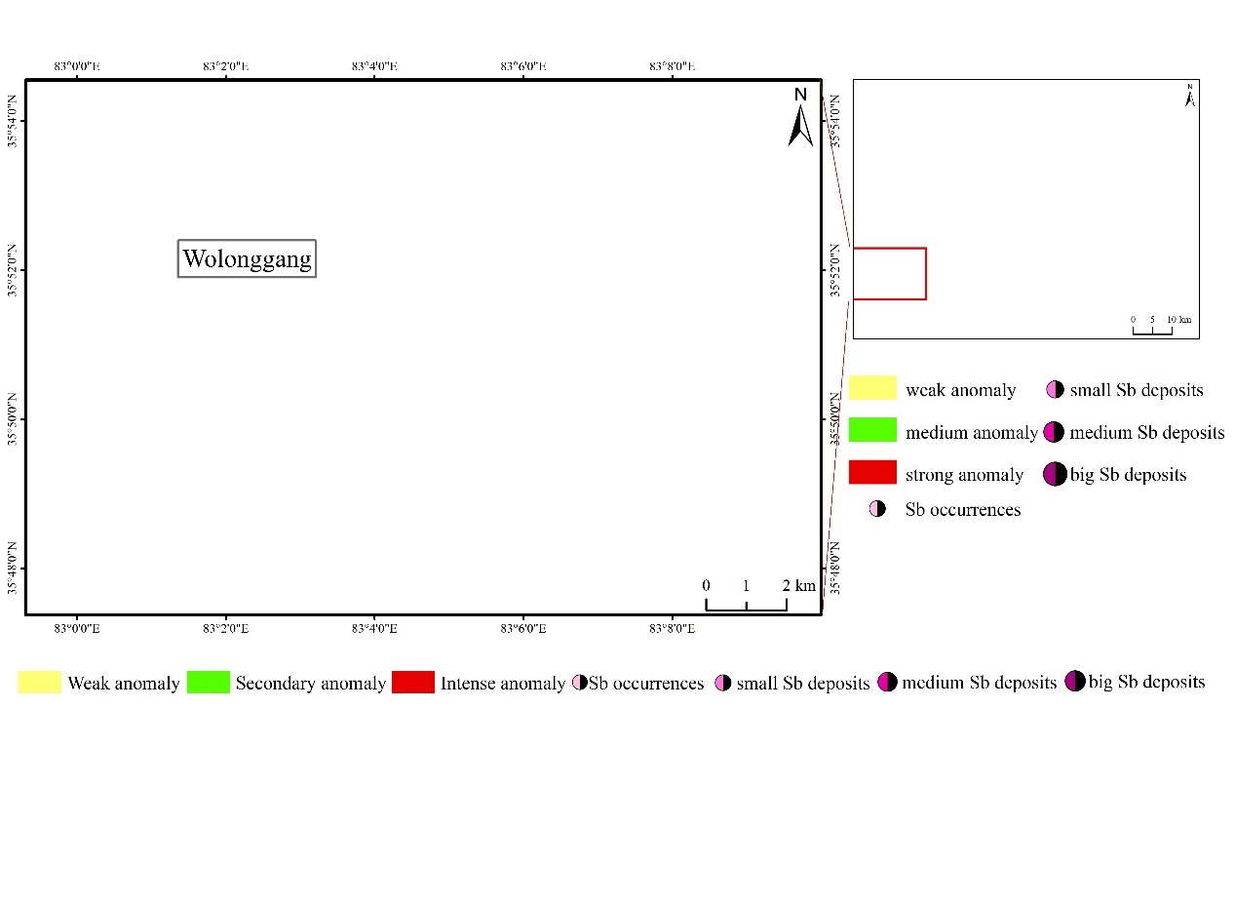
Figure 8 Results of limonite (a) Landsat 8 PCA B2, B4, B5, B6; (b) Sentinel-2 PCA B2, B5, B8A, B11
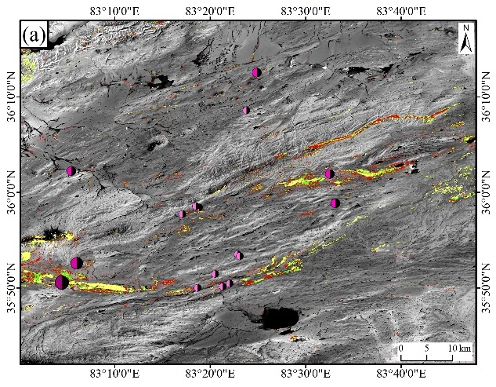
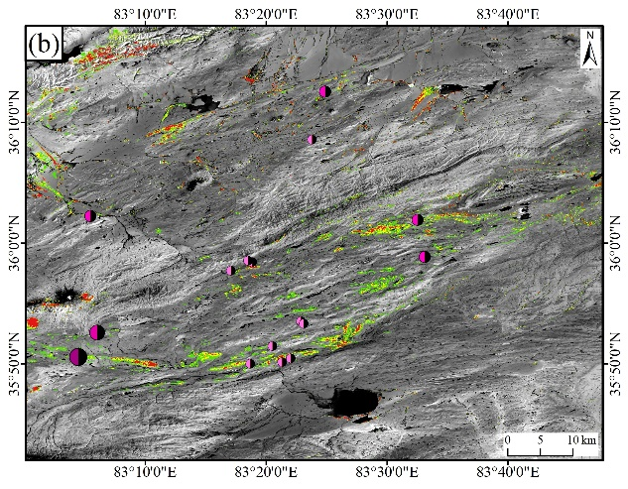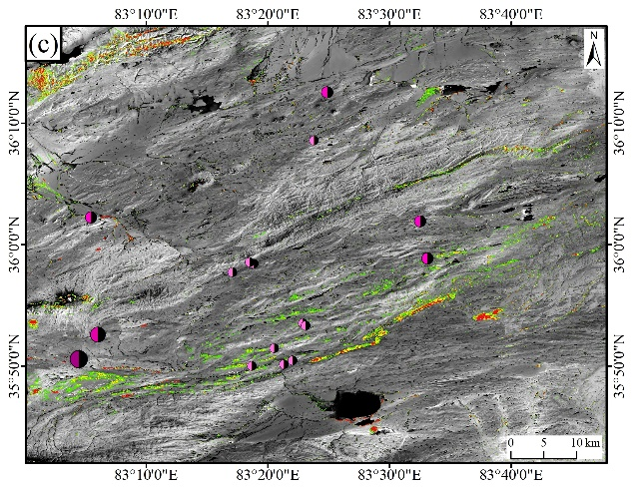
Figure 9 Results of hydroxyl alteration (a) Hydroxyl-Landsat 8 PCA B2, B5, B6, B7; (b) Al-OH-Sentinel-2 PCA B6, B8A, B11, B12; (c) Mg-OH-Sentinel-2 PCA B2, B8A, B11, B12
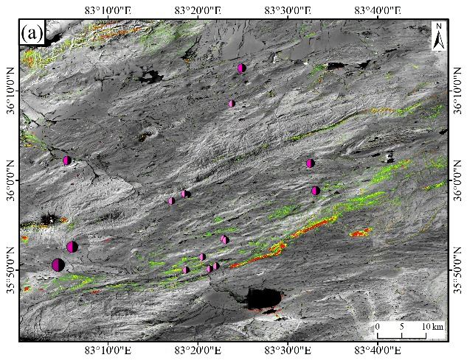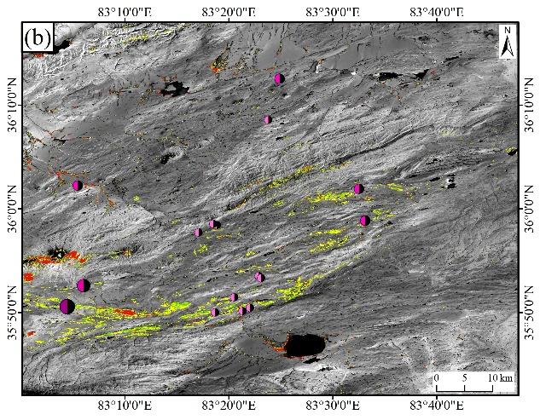
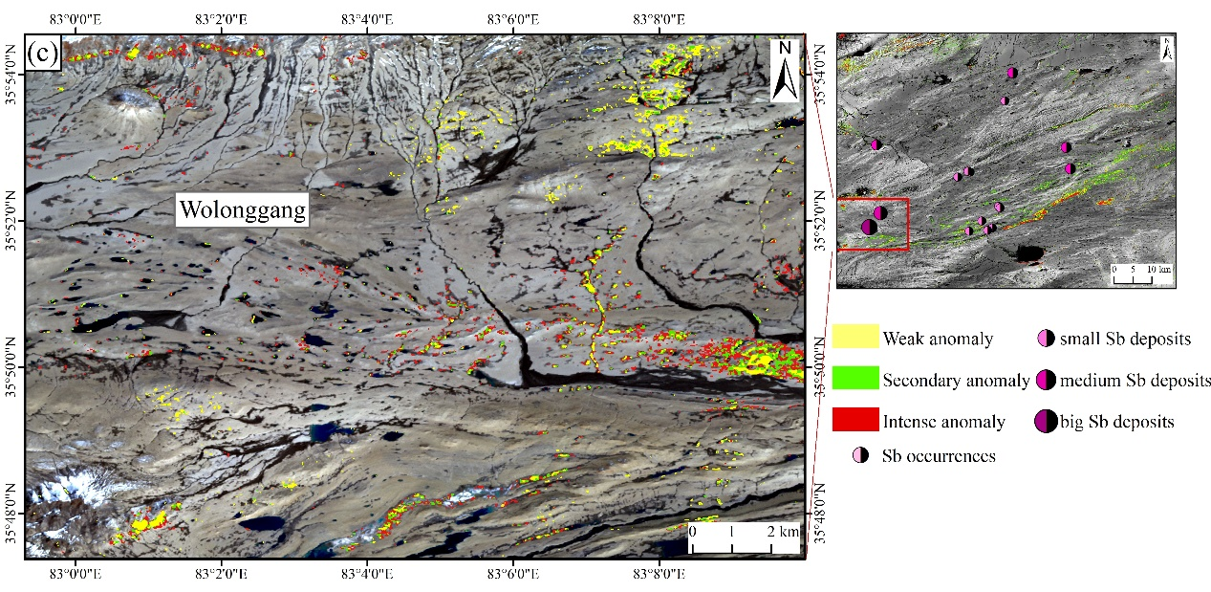
Figure 10 Results of carbonate alteration (a) Sentinel-2 PCA B3, B8A, B11, B12; (b) Landsat 8 B6/B7; (c) ASTER PCA B1, B3, B4, B7
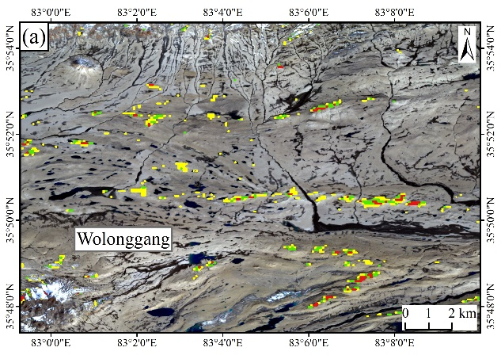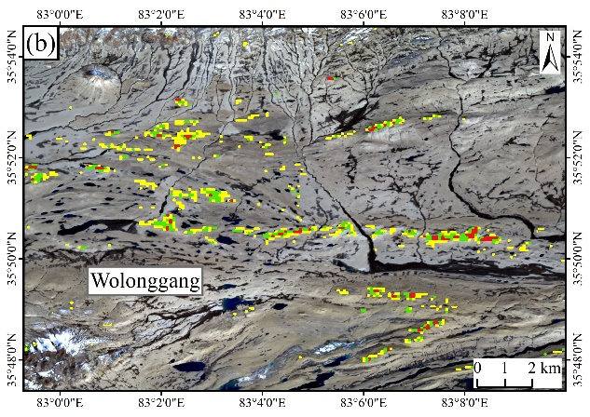
Figure 11 Results of silicified alteration (A) ASTER SiO₂ content; (B) ASTER B12/B13

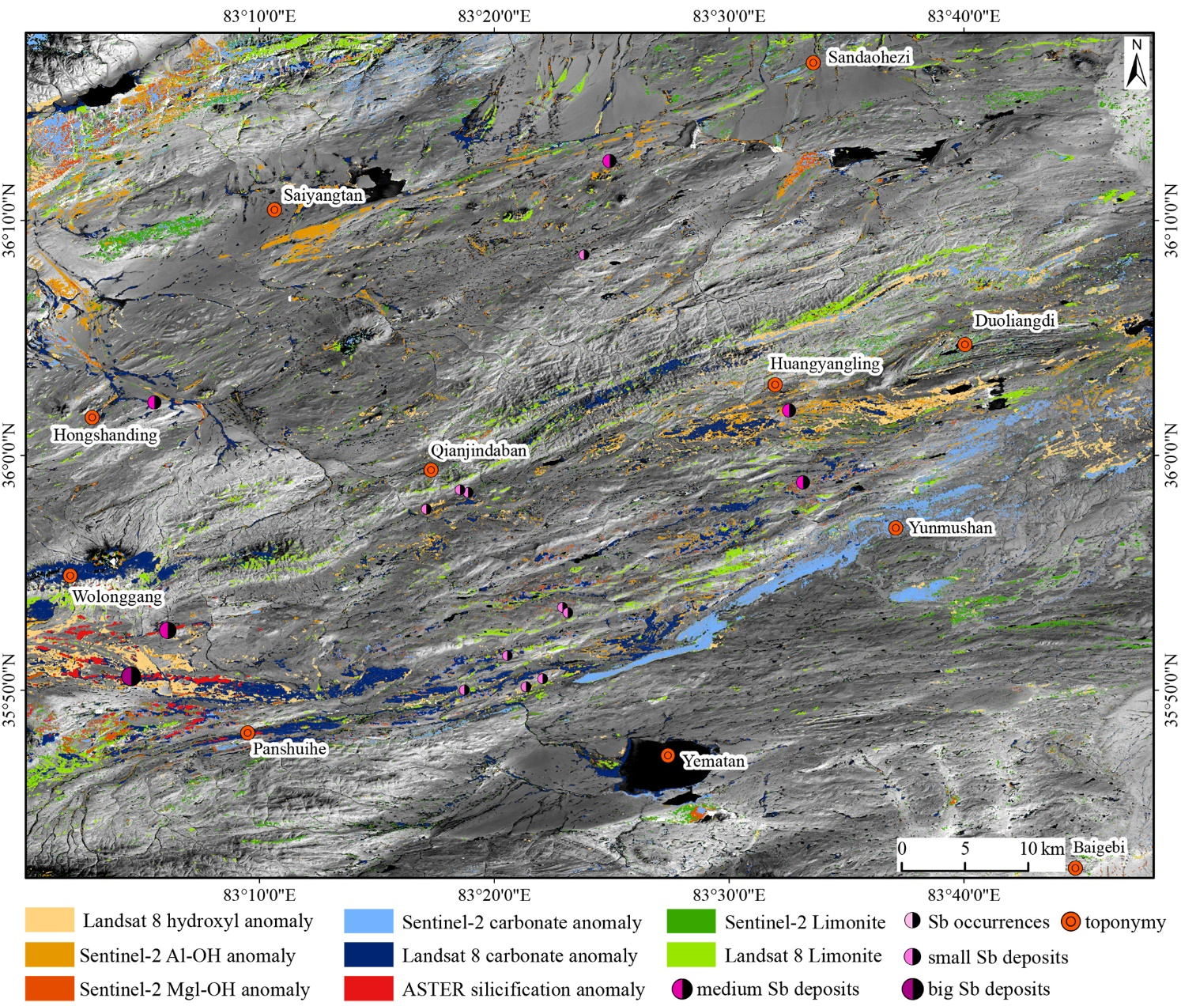
Figure 12 Comprehensive distribution map of alteration information
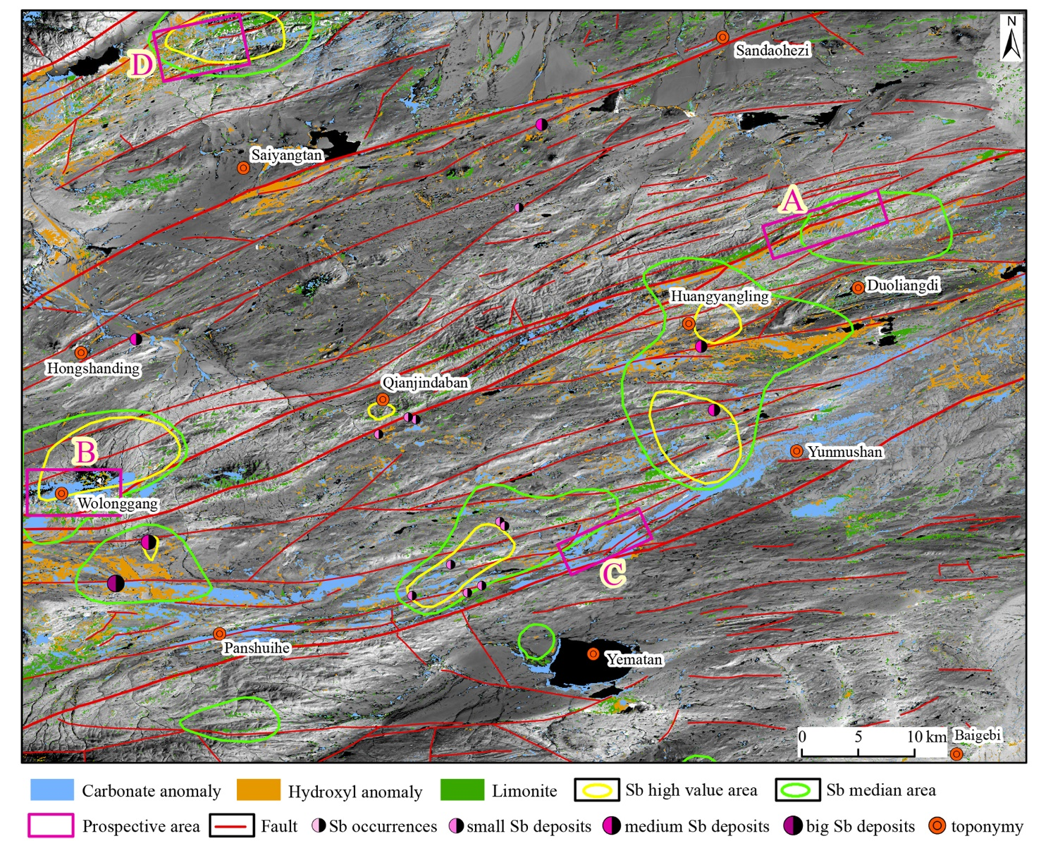
Figure 13 Multiple information superposition and antimony ore prospecting prediction (the Landsat 8 image is the base map)

