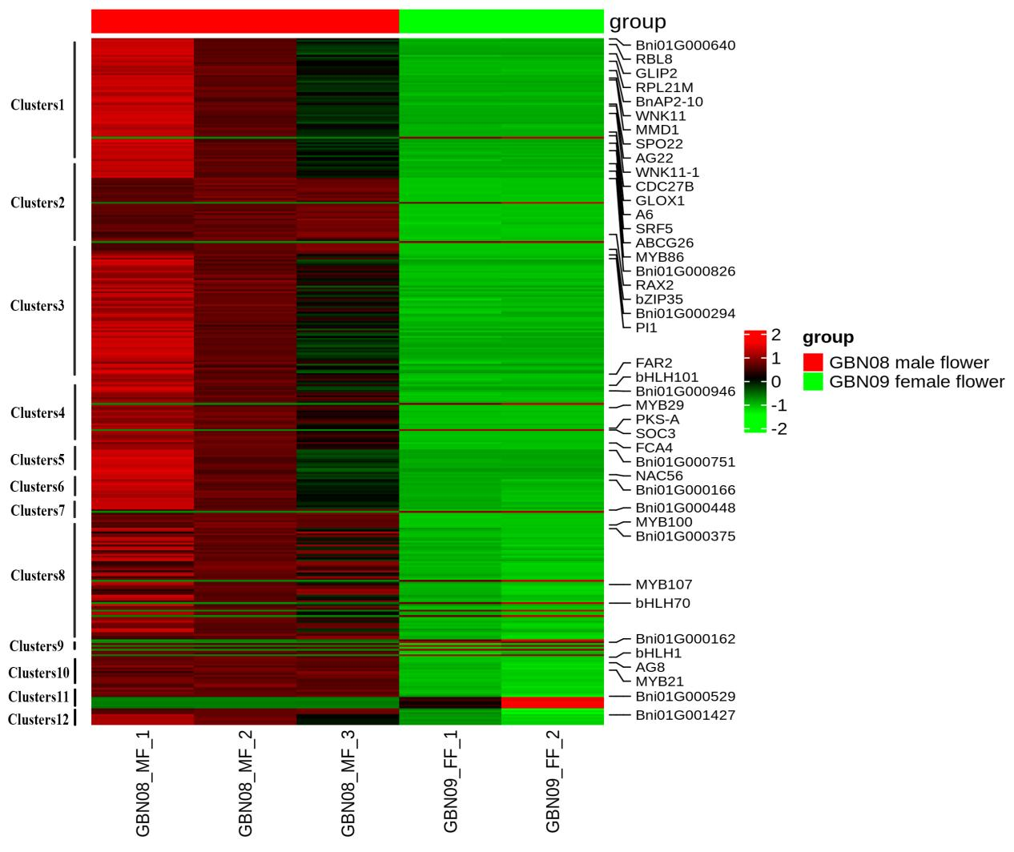

Figure S10 Expression profiles of clustered genes in different sexual flowers.