Supplementary Material

# Supplementary Figures

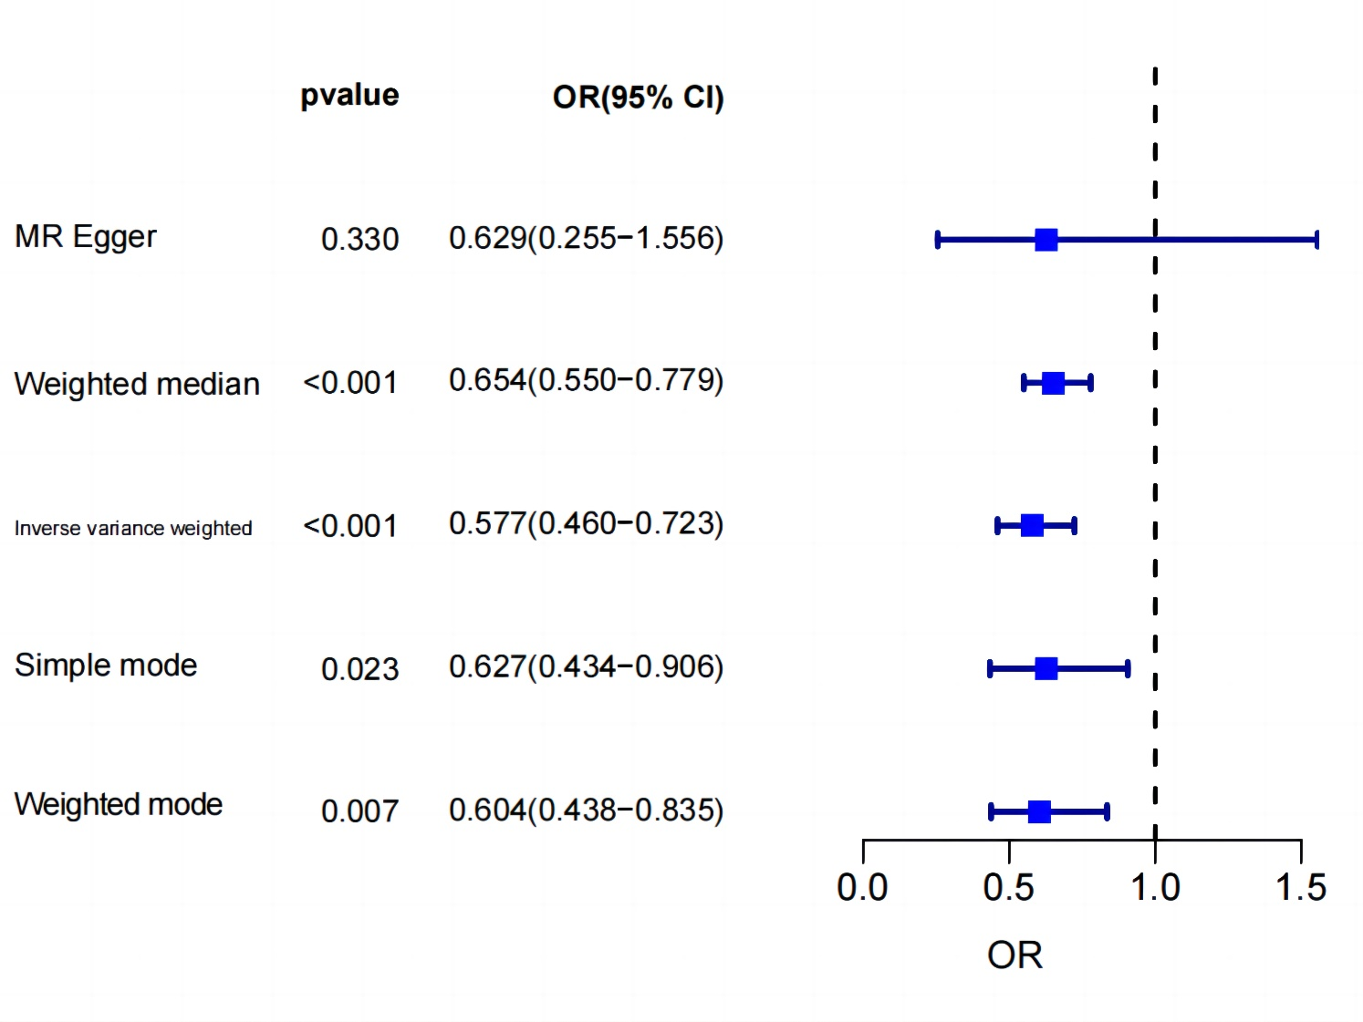

**Supplementary Figure S1**. MR estimation of cognitive performance influenced by MVPA

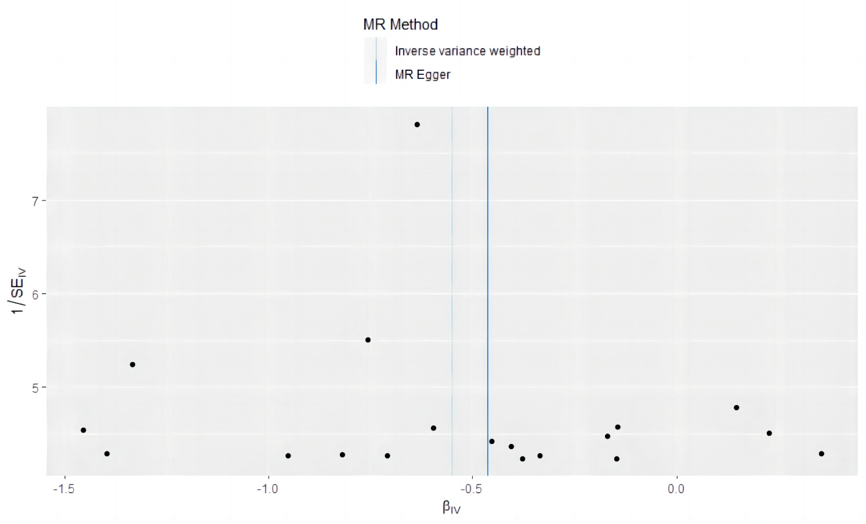

**Supplementary Figure S2**. Funnel diagram depicting the influence of MVPA on cognitive performance

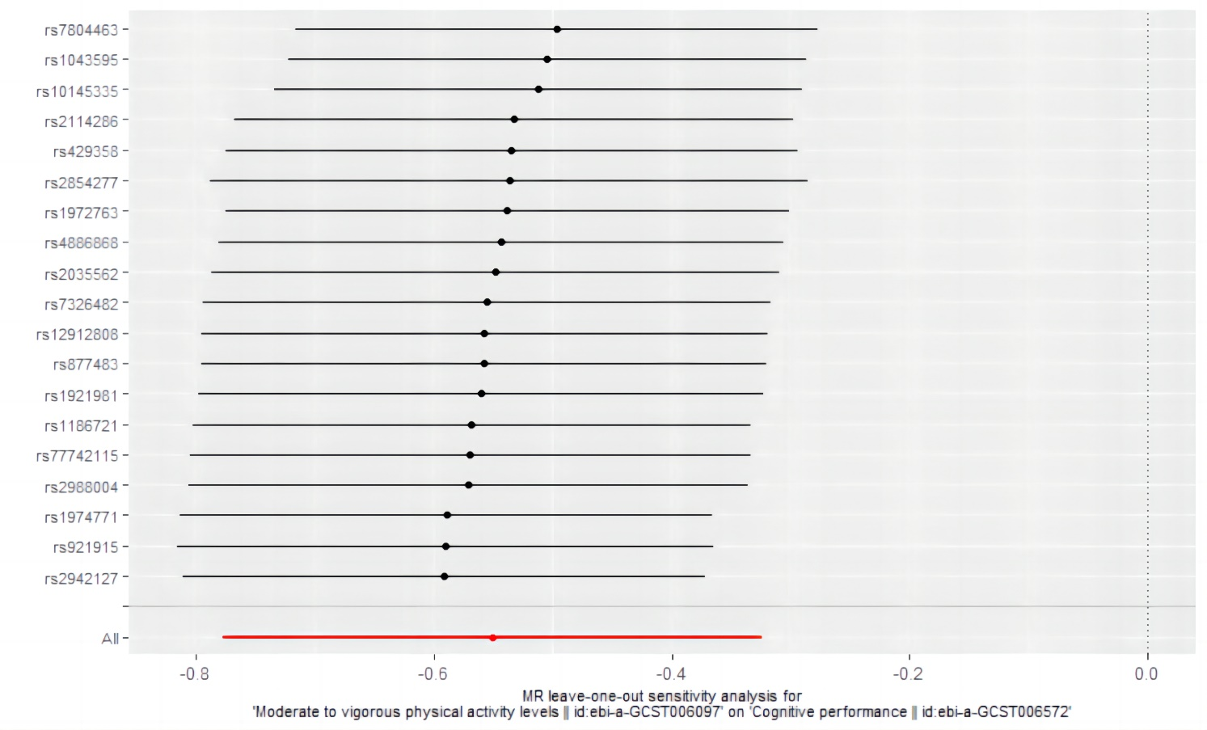

**Supplementary Figure S3**. Analysis of the impact of MVPA on cognitive performance

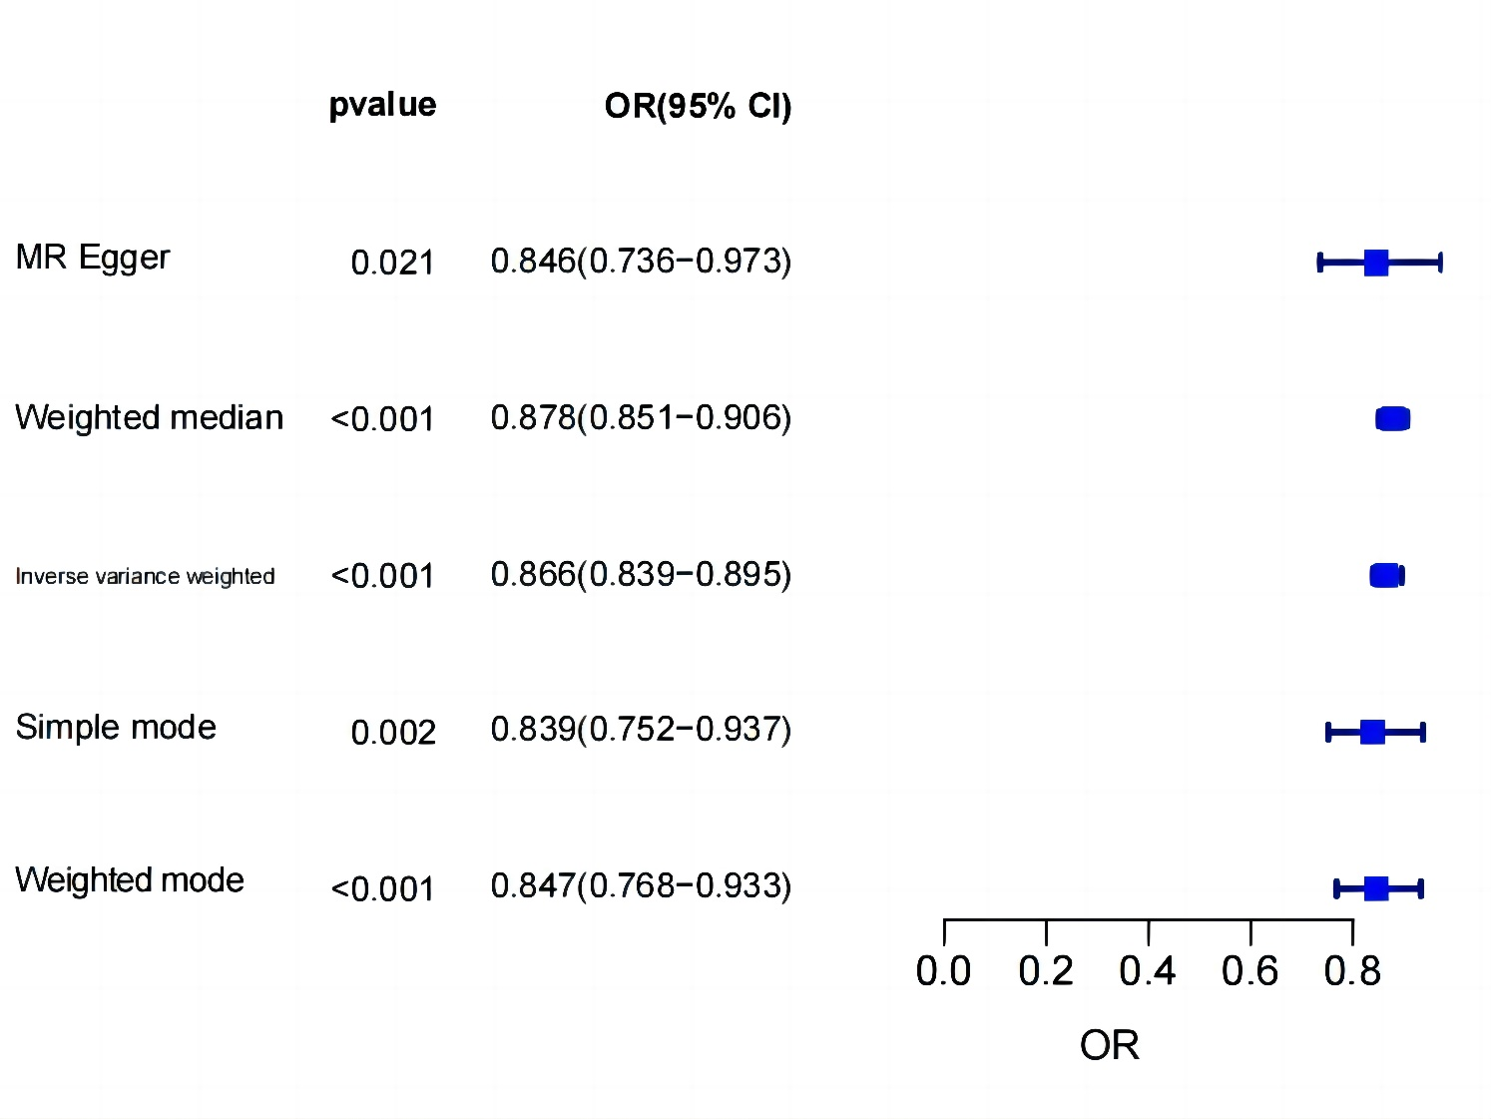

**Supplementary Figure S4**. MR estimation of the impact of cognitive performance on MVPA

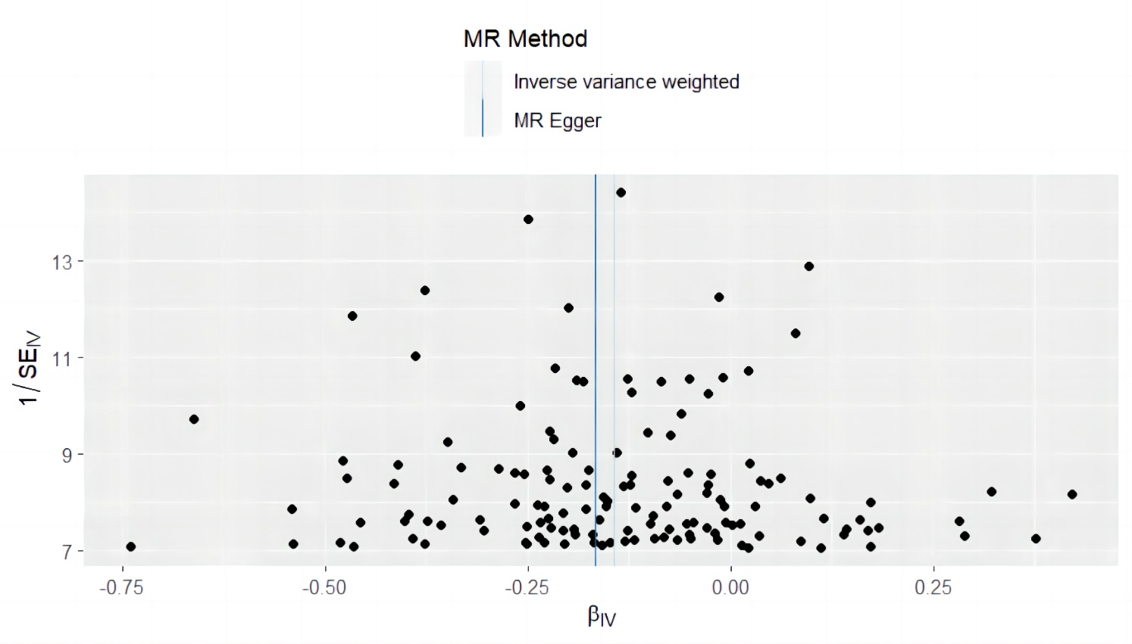 **Supplementary Figure S5**. Funnel chart illustrating the impact of cognitive performance on MVPA

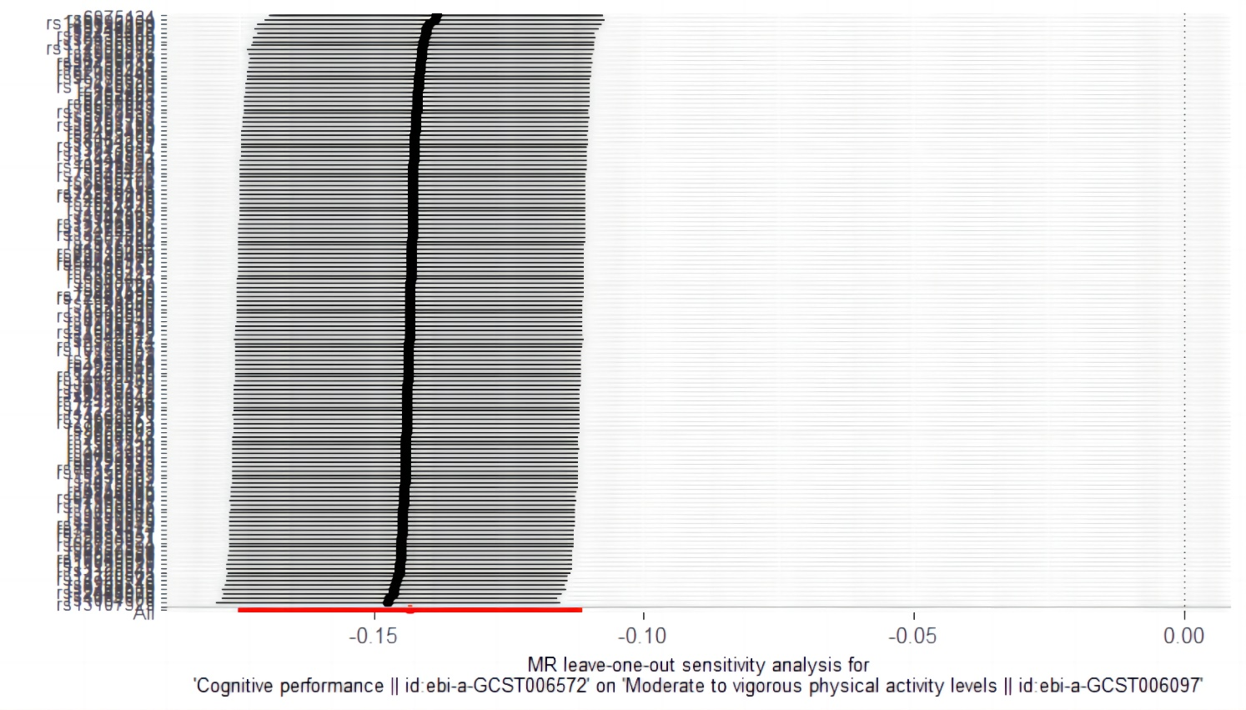 **Supplementary Figure S6**. Analysis of the effect of cognitive performance on MVPASensitivity analysis