Supplementary Material
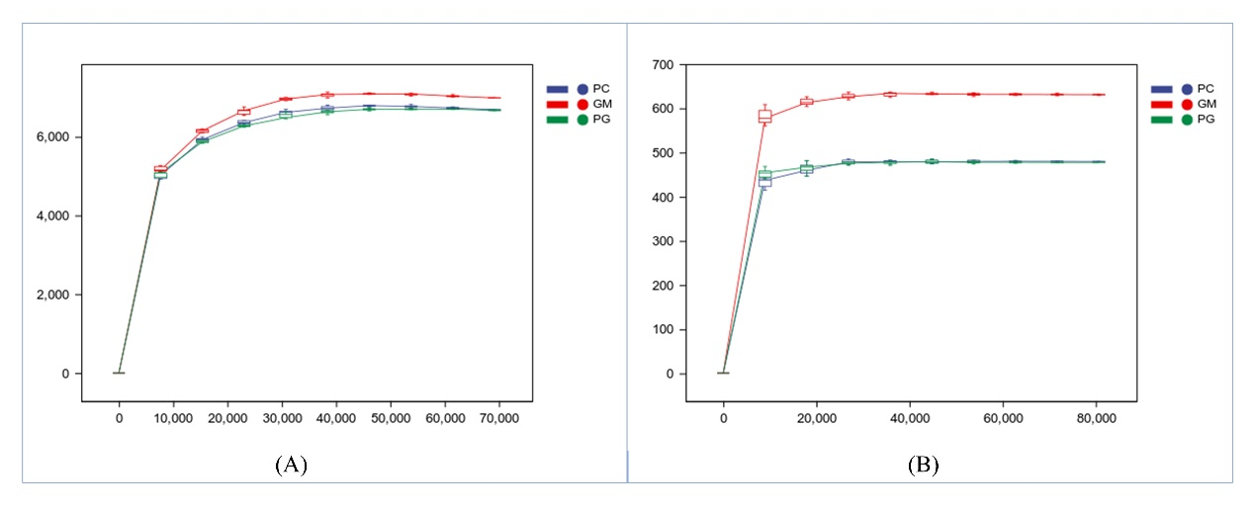
Supplementary Figure 1. Sparse curve of soil bacterial (A) and fungal (B) communities. PC: poplar single cropping; GM: black bean single cropping; PG: poplar black bean intercropping.

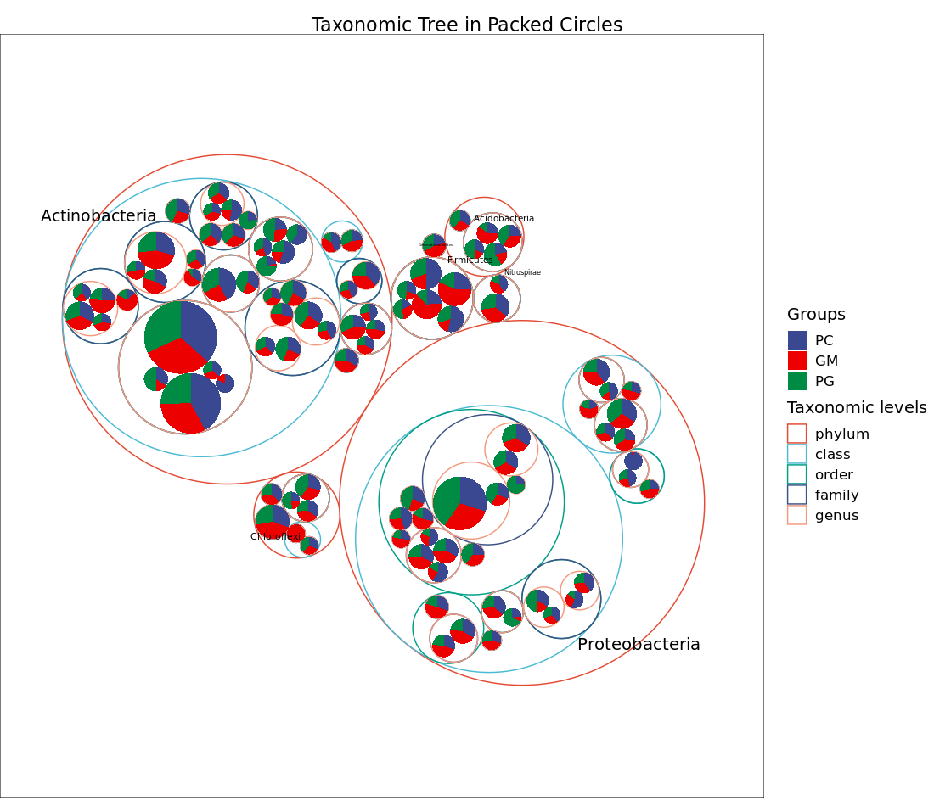
Supplementary Figure 2. Taxonomic tree in packed circles of soil bacterial communities in different samples. PC: poplar single cropping; GM: black bean single cropping; PG: poplar black bean intercropping.

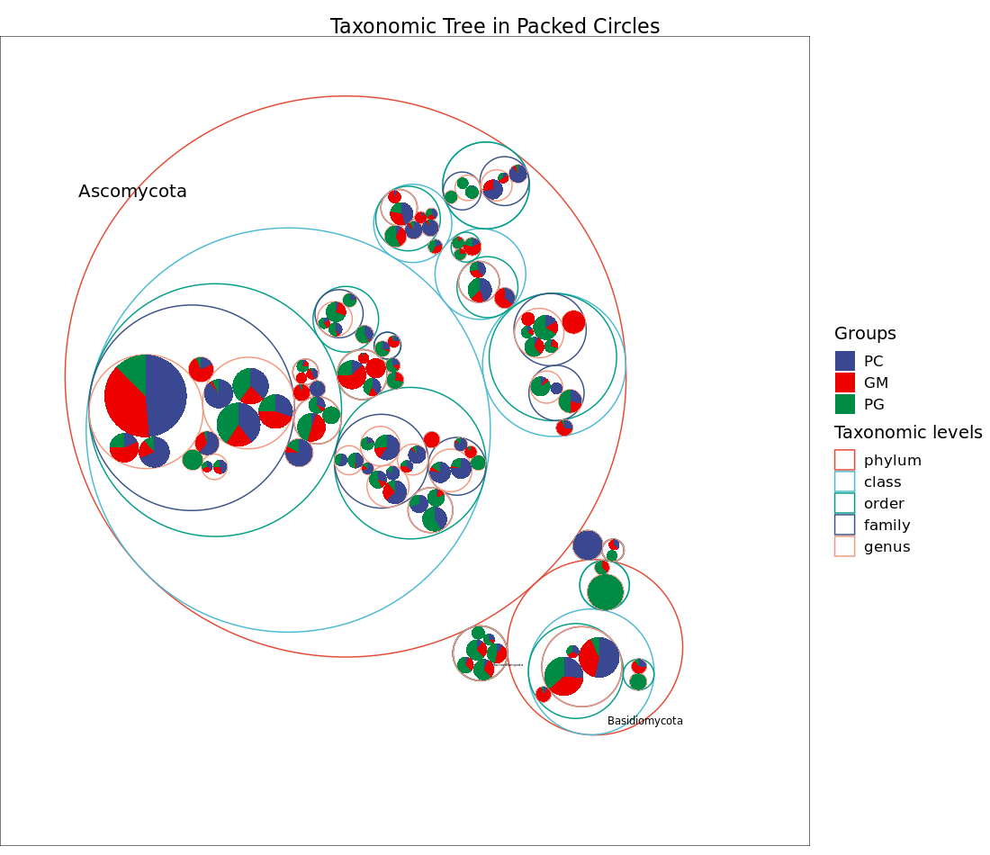
Supplementary Figure 3. Taxonomic tree in packed circles of soil fungal communities in different samples. PC: poplar single cropping; GM: black bean single cropping; PG: poplar black bean intercropping.

