Supplementary Material

Geochemical reactions initiated by subglacial abrasion of natural quartz and orthoclase feldspar

Beatriz Gill-Olivas1*, Jon Telling, Martyn Tranter

**\* Correspondence:** Beatriz Gill-Olivas: b.gillolivas@envs.uni.au.dk

# Supplementary Methods

## X-Ray Diffraction analysis.

The mineral composition of the two samples was analysed by X-ray Diffraction (XRD) with patterns acquired on a STOE STADI P (STOE & Cie GmbH, Germany) diffractometer using Cu Kα radiation (λ = 1.5406 Å), operating at 40 kV and 40 mA, equipped with a curved Ge-(111) monochromator in a flat plate transmission geometry. The XRD patterns were analysed using GSAS-II software (Toby and Von Dreele, 2013) with the reference CIF files obtained from AMCSD database.

# Supplementary Figures

## X-Ray Diffraction of crushed Quartz

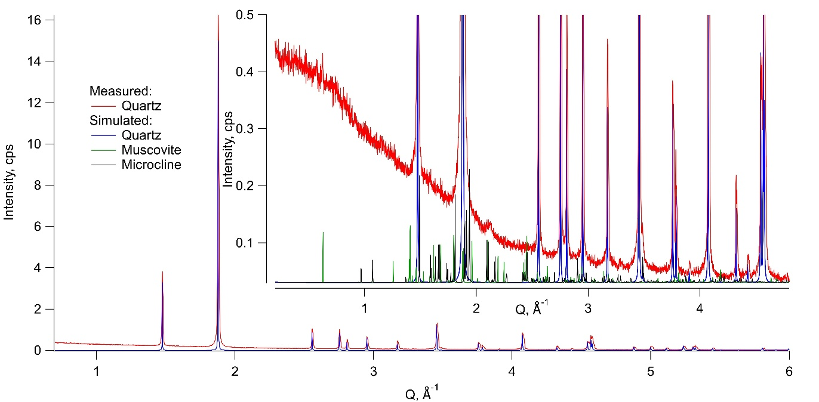

**Supplementary Figure 1.** X-Ray Diffraction Spectra obtained from crushed Quartz samples used in incubation experiments (red), and simulated spectra of quartz (blue), muscovite (green) and microcline (grey).

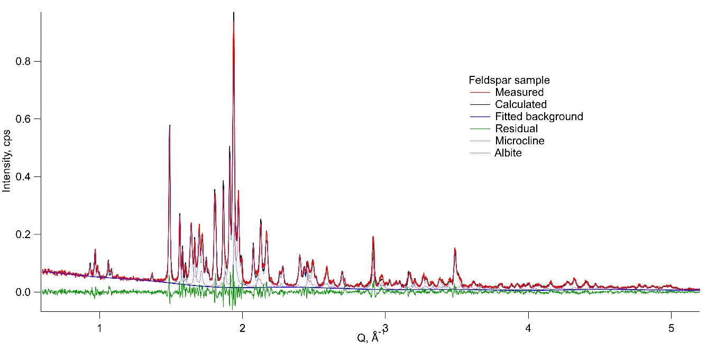

**Supplementary Figure 2.** X-Ray Diffraction Spectra obtained from crushed orthoclase feldspar samples used in incubation experiments (red), and simulated spectra of microcline (grey), albite (purple).

TOBY, B. H. & VON DREELE, R. B. 2013. GSAS-II: the genesis of a modern open-source all purpose crystallography software package. *Journal of Applied Crystallography,* 46**,** 544-549.