***Supplementary Materials***

**1 Supplementary Figures**

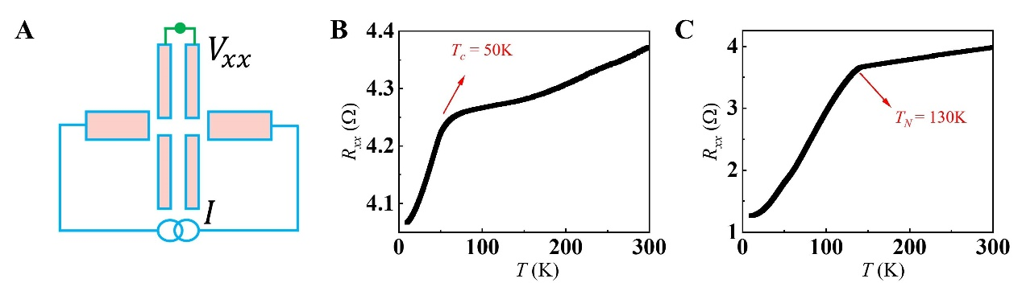

**Supplementary Figure 1 (A)** Schematic of the experimental configuration diagram. **(B)** The curve of zero-field correlation resistance Rxx versus temperature for Fe0.12TaSe2. **(C)** The curve of zero-field correlation resistance Rxx versus temperature for Fe0.25TaSe2.