Supplementary Material

Supplementary Data
; Nicotine PBPK model created for Imperial Brand (July 2nd, 2020)
METHOD RK4 ; Runge-Kutta 4th-order solver

STARTTIME = 0 ; Hours
STOPTIME = 24 ; Hours
DT = 0.001 ; Step Size
DTMAX = 0.0001 ; Controls the interval at which results are stored in memory

Minutes = TIME*60
Seconds = Minutes*60

; Nicotine molecular weight
MW = 162.23 ; g/mol

; PHYSIOLOGICAL PARAMETERS
BW = 81.2 ; Body Weight (kg)

; Blood flow rates
QC = 423.37 ; Cardiac output (L/hr)
QLc = 0.235 ; Fraction of blood flow to liver
QURTc = 0.00247 ; Fraction of blood flow to the upper respiratory tract (Campbell et al. 2015)
QTBc = 0.0075 ; Fraction of blood flow to the tracheo-bronchial region (Brown et al. 1997)
QALVc = 0.0067 ; Fraction of blood flow to the alveolar region (Butler et al. 1992)

TV = 1.3 ; Tidal Volume (L)
DS = 0.15 ; Dead space in the lung (L)
BR = 720 ; Breathing rate (/h)

; Scale blood flows by total cardiac output
QP = (TV-DS)*BR ; Alveolar flow (L/h)
QL = QLc*QC ; Liver blood flow (L/h)
QURT = QURTc*QC ; Upper respiratory tract blood flow (L/h)
QTB = QTBc*QC ; Tracheobronchial blood flow (L/h)
QALV = QALVc*QC ; Alveolar blood flow (L/h)
QRB = QC - QL - QURT - QTB - QALV ; Rest of the body blood flow (L/h)

Qbal = QL + QRB + QURT + QTB + QALV - QC ; Blood flow balance check =0?

; Surface area (cm2)
SAurt = 154.8 ; Upper airway
SAtb = 4440 ; Tracheobronchial region (Conducting airways with terminal bronchioles)
SAta = 6220 ; transitional (respiratory bronchioles)
SApulm = 700146.6 ; Pulmonary region (MMPD original value 706366.6 where was subtracted the respiratory bronchioles from Sarangapani to consider the difference in thickness in those 2 regions)

; Tissue thickness (cm) Sarangapani et al. 2005 and IRCP
TmucepithURT = 0.006 ; (mucus + epithelium) Nasal cavity
TmucepithTB =0.0066 ; Tracheobronchial region (IRCP)
TmucepithTA = 0.001 ; transitional airways (respiratory bronchioles)
TmucepithPULM = 0.0005 ; Pulmonary region

; The submucosal thickness was assumed to be approximately twice the epithelium thickness, based on histological sectioning (Matthew Bogdanffy, personal communication).
TURT = 0.012 ; submucosa nasal cavity
TTB = 0.0132 ; submucosa Tracheobronchial region
TTA = 0.002 ; submucosa Transitional airway

; Volumes lung region (L)
Vt1 = SAurt*TmucepithURT*0.001 ; Volume mucus + epithelium upper resp tract
Vt2 = SAtb*TmucepithTB*0.001 ; Volume mucus + epithelium TB region
Vt3 = SAta*TmucepithTA*0.001 + SApulm*TmucepithPULM*0.001 ; Volume mucus + epithelium pulmonary region (respiratory bronchioles transitional airways ta and alveoles pulm)
VURT = SAurt*TURT*0.001 ; *0.001 to adjust from cm^3 to L (1 cm^3 = 1 mL)
VTB = SAtb*TTB*0.001 ; Volume submucosa region
VPULM = SAta*TTA*0.001 ; Volume submucosa transitional airways (ta) as there is no submucosa region in the alveoli

VLu = VURT + VTB + VPULM + Vt1 + Vt2 + Vt3
VLuc = VLu / BW ; Lung fraction Brown has a value of 0.0073 as an average.

; Tissue Volume Fractions (L or kg per kg Body Weight)
VLc = 0.0197 ; Fraction of liver tissue
VArtc = 0.0142 ; Fraction of arterial blood (0.0569*1/4)
VVc = 0.0427 ; Fraction of venous blood (0.0569*3/4)
VRBc = 0.85-(VLc+VArtc+VVc+VLuc) ; Rest of the body volume

; Allometric scaling of tissue volumes (L)
VL = VLc*BW ; Liver volume
VArt = VArtc*BW ; Arterial blood volume
VV = VVc*BW ; Venous blood volume
VRB = VRBc * BW

VBal = 0.85 - VLc - VRBc - VArtc - VVc - VLuc ; Volume check (15% of the body is assumed not perfused) Clewell et al. 2004

; BIOCHEMICAL PARAMETERS

; Transfer coefficients
DLc = 4.87*10^-9 ; Nicotine diffusion coefficient for transfer across epithelium (cm2/s)
DL = DLc*3600 ; cm2/hr

; Units are cm3/h = mL/h (assuming density of 1 mL/cm3)
KtURT = (DL * SAurt) / ((TmucepithURT/2)+( TURT/2)) ; Upper respiratory tract (cm3/hr)
KtTB = (DL * SAtb) / ((TmucepithTB/2)+(TTB/2)) ; Tracheobronchial region (cm3/hr)
KtPULM = (DL * (SAta+SApulm)) / ((TmucepithPULM/2)+(TTA/2)) ; Pulmonary region (cm3/hr)

; Partition coefficients
PL = 7 ; liver/blood partition coefficient
PURT = 1.23 ; Upper respiratory tract partition coefficient
PTB = 0.1 ; Tracheobronchial region partition coefficient
PALV = 0.1 ; Alveolar region partition coefficient
PRB = 1.48 ; Rest of the body partition coefficient

; Protein Binding
Fu =0.95 ; plasma unbound fraction

; Renal and hepatic clearance
CLr = 4.25 ; Renal clearance (L/h)
CLint = 128.5 ; Hepatic Intrinsic Clearance (L/h)

; Aerosol exposure
; Particle/aerosol deposition fraction in respiratory tract regions from MPPD
FURT = 0.0082 ; Fraction deposited in the upper respiratory tract
FTB = 0.0608 ; Fraction deposited in the tracheobronchial region
FPULM = 0.1454 ; Fraction deposited in the pulmonary region

tBreath = 1/npuffpersession/60 ; time for one breath or puff (h)

Puff_dur = 2.3 ; Puff duration in second
puffduration = Puff_dur/3600 ; Puff duration in hour

Puff_int = 30 ; Puff interval in second
repeatpuff = Puff_int/3600 ; Puff interval in hour

npuffpersession = 10 ; Number of puffs per session
N_session = 1 ; Number of sessions
Npuff_total = Npuffpersession*N_session

is_inhtime = IF mod(TIME, repeatpuff) < puffduration THEN 1 ELSE 0
reachedMaxDosing = IF mod(TIME, 1)/repeatpuff >= npuffpersession THEN 1 ELSE 0

dosing = IF ( (is_inhtime = 1) AND (reachedMaxDosing = 0) AND (TIME < N_session) ) THEN 1 ELSE 0

DOSEnicotine_total = 0.56 ; Amount of nicotine (mg total)
DOSEnicotine_A = DOSEnicotine_total - (DOSEnicotine_total*Fvapor) ; Amount of nicotine as particles
Apuff = (DOSEnicotine_A/Npuff_total)*1000/MW ; Amount of nicotine particles in one puff transformed from mg to umol (umol)

Rpuff = Apuff/puffduration ; Rate of nicotine particles (umol/h)

; Vapor exposure
PuffVolume = 0.0695 ; Volume of 1 puff (L)
Fvapor = 0.2 ; Vapor fraction per puff (Haghnegahdar et al. 2018)
Cinh = (DOSEnicotine_total/(PuffVolume*Npuff_total))*1000*Fvapor /MW ; Concentration inhaled (umol/L) per puff

CI = Cinh*dosing

; EQUATIONS

; Liver compartment
AMTot' = CLint*Fu*CVL ; Rate of metabolism in the liver (umole/hr)
init AMTot = 0 ; Amount metabolized in the liver (umole)
AL' = QL * (Cart - CVL) - AMTot' ; Rate of change of nicotine in the liver (umole/hr)
init AL = 0 ; Amount of nicotine in the liver (umole)
CL = AL / VL ; Concentration of nicotine in the liver (umole/L)
CVL = CL / PL ; Free concentration leaving the liver (umole/L)

; Rest of the body compartment
ARB' = QRB * (Cart - CVRB) ; Rate of change of nicotine in the rest of the body (umole/hr)
init ARB = 0 ; Amount of nicotine in the rest of the body (umole)
CRB = ARB / VRB ; Concentration of nicotine in the rest of the body (umole/L)
CVRB = CRB / PRB ; Free concentration leaving the rest of the body (umole/L)

; Arterial blood
AMR' = CLr * Cart ; Rate of metabolism in blood (umole/hr)
init AMR = 0 ; Amount metabolized in blood (umole)

Aart' = QC * (CV - Cart) + (QP*CI) - AMR' ; rate of change in arterial blood (umole/hr)
init Aart = 0 ; Amount in arterial blood (umole)
Cart = Aart / VArt ; Concentration in arterial blood (umole/L)

; Venous blood
AV' = (QL * CVL) + (QRB * CVRB) + (QURT * CVURT) + (QTB * CVTB) + (QALV * CVALV) - (QC * CV) ; Rate of change in venous blood (umole/hr)
init AV = 0 ; Amount in venous blood (umole)
CV = AV / VV ; Concentration in venous blood (umole / L)

; Upper respiratory tract
ADepURT' = FURT*RPuff*dosing ; Rate of change of deposition in the URT (umol/hr)
init ADepURT = 0 ; Amount deposited in the URT (umol)

; Mucus + epith
At1' = ADepURT' - KtURT*0.001 * Ct1 / PURT ; Rate of change in the mucus (umole/hr)
init At1 = 0 ; Amount in the mucus (umole)
Ct1 = At1 / Vt1 ; Concentration (umole/L)

; Tissue
AURT' = KtURT *0.001* (Ct1 / PURT) + QURT * (Cart - CVURT) ; Rate of change in the URT (umole/hr)
init AURT = 0 ; Amount in the URT tissue (umole)
CURT = AURT / VURT ; Concentration in the URT tissue (umole/L)
CVURT = CURT / PURT ; Free concentration leaving the URT tissue (umole/L)

; TB region
ADepTB' = FTB * RPuff * dosing ; Rate of change of deposition in the TB region (umole/h)
init ADepTB = 0 ; Amount deposited in the TB (umol)

; Mucus + epith
At2' = ADepTB' - KtTB*0.001 * Ct2 / PTB ; Rate of change (umole/hr)
init At2 = 0 ; Amount (umole)
Ct2 = At2 / Vt2 ; Concentration (umole/L)

; Tissue
ATB' = KtTB*0.001 * (Ct2 / PTB) + QTB * (Cart - CVTB) ; Rate of change (umole/hr)
init ATB = 0 ; Amount (umole)
CTB = ATB / VTB ; Concentration (umole/L)
CVTB = CTB / PTB ; Free concentration leaving the tissue (umole/L)

; Pulmonary region
ADepPULM' = FPULM * RPuff * dosing ; Rate of change of deposition in the pulmonary region (umole/h)
init ADepPULM = 0 ; Amount deposited in the pulmonary region (umol)

; Mucus + epith
At3' = ADepPULM' - KtPULM*0.001 * Ct3 / PALV ; Rate of change (umole/hr)
init At3 = 0 ; Amount (umole)
Ct3 = At3 / Vt3 ; Concentration (umole/L)

; Tissue
APULM' = KtPULM*0.001 * (Ct3 / PALV) + QALV * (Cart - CVALV) ; Rate of change (umole/hr)
init APULM = 0 ; Amount of nicotine in the tissue (umole)
CALV = APULM / VPULM ; Concentration of nicotine in the tissue (umole/L)
CVALV = CALV / PALV ; Free concentration of nicotine leaving the tissue (umole/L)

; DOSE METRICS
CVmgpl = CV*MW ; Venous concentration in ug /L (ng/ml)
Cartmgpl = Cart*MW ; Arterial concentration in ug/L (ng/ml)

AUCCV' = CV ; Area under the curve (umol*h/L)
init AUCCV = 0
AUCmgpl = AUCcv * MW ; Area under the curve (ug*h / L)

; MASS BALANCE
InhDose' = QP*CI
init InhDose = 0 ; Amount inhaled (umole)

IN = ADepURT + ADepTB + ADepPULM + InhDose
STORED = AL + ARB + Aart + AURT + ATB + APULM + At1 + At2 + At3 + AV
Out = AMTot + AMR
MASSBAL = IN - STORED – Out

Supplementary Figures and Tables

Supplementary Tables

Supplementary Table 1. PBPK model parameters distributions

 | CV | Distribution | SD
Puff duration | 0.3 | N | 0.69
Puff interval | 0.3 | N | 9
Breathing rate (BR) | 0.12 | LN | 86.4
Tidal Volume (TV) | 0.12 | LN | 0.156
BW | 0.22 | LN | 17.864
Puff volume | 0.3 | N | 0.0208
Fraction of vapor | 0.3 | Uniform | 0.06
Partition coef. Rest of the body (PRB) | 0.3 | LN | 0.444
Deposition fraction in pulm region (FPULM) | 0.3 | Uniform | 0.0437
Cardiac Output | 0.17 | N | 71.97
Dead Space (DS) | 0.12 | LN | 0.018
Blood flow to the Liver (QLc) | 0.16 | N | 0.0376
Hepatic Intrinsic Clearance (CLint) | 0.3 | LN | 38.55

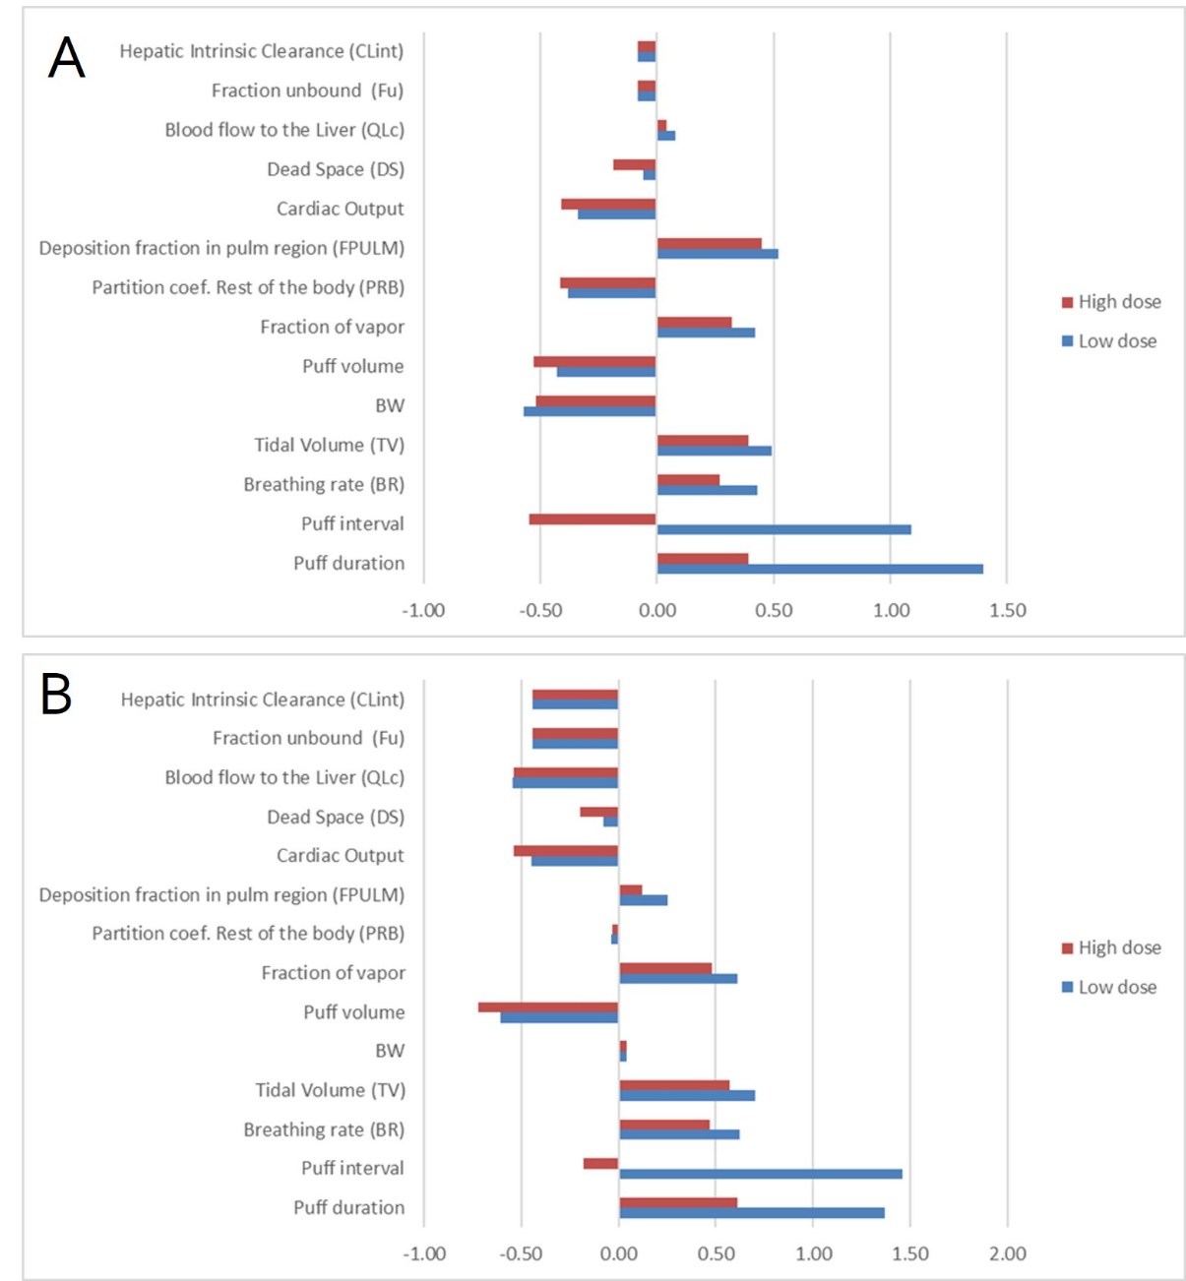
Supplemental Figure 1. Sensitivity analysis coefficient after inhalation evaluated for plasma Cmax (A) and plasma AUC (B).

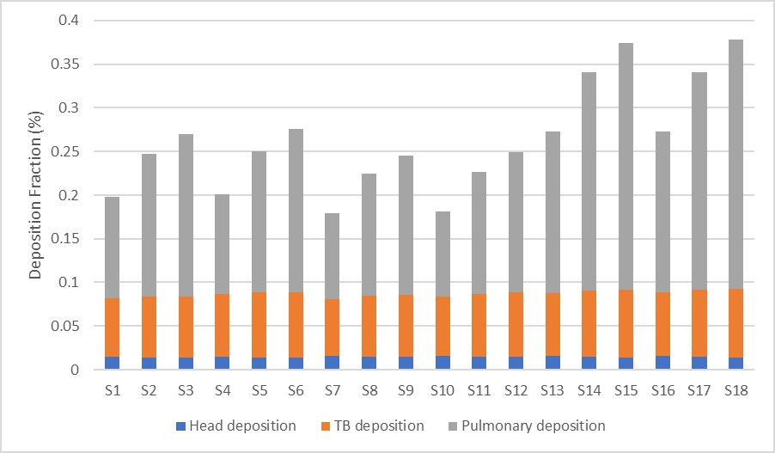
Supplemental Figure 2. Regional deposition fractions of inhaled aerosol particles as a function of different breathing scenarios (Table S2).

Supplementary Table 2. Breathing pattern scenario according to MPPD model.
Scenario* | Breathing rate (/h) | Tidal Volume (L) | Inspiration fraction | Pause fraction | Inhalation time (s) | Exhalation time (s) | Notes
1 | 12 | 1.3 | 0.5 | 0 | 2.5 | 2.5 | Deep Breathing at resting, same inh/Exh time, no breath hold
2 | 12 | 1.3 | 0.5 | 0.1 | 2.5 | 2 | Deep Breathing at resting, same inh/exh time, short breath hold
3 | 12 | 1.3 | 0.5 | 0.25 | 2.5 | 1.25 | Deep Breathing at resting, same inh/exh time, extended breath hold
4 | 12 | 1.3 | 0.3 | 0 | 1.5 | 3.5 | Deep Breathing at resting, shorter inhalation and extended exhalation, no breath hold
5 | 12 | 1.3 | 0.3 | 0.1 | 1.5 | 3 | Deep Breathing at resting, shorter inhalation and extended exhalation, short breath hold
6 | 12 | 1.3 | 0.3 | 0.25 | 1.5 | 2.25 | Deep Breathing at resting, shorter inhalation and extended exhalation, extended breath hold
7 | 12 | 0.75 | 0.5 | 0 | 2.5 | 2.5 | Normal Breathing at resting, same inh/Exh time, no breath hold
8 | 12 | 0.75 | 0.5 | 0.1 | 2.5 | 2 | Normal Breathing at resting, same inh/exh time, short breath hold
9 | 12 | 0.75 | 0.5 | 0.25 | 2.5 | 1.25 | Normal Breathing at resting, same inh/exh time, extended breath hold
10 | 12 | 0.75 | 0.3 | 0 | 1.5 | 3.5 | Normal Breathing at resting, shorter inhalation and extended exhalation, no breath hold
11 | 12 | 0.75 | 0.3 | 0.1 | 1.5 | 3 | Normal Breathing at resting, shorter inhalation and extended exhalation, short breath hold
12 | 12 | 0.75 | 0.3 | 0.25 | 1.5 | 2.25 | Normal Breathing at resting, shorter inhalation and extended exhalation, extended breath hold
13 | 5 | 1.3 | 0.5 | 0 | 6 | 6 | Deep slow breathing, same inh/Exh time, no breath hold
14 | 5 | 1.3 | 0.5 | 0.1 | 6 | 4.8 | Deep slow breathing, same inh/exh time, short breath hold
15 | 5 | 1.3 | 0.5 | 0.25 | 6 | 3 | Deep slow breathing, same inh/exh time, extended breath hold
16 | 5 | 1.3 | 0.3 | 0 | 3.6 | 8.4 | Deep slow breathing, shorter inhalation and extended exhalation, no breath hold
17 | 5 | 1.3 | 0.3 | 0.1 | 3.6 | 7.2 | Deep slow breathing, shorter inhalation and extended exhalation, short breath hold
18 | 5 | 1.3 | 0.3 | 0.25 | 3.6 | 5.4 | Deep slow breathing, shorter inhalation and extended exhalation, extended breath hold
*Particle diameter CMD = 0.163 µm with GSD 1.44

