Supplementary Figures

## 

**Supplementary Figure 1. The recombinant strains of Saccharomyces cerevisiae were constructed using the δ-integration strategy to achieve high copy number of ASFV antigen cocktails. (A)**The standard curve of the recombinant plasmid was obtained by a qPCR assay. Of the recombinant plasmid, 108–102copies/ml were used as the template for the reaction. A standard curve of the correlation between DNA copy number and qPCR cycle threshold (Ct) value was constructed using GraphPad Prism version 9.4.1.681. R2 represents the degree of fit of the regression line. The slope of the standard curve represents the amplification efficiency (E), through the following formula E =10 (‒1/slope). **(B)** Growth curves of EBY100 and recombinant Saccharomyces cerevisiae strains. Growth progression was monitored by measurement of the optical density at 600 nm (OD 600). **(C)** Genetic identity and genetic stability of the recombinant saccharomyces cerevisiae strains were assessed via polymerase chain reaction (PCR) analysis of the genomic DNA. M is for DNA size marker. Strains from subcultures 1, 10, 20, 30, 40, and 50 (designated as 1, 2, 3, 4, 5, and 6 respectively) were utilized as seeds for cultivation and subsequent analysis.

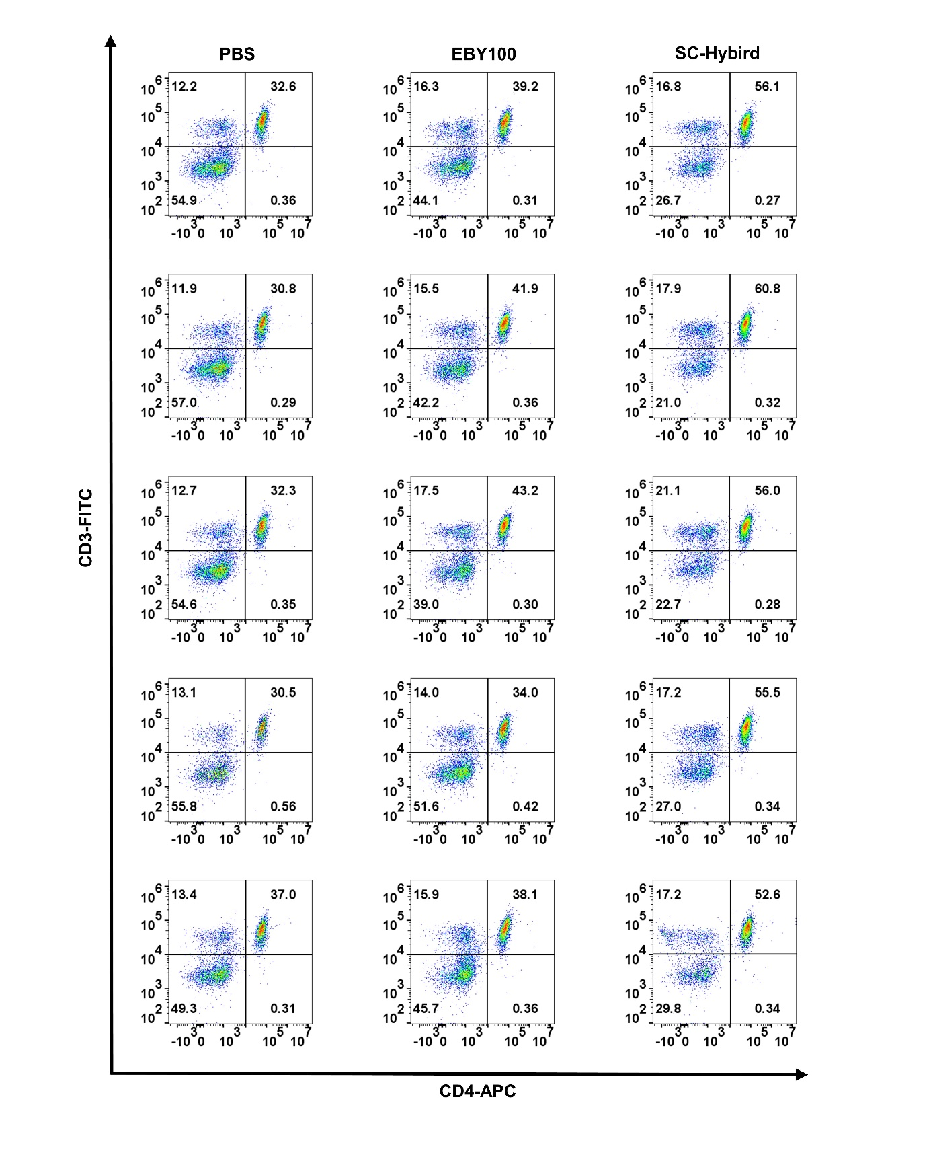

**Supplementary Figure 2. The percentages of CD3 + and CD4 + T lymphocytes in the purified splenocytes were determined by flow cytometry.**

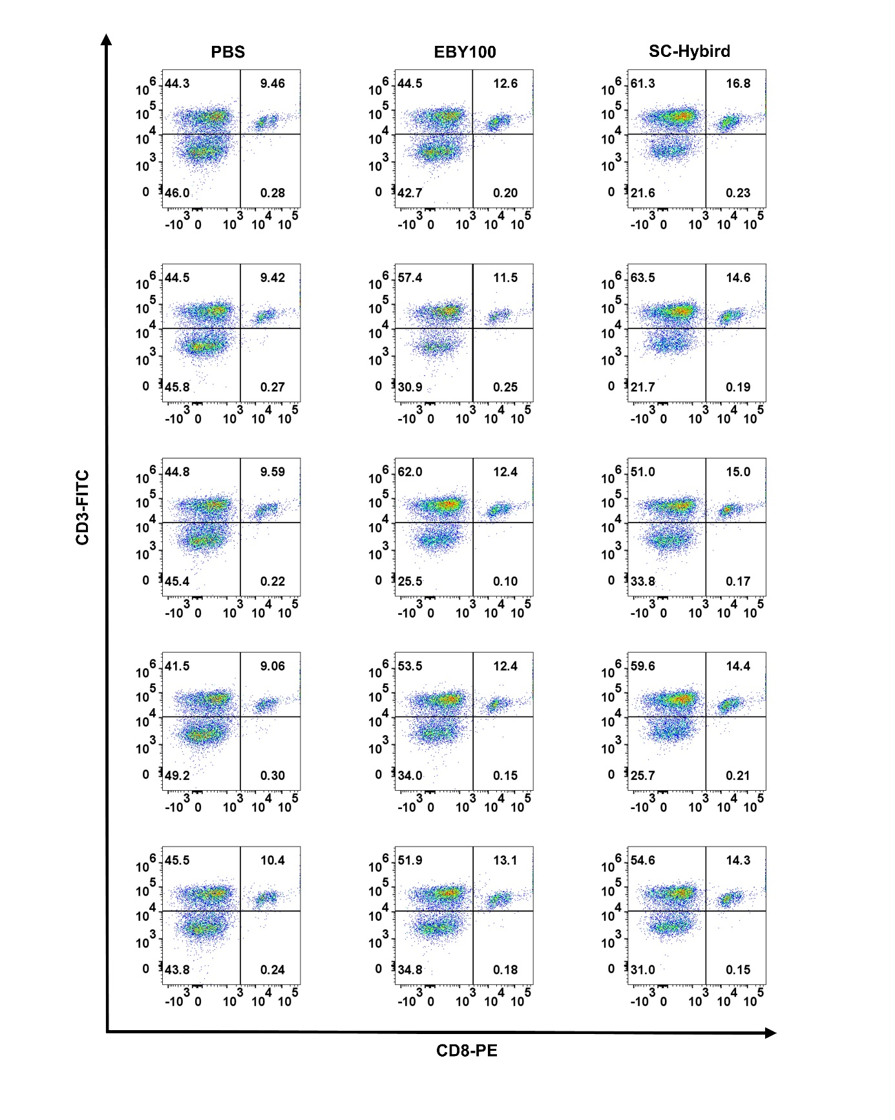

**Supplementary Figure 3. The percentages of CD3 + and CD8 + T lymphocytes in the purified splenocytes were determined by flow cytometry.**