Supplementary Material

Hindcasting estuary ecological states using sediment cores, modelled historic nutrient loads, and a Bayesian network.
Rachel Hale^{1*}, John Zeldis², Bruce D. Dudley², Arman Haddadchi², David Plew², Ude Shankar², Andrew Swales³, Keryn Roberts⁴, Sorrel O’Connell-Milne⁴ and Piet Verburg⁵
* Correspondence: Corresponding Author: rachel.hale@niwa.co.nz

Supplementary Material: BBN Information
The relationships between nodes of the ETI Tool 3 BBN detailed in Zeldis and Plew (2022) modifications to the BBN since publication of Zeldis and Plew (2022). Modifications are also available in the ‘Change Log’ file available in the online ETI Tool 3.

Macroalgae Ecological Quality Rating (EQR)
Abundant nuisance macroalgae are a primary symptom of estuary eutrophication and increased macroalgal biomass and spatial extent are key indicators of degraded ecological health in tidal lagoons (Barr et al., 2013; Barr et al., 2020; Stevens et al., 2022). They can out-compete other seaweed species, forming mats on the estuary surface which adversely impact underlying sediments and other algae, macrobenthos, fish, birds, seagrass, and salt marsh (Valiela et al., 1997; National Research Council, 2000) and cause oxygen depletion and nuisance odours (Green et al., 2014; Sutula et al., 2014). In the BBN (Figure 4), macroalgae are indexed using macroalgal Ecological Quality Rating (EQR). This index combines macroalgal biomass and spatial measures, derived using the Opportunistic Macroalgal Blooming Tool (WFD-UKTAG, 2014), modified for NZ (Plew et al., 2020; Stevens et al., 2022), and calculated for the whole estuary. In Zeldis and Plew (2022), EQR was predicted using a conditional probability table (CPT) based on a relationship between potential TN and observations of EQR from 21 NZ estuary field surveys. In the present study, the EQR CPT was recalibrated using 47 observations of EQR with accompanying potential TN concentrations collated from 37 NZ estuaries (Roberts et al., 2022; Stevens et al., 2022). The resulting relationship predicted potential TN concentrations corresponding to EQR thresholds of 0.8, 0.6 and 0.4, which are the thresholds between A–B (minimal-moderate), B–C (moderate-high) and C–D (high–very high) bands of macroalgal eutrophication, respectively (Robertson et al., 2016; Plew et al., 2020). The modified CPT for EQR is provided in Supplementary Material Table S1.

Apparent Redox Potential Discontinuity (aRPD) depth
The apparent Redox Potential Discontinuity (aRPD) Depth marks the depth of the boundary between oxic near-surface sediment and the underlying suboxic or anoxic sediment. Shallowing of aRPD is related to reduced benthic habitat quality and volume, deleterious alterations in macrobenthic community structure (Green et al., 2014) and undesirable changes in sedimentary biogeochemical cycling (Eyre and Ferguson, 2009; Sutula, 2011). Shallow aRPD is often associated with excessive organic matter additions from macroalgae (Sutula et al., 2014), in estuary types that support appropriate conditions for macroalgal blooms. Excessive sediment TOC associated with mud inputs can also lead to shallowing of aRPD, accompanied by depleted oxygen, and excessive ammonium and hydrogen sulphide concentrations in sediments (Eyre and Ferguson, 2009). The BBN therefore considers the interacting effects of macroalgal EQR and %TOC on aRPD (Figure 4), in bands ranging from a low impact ‘reference threshold’ of > 4 cm depth to an ‘exhaustion threshold’ of < 1 cm depth, with intermediate thresholds at 2.5 to 4 cm and 1 to 2.5 cm (Zeldis and Plew 2022).

Seagrass
Seagrasses (Zostera muelleri) are vascular, rooted estuarine macrophytes that are keystone ecological components of many NZ estuaries (Tan et al., 2020). In the original ETI BBN, seagrass decline was predicted from potential TN concentration and sediment mud content (% mud) (Zeldis and Plew, 2022). This is updated here with seagrass decline predicted from SAR and macroalgal EQR. Zabarte-Maeztu et al. (2021) showed that Z. muelleri shoot growth was impeded by reduced light levels associated with increased SAR and that it was likely to decline at SAR exceeding ~5 mm y⁻¹. For healthy Z. muelleri beds, a natural sediment accumulation rate of 3-5 mm year⁻¹ has been documented (Chenhall et al., 1995; Zabarte-Maeztu et al., 2021). Direct burial, in as little as 7.5 mm, was sufficient to cause sublethal decline in shoot density in Australian Z. muelleri in mesocosms, with very low growth at burial > 10 mm depth (Benham et al., 2019). Zabarte-Maestu et al. (2021) and Cabaço and Santos (2007) noted that smaller seagrass species like Z. muelleri were sensitive to lesser burial depths than other larger seagrass species.
Macroalgal overgrowth is also a factor driving seagrass decline. Transplant experiments by Cummins et al. (2004) showed that high biomasses of Ulva (equivalent to the D band of EQR) caused nearly complete losses of a mixed assemblage of seagrasses in Australia, similar to Holmquist (1997) in manipulation experiments in Florida seagrasses subjected to cover by dense macroalgae (40 cm canopy height). Siciliano et al. (2019) conducted paired sediment burial/macroalgal (Ulva) impact experiments on Z. muelleri in Avon-Heathcote Estuary (Christchurch, New Zealand). They showed that sediment additions (10 mm depth) had strong effects on leaf and root biomass and shoot density, while additions of Ulva had lesser, but significant, depressing effects on leaf biomass and shoot density, probably by reducing light levels. The sensitivity to macroalgal additions was consistent with findings in Avon-Heathcote Estuary showing 40% Z. muelleri range expansion (Gibson and Marsden, 2016) following diversion of the city wastewater to an ocean outfall and subsequent large decreases in macroalgal cover (Barr et al., 2020; Zeldis et al., 2020).
Considering these findings, the Z. muelleri seagrass response CPT used in the BBN was configured to respond to both SAR and macroalgae EQR (Figure 4; Supplementary material Table S2). For EQR values > 0.6 (minimal to moderate macroalgal eutrophication), macroalgae was assumed to have no effect on seagrass, and the seagrass CPT was driven only by SAR. SAR was considered to have negligible effects at SAR < 5 mm y⁻¹, but moderate to severe decline at SAR > 5 – 10 mm y⁻¹, and extreme declines at SAR > 10 mm y⁻¹, independent of macroalgal effects. For macroalgae EQR < 0.6 (its B-C threshold), SAR and macroalgae interact, with decreasing EQR and increasing SAR causing increasing declines of seagrass.

Macrobenthos
Excessive macroalgal biomass, high % TOC in sediments and excessive muddiness can act synergistically to affect the health of macrobenthos by smothering their habitats and by creating anoxic and sulphidic conditions in their sedimentary environments (Green et al., 2014; Pratt et al., 2014; Robertson et al., 2015; Robertson et al., 2016). The BBN incorporates these interacting effects (Figure 4) using regression trees developed by Robertson et al. (2016) that identified threshold values of % mud and % TOC delimiting macrobenthic taxon abundance and richness, expressed in terms of locally-calibrated AMBI (AZTI Marine Benthic Index: Borja et al., 2000) Biotic Coefficients (NZ AMBI). These ranged from ‘Normal’ (band B: 1.2 – 3.3) to ‘Transitional to pollution’ (band C: 3.3 – 4.3), to ‘Polluted’ (band D: > 4.3), with increasing % mud. % TOC values became an increasingly important criterion if % mud was high (> ~34% for abundance weighted AMBI). Green et al. (2014) described macroalgal eutrophication effects on macrobenthic health, indicating that macroalgal biomasses below 15 g dm (dry mass) m⁻² had no negative effects on macrobenthos, while a value of 110 g dm m⁻² was an approximate midpoint between ‘no effect’ and an ‘exhaustion threshold’ occurring at ~185 g dm m⁻². The latter value corresponded well with the value of 175 g dm m⁻² found by Sutula et al. (2014) for an exhaustion threshold for aRPD. These values were converted to EQR equivalents and combined with the % mud and % TOC thresholds to derive the macrobenthic CPT, in terms of NZ AMBI biotic coefficients (Zeldis and Plew, 2022).

References
Barr, N., Zeldis, J., Scheuer, K., and Schiel, D. (2020). Macroalgal bioindicators of recovery from eutrophication in a tidal lagoon following wastewater diversion and earthquake disturbance. Estuaries and Coasts 43(2), 240-255. doi: https://doi.org/10.1007/s12237-019-00654-7.
Barr, N.G., Dudley, B.D., Rogers, K.M., and Cornelisen, C.D. (2013). Broad-scale patterns of tissue-δ15N and tissue-N indices in frondose Ulva spp.; developing a national baseline indicator of nitrogen-loading for coastal New Zealand. Marine Pollution Bulletin 67(1), 203-216. doi: http://dx.doi.org/10.1016/j.marpolbul.2012.11.033.
Borja, A., Franco, J., and Pérez, V. (2000). A marine biotic index to establish the ecological quality of soft-bottom benthos within European estuarine and coastal environments. Marine Pollution Bulletin 40(12), 1100-1114. doi: https://doi.org/10.1016/S0025-326X(00)00061-8.
Cummins, S.P., Roberts, D.E., and Zimmerman, K.D. (2004). Effects of the green macroalga Enteromorpha intestinalis on macrobenthic and seagrass assemblages in a shallow coastal estuary. Marine Ecology Progress Series 266, 77-87.
Eyre, B., and Ferguson, A.P. (2009). Denitrification efficiency for defining critical loads of carbon in shallow coastal ecosystems. Hydrobiologia 629(1), 137-146. doi: 10.1007/s10750-009-9765-1.
Gibson, K., and Marsden, I.D. (2016). "Seagrass Zostera muelleri in the Avon-Heathcote Estuary/Ihutai, summer 2015–2016", in: Estuarine Research Report. University of Canterbury, Christchurch ).
Green, L., Sutula, M., and Fong, P. (2014). How much is too much? Identifying benchmarks of adverse effects of macroalgae on the macrofauna in intertidal flats. Ecological Applications 24(2), 300-314. doi: 10.1890/13-0524.1.
National Research Council (2000). Clean Coastal Waters: Understanding and Reducing the Effects of Nutrient Pollution. Washington, DC: The National Academies Press.
Plew, D.R., Zeldis, J.R., Dudley, B.D., Whitehead, A.L., Stevens, L.M., Robertson, B.M., et al. (2020). Assessing the eutrophic susceptibility of New Zealand estuaries. Estuaries and Coasts 43(8), 2015-2033. doi: https://doi.org/10.1007/s12237-020-00729-w.
Pratt, D.R., Lohrer, A.M., Pilditch, C.A., and Thrush, S.F. (2014). Changes in ecosystem function across sedimentary gradients in estuaries. Ecosystems 17(1), 182-194. doi: 10.1007/s10021-013-9716-6.
Roberts, K.L., Stevens, L.M., Forrest, B.M., Dudley, B.D., Plew, D.R., Shankar, U., et al. (2022). "Use of a multi-metric macroalgal index to track changes in response to nutrient loads, New River Estuary", in: Salt Ecology Report / NIWA Client Report. Salt Ecology / NIWA).
Robertson, B.P., Gardner, J.P.A., and Savage, C. (2015). Macrobenthic–mud relations strengthen the foundation for benthic index development: A case study from shallow, temperate New Zealand estuaries. Ecological Indicators 58, 161-174. doi: https://doi.org/10.1016/j.ecolind.2015.05.039.
Robertson, B.P., Savage, C., Gardner, J.P.A., Robertson, B.M., and Stevens, L.M. (2016). Optimising a widely-used coastal health index through quantitative ecological group classifications and associated thresholds. Ecological Indicators 69, 595-605. doi: http://dx.doi.org/10.1016/j.ecolind.2016.04.003.
Siciliano, A., Thomsen, M., and Schiel, D. (2019). Effects of local anthropogenic stressors on a habitat cascade in an estuarine seagrass system. Marine and Freshwater Research 70. doi: 10.1071/MF18414.
Stevens, L.M., Forrest, B.M., Dudley, B.D., Plew, D.R., Zeldis, J.R., Shankar, U., et al. (2022). Use of a multi-metric macroalgal index to document severe eutrophication in a New Zealand estuary. New Zealand Journal of Marine and Freshwater Research, 1-20. doi: 10.1080/00288330.2022.2093226.
Sutula, M. (2011). "Review of Indicators for Development of Nutrient Numeric Endpoints in California Estuaries", in: Southern California Coastal Water Research Project Technical Report.).
Sutula, M., Green, L., Cicchetti, G., Detenbeck, N., and Fong, P. (2014). Thresholds of Adverse Effects of Macroalgal Abundance and Sediment Organic Matter on Benthic Habitat Quality in Estuarine Intertidal Flats. Estuaries and Coasts 37(6), 1532-1548.
Tan, Y.M., Dalby, O., Kendrick, G.A., Statton, J., Sinclair, E.A., Fraser, M.W., et al. (2020). Seagrass Restoration Is Possible: Insights and Lessons From Australia and New Zealand. Frontiers in Marine Science 7(617). doi: 10.3389/fmars.2020.00617.
Valiela, I., McClelland, J., Hauxwell, J., Behr, P.J., Hersh, D., and Foreman, K. (1997). Macroalgal blooms in shallow estuaries: controls and ecophysiological and ecosystem consequences. Limnology and Oceanography 42(5), 1105-1118. doi: 10.4319/lo.1997.42.5_part_2.1105.
Zabarte-Maeztu, I., Matheson, F.E., Manley-Harris, M., Davies-Colley, R.J., and Hawes, I. (2021). Fine sediment effects on seagrasses: A global review, quantitative synthesis and multi-stressor model. Marine Environmental Research 171, 105480. doi: https://doi.org/10.1016/j.marenvres.2021.105480.
Zeldis, J.R., Depree, C., Gongol, C., South, P.M., Marriner, A., and Schiel, D.R. (2020). Trophic indicators of ecological resilience in a tidal lagoon estuary following wastewater diversion and earthquake disturbance. Estuaries and Coasts 43(2), 223-239. doi: https://doi.org/10.1007/s12237-019-00637-8.
Zeldis, J.R., and Plew, D.R. (2022). Predicting and Scoring Estuary Ecological Health Using a Bayesian Belief Network. Frontiers in Marine Science 9. doi: 10.3389/fmars.2022.898992.

Supplementary Figures and Tables

Supplementary Figures

A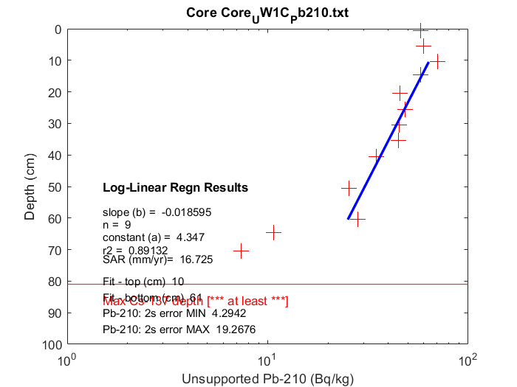 | B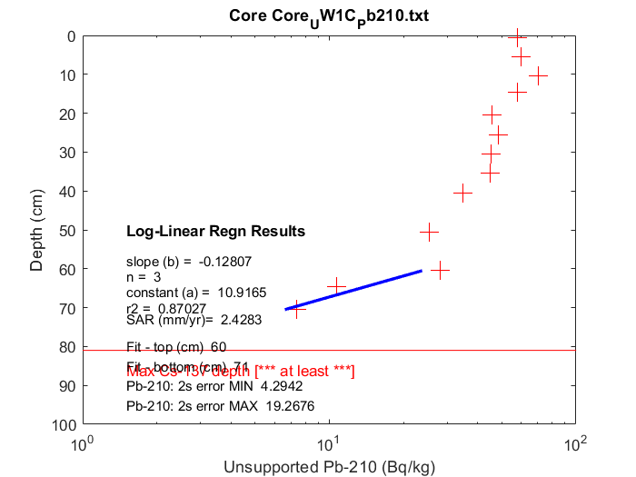
C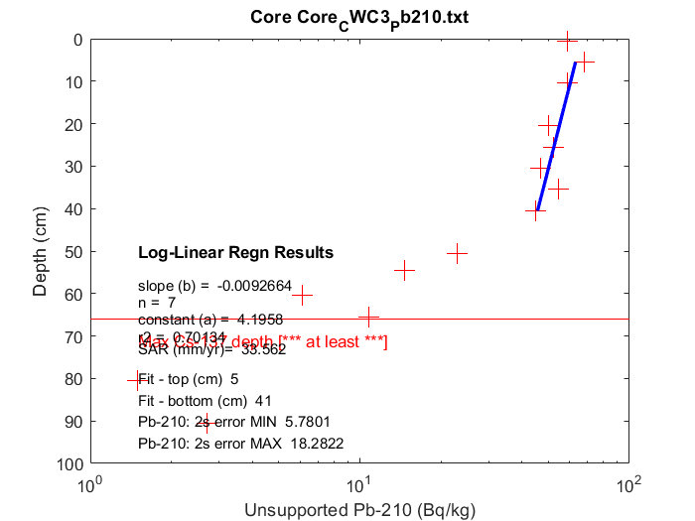 | D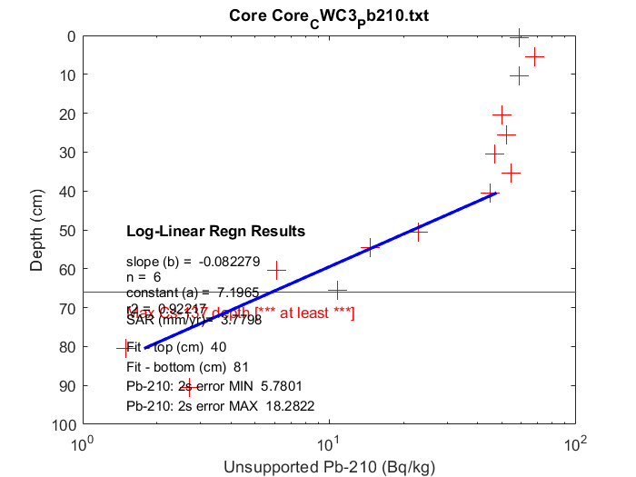
Supplementary material Figure S1. Log-linear regression graphical interpretations used to determine best fit sediment accumulation rates at A. the upper core fitted from 10 to 61 cm, B. the upper core fitted from 60 to 71 cm, C. the central core fitted from 5 to 41 cm, and D. the central core fitted from 40 to 81 cm. Red crosses show the unsupported ²¹⁰Pb determined at each core slice depth, the blue line shows the fitted proposed accumulation rate, and the horizontal red line shows the inferred maximum ¹³⁷Cs deposition depth.

Supplementary Tables
Supplementary material Table S1. EQR CPT.
% intertidal area | Potential TN  (mg m⁻³⁾ | EQR>0.8 | 0.8>EQR>0.6 | 0.6>EQR>0.4 | EQR<0.4
0 to 5 | 0 to 50 | 100 | 0 | 0 | 0
0 to 5 | 50 to 100 | 100 | 0 | 0 | 0
0 to 5 | 100 to 150 | 100 | 0 | 0 | 0
0 to 5 | 150 to 200 | 100 | 0 | 0 | 0
0 to 5 | 200 to 300 | 99.95 | 0.05 | 0 | 0
0 to 5 | 300 to 400 | 99.31 | 0.69 | 0 | 0
0 to 5 | 400 to 500 | 94.83 | 5.17 | 0 | 0
0 to 5 | 500 to 600 | 78.97 | 21.03 | 0 | 0
0 to 5 | 600 to 700 | 49.96 | 50.04 | 0 | 0
0 to 5 | 700 to 1000 | 9.78 | 89.67 | 0.55 | 0
0 to 5 | 1000 to 2000 | 0.03 | 25.03 | 57.26 | 17.68
5 to 30 | 0 to 50 | 97.13 | 2.85 | 0.02 | 0
5 to 30 | 50 to 100 | 93.21 | 6.7 | 0.09 | 0
5 to 30 | 100 to 150 | 85.87 | 13.8 | 0.33 | 0
5 to 30 | 150 to 200 | 74.38 | 24.55 | 1.07 | 0
5 to 30 | 200 to 300 | 50.91 | 43.98 | 5.05 | 0.06
5 to 30 | 300 to 400 | 21.23 | 57.8 | 20.18 | 0.79
5 to 30 | 400 to 500 | 5.36 | 44.11 | 44.83 | 5.7
5 to 30 | 500 to 600 | 0.81 | 19.78 | 56.97 | 22.44
5 to 30 | 600 to 700 | 0.08 | 5.32 | 42.68 | 51.92
5 to 30 | 700 to 1000 | 0 | 0.34 | 8.77 | 90.89
5 to 30 | 1000 to 2000 | 0 | 0 | 0.02 | 99.98
30 to 36 | 0 to 50 | 97.13 | 2.85 | 0.02 | 0
30 to 36 | 50 to 100 | 93.21 | 6.7 | 0.09 | 0
30 to 36 | 100 to 150 | 85.87 | 13.8 | 0.33 | 0
30 to 36 | 150 to 200 | 74.38 | 24.55 | 1.07 | 0
30 to 36 | 200 to 300 | 50.91 | 43.98 | 5.05 | 0.06
30 to 36 | 300 to 400 | 21.23 | 57.8 | 20.18 | 0.79
30 to 36 | 400 to 500 | 5.36 | 44.11 | 44.83 | 5.7
30 to 36 | 500 to 600 | 0.81 | 19.78 | 56.97 | 22.44
30 to 36 | 600 to 700 | 0.08 | 5.32 | 42.68 | 51.92
30 to 36 | 700 to 1000 | 0 | 0.34 | 8.77 | 90.89
30 to 36 | 1000 to 2000 | 0 | 0 | 0.02 | 99.98

Supplementary material Table S2. Predicted effects of sediment accumulation rate (SAR, mm y⁻¹) and macroalgal Ecological Quality Rating (EQR) on seagrass decline.
Parent node band |  | Band percent probabilities: seagrass decline
SAR (mm y⁻¹) | EQR | Extreme decline | Severe decline | Moderate decline | Negligible to minor decline
0 to <0.1 | 0.8 to 1.0 | 1 | 1 | 2 | 96
0.1 to <0.5 | 0.8 to 1.0 | 1 | 3 | 7 | 89
0.5 to <1.0 | 0.8 to 1.0 | 1 | 5 | 14 | 80
1.0 to <2.0 | 0.8 to 1.0 | 1 | 4 | 25 | 70
2.0 to <5.0 | 0.8 to 1.0 | 1 | 10 | 79 | 10
5.0 to <10.0 | 0.8 to 1.0 | 10 | 79 | 10 | 1
10.0 to 20.0 | 0.8 to 1.0 | 88 | 10 | 1 | 1
0 to <0.1 | 0.6 to <0.8 | 1 | 1 | 2 | 96
0.1 to <0.5 | 0.6 to <0.8 | 1 | 3 | 7 | 89
0.5 to <1.0 | 0.6 to <0.8 | 1 | 5 | 14 | 80
1.0 to <2.0 | 0.6 to <0.8 | 1 | 4 | 25 | 70
2.0 to <5.0 | 0.6 to <0.8 | 1 | 10 | 79 | 10
5.0 to <10.0 | 0.6 to <0.8 | 10 | 79 | 10 | 1
10.0 to 20.0 | 0.6 to <0.8 | 88 | 10 | 1 | 1
0 to <0.1 | 0.4 to <0.6 | 5 | 10 | 70 | 15
0.1 to <0.5 | 0.4 to <0.6 | 5 | 20 | 65 | 10
0.5 to <1.0 | 0.4 to <0.6 | 10 | 30 | 55 | 5
1.0 to <2.0 | 0.4 to <0.6 | 15 | 35 | 45 | 5
2.0 to <5.0 | 0.4 to <0.6 | 15 | 50 | 30 | 5
5.0 to <10.0 | 0.4 to <0.6 | 66 | 30 | 3 | 1
10.0 to 20.0 | 0.4 to <0.6 | 92 | 5 | 2 | 1
0 to <0.1 | 0 to <0.4 | 20 | 60 | 19 | 1
0.1 to <0.5 | 0 to <0.4 | 30 | 59 | 10 | 1
0.5 to <1.0 | 0 to <0.4 | 50 | 44 | 5 | 1
1.0 to <2.0 | 0 to <0.4 | 60 | 37 | 2 | 1
2.0 to <5.0 | 0 to <0.4 | 70 | 28 | 1 | 1
5.0 to <10.0 | 0 to <0.4 | 80 | 18 | 1 | 1
10.0 to 20.0 | 0 to <0.4 | 97 | 1 | 1 | 1

