Supplementary Material
AN Overview of Integration of Blockchain with Artificial Intelligence Technologies in The Energy Sector: A Systematic Review

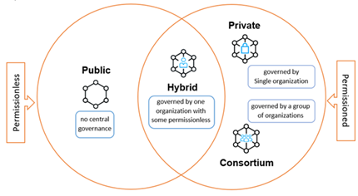
Figure 1. Types of blockchains

Table 1. ML learning techniques
Supervised Learning | Un-Supervised Learning |  |  | Semi-Supervised Learning | Reinforcement Learning
Used labelled data to train the machine. E.g., classification & regression |  | Machine is pushed to train itself with unlabelled data.  E.g., clustering & association | Machine uses less labelled data and more unlabelled data to train. |  | Interact with the environment to train.  E.g., robot & gaming

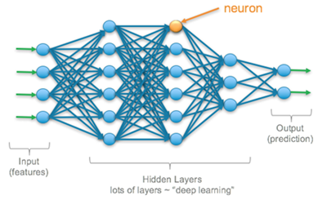
Figure 2. Biological neuron model

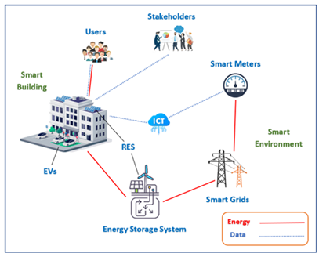
Figure 3. Smart city

Major applications of Blockchain in the energy domain
Energy management system | Energy trading (Peer-to-peer) | Smart grids | Electric vehicle | Energy storage | Carbon emission
Table 2. The main applications of Blockchain in the energy sector

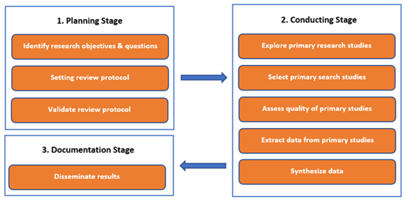
Figure 4. Systematic review stages
Table 3. Research inclusion and exclusion criteria
Inclusion criteria |  | Exclusion criteria
Journal articles  Conference proceedings  Book chapters  Magazines | Prior to year 2018  Non-English language  Irrelevant to the scope of the article  Duplicate

Table 4. Initial results with first screening step
Digital library | IEEE Xplore | Springer  Link |  | ScienceDirect |  | ACM
Preliminary results  < 2018  Remainder  Total | 113,547  40,862  72,685 |  | 16,916  64  16,852  236,300 | 194,103  93,973  100,130 | 144,636  98,003  46,633

Table 5. Second results with application of inclusion and exclusion criteria
Digital library | IEEE Xplore | SpringerLink |  | ScienceDirect | ACM
Secondary results  With exclusion & inclusion criteria  Remainder  Total | 72,685  72,301  384 |  | 16,852  16,747  105  1236 | 100,130  99,640  490 | 46,633  46,376  2547

Table 6. Final results with confirming study topic compliancy
Digital library | IEEE Xplore | Springer  Link |  | ScienceDirect |  | ACM | Others  (i.e., MDPI)
Final screening results  Out of “Energy” scope  Remainder  Total | 384  364  21 |  | 105  105  0  27 | 490  486  4 | 257  257  0 |  |  | -  -  2

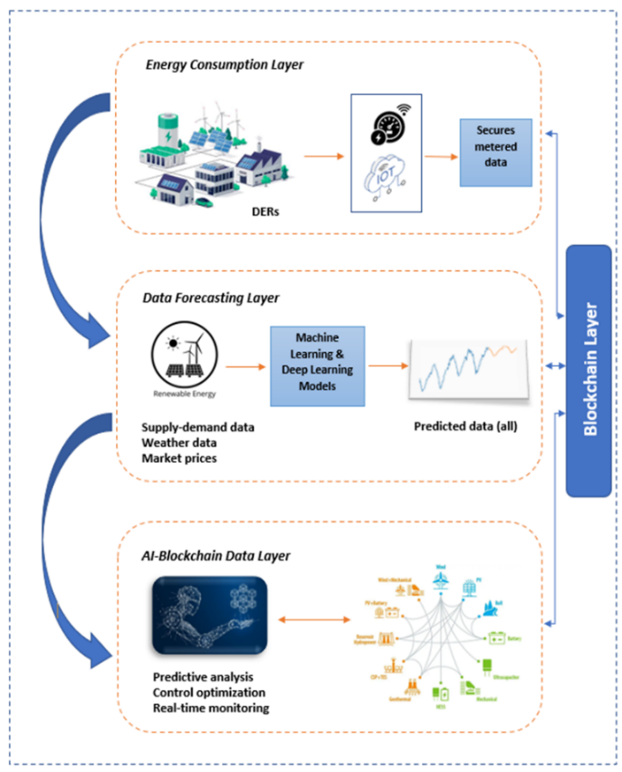
Figure 5. General AI-Blockchain energy architecture

Figure 6. AI-Blockchain integration advantages
