Supplemental Table S1. Demographic, clinical, and biochemical characteristics in 147 patients hospitalised for COVID-19 included in the original NOR-Solidarity cohort. Further, 15 patients from the primary cohort were included in the present study's RNA-seq analysis (RNAseq Cohort).
Parameter | Main Cohort  n=147 | RNAseq Cohort  n=15
Age, years | 59.6±15.5 | 60.0±13.4
Male gender (%) | 91 (62) | 12 (80)
Body Mass Index, kg/m2 | 28.1±4.6 | 29.5±4.7
Vaccinated ≥ 1 dose (%) | 0 (0) | 0 (0)
Dexamethasone (%) | 1 (1) | 1 (7)
Comorbidities
Chronic cardiac disease (%) | 24 (16) | 0 (0)
Hypertension (%) | 46 (32) | 5 (36)
Chronic pulmonary disease (%) | 28 (19) | 4 (29)
Obesity (%) | 37 (28) | 6 (40)
Diabetes (%) | 24 (16) | 3 (21)
Current smoker (%) | 3 (2) | 2 (14)
HIV (%) | 8 (5) | 0 (0)
Oxygen therapy (%) | 81 (55) | 11 (73)
Outcomes
ICU admission (%) | 26 (18) | 5 (33)
P/F-ratio at admission, kPa | 42.4 (32.9,49.6) | 39.6 (30.4, 45.4)
Haemoglobin, g/dL | 13.1±1.6 | 13.6± 1.1
C-reactive protein, mg/L | 69 (34,131) | 85 (48, 161)
Ferritin, µg/L | 619 (368,1115) | 586 (293, 1065)
White blood cell count, x 10⁹/L | 6.4±2.6 | 7.8±4.0
Neutrophils, x 10⁹/L | 4.7±2.5 | 6.3±4.1*
Lymphocytes, x 10⁹/L | 1.2±0.54 | 1.0±0.4
eGFR | 87±24 | 93.3±25.9

ICU; intensive care unit, P/F-ratio; PaO2/FiO2-ratio, eGFR; estimated glomerular filtration rate. Values are presented as mean ± SD or median (25th, 75th) quantiles for continuous variables. * p-value <0.05, t-test.
Supplemental Figure S1. Batch correction of COVID-19 and healthy control samples.
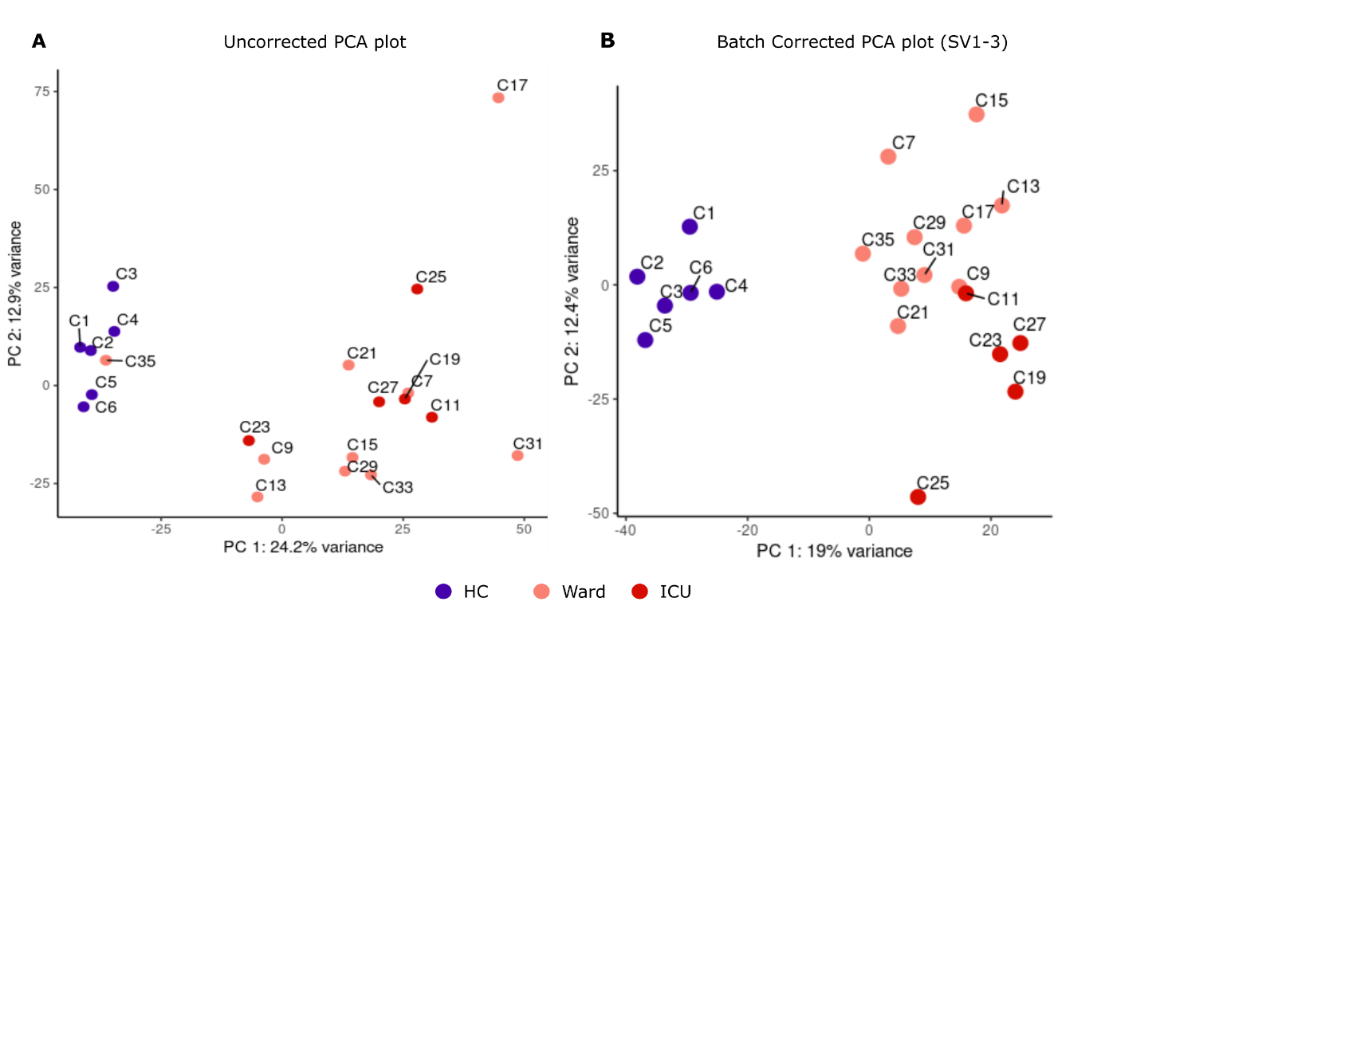
Principal component analysis (PCA) of variance stabilised, uncorrected normalised counts (A). Principal component analysis (PCA) of variance stabilised, batch-corrected with surrogate variables package (SVA), normalised counts. Of 5 surrogate variables (SV) detected, SV1, SV2 and SV3 are included (B). HC = healthy control, Ward = hospitalised ward patients, ICU = Intensive Care Unit patients.
Supplemental Table S2. Sample metadata and surrogate variables of PBMC from COVID-19 patients and healthy controls
Sample metadata and surrogate variables detected during the batch correction, before formal analysis, of COVID-19 PBMC versus healthy controls comparison.
ID | Condition | Type | SV1 | SV2 | SV3 | SV4 | SV5
C1 | HC | CTR | -0,22773 | 0,155271 | 0,14606 | -0,19177 | 0,225017
C2 | HC | CTR | -0,2079 | 0,13188 | -0,23785 | 0,059099 | -0,01114
C3 | HC | CTR | -0,19406 | 0,28029 | -0,29888 | 0,080281 | 0,189852
C4 | HC | CTR | -0,22237 | 0,18311 | -0,24417 | 0,083828 | 0,020913
C5 | HC | CTR | -0,20404 | -0,00241 | 0,224483 | 0,144015 | -0,15342
C6 | HC | CTR | -0,24722 | 0,009935 | 0,23389 | 0,009722 | -0,16212
C7 | Ward | COVID-19 | 0,22327 | -0,07844 | 0,071062 | -0,33974 | 0,528621
C9 | Ward | COVID-19 | -0,07317 | -0,14199 | 0,186455 | 0,025413 | -0,16677
C11 | ICU | COVID-19 | 0,192626 | -0,15899 | 0,077941 | -0,06883 | 0,083925
C13 | Ward | COVID-19 | -0,11977 | -0,18089 | 0,17584 | -0,20164 | -0,20286
C15 | Ward | COVID-19 | 0,080694 | -0,08388 | -0,04227 | -0,4537 | -0,33178
C17 | Ward | COVID-19 | 0,546265 | 0,670171 | 0,043735 | -0,15181 | -0,26989
C19 | ICU | COVID-19 | 0,138459 | -0,1103 | 0,119826 | 0,125555 | -0,11733
C21 | Ward | COVID-19 | 0,047671 | 0,021655 | -0,35224 | 0,174114 | 0,133009
C23 | ICU | COVID-19 | -0,17548 | -0,04879 | -0,18328 | 0,147309 | -0,3792
C25 | ICU | COVID-19 | 0,23945 | 0,054126 | 0,285526 | 0,658635 | 0,119776
C27 | ICU | COVID-19 | 0,089137 | -0,06242 | 0,124468 | -0,01243 | -0,00095
C29 | Ward | COVID-19 | -0,00098 | -0,22365 | -0,34534 | -0,10175 | -0,03732
C31 | Ward | COVID-19 | 0,302613 | -0,3124 | -0,35831 | 0,086771 | 0,07542
C33 | Ward | COVID-19 | 0,102252 | -0,3072 | 0,16133 | 0,043407 | 0,119009
C35 | Ward | COVID-19 | -0,28973 | 0,204931 | 0,21172 | -0,11649 | 0,337243
Type = Sample biotype; CTR = control group; COVID-19 = COVID-19 patients. Condition = sample condition; HC= healthy control; ward= ward patient; ICU = intensive care unit patient.SV= surrogate variable.

Supplemental Figure S2. Batch correction of ICU and Ward samples.
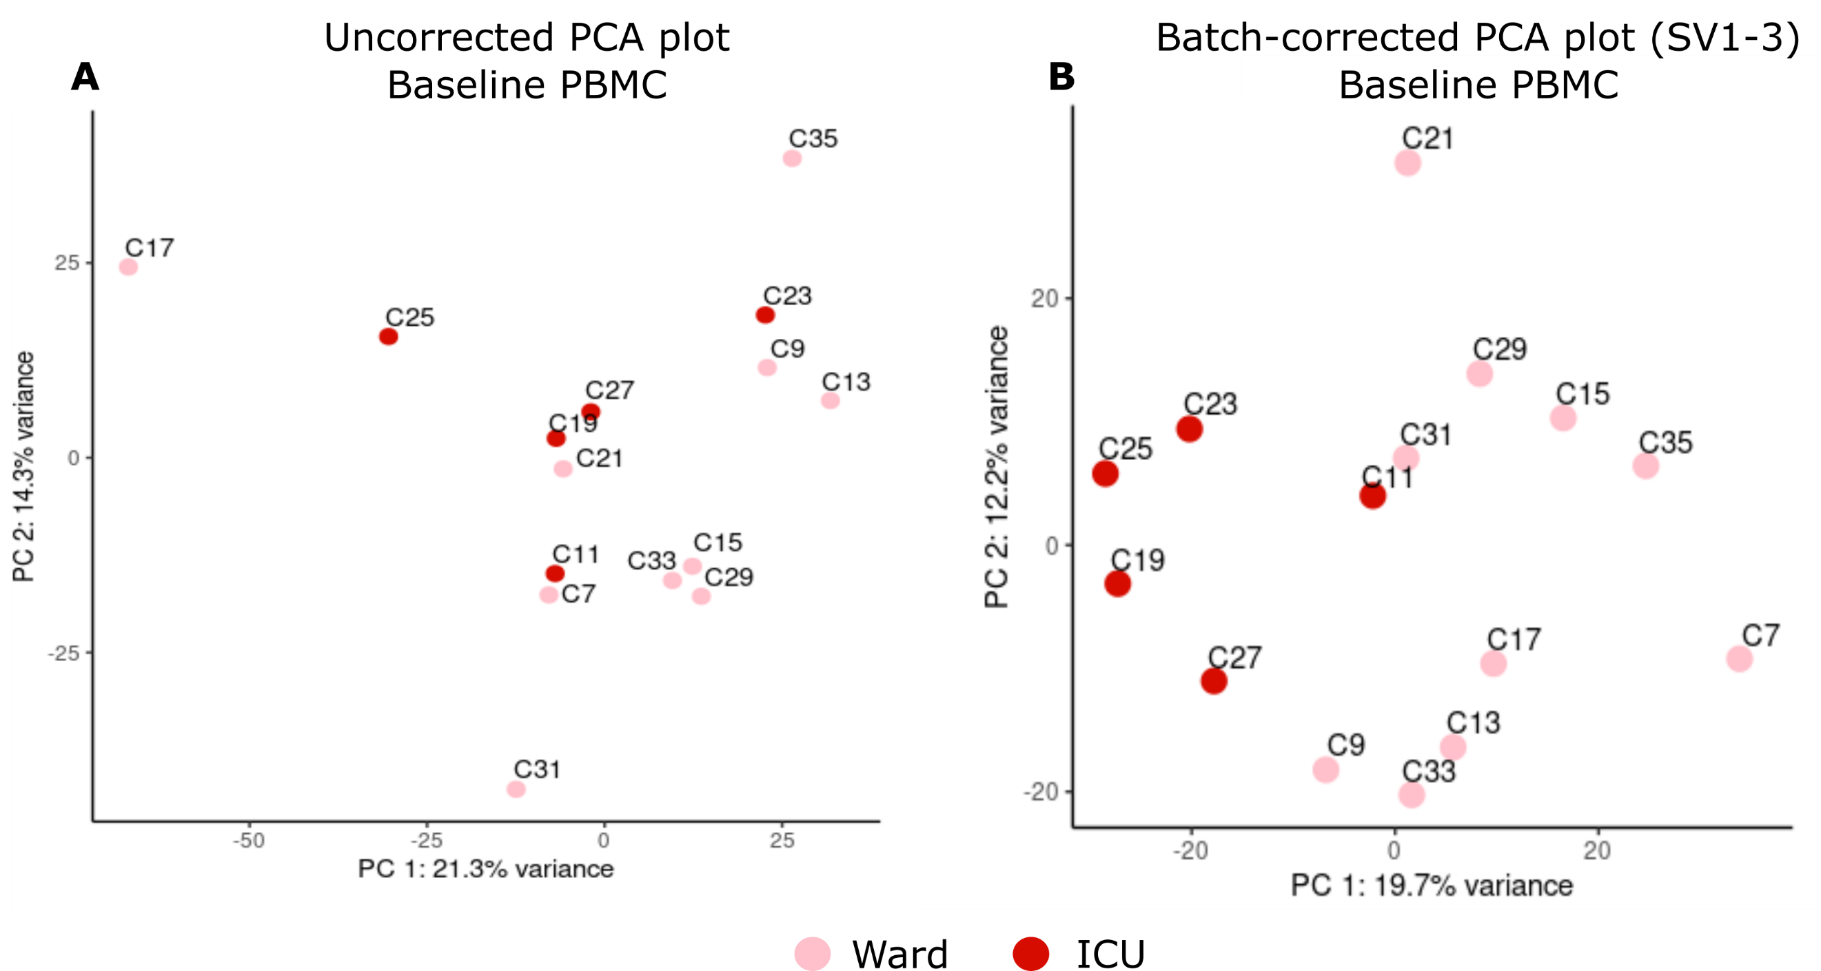
Principal component analysis (PCA) of variance stabilised, uncorrected normalised counts of ICU and WARD samples (A). PCA Principal component analysis (PCA) of batch-corrected variance stabilised normalised counts. Of the 3 surrogate variables (SV) detected, SV1, SV2 and SV3 are included to adjust for unknown batch effects (B). Ward = hospitalised ward patients, ICU = Intensive Care Unit patients.

Supplemental Table S3. Sample metadata and surrogate variables of PBMC from ICU- and Ward patients.
Sample metadata and surrogate variables were detected during the batch correction of ICU and Ward's patient samples, performed before formal analysis.
ID | Condition | Type | SV1 | SV2 | SV3
C19 | ICU | COVID-19 | -0,04063 | 0,008119 | 0,016857
C17 | Ward | COVID-19 | -0,76182 | -0,33309 | -0,34301
C31 | Ward | COVID-19 | -0,12569 | 0,461012 | 0,100303
C9 | Ward | COVID-19 | 0,216903 | -0,11192 | -0,07074
C11 | ICU | COVID-19 | -0,06013 | 0,186968 | 0,065267
C13 | Ward | COVID-19 | 0,308144 | -0,02828 | -0,18842
C15 | Ward | COVID-19 | 0,053602 | 0,153358 | -0,5105
C23 | ICU | COVID-19 | 0,234296 | -0,27442 | -0,21993
C35 | Ward | COVID-19 | 0,308148 | -0,57189 | 0,234803
C29 | Ward | COVID-19 | 0,151829 | 0,220816 | -0,13339
C25 | ICU | COVID-19 | -0,24524 | -0,1864 | 0,586138
C33 | Ward | COVID-19 | 0,103644 | 0,222944 | 0,212565
C27 | ICU | COVID-19 | -0,00578 | 0,003452 | -0,04342
C21 | Ward | COVID-19 | -0,05357 | -0,01312 | 0,070467
C7 | Ward | COVID-19 | -0,08371 | 0,262465 | 0,223013
Type = Sample biotype; COVID-19 = COVID-19 patients. Condition = sample condition; ward= ward patient; ICU = intensive care unit patient. SV = surrogate variable.

Supplemental Figure S3. Severe COVID-19 Proteomics samples.
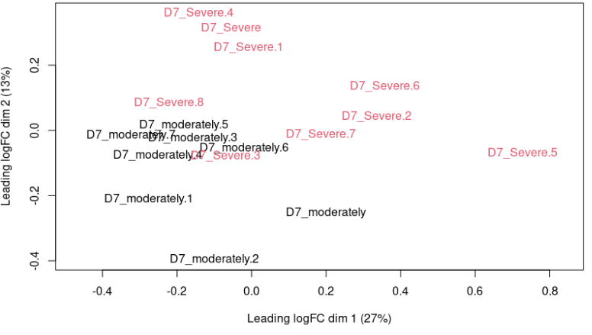
A Multidimensional Scaling (MDS) plot of normalised, log2foldchange transformed, imputed, and batch-corrected proteomics data from PBMC collected during the first week of hospitalisation (D7). Moderate = hospital ward patients, Severe = intensive care unit patients.

Supplemental Figure S4. Regulation of ECM-related geneset gene sets in PBMC.
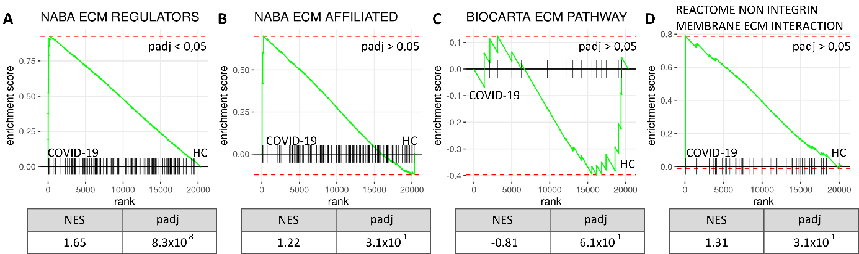
RNAseq data of PBMC from hospitalised COVID-19 patients (n=15) and age-matched healthy controls (n=6) was tested against the gene sets NABA ECM REGULATORS (A), NABA ECM AFFILIATED (B), BIOCARTA ECM PATHWAY (C) and REACTOME NON INTERGRIN MEMBRANE ECM INTERACTION (D) for enrichment. PBMC from COVID-19 patients showed an increased enrichment of ECM regulators compared to the healthy controls (padj < 0.05). padj= p-adjusted value, HC=healthy controls.

Supplemental Figure S5. Gene expression of ECM Regulator genes in COVID-19 PBMC.
169 of 238 genes belonging to the NABA_ECM_REGULATORS gene set were expressed in COVID-19 PBMC and presented below as a heatmap, with genes sorted on GSEA rank. Type = Sample biotype; HC = healthy control; COVID-19 = COVID-19 patients. Condition = sample condition; HC= healthy control; wWard= ward patient; ICU = intensive care unit patient.
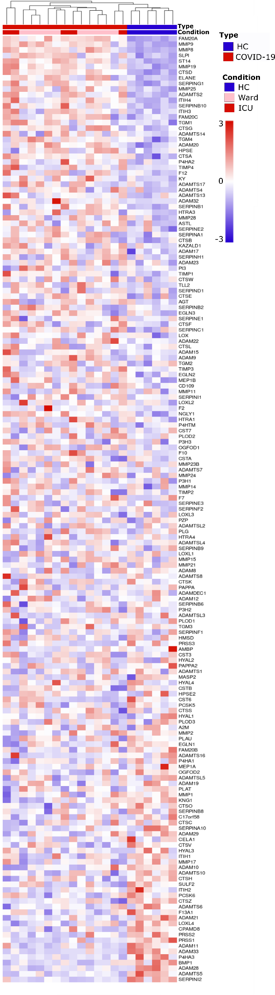
Supplemental table S4. ECM Regulator gene expression in severe COVID-19.
ECM regulator genes were significantly expressed in ICU patients compared to Ward COVID-19 patients.
GENE | DESCRIPTION | Mean | Log2FC* | p-value* | Padj*
A2M | alpha-2-macroglobulin | 20,0 | -0,081 | 0,000 | 0,043
ADAM15 | ADAM metallopeptidase domain 15 | 1153,0 | 0,136 | 0,018 | 0,298
ADAMTS13 | ADAM metallopeptidase with thrombospondin type 1 motif 13 | 63,9 | 0,118 | 0,016 | 0,279
ADAMTS2 | ADAM metallopeptidase with thrombospondin type 1 motif 2 | 1043,5 | 2,373 | 0,000 | 0,051
ADAMTSL4 | ADAMTS like 4 | 892,5 | 0,093 | 0,015 | 0,271
AGT | angiotensinogen | 52,0 | 0,501 | 0,003 | 0,137
CPAMD8 | C3 and PZP like alpha-2-macroglobulin domain containing 8 | 175,8 | 0,088 | 0,021 | 0,317
CTSA | cathepsin A | 7264,0 | 0,175 | 0,026 | 0,402
CTSD | cathepsin D | 12382,6 | 0,331 | 0,010 | 0,249
EGLN2 | egl-9 family hypoxia inducible factor 2 | 1834,8 | 0,142 | 0,039 | 0,421
HTRA1 | HtrA serine peptidase 1 | 50,4 | 0,063 | 0,024 | 0,340
ITIH3 | inter-alpha-trypsin inhibitor heavy chain 3 | 15,6 | 0,061 | 0,026 | 0,351
ITIH4 | inter-alpha-trypsin inhibitor heavy chain 4 | 476,1 | 0,164 | 0,031 | 0,376
LOXL1 | lysyl oxidase like 1 | 19,4 | -0,045 | 0,039 | 0,415
MMP19 | matrix metallopeptidase 19 | 66,8 | 1,394 | 0,000 | 0,039
MMP23B | matrix metallopeptidase 23B | 216,3 | 0,170 | 0,018 | 0,300
MMP25 | matrix metallopeptidase 25 | 1845,7 | 0,960 | 0,001 | 0,078
P4HA2 | prolyl 4-hydroxylase subunit alpha 2 | 8,9 | 0,035 | 0,014 | 0,269
P4HTM | prolyl 4-hydroxylase, transmembrane | 875,6 | -0,300 | 0,004 | 0,153
PAPPA | pappalysin 1 | 9,7 | -0,023 | 0,008 | 0,215
PCSK6 | proprotein convertase subtilisin/kexin type 6 | 860,0 | 0,620 | 0,003 | 0,121
PLAT | plasminogen activator, tissue type | 11,4 | -0,062 | 0,012 | 0,250
PLOD1 | procollagen-lysine,2-oxoglutarate 5-dioxygenase 1 | 846,4 | 0,141 | 0,045 | 0,442
SERPINB1 | serpin family B member 1 | 3300,0 | 0,218 | 0,018 | 0,344
SERPING1 | serpin family G member 1 | 559,4 | 0,044 | 0,013 | 0,260
ST14 | ST14 transmembrane serine protease matriptase | 751,4 | 0,113 | 0,032 | 0,382
TIMP1 | TIMP metallopeptidase inhibitor 1 | 3270,5 | 0,331 | 0,010 | 0,261
TIMP3 | TIMP metallopeptidase inhibitor 3 | 19,7 | 0,040 | 0,023 | 0,326
TIMP4 | TIMP metallopeptidase inhibitor 4 | 7,8 | 3,325 | 0,000 | 0,001
* P-values, adjusted p-values (padj) and Log2fold change (Log2FC) are represented as ICU/Ward comparison values. Mean = mean expression value.
Supplemental Table S5. ECM regulator proteins.
Peripheral blood mononuclear cell proteins from severe COVID-19 patients that were recognised as ECM Regulator proteins.
UniProt | SYMBOL | Log2FC* | p-val* | p-adj*
P10619 | CTSA | 0,43 | 0,000 | 0,021
O14672 | ADAM10 | 0,28 | 0,004 | 0,080
P00488 | F13A1 | 0,67 | 0,005 | 0,088
P07339 | CTSD | 0,30 | 0,007 | 0,102
P50452 | SERPINB8 | -0,23 | 0,027 | 0,163
P50453 | SERPINB9 | -0,21 | 0,057 | 0,236
P25774 | CTSS | -0,18 | 0,163 | 0,409
P53634 | CTSC | -0,19 | 0,163 | 0,410
P04080 | CSTB | -0,12 | 0,253 | 0,520
P07858 | CTSB | -0,10 | 0,357 | 0,618
P30740 | SERPINB1 | 0,07 | 0,589 | 0,784
P22894 | MMP8 | -0,17 | 0,597 | 0,787
P48595 | SERPINB10 | -0,06 | 0,735 | 0,874
P14780 | MMP9 | -0,11 | 0,750 | 0,883
P08246 | ELANE | 0,08 | 0,762 | 0,885
Q9UBR2 | CTSZ | 0,04 | 0,776 | 0,893
Q9Y251 | HPSE | 0,03 | 0,884 | 0,949
P35237 | SERPINB6 | -0,01 | 0,927 | 0,971
P01009 | SERPINA1 | -0,01 | 0,963 | 0,987
P08311 | CTSG | 0,00 | 0,998 | 0,999
*log2fold change (log2FC), p-value (p-val) and p-adjusted value (p-adj) are derived from Limma results and presented as ICU/Ward comparison values.

Supplemental Figure S6. Regulation of ECM-related gene sets in inflamed tissue.
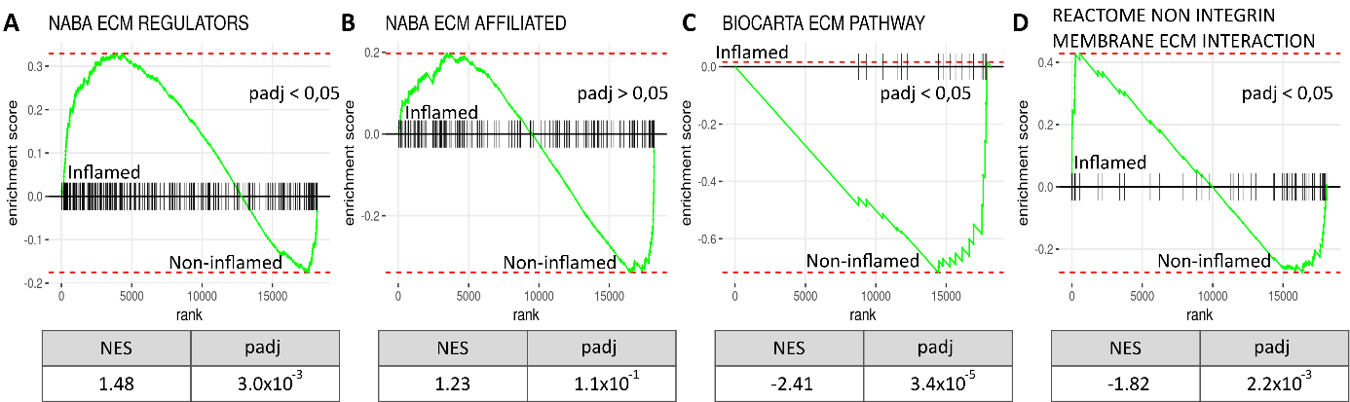
Comparing a publicly available gene expression data set of inflamed lung tissue to paired non-inflamed tissue from the same deceased COVID-19 patients (N=5, inflamed biopsies = 49, non-inflamed biopsies=17) shows ECM regulatory activity when using GSEA analysis on the gene dataset: NABA ECM REGULATORS (A), NABA ECM AFFILIATED (B), BIOCARTA ECM PATHWAY (C) and REACTOME NON INTERGRIN MEMBRANE ECM INTERACTION (D). The ECM regulators gene set was significantly increased in inflamed tissue. Meanwhile, the Biocarta ECM pathway and Reactome non-integrin membrane ECM interaction was significantly decreased. Finally, the ECM-affiliated gene set was not considerably regulated between the two conditions.

