**Supplemental figures**

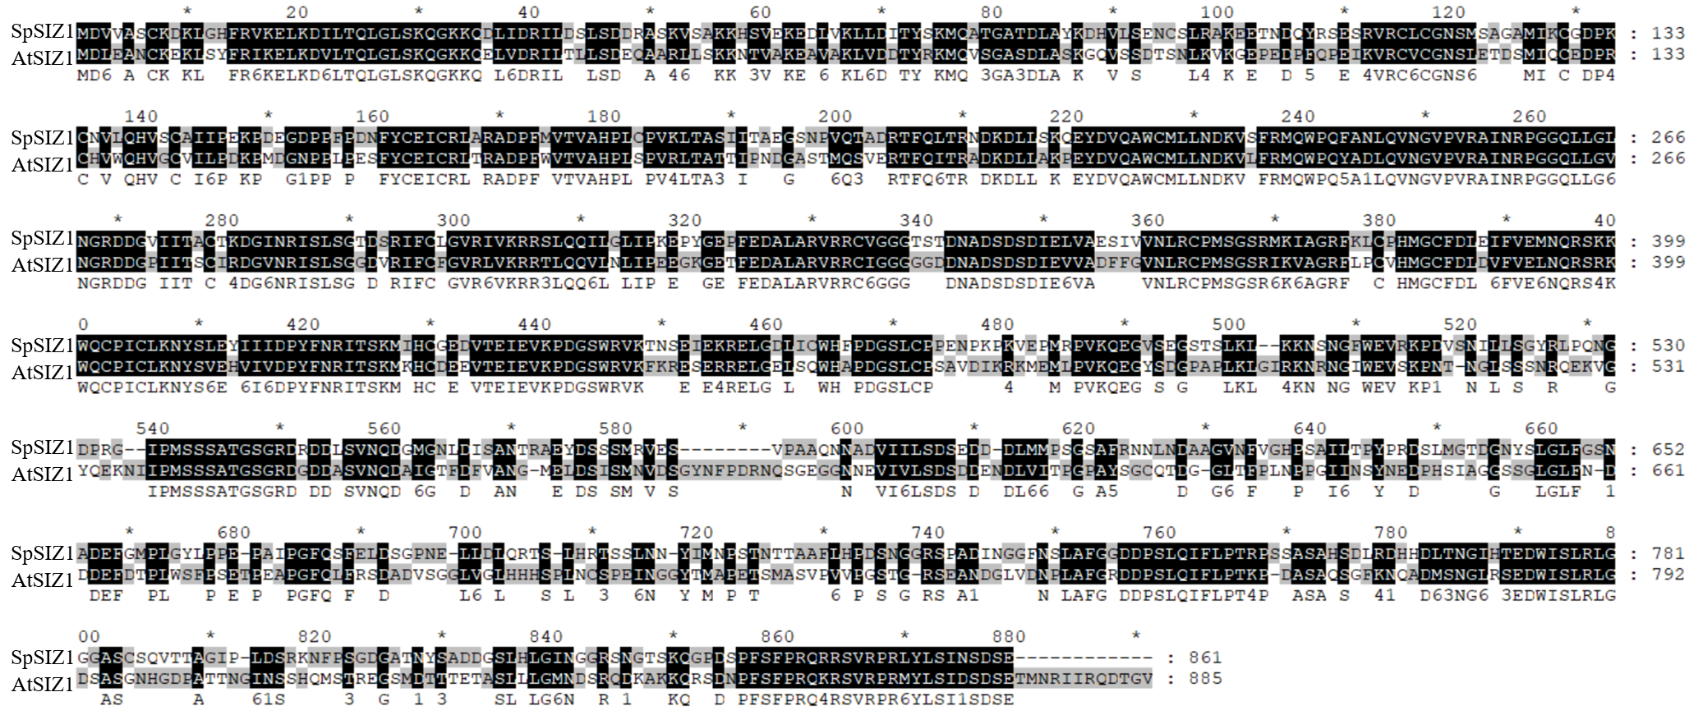

**Figure S1.** Full-length protein structure similarity alignment of AtSIZ1 and SpSIZ1 using MEGA 7 and genedoc software.

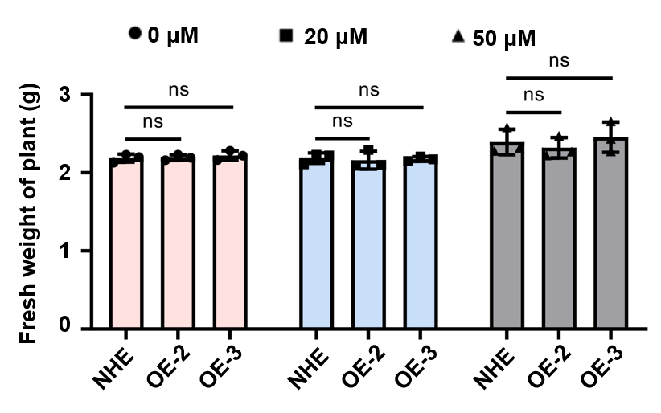

**Figure S2.** The fresh weight of NHE and SpSIZ1-OE lines before different concentrations of Cd stress treatments. Data are shown as mean ± SD (n = 3). ns indicate not statistically significant differences compared with wild-type NHE.

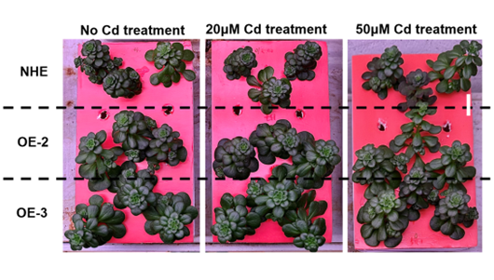

**Figure S3.** Treatment of different concentrations of Cd stress on the NHE and SpSIZ1-OE lines in the same cultivation environment. The CdCl2 stress conditions were 20 μM for 10 d and 50 μM for 10 d. A 10-d period without Cd treatment was used as a negative control. Scale bar, 5 cm.

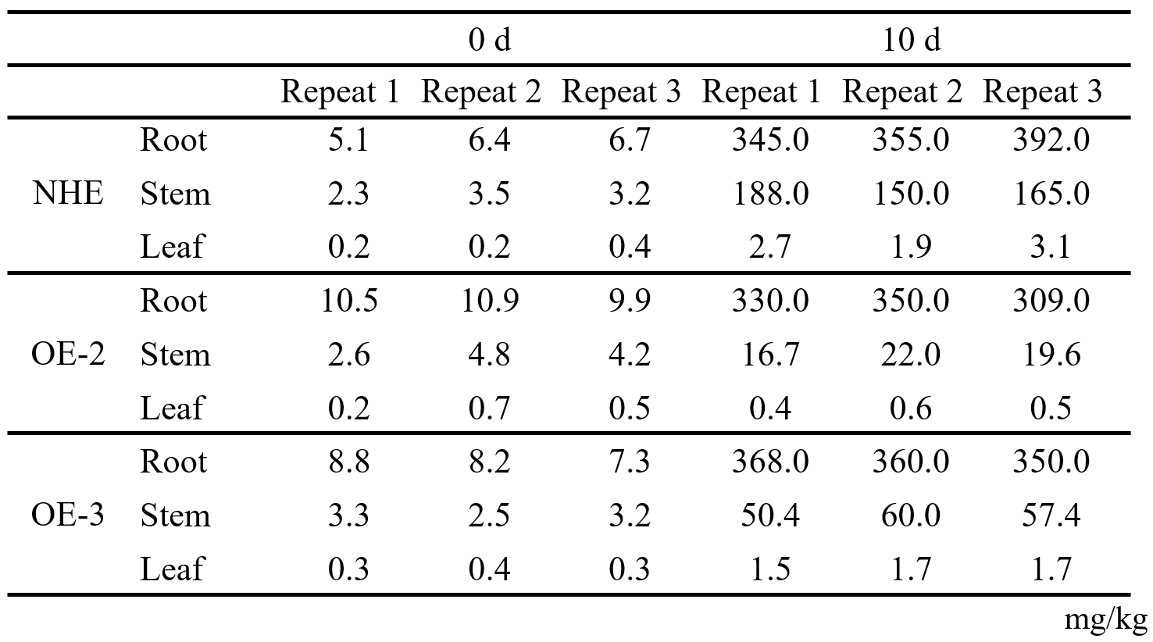

**Table S1.** The Cd content in the root, stem, and leaf of NHE and SpSIZ1-OE lines after 0 d and 10 d treatment with 50 μM CdCl2.

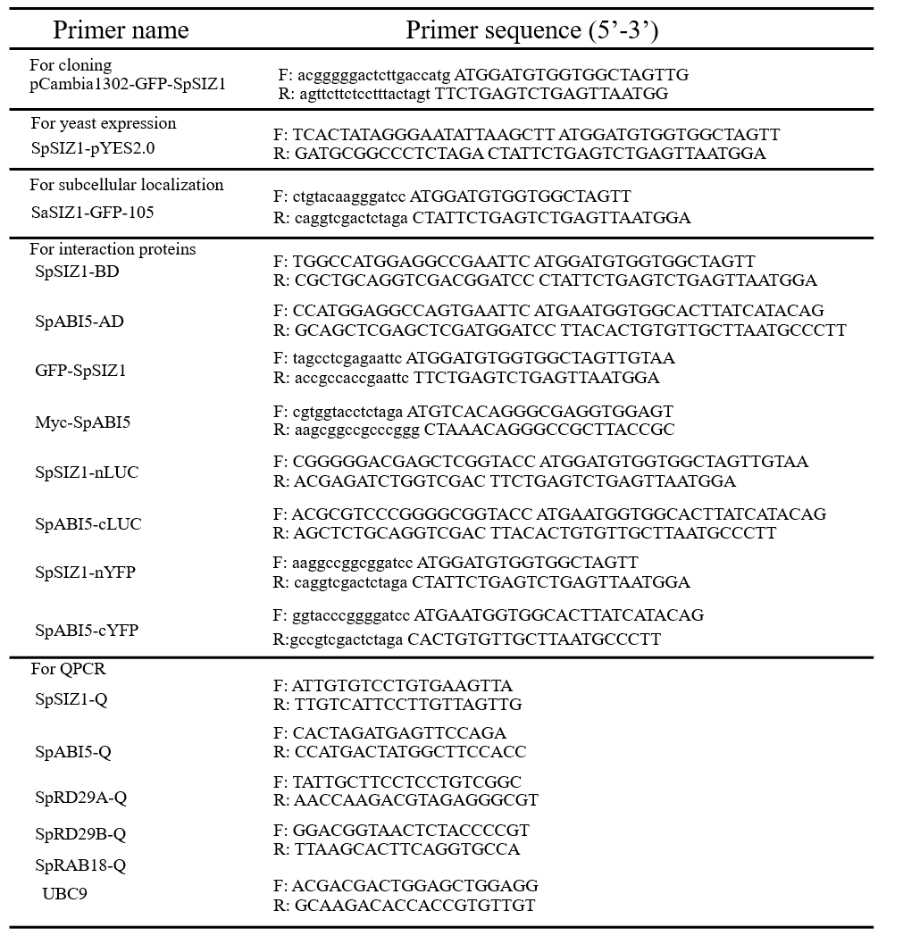

**Table S2.** Sequences of primers used in this study.