Supplementary Fig. 1: Degradation of FA at pH 4.5
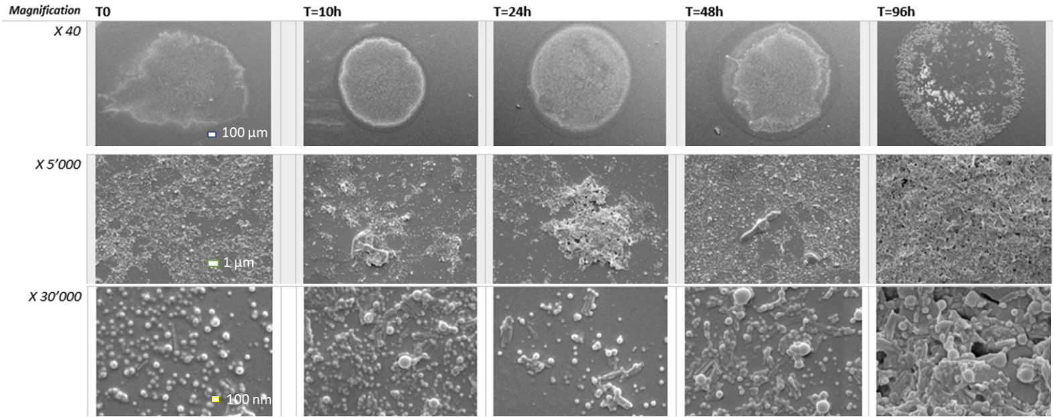
Figure S1: SEM images of FA degradation at pH 4.5 over 96 h at different magnifications. 96 h was considered as degradation endpoint as NPs are highly disrupted and the polymer aggregated. Scale bars are at 100 µm at X 40 magnification, 1 µm at X 5000 and 100 nm at X 30000.

Supplementary Fig 2: Influence of PLGA and Cholesterol on Tomatine’s hemolytic activity
Figure S2: Titration of tomatine’s hemolytic activity on sheep RBC after incubation with tomatine alone, tomatine formulated with PLGA and tomatine formulated with PLGA-Chol (1:1 tomatine-Chol ratio). Tomatine alone was dissolved in a 10% DMSO solution and added to the cells. PBS was used as a negative control and WFI as positive control.

