Supplementary Table 1. Tomato Leaf Image Information
Type of tomato leaf disease | Training Images | Validation Images | Test (Epoch)
Late Blight | 750 | 250 | 100
Healthy | 750 | 250 | 100
Early Blight | 750 | 250 | 100
Septoria Leaf Spot | 750 | 250 | 100
Yellow Leaf Curl Virus | 750 | 250 | 100
Bacterial Spot | 750 | 250 | 100
Target Spot | 750 | 250 | 100
Mosaic Virus | 750 | 250 | 100
Leaf Mold | 750 | 250 | 100
Two Spotted Spider Mite | 750 | 250 | 100

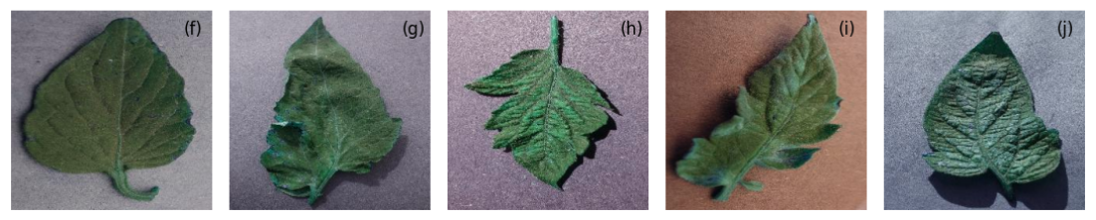
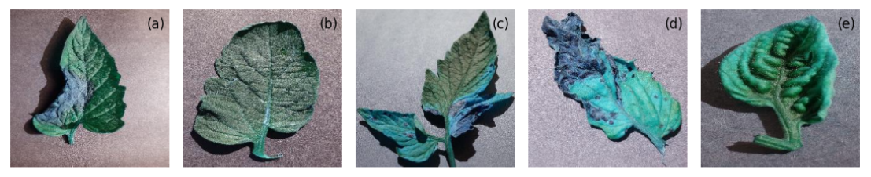
Supplementary Figure 1 : Classification of Input Images of Tomato Leaves representing (a) Late Blight, (b) Healthy, (c) Early Blight, (d) Septoria Leaf Spot, (e) Yellow Leaf Curl Virus, (f) Bacterial Spot, (g)Target Spot, (h) Mosaic Virus, (i) Leaf Mold, (j) Two Spotted Spider Mite

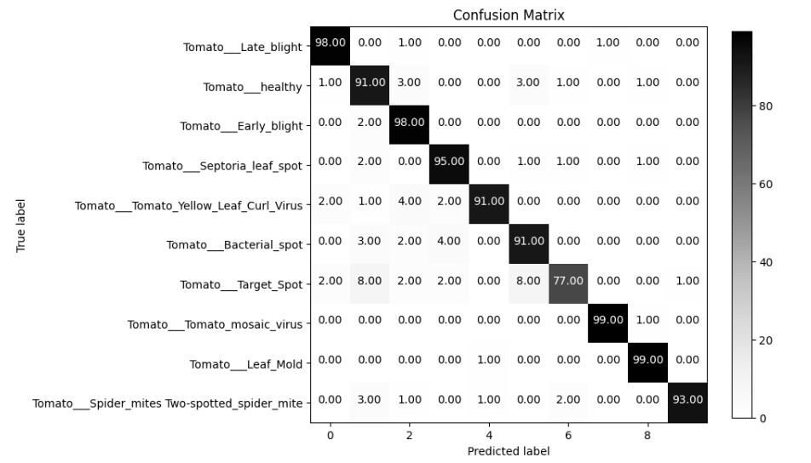
Supplementary Figure 2. Confusion Matrix of the VGG16 Fine Tuned Model
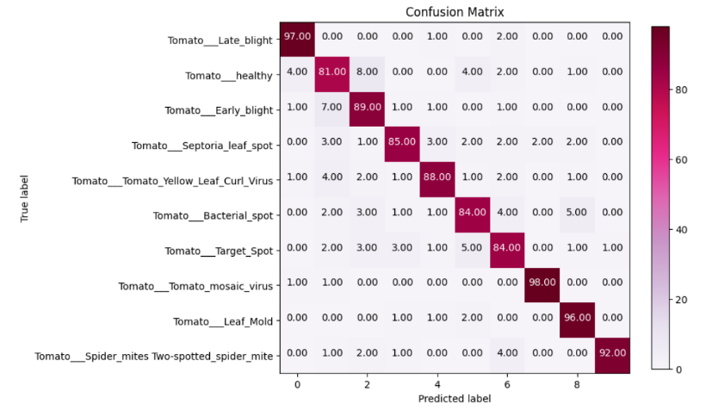
Supplementary Figure 3. Confusion Matrix of the NASNet model

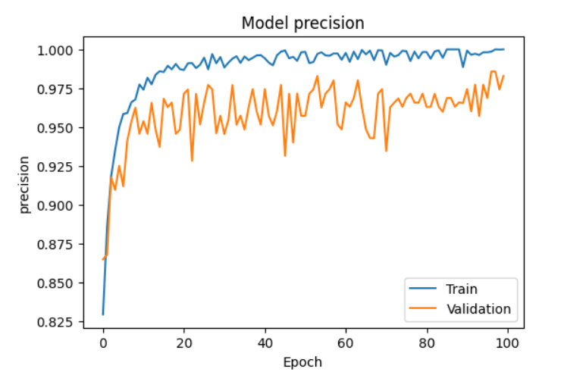  (a) |  | 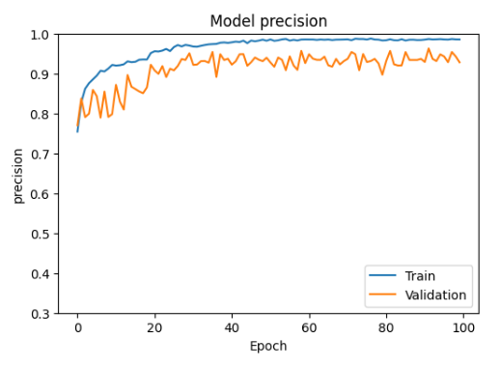  (b)
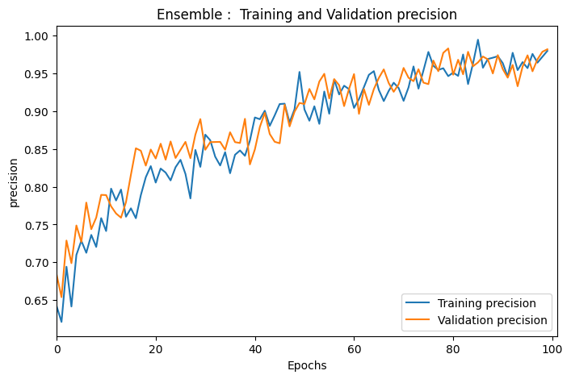
(c)
Supplementary Figure 4. Precision Curves of (a) VGG-16, (b) NASNet, (c) Proposed Model

