***Supplementary Material***

**Uptake and translocation of Pharmaceutically Active Compounds by olive tree (*Olea europaea* L.) irrigated with treated municipal wastewater**

**Alba N. Mininni1*, Angela Pietrafesa1, Maria Calabritto1, Roberto Di Biase1, Gennaro Brunetti2, Francesco De Mastro2, Sapia Murgolo3, Cristina De Ceglie3, Carlo Salerno3, Bartolomeo Dichio1**

1 University of Basilicata, Department DICEM, Via Lanera 20, 75100, Matera, Italy

2 University of Bari, Department of Soil, Plant, and Food Science, Piazza Umberto I, 70121, Bari, Italy

3 CNR, Istituto di Ricerca Sulle Acque, Department of Bari, V.le F. De Blasio 5, 70132, Bari, Italy

**\* Correspondence:**Alba N. Mininni  
alba.mininni@unibas.it

# Supplementary Figures and Tables

## Supplementary Figures

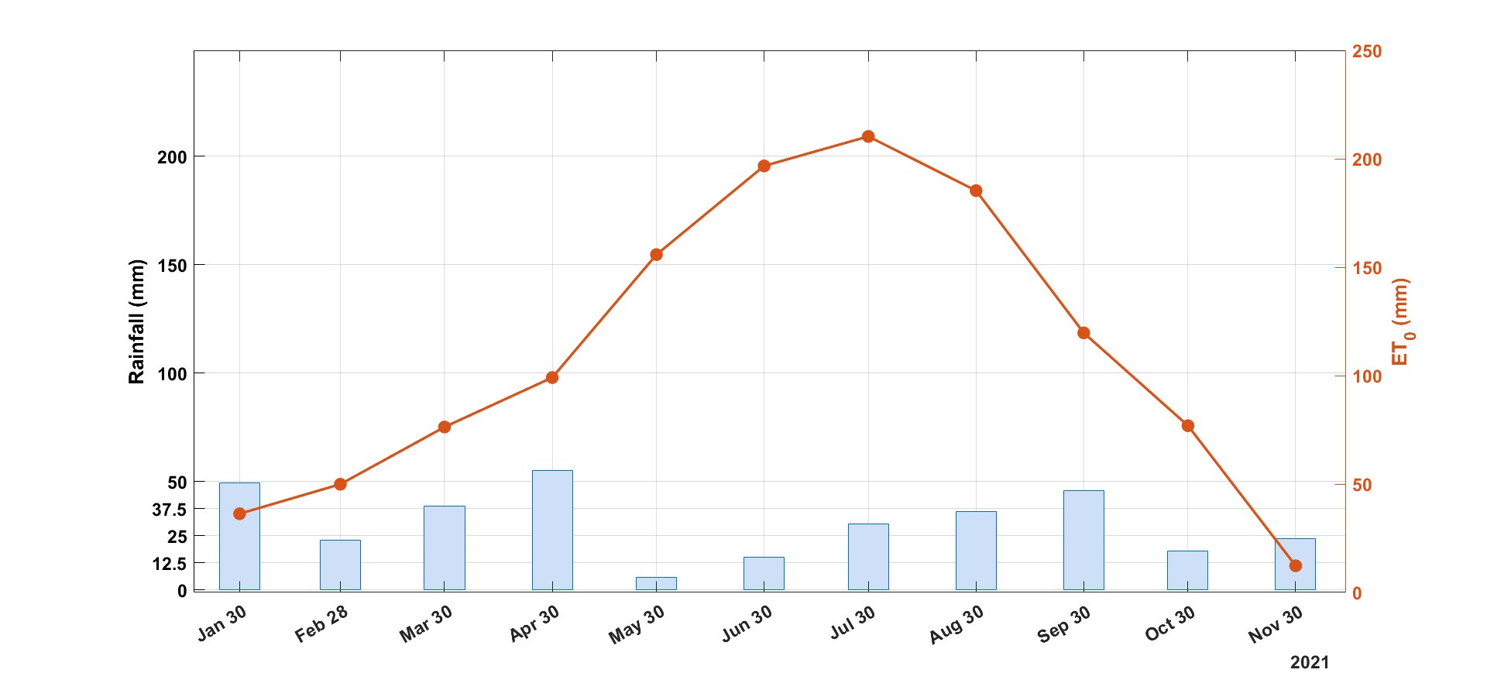

**FIGURE S1** Monthly reference evapotranspiration (ET0) and rainfall for 2021 obtained from the AASD Pantanello weather station of ALSIA Research Institute.

* 1. **Supplementary Tables**

**TABLE S1** Physico-chemical properties of the Pharmaceutically Active Compounds (PhACs) selected in this study.

|  |  |  |  |  |  |  |
| --- | --- | --- | --- | --- | --- | --- |
| **PhACs** | **Molecular weight (g mol-1)** | **Chemical Structure** | **Therapeutic class** | **Water**  **Solubility**  **mg L-1** | **logKOW** | **pKa** |
| Clarithromycin | 748.0 |  | antibiotic | 1.69 at 25°C | 3.16 | 8.99 |
| Sulfamethoxazole | 253.3 |  | antibiotic | 610 at 37°C | 0.89 | 1.6 |
| Trimethoprim | 290.3 |  | antibiotic | 400 at 25°C | 0.91 | 7.12 |
| Ketoprofen | 254.3 |  | anti-inflammatory | 51 at 22°C | 3.12 | 4.45 |
| Carbamazepine | 236.27 |  | antiepileptic | 18 at 25°C | 2.45 | 13.9 |
| Diclofenac | 296.1 |  | anti-inflammatory | 2.37 at 25°C | 4.51 | 4.15 |
| Metoprolol | 267.36 |  | beta-blocker | 0.4 at 25°C | 1.88 | 9.7 |
| Fluconazole | 306.27 |  | antifungal | 4.36 at 25°C | 0.25 | 2.27 |
| Climbazole | 292.76 |  | antifungal | 50 at 25°C | 3.76 | 7.5 |
| Naproxen | 230.26 |  | anti-inflammatory | 15.9 at 25°C | 3.18 | 4.15 |