**Supporting Information**

**Heterostructured Ti3C2Tx/carbon nanohorn based gas sensor for NH3 detection at room temperature**

**Yutong Han#, Yuan Ding#, Yu Yao, Zhanhong Li, Zhigang Zhu\***

School of Health Science and Engineering, University of Shanghai for Science and Technology, Shanghai 200093, People’s Republic of China

*Corresponding author, Email address: zhigang_zhu259@163.com (Z. Zhu)

**#** These authors contributed equally to this work.

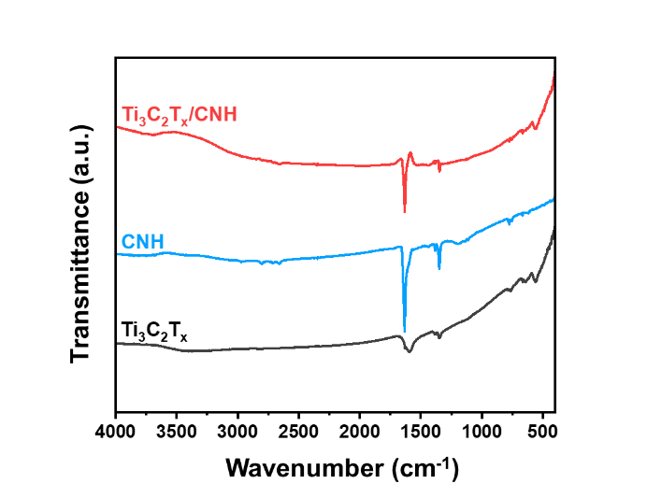

**Fig. S1** FT-IR spectra of Ti3C2Tx, CNH, and Ti3C2Tx/CNH.

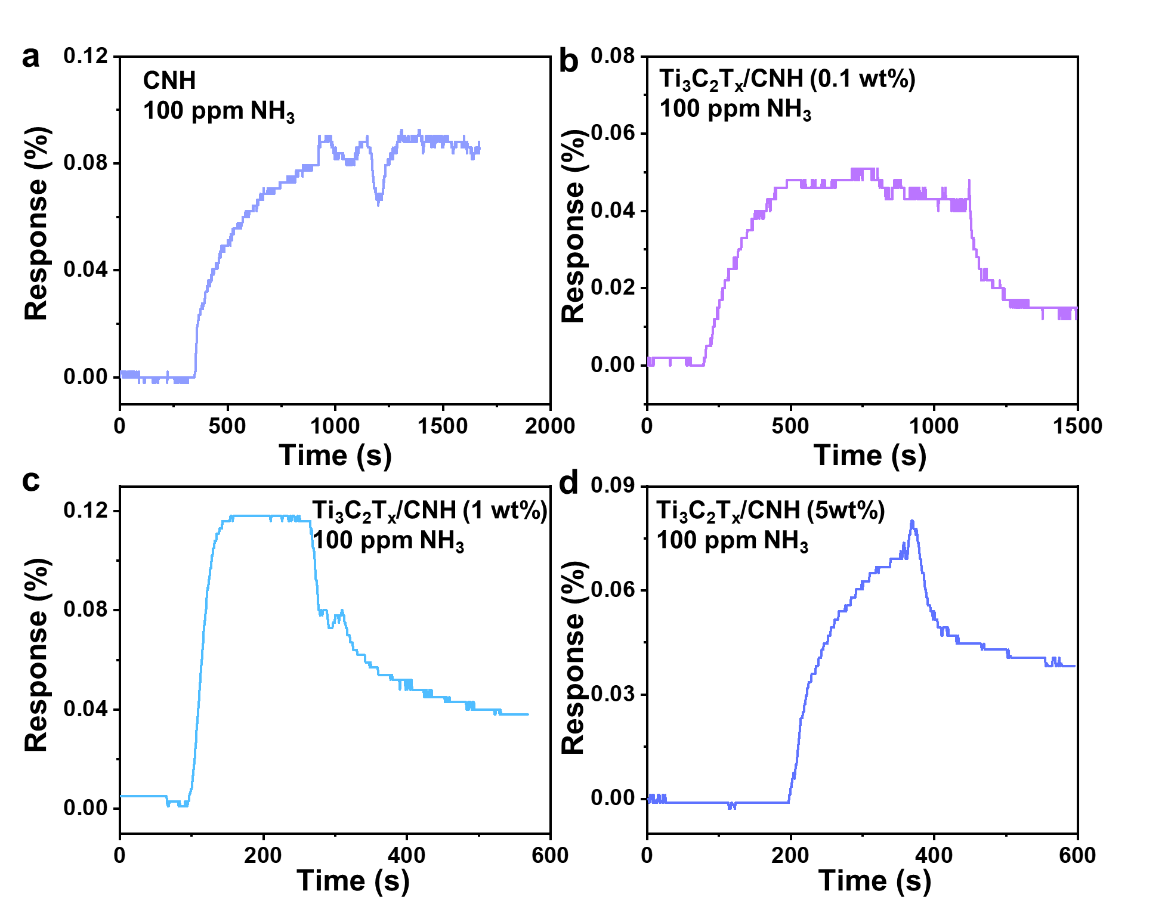

**Fig. S2** The dynamic response/recovery characteristic of the (a) CNH sensor, (b) Ti3C2Tx/CNH (0.1 wt%), (c) Ti3C2Tx/CNH (1 wt%), and (d) Ti3C2Tx/CNH (5 wt%) to 100 ppm NH3 at room temperature.

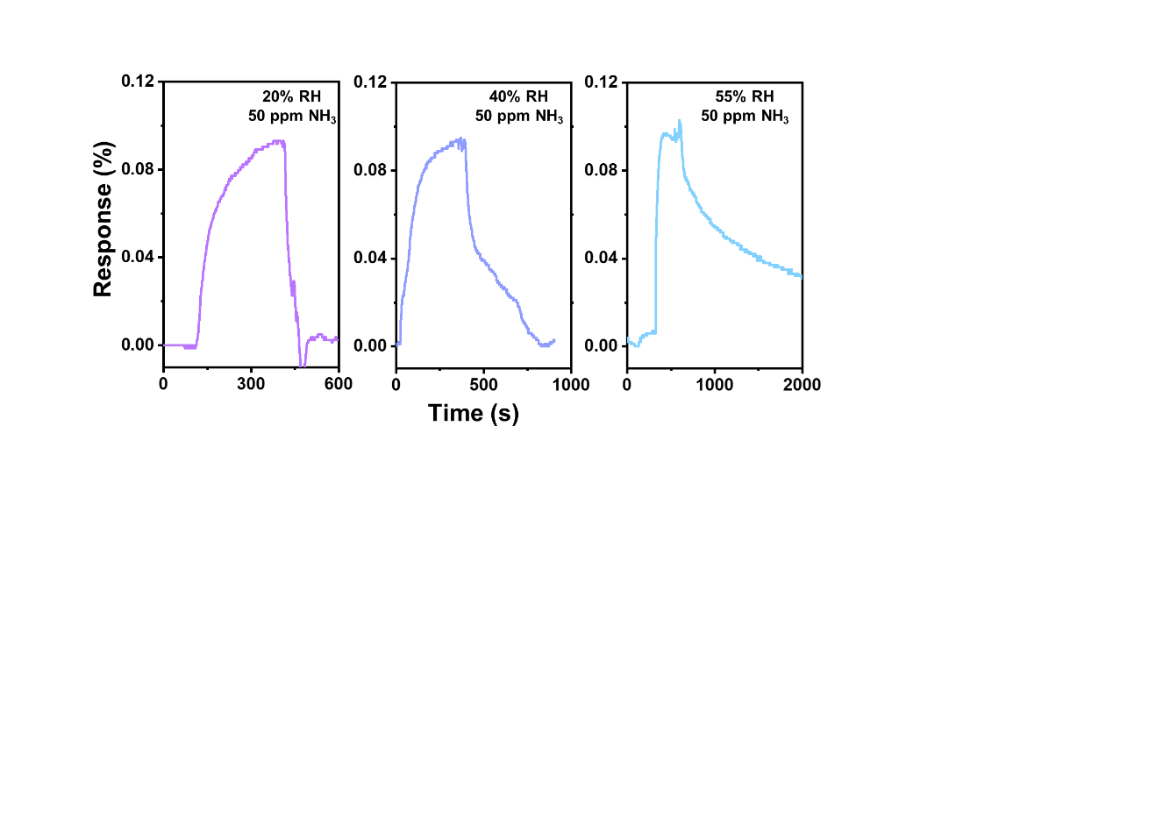

**Fig. S3** Dynamic response/recovery curve of Ti3C2Tx/CNH (0.5 wt%) sensor to 100 ppm NH3 at different RHs.