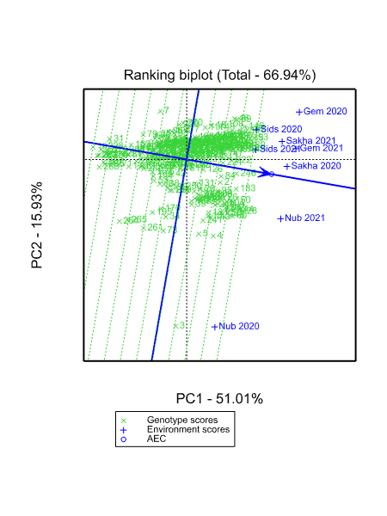

**Supplementary figure 1. The mean vs. stability view of the GGE biplot for the days to heading (DH).**

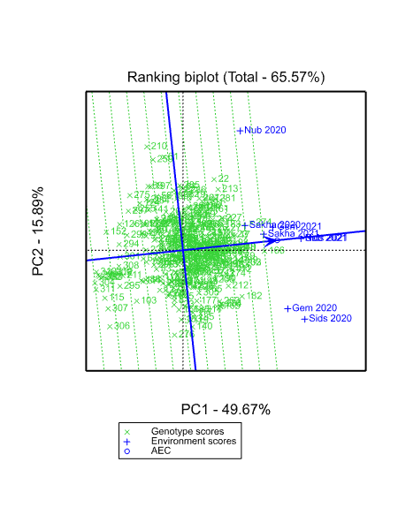

**Supplementary figure 2. The mean vs. stability view of the GGE biplot for plant height.**

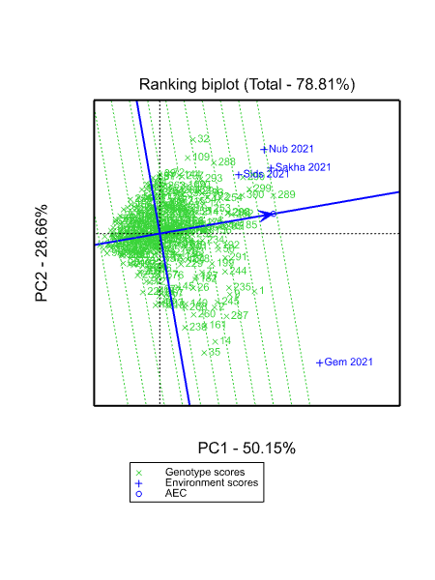

**Supplementary figure 3. The mean vs. stability view of the GGE biplot for 1000 kernel weight.**