Overexpression of the ribosome-inactivating protein OsRIP1 modulates the jasmonate signaling pathway in rice

Simin Chen^{1†}, Noémie De Zutter², Anikó Meijer^{1†}, Koen Gistelinck¹, Pieter Wytynck¹, Isabel Verbeke¹, Vinicius J.S. Osterne¹, Subramanyam Kondeti^{1†}, Tim De Meyer³, Kris Audenaert², Els J.M. Van Damme¹*

¹Department of Biotechnology, Faculty of Bioscience Engineering, Ghent University, B-9000, Ghent, Belgium
²Laboratory of Applied Mycology and Phenomics, Department of Plants and Crops, Faculty of Bioscience Engineering, Ghent University, B-9000, Ghent, Belgium
³Department of Data Analysis & Mathematical Modelling, Ghent University, B-9000, Ghent, Belgium

* Correspondence:
Els J.M. Van Damme
elsjm.vandamme@ugent.be

Supplementary information

Figure S1. OsRIP1 expression in rice plants overexpressing OsBAG4 compared to that in WT plants in the background of Japonica rice (Oryza sativa L) variety Zhonghua 11 (Genevestigator).

Figure S2. OsRIP1 expression in a mutant ebr1 compared to that in WT plants in the background of Japonica rice (Oryza sativa L) variety Zhonghua 11 (Genevestigator).

Figure S3. OsRIP1 expression in shoots of drought-treated transgenic rice plants overexpressing OsJAZ1 (OsJAZ1-OE) compared to mock-treated transgenic OsJAZ1-OE rice plants in the background of Japonica rice (Oryza sativa L) variety Zhonghua 11 (Genevestigator).

Figure S4. OsRIP1 expression in rice plants from the Xanthomonas resistance variety cea62 compared to that in WT plants in the background of Japonica (Oryza sativa ssp. japonica) variety Nipponbare (Genevestigator).

Figure S5. OsJAZ (LOC_Os10g25290) expression in rice plants from the Xanthomonas resistance variety cea62 compared to that in WT plants in the background of Japonica (Oryza sativa ssp. japonica) variety Nipponbare (Genevestigator).

Figure S6. Gene ontology (GO) analysis in biological processes of sets of differentially expressed genes (DEGs) (log2 fold change [FC] > 1, log2 [FC] < -1, FDR < 0.05) unique in roots of WT plants or in roots of OsRIP1-OE plants from line J after MeJA treatment (MeJA vs. Mock) at 3 h and 24 h, respectively. (A) Venn diagram of DGEs at 3 h (A1) or 24 h (A2) post treatment of “MeJA vs. Mock” between WT plants and OsRIP1-OE plants from line J. (B) enriched GO terms at 3 h (B1) or 24 h (B2) for up-regulated gene lists, (B3) for down-regulated gene lists in the biological process category.

Figure S7. Representative side-view images using PathoViewer for the evaluation of health parameters of rice plants. During the process of rice cultivation for the same genotype, some plants from grew vigorously while others grew smaller. A single image containing rice plants with different growth patterns is used to represent the overall situation for plants grown under identical conditions.

Figure S8. Multispectral parameters evaluated on WT plants and OsRIP1-OE plants under MeJA treatment and mock treatment based on side-view images throughout time (n = 15 plants) captured by the multispectral imaging platform, including (A) estimated biomass (in pixels) of rice plants; (B) efficiency of photosystem II (Fv/Fm); (C) chlorophyll index (ChlIdx); (D) modified anthocyanin reflectance index (mARI).

Figure S9. Analysis of differentially expressed genes (DEGs) (log₂ fold change [FC] > 1, log₂ [FC] < -1, FDR < 0.05, line J vs. WT) in roots (A) and shoots (B) under mock treatment via mRNA-sequencing. Venn diagram of DEGs in the mock-treated groups from line J vs. WT between 3 h and 24 h, (A) root, (B) shoot. (C) Geno ontology (GO) analysis for common up-regulated DEGs in roots (35 annotated genes) and shoots (35 annotated genes) at 3 h and 24 h, respectively. Note that no GO terms were found in the set of common down-regulated DEGs either in roots or in shoots. BP, biological process; MF, molecular function; Count, gene number. Numbers in brackets refer to the number of genes with annotation on the platform of Monocots PLAZA 4.5. DEGs involved in each GO term are listed next to bubbles, and their descriptions are shown in Table 2.

Figure S10. Pull-down assays for putative interaction partners of OsRIP1. Silver staining analysis (A) and Western blot analysis (B) on 15% SDS-PAGE. The protein patterns of samples were visualized in the following order, lane 1: bait sample after pull-down assays; lane 2: control sample after pull-down assays; lane 3: unbound protein fraction from bait sample in lane 1; lane 4: unbound protein fraction from control sample in lane 2; lane 5: wash fraction containing 50 mM imidazole from bait sample in lane 1; lane 6: wash fraction containing 50 mM imidazole from control sample in lane 2; lane 7: 16.62 μg of plant protein extracts; lane 8: 1 μg of purified recombinant OsRIP1 (31.4 kDa). Western blot analysis was performed using an anti-HIS antibody (1:1000, Thermo Fisher Scientific). PageRuler™ Prestained Protein Ladder (1:10,000, Thermo Fisher Scientific) was loaded as a reference. For the lanes with proteins released from beads, 12.5 μl from a total of 25 μl harvested beads were loaded. For the wash and unbound protein fractions 15 μl of samples were loaded, representing 10% of the liquid from one wash step or 1.5% of the unbound protein fraction. The red asterisk refers to the OsRIP1 polypeptide, while red arrows indicate potential interaction partners. (C) Volcano plot of proteins identified by LC/MS-MS (N = 3). Recombinant OsRIP1 with the His-tag is marked in blue, 11 significantly enriched proteins in OsRIP1-treated samples are indicated in green, those significantly enriched proteins in control samples are indicated in red, and non-significantly enriched proteins are shown in grey.

Figure S11. Modeling of protein binding between OsRIP1 and its putative interaction partners identified by pull-down assays. (A) Photosystem II 10 kDa polypeptide. (B) 40S ribosomal protein S5. (C) Tubulin alpha-1 chain.

Figure S12. Analysis of the gene regulatory network for OsRIP1 at 3 h using differentially expressed genes with log₂FC > 2. CYP76M2 (Os08g0508000), cytokinin-O-glucosyltransferase 2 (Os02g0755900) and ICL (Os070529000).

Table S1. Primers of genes of interest for RT-qPCR analysis

Table S2. GO analysis of 199 annotated out of 215 down-regulated differentially expressed genes (DEGs) (log2FC<-1) unique in shoots of plants from line J at 3 h (MeJA-line J vs. Mock-line J)

Table S3. GO analysis of 358 annotated out of 377 down-regulated differentially expressed genes (DEGs) (log₂FC < -1) unique in shoots of WT plants at 3 h (MeJA-WT vs. Mock-WT)

Table S4. GO analysis of 360 annotated out of 378 up-regulated differentially expressed genes (DEGs) (log₂FC > 1) unique in shoots of WT plants at 3 h (MeJA-WT vs. Mock-WT)

Table S5. GO analysis of 330 annotated out of 362 down-regulated differentially expressed genes (DEGs) (log₂FC < -1) unique in shoots of plants from line J at 24 h (MeJA-line J vs. Mock-line J)

Table S6. GO analysis of 437 annotated out of 472 down-regulated differentially expressed genes (DEGs) (log₂FC < -1) unique in shoots of WT plants at 24 h (MeJA-WT vs. Mock-WT)

Table S7. GO analysis of 320 annotated out of 338 up-regulated differentially expressed genes (DEGs) (log₂FC > 1) unique in shoots of plants from line J at 24 h (MeJA-line J vs. Mock-line J)

Table S8. GO analysis of 356 annotated out of 381 up-regulated differentially expressed genes (DEGs) (log₂FC > 1) unique in shoots of WT plants at 24 h (MeJA-WT vs. Mock-WT)

Table S9. GO analysis of 694 annotated out of 747 down-regulated differentially expressed genes (DEGs) (log₂FC < -1) unique in roots of WT plants at 3 h (MeJA-WT vs. Mock-WT)

Table S10. GO analysis of 449 annotated out of 477 up-regulated differentially expressed genes (DEGs) (log2FC > 1) unique in roots of WT plants at 3 h (MeJA-WT vs. Mock-WT)

Table S11. GO analysis of 521 annotated out of 587 up-regulated differentially expressed genes (DEGs) (log₂FC > 1) unique in roots of plants from line J at 24 h (MeJA-line J vs. Mock-line J)

Table S12. GO analysis of 437 annotated out of 472 up-regulated differentially expressed genes (DEGs) (log₂FC > 1) unique in roots of WT plants at 24 h (MeJA-WT vs. Mock-WT)

Table S13. GO analysis of 641 annotated out of 691 down-regulated differentially expressed genes (DEGs) (log₂FC < -1) unique in roots of plants from line J at 24 h (MeJA-line J vs. Mock-line J)

Table S14. GO analysis of 943 annotated out of 1017 down-regulated differentially expressed genes (DEGs) (log₂FC < -1) unique in roots of WT plants at 24 h (MeJA-WT vs. Mock-WT)

Table S15. GO analysis of 35 common differentially expressed genes (DEGs) (log₂FC>1) in root samples at both 3 h and 24h (Mock-line J vs. Mock-WT)

Table S16. GO analysis of 35 common differentially expressed genes (DEGs) (log₂FC>1) in shoot samples at both 3 h and 24h (Mock-line J vs. Mock-WT)

Table S17. Differentially expressed genes (DEGs) involved in GO terms shown in Figure S9

Table S18. 50 positively co-expressed genes of 40S ribosomal protein S5 (RPS5A) identified by Genevestigator on the mRNA-Seq platform

Table S19. 6 out of top 50 positively co-expressed genes of RPS5A clustered in the biological process of response to cytokinin (GO:0009735)

Table S20. Expression levels of differentially expressed genes (DEGs) clustered in the biological process of response to cytokinin (GO:0009735) (MeJA vs. Mock)

Table S21. Genes involved in the gene regulatory network for OsRIP1 at 3 h (shown in Figure S11)

Table S22. Differentially expressed genes (DEGs) (log₂FC > 2) unique in shoots of plants from line J at 24 h (MeJA-line J vs. mock-line J) clustered in the molecular function of antioxidant activity (GO:0016209)

Supplementary figures
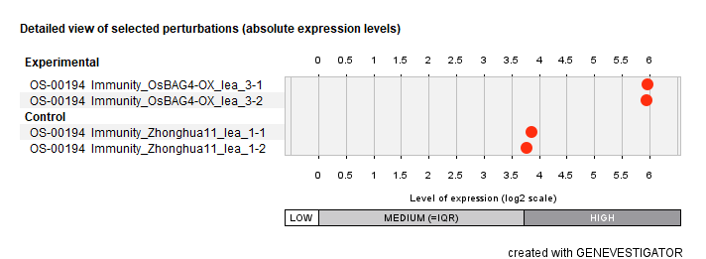
Figure S1. OsRIP1 expression in rice plants overexpressing OsBAG4 compared to that in WT plants in the background of Japonica rice (Oryza sativa L) variety Zhonghua 11 (Genevestigator).

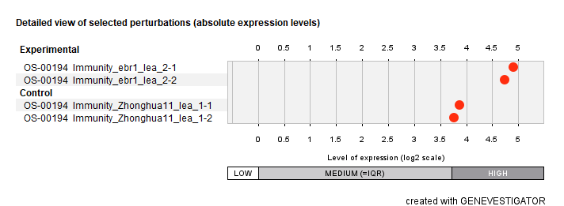
Figure S2. OsRIP1 expression in a mutant ebr1 compared to that in WT plants in the background of Japonica rice (Oryza sativa L) variety Zhonghua 11 (Genevestigator).

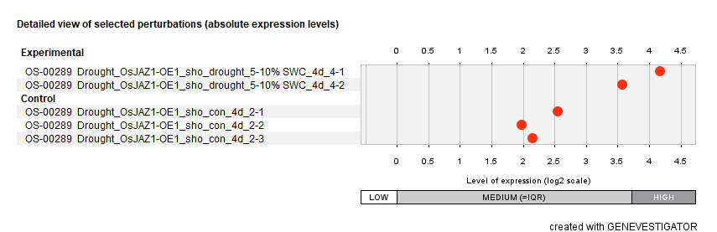
Figure S3. OsRIP1 expression in shoots of drought-treated transgenic rice plants overexpressing OsJAZ1 (OsJAZ1-OE) compared to mock-treated transgenic OsJAZ1-OE rice plants in the background of Japonica rice (Oryza sativa L) variety Zhonghua 11 (Genevestigator).

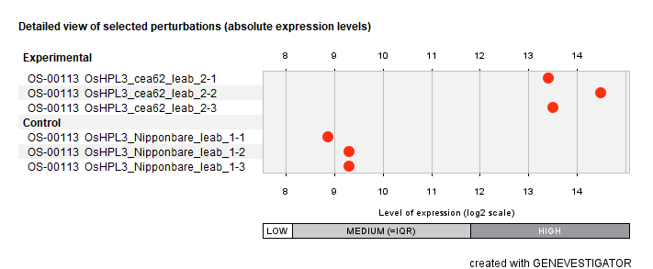
Figure S4. OsRIP1 expression in rice plants from the Xanthomonas resistance variety cea62 compared to that in WT plants in the background of Japonica (Oryza sativa ssp. japonica) variety Nipponbare (Genevestigator).

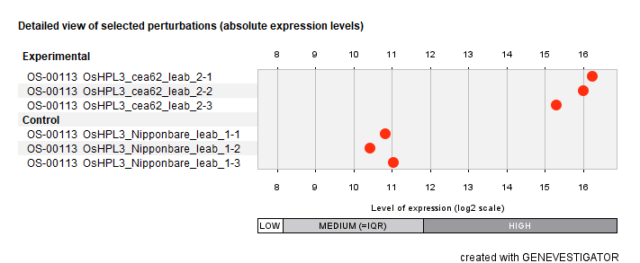

Figure S5. OsJAZ (LOC_Os10g25290) expression in rice plants from the Xanthomonas resistance variety cea62 compared to that in WT plants in the background of Japonica (Oryza sativa ssp. japonica) variety Nipponbare (Genevestigator).
(A1)
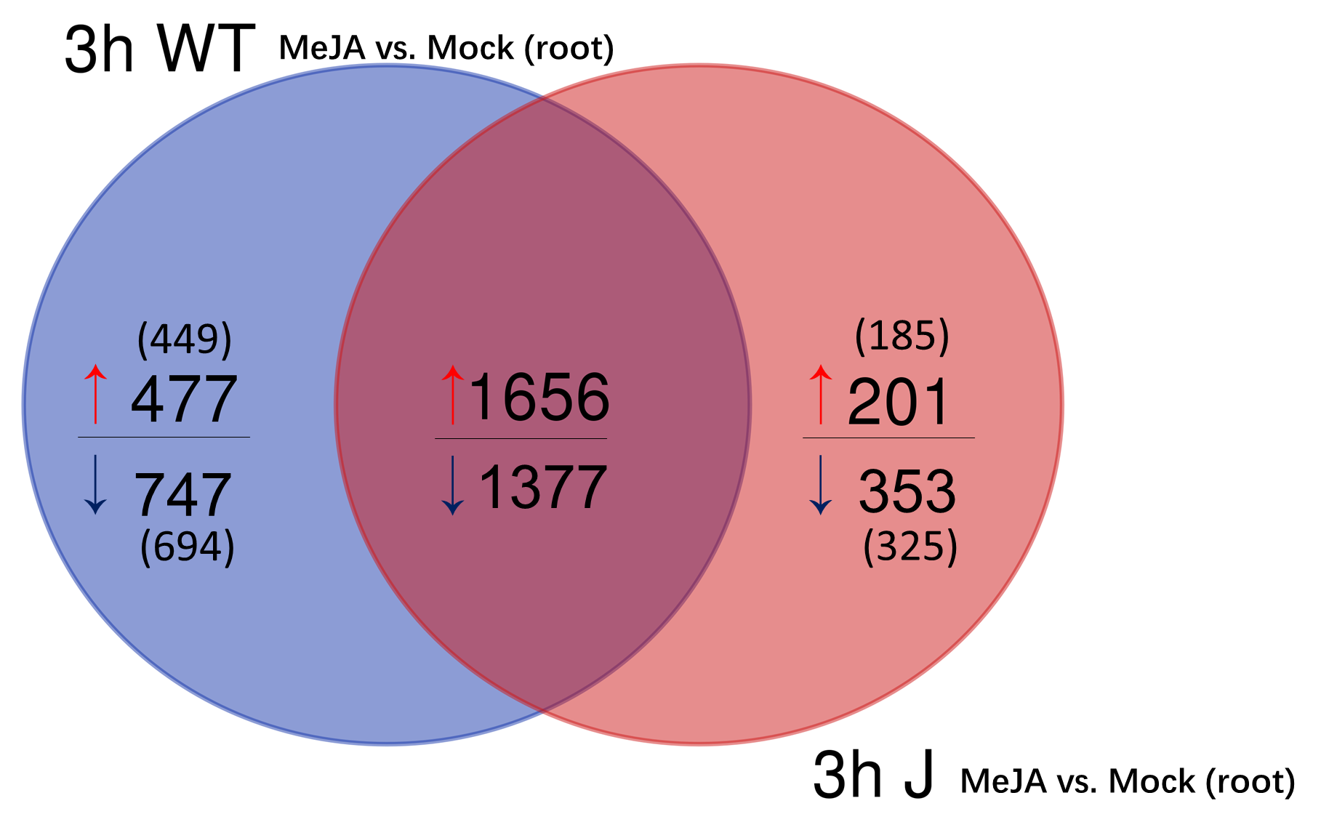
(B1)
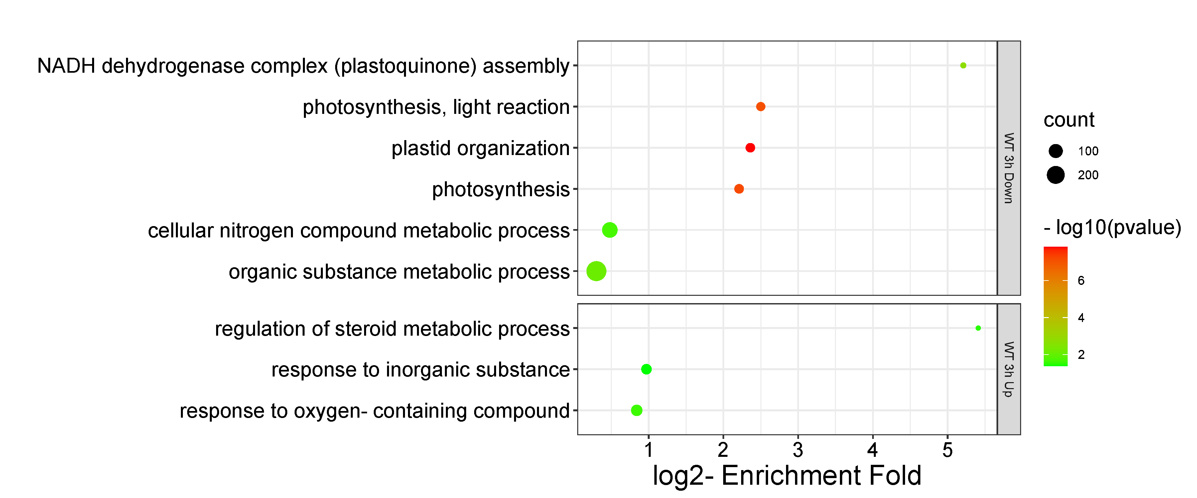
(A2)
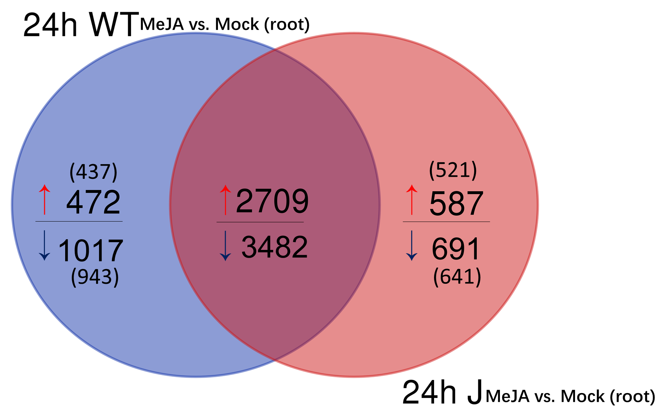

(B2)
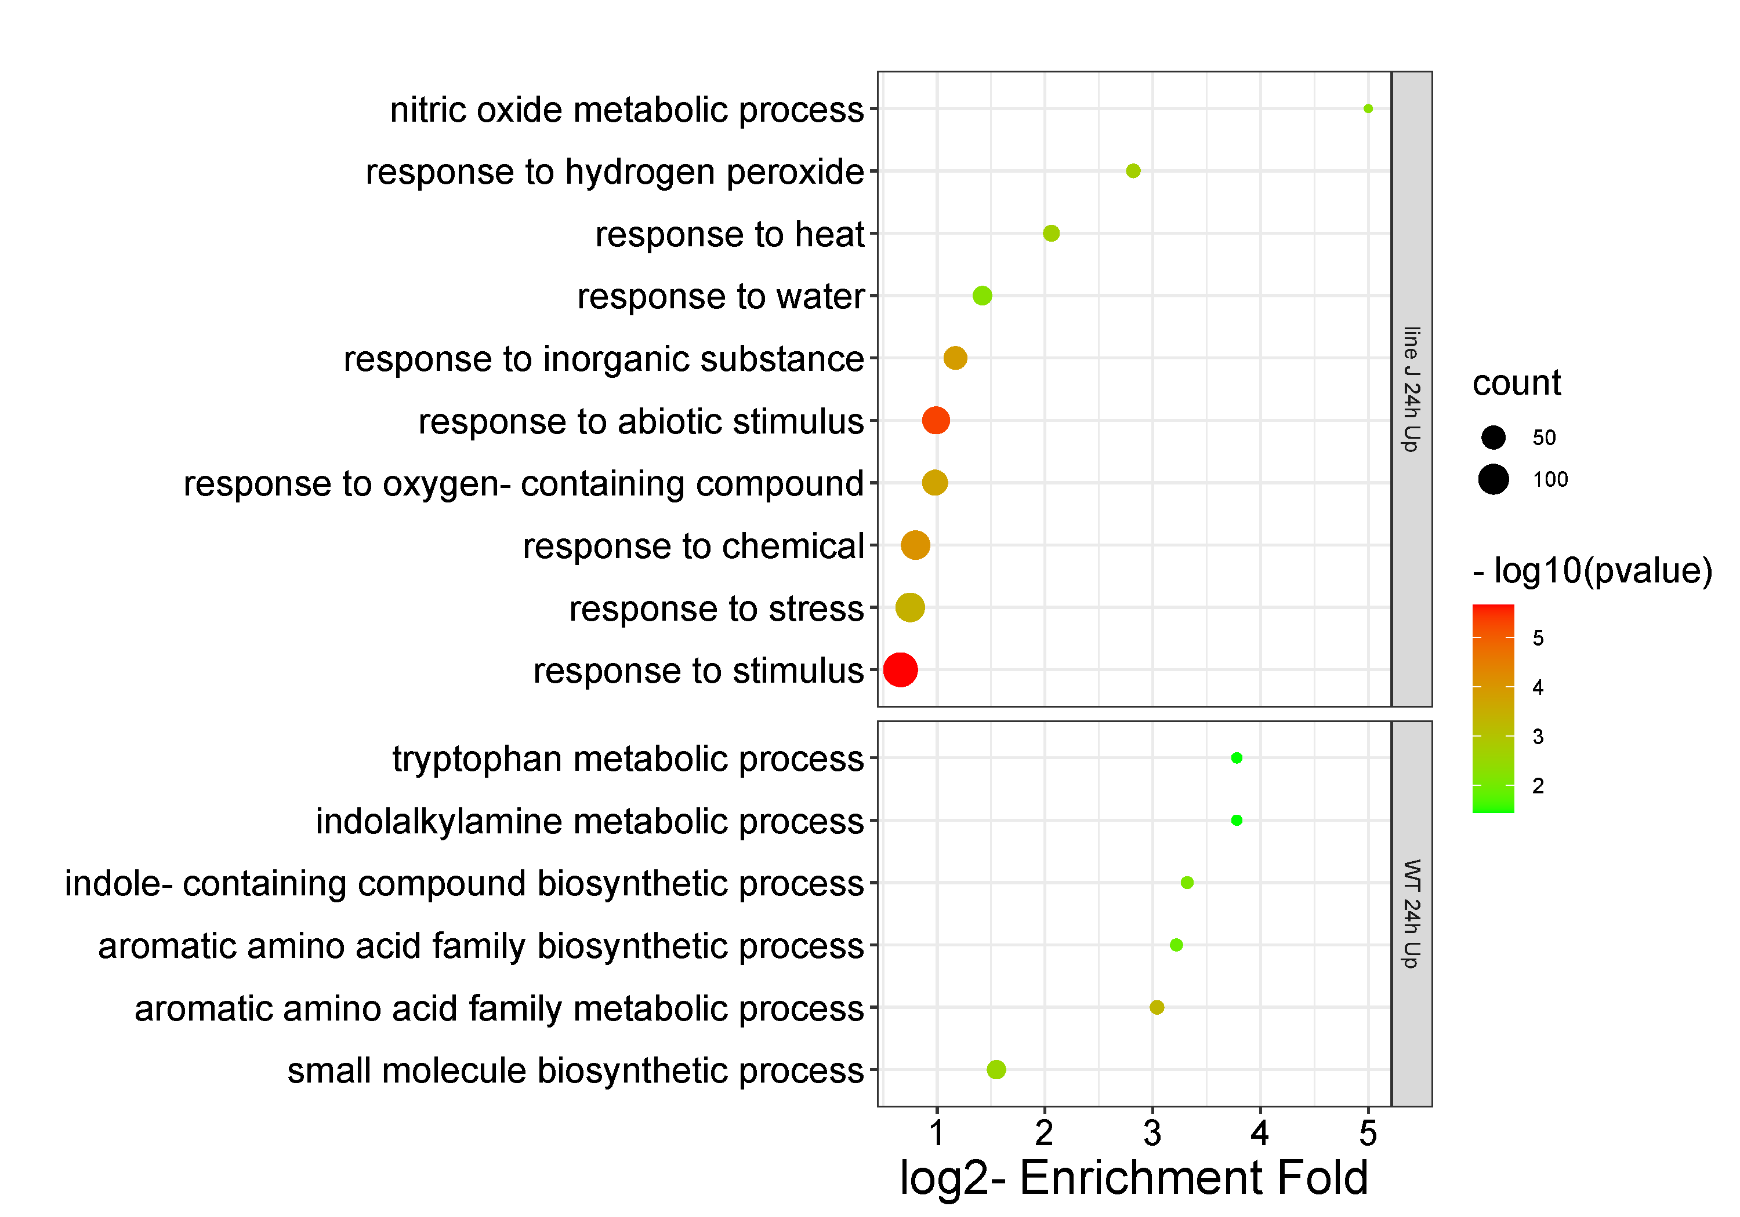
(B3)
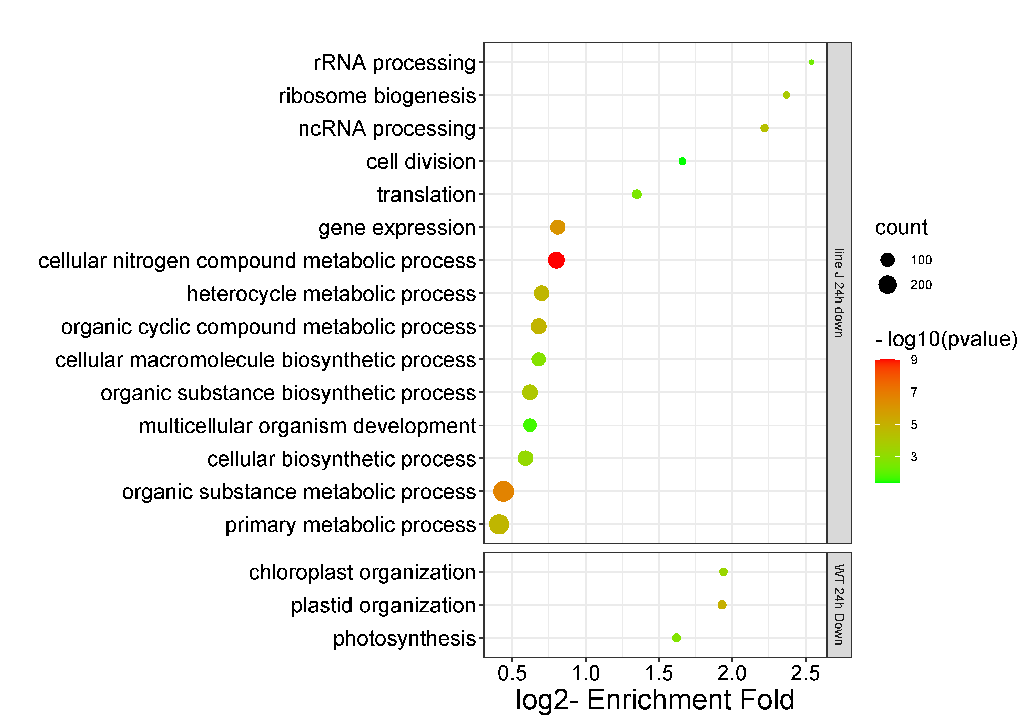
Figure S6. Gene ontology (GO) analysis in biological processes of sets of differentially expressed genes (DEGs) (log2 fold change [FC] > 1, log2 [FC] < -1, FDR < 0.05) unique in roots of WT plants or in roots of OsRIP1-OE plants from line J after MeJA treatment (MeJA vs. Mock) at 3 h and 24 h, respectively. (A) Venn diagram of DGEs at 3 h (A1) or 24 h (A2) post treatment of “MeJA vs. Mock” between WT plants and OsRIP1-OE plants from line J. (B) enriched GO terms at 3 h (B1) or 24 h (B2) for up-regulated gene lists, (B3) for down-regulated gene lists in the biological process category.

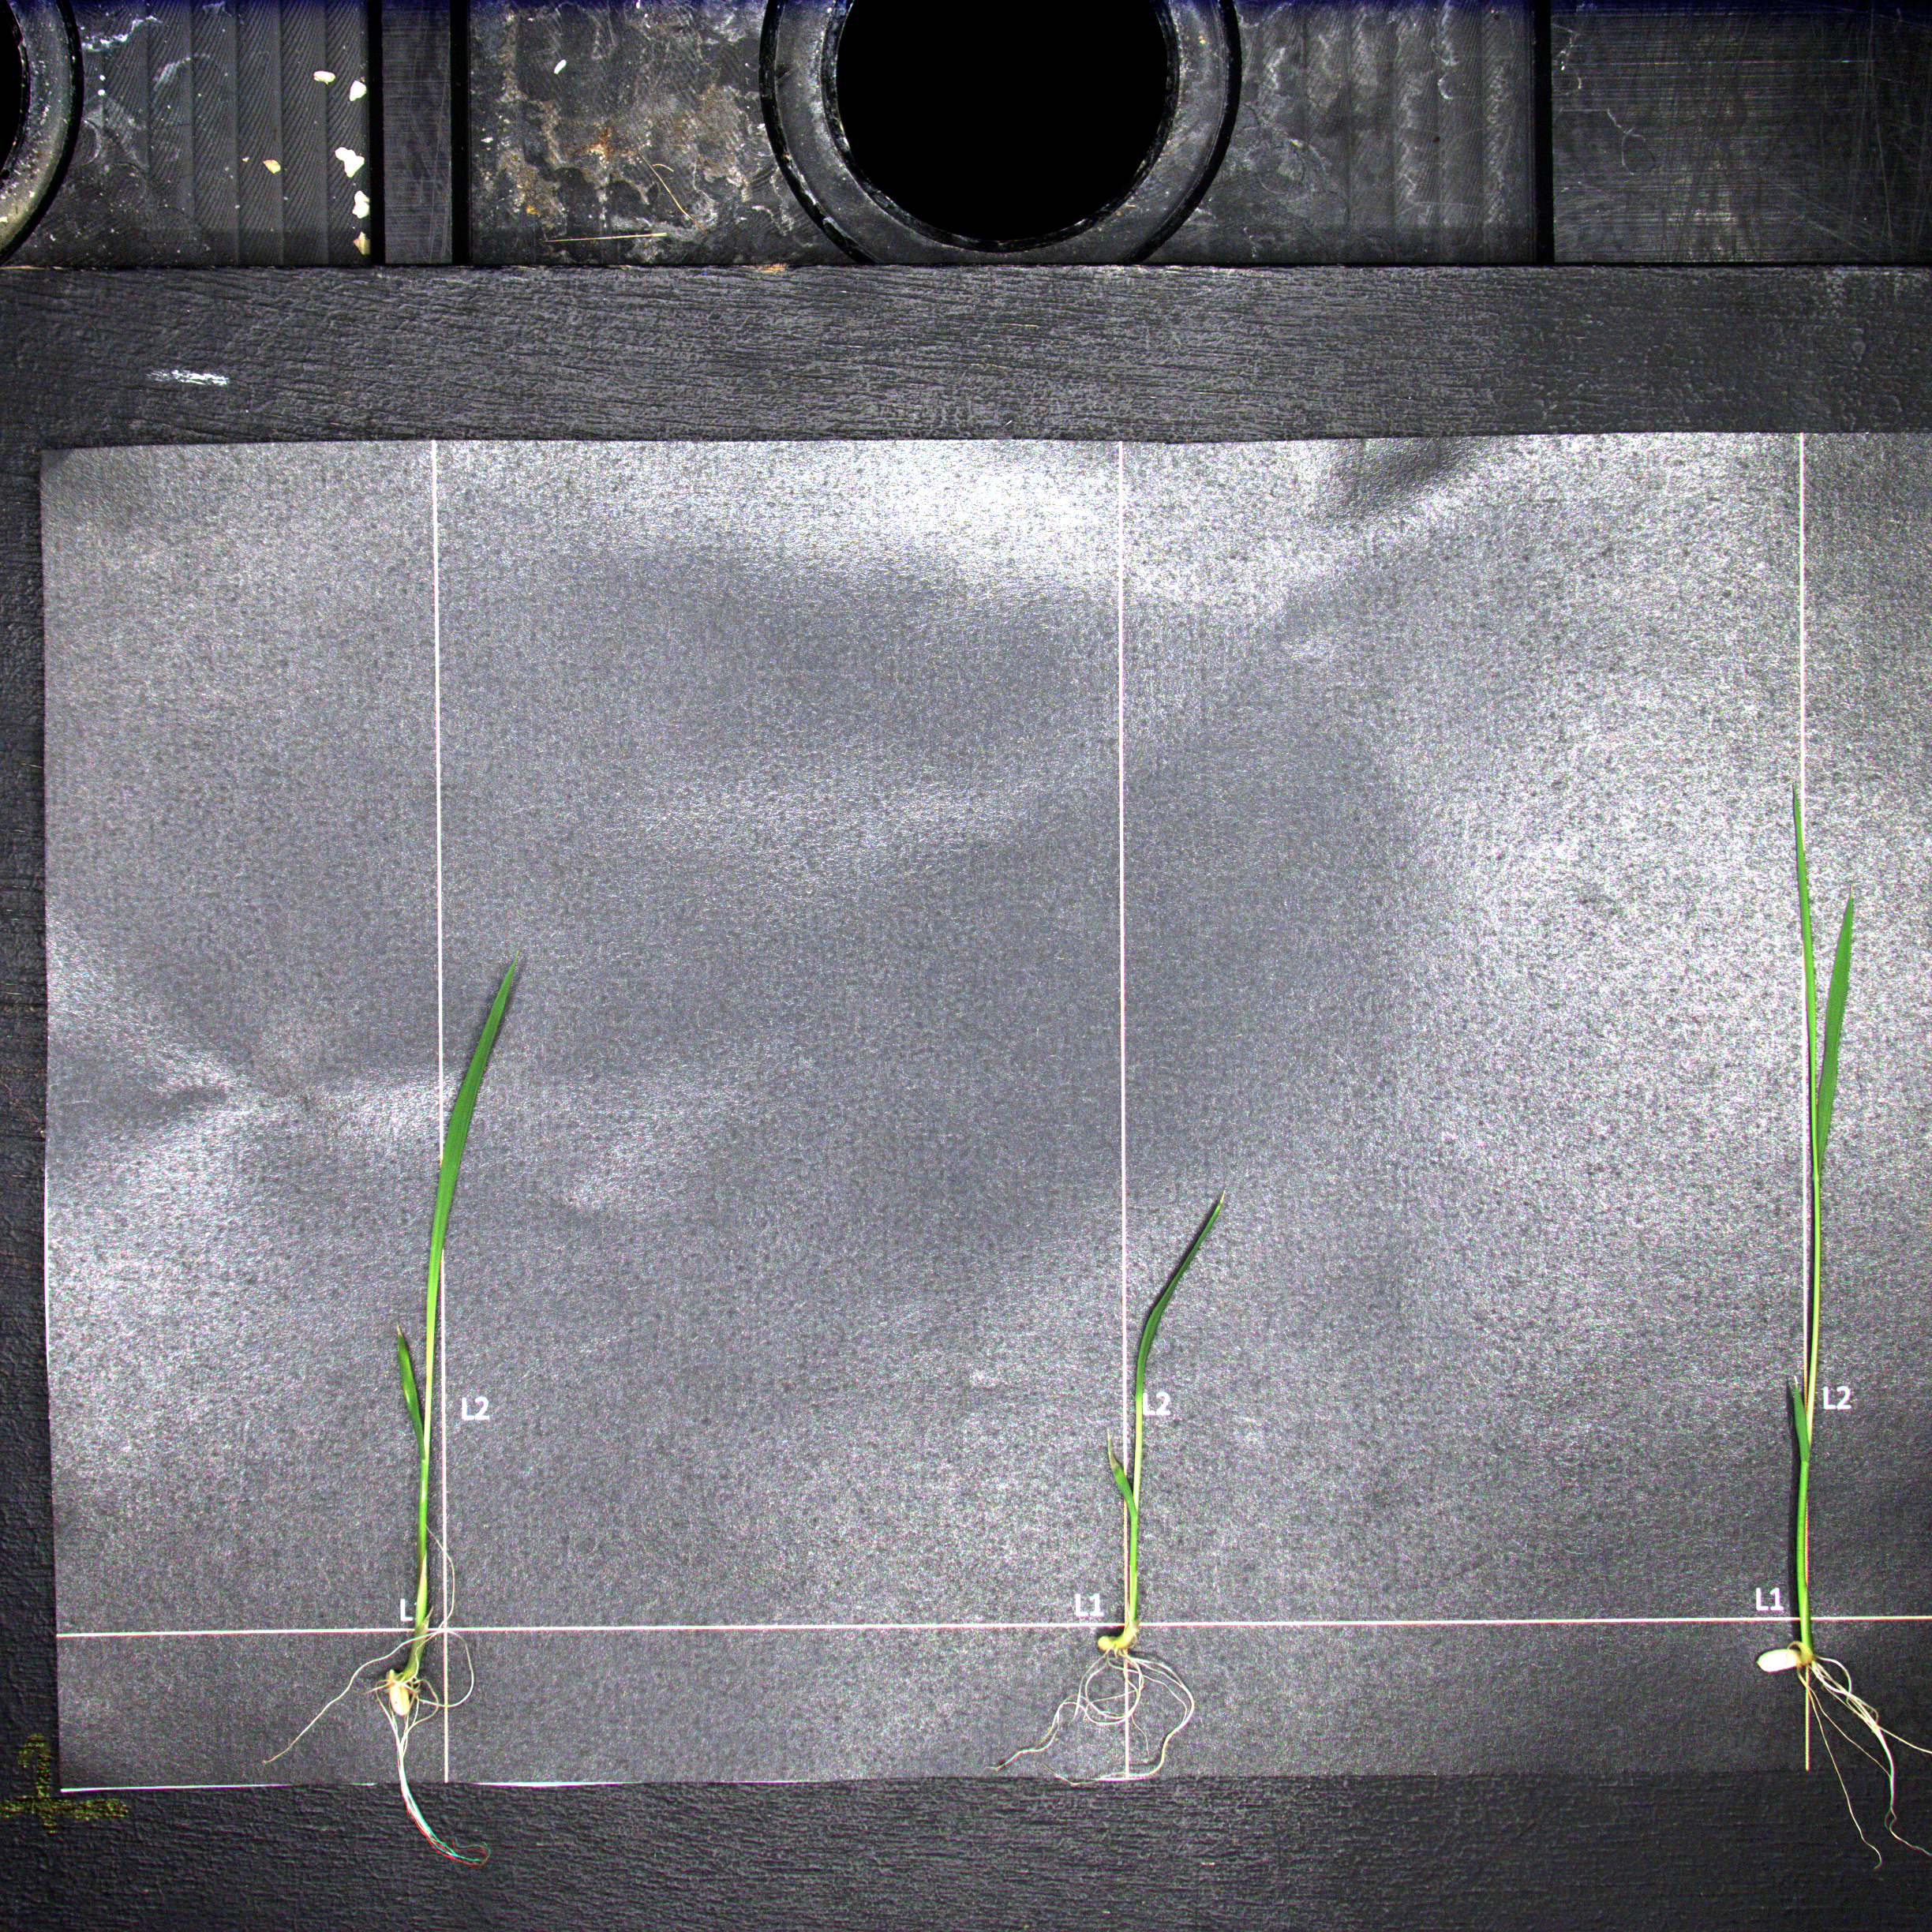
Figure S7. Representative side-view images using PathoViewer for the evaluation of health parameters of rice plants. During the process of rice cultivation for the same genotype, some plants from grew vigorously while others grew smaller. A single image containing rice plants with different growth patterns is used to represent the overall situation for plants grown under identical conditions.

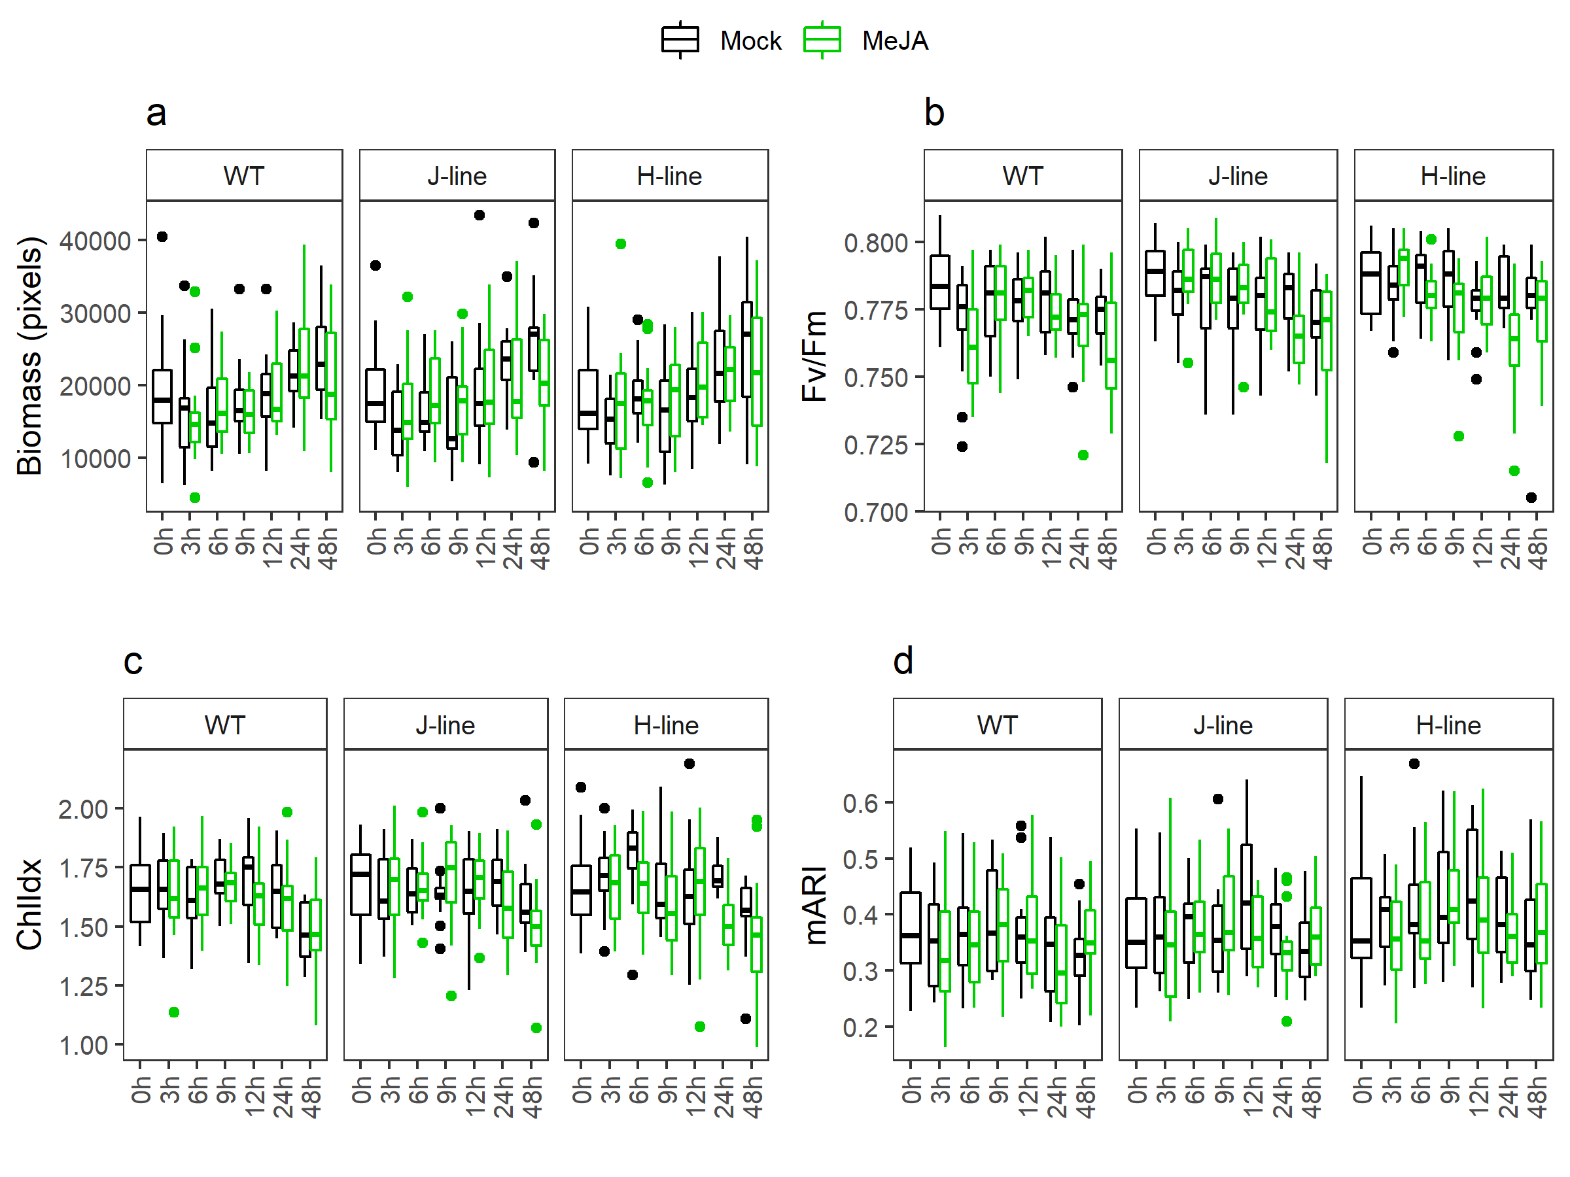
Figure S8. Multispectral parameters evaluated on WT plants and OsRIP1-OE plants under MeJA treatment and mock treatment based on side-view images throughout time (n = 15 plants) captured by the PathoViewer platform, including (A) estimated biomass (in pixels) of rice plants; (B) efficiency of photosystem II (Fv/Fm); (C) chlorophyll index (ChlIdx); (D) modified anthocyanin reflectance index (mARI).

(A) (B)
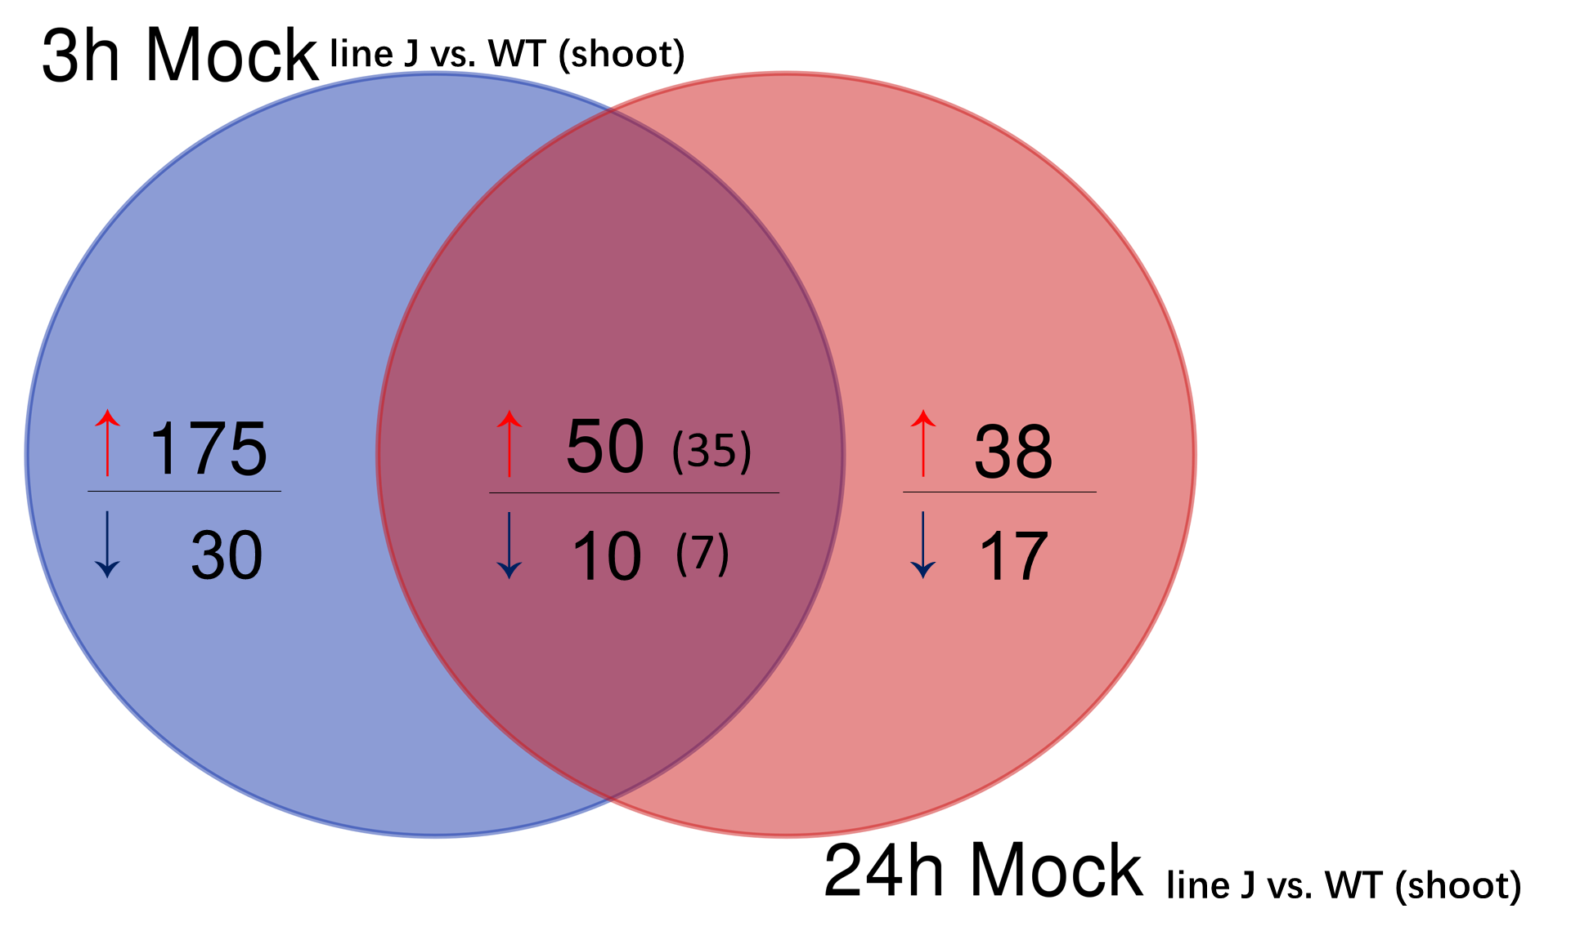
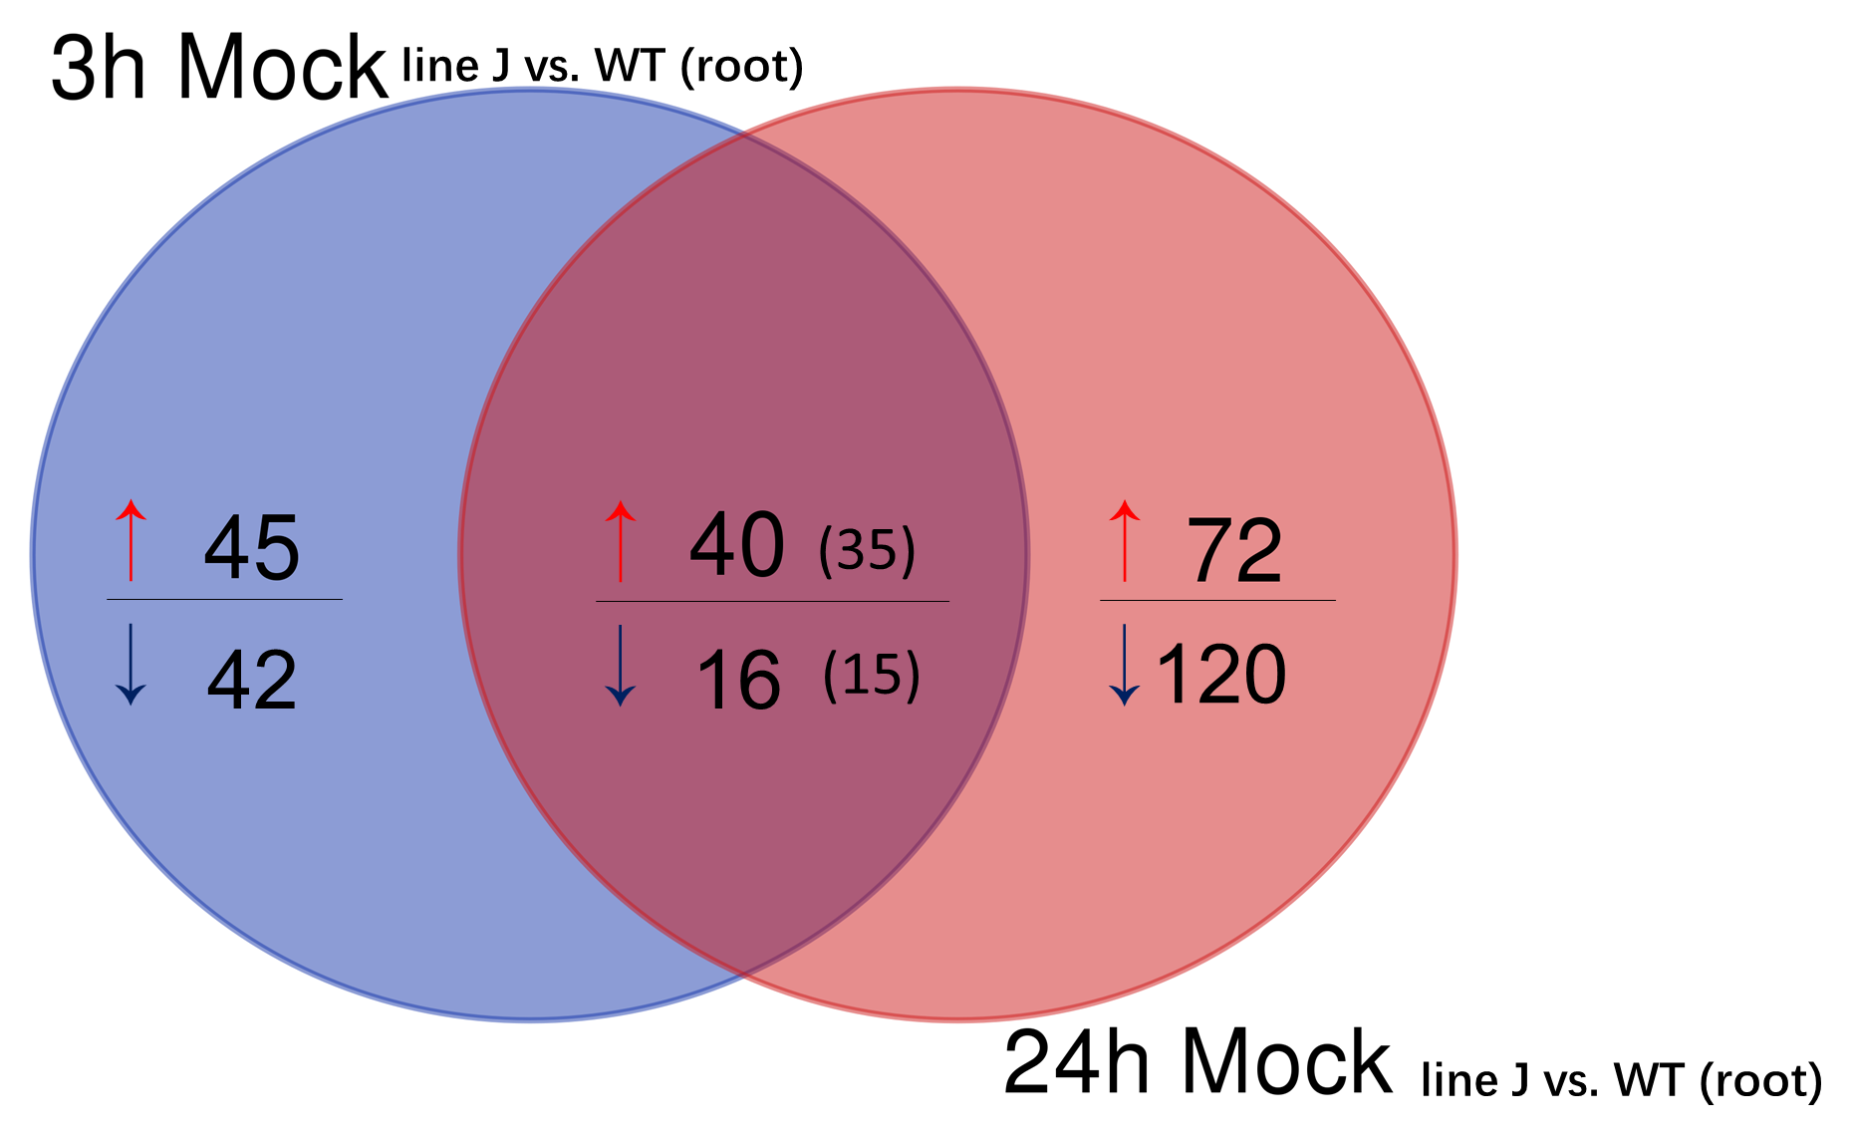
(C)
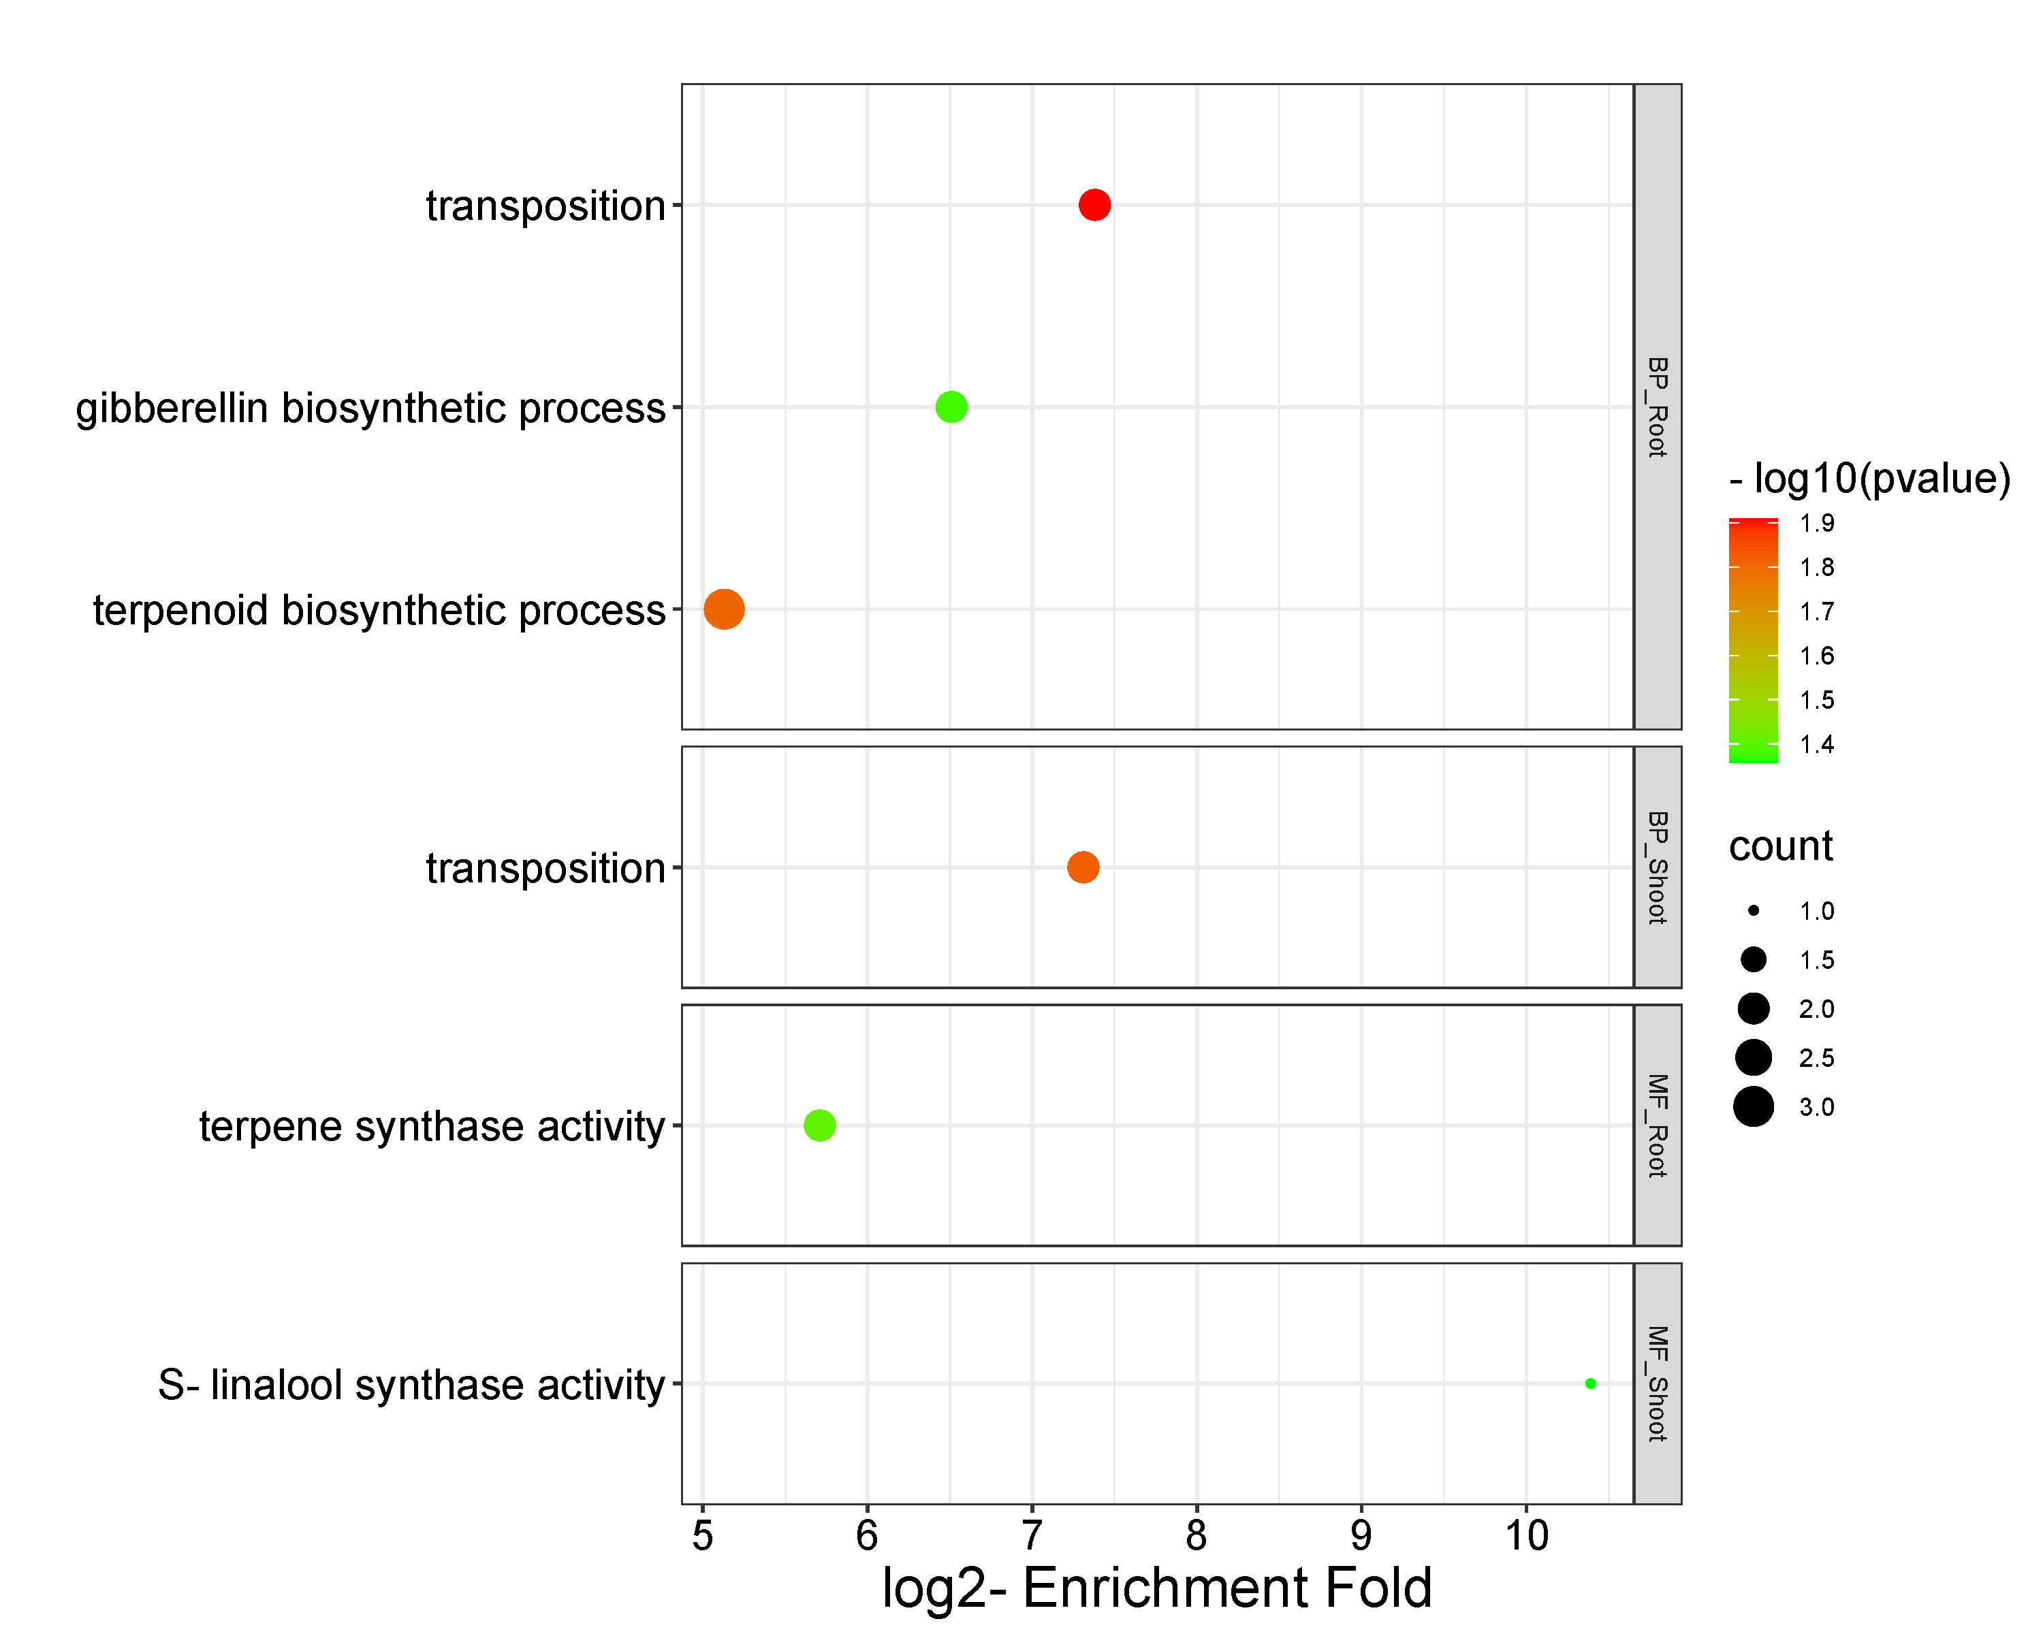
Os02g0121700
Os04g0178300
Os11g0475000
Os05g0438201
Os07g0153150
Os04g0178300
Os04g0179100
Os11g0475000
Os04g0178300
Os11g0475000
Os05g0438201
Os07g0153150
Figure S9. Analysis of differentially expressed genes (DEGs) (log2 fold change [FC] > 1, log2 [FC] < -1, FDR < 0.05, line J vs. WT) in roots (A) and shoots (B) under mock treatment via mRNA-sequencing. Venn diagram of DEGs in the mock-treated groups from line J vs. WT between 3 h and 24 h, (A) root, (B) shoot. (C) Geno ontology (GO) analysis for common up-regulated DEGs in roots (35 annotated genes) and shoots (35 annotated genes) at 3 h and 24 h, respectively. Note that no GO terms were found in the set of common down-regulated DEGs either in roots or in shoots. BP, biological process; MF, molecular function; Count, gene number. Numbers in brackets refer to the number of genes with annotation on the platform of Monocots PLAZA 4.5. DEGs involved in each GO term are listed next to bubbles, and their descriptions are shown in Table 2.

Figure S10. Pull-down assays for putative interaction partners of OsRIP1. Silver staining analysis (A) and Western blot analysis (B) on 15% SDS-PAGE. The protein patterns of samples were visualized in the following order, lane 1: bait sample after pull-down assays; lane 2: control sample after pull-down assays; lane 3: unbound protein fraction from bait sample in lane 1; lane 4: unbound protein fraction from control sample in lane 2; lane 5: wash fraction containing 50 mM imidazole from bait sample in lane 1; lane 6: wash fraction containing 50 mM imidazole from control sample in lane 2; lane 7: 16.62 μg of plant protein extracts; lane 8: 1 μg of purified recombinant OsRIP1 (31.4 kDa). Western blot analysis was performed using an anti-HIS antibody (1:1000, Thermo Fisher Scientific). PageRuler™ Prestained Protein Ladder (1:10,000 Thermo Fisher Scientific) was loaded as a reference. For the lanes with proteins released from beads, 12.5 μl from a total of 25 μl harvested beads were loaded. For the wash and unbound protein fractions 15 μl of samples were loaded, representing 10% of the liquid from one wash step or 1.5% of the unbound protein fraction. The red asterisk refers to the OsRIP1 polypeptide, while red arrows indicate potential interaction partners. (C) Volcano plot of proteins identified by LC/MS-MS (N = 3). Recombinant OsRIP1 with the His-tag is marked in blue, 11 significantly enriched proteins in OsRIP1-treated samples are indicated in green, those significantly enriched proteins in control samples are indicated in red, and non-significantly enriched proteins are shown in grey.

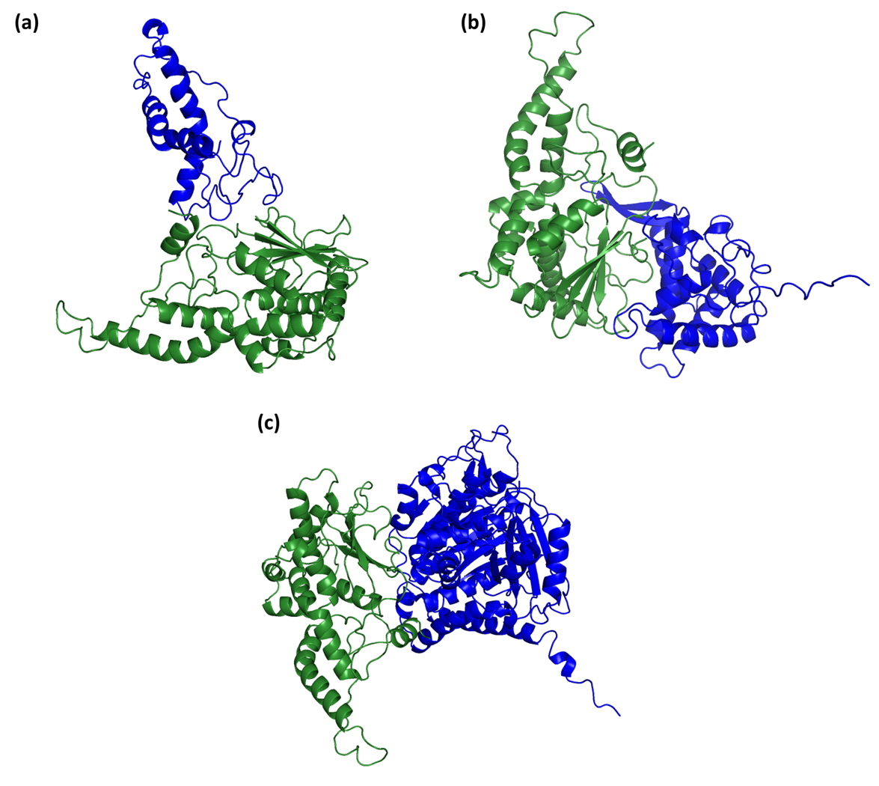
Figure S11. Modeling of protein binding between OsRIP1 and its putative interaction partners identified by pull-down assays. (A) Photosystem II 10 kDa polypeptide. (B) 40S ribosomal protein S5. (C) Tubulin alpha-1 chain.

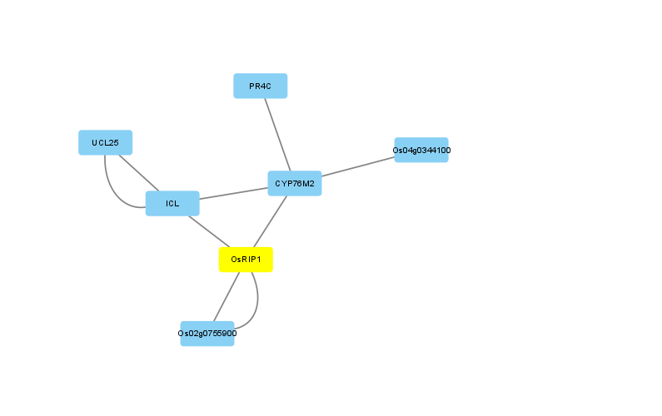
Figure S12. Analysis of the gene regulatory network for OsRIP1 at 3 h using differentially expressed genes with log₂FC > 2. CYP76M2 (Os08g0508000), cytokinin-O-glucosyltransferase 2 (Os02g0755900) and ICL (Os070529000).

Supplementary tables
Table S1. Primers of genes of interest for RT-qPCR analysis

Category | Gene | Primer sequence | Size of amplicon | Efficiency | Correlation coefficients (R²)
Photosynthesis | OsRBCS2  (LOC_Os12g17600) | L601: 5′- AAGAAGGCGTACCCTGATGC -3′ | 192 bp | 2.052 +/- 0.017 | 0.998
 |  | L602: 5′- ACGAAACAAGGTGGGAGACA -3′
 | OsRBCS5  (LOC_Os12g19381) | L605: 5′- GGAAGCTGCCTATGTTCGGA -3′ | 200 bp | 2.039 +/- 0.014 | 0.999
 |  | L606: 5′- GCTGGCTTGCCAACTAGCTTA -3′
 | OsRBCS4  (LOC_Os12g19470) | L607: 5′- TACTTGCCGCCATTGACAGT -3′ | 182 bp | 2.040 +/- 0.009 | 0.999
 |  | L608: 5′- GTGCATCCAAACATGGGCAG -3′
Jasmonate signaling pathway | OsbHLH148  (LOC_Os03g53020) | L613: 5′- GGAAGCTGCCTATGTTCGGA -3′ | 90 bp | 2.034 +/- 0.051 | 0.983
 |  | L614: 5′- GCTGGCTTGCCAACTAGCTTA -3′
 | OsJAZ12  (LOC_Os10g25290) | L615: 5′- GGCCCAAACCCAAAGAGTTC -3′ | 198 bp | 2.231 +/- 0.038 | 0.994
 |  | L616: 5′- GTGCATCCAAACATGGGCAG -3′
Oxidative-stress marker genes | Cytochrome P450  (LOC_Os01g41810) | L629: 5′- TACGACTTTCGGCTTGTGCT -3′ | 220 bp | 2.028 +/- 0.051 | 0.984
 |  | L630: 5′- TCTGAAAGCCCTCCTGGTCT -3′
Reference genes | EIF5C  (LOC_Os11g21990.1) | Evd912 5′- CACGTTACGGTGACACCTTTT -3′ | 90 bp | 2.024 +/- 0.021 | 0.995
 |  | Evd913: 5′- GACGCTCTCCTTCTTCCTCAG -3′
 | EXP | Evd910: 5′- TGTGAGCAGCTTCTCGTTTG -3′ | 101 bp | 2.122 +/- 0.017 | 0.994
 | (LOC_Os03g27010) | Evd911: 5′- TGTTGTTGCCTGTGAGATCG -3′
 | EXPNarsai | L687: 5′- AGGAACATGGAGAAGAACAAGG -3′ | 112 bp | 1.981 +/- 0.014 | 0.997
 | (LOC_Os07g02340.1) | L688: 5′- CAGAGGTGGTGCAGATGAAA -3′

Table S2. GO analysis of 199 annotated out of 215 down-regulated differentially expressed genes (DEGs) (log₂FC<-1) unique in shoots of plants from line J at 3 h (MeJA-line J vs. Mock-line J)

Identifier | Type | Log2-Enrichment Fold | P-Value | Subset Ratio | Description | Best Hierarchical | gene number
GO:0015995 | BP | 3.72 | 3.42E-02 | 3.18% | chlorophyll biosynthetic process | 1 | 5
GO:0050794 | BP | 0.95 | 8.21E-03 | 26.75% | regulation of cellular process | 1 | 42
GO:0050896 | BP | 0.77 | 7.24E-03 | 35.67% | response to stimulus | 1 | 56
GO:0016607 | CC | 3.72 | 2.46E-02 | 2.55% | nuclear speck | 1 | 4
GO:0005381 | MF | 5 | 2.66E-02 | 1.91% | iron ion transmembrane transporter activity | 1 | 3
GO:0003700 | MF | 1.72 | 1.97E-02 | 8.92% | DNA-binding transcription factor activity | 1 | 14
GO:0003677 | MF | 1.15 | 2.25E-02 | 15.92% | DNA binding | 1 | 27

Table S3. GO analysis of 358 annotated out of 377 down-regulated differentially expressed genes (DEGs) (log₂FC < -1) unique in shoots of WT plants at 3 h (MeJA-WT vs. Mock-WT)

Identifier | Type | Log2-Enrichment Fold | P-Value | Subset Ratio | Description | Best Hierarchical | gene number
GO:0006268 | BP | 6.17 | 1.46E-06 | 1.60% | DNA unwinding involved in DNA replication | 1 | 5
GO:0006270 | BP | 5.01 | 2.00E-05 | 1.92% | DNA replication initiation | 1 | 6
GO:0042793 | BP | 4.97 | 6.53E-03 | 1.28% | plastid transcription | 1 | 4
GO:0070828 | BP | 4.73 | 1.38E-02 | 1.28% | heterochromatin organization | 1 | 4
GO:0009658 | BP | 2.53 | 1.37E-03 | 3.85% | chloroplast organization | 1 | 12
GO:0009657 | BP | 2.47 | 1.16E-04 | 4.81% | plastid organization | 1 | 15
GO:0042555 | CC | 5.94 | 7.24E-07 | 1.60% | MCM complex | 1 | 5
GO:0010369 | CC | 5.21 | 1.10E-06 | 1.92% | chromocenter | 1 | 6
GO:0000229 | CC | 5.15 | 7.95E-08 | 2.24% | cytoplasmic chromosome | 1 | 7
GO:0009508 | CC | 5.15 | 7.95E-08 | 2.24% | plastid chromosome | 1 | 7
GO:0000347 | CC | 4.97 | 9.37E-04 | 1.28% | THO complex | 1 | 4
GO:0000786 | CC | 4.8 | 1.07E-21 | 6.41% | nucleosome | 1 | 20
GO:0042644 | CC | 4.16 | 3.54E-09 | 3.53% | chloroplast nucleoid | 1 | 11
GO:0009505 | CC | 1.8 | 4.27E-03 | 4.81% | plant-type cell wall | 1 | 15
GO:0009579 | CC | 1.73 | 1.37E-05 | 8.33% | thylakoid | 1 | 26
GO:0009526 | CC | 1.34 | 1.19E-02 | 6.73% | plastid envelope | 1 | 21
GO:0009507 | CC | 1.31 | 6.26E-12 | 24.36% | chloroplast | 1 | 76
GO:0046982 | MF | 3.65 | 9.47E-15 | 6.73% | protein heterodimerization activity | 1 | 21

Table S4. GO analysis of 360 annotated out of 378 up-regulated differentially expressed genes (DEGs) (log₂FC > 1) unique in shoots of WT plants at 3 h (MeJA-WT vs. Mock-WT)

Identifier | Type | Log2-Enrichment Fold | P-Value | Subset Ratio | Description | Best Hierarchical | gene number
GO:0016143 | BP | 2.7 | 1.14E-02 | 2.83% | S-glycoside metabolic process | 1 | 9
GO:0019757 | BP | 2.7 | 1.14E-02 | 2.83% | glycosinolate metabolic process | 1 | 9
GO:0019760 | BP | 2.7 | 1.14E-02 | 2.83% | glucosinolate metabolic process | 1 | 9
GO:0009414 | BP | 1.74 | 2.70E-04 | 7.55% | response to water deprivation | 1 | 24
GO:0055114 | BP | 1.44 | 2.62E-08 | 16.67% | oxidation-reduction process | 1 | 53
GO:0001101 | BP | 1.29 | 6.23E-06 | 15.09% | response to acid chemical | 1 | 48
GO:0006970 | BP | 1.26 | 3.08E-02 | 8.18% | response to osmotic stress | 1 | 26
GO:1901700 | BP | 1.23 | 1.52E-06 | 17.61% | response to oxygen-containing compound | 1 | 56
GO:0009605 | BP | 1.07 | 2.40E-03 | 13.52% | response to external stimulus | 1 | 43
GO:0010033 | BP | 1.03 | 1.93E-04 | 17.30% | response to organic substance | 1 | 55
GO:0016705 | MF | 1.89 | 9.88E-05 | 6.60% | oxidoreductase activity, acting on paired donors, with incorporation or reduction of molecular oxygen | 1 | 21
GO:0050662 | MF | 1.83 | 3.72E-04 | 6.29% | coenzyme binding | 1 | 22
GO:0020037 | MF | 1.78 | 5.58E-05 | 7.55% | heme binding | 1 | 24
GO:0005506 | MF | 1.75 | 2.53E-03 | 5.66% | iron ion binding | 1 | 19
GO:0048037 | MF | 1.73 | 1.70E-10 | 14.78% | cofactor binding | 1 | 49
GO:0016491 | MF | 1.53 | 2.13E-11 | 18.87% | oxidoreductase activity | 1 | 61

Table S5. GO analysis of 330 annotated out of 362 down-regulated differentially expressed genes (DEGs) (log₂FC < -1) unique in shoots of plants from line J at 24 h (MeJA-line J vs. Mock-line J)

Identifier | Type | Log2-Enrichment Fold | P-Value | Subset Ratio | Description | Best Hierarchical | gene number
GO:0110102 | BP | 5.66 | 2.00E-02 | 1.13% | chloroplast ribulose bisphosphate carboxylase complex assembly | 1 | 3
GO:0015979 | BP | 2.4 | 4.97E-04 | 5.26% | photosynthesis | 1 | 14
GO:0010598 | CC | 5.07 | 7.59E-04 | 1.50% | NAD(P)H dehydrogenase complex (plastoquinone) | 1 | 4
GO:0009543 | CC | 3.66 | 7.56E-03 | 1.88% | chloroplast thylakoid lumen | 1 | 5
GO:0031978 | CC | 3.66 | 7.56E-03 | 1.88% | plastid thylakoid lumen | 1 | 5
GO:0031977 | CC | 3.59 | 5.40E-05 | 3.01% | thylakoid lumen | 1 | 8
GO:0009579 | CC | 2.07 | 2.68E-08 | 10.53% | thylakoid | 1 | 28
GO:0009507 | CC | 1.2 | 7.20E-08 | 22.56% | chloroplast | 1 | 60

Table S6. GO analysis of 437 annotated out of 472 down-regulated differentially expressed genes (DEGs) (log₂FC < -1) unique in shoots of WT plants at 24 h (MeJA-WT vs. Mock-WT)

Identifier | Type | Log2-Enrichment Fold | P-Value | Subset Ratio | Description | Best Hierarchical | gene number
GO:0045786 | BP | 3.56 | 1.41E-02 | 1.71% | negative regulation of cell cycle | 1 | 6
GO:0051726 | BP | 2.5 | 2.71E-04 | 3.99% | regulation of cell cycle | 1 | 14
GO:0044445 | CC | 2.11 | 2.01E-04 | 4.56% | cytosolic part | 1 | 16
GO:0005694 | CC | 1.94 | 1.35E-02 | 3.42% | chromosome | 1 | 12
GO:0048046 | CC | 1.51 | 1.85E-02 | 4.84% | apoplast | 1 | 17
GO:0009532 | CC | 1.34 | 7.15E-04 | 8.26% | plastid stroma | 1 | 29
GO:0044434 | CC | 1.29 | 1.49E-06 | 13.68% | chloroplast part | 1 | 48
GO:0009507 | CC | 1.02 | 8.74E-07 | 19.94% | chloroplast | 1 | 70

Table S7. GO analysis of 320 annotated out of 338 up-regulated differentially expressed genes (DEGs) (log₂FC > 1) unique in shoots of plants from line J at 24 h (MeJA-line J vs. Mock-line J)

Identifier | Type | Log2-Enrichment Fold | P-Value | Subset Ratio | Description | Best Hierarchical | gene number
GO:0009751 | BP | 2.26 | 3.18E-03 | 4.96% | response to salicylic acid | 1 | 13
GO:0009611 | BP | 2.01 | 4.51E-03 | 5.73% | response to wounding | 1 | 15
GO:0046677 | BP | 1.99 | 2.60E-03 | 6.11% | response to antibiotic | 1 | 16
GO:0009753 | BP | 1.91 | 2.06E-02 | 5.34% | response to jasmonic acid | 1 | 14
GO:0042493 | BP | 1.83 | 6.97E-05 | 9.16% | response to drug | 1 | 24
GO:1901700 | BP | 1.09 | 1.55E-03 | 16.03% | response to oxygen-containing compound | 1 | 42
GO:0010033 | BP | 1.08 | 4.10E-04 | 17.94% | response to organic substance | 1 | 47
GO:0005777 | CC | 2.08 | 1.67E-02 | 3.82% | peroxisome | 1 | 10
GO:0042579 | CC | 2.08 | 1.67E-02 | 3.82% | microbody | 1 | 10

Table S8. GO analysis of 356 annotated out of 381 up-regulated differentially expressed genes (DEGs) (log₂FC > 1) unique in shoots of WT plants at 24 h (MeJA-WT vs. Mock-WT)

Identifier | Type | Log2-Enrichment Fold | P-Value | Subset Ratio | Description | Best Hierarchical | gene number
GO:0006527 | BP | 5.72 | 1.72E-02 | 0.98% | arginine catabolic process | 1 | 3
GO:0006596 | BP | 4.39 | 3.78E-03 | 1.63% | polyamine biosynthetic process | 1 | 5
GO:0009686 | BP | 4.09 | 1.38E-03 | 1.96% | gibberellin biosynthetic process | 1 | 6
GO:0097164 | BP | 3.31 | 3.37E-02 | 1.96% | ammonium ion metabolic process | 1 | 6
GO:0071229 | BP | 1.67 | 5.72E-03 | 6.54% | cellular response to acid chemical | 1 | 20
GO:0042493 | BP | 1.41 | 4.09E-02 | 6.86% | response to drug | 1 | 21
GO:0055085 | BP | 1.22 | 3.29E-02 | 8.82% | transmembrane transport | 1 | 29
GO:0055114 | BP | 1.09 | 3.93E-03 | 13.07% | oxidation-reduction process | 1 | 40
GO:1901700 | BP | 1.03 | 1.60E-03 | 15.36% | response to oxygen-containing compound | 1 | 47
GO:0042221 | BP | 0.88 | 2.31E-04 | 22.22% | response to chemical | 1 | 68
GO:0006950 | BP | 0.81 | 1.36E-03 | 22.22% | response to stress | 1 | 68
GO:0000323 | CC | 4.72 | 2.22E-02 | 0.98% | lytic vacuole | 1 | 3
GO:0009899 | MF | 5.29 | 8.44E-04 | 1.31% | ent-kaurene synthase activity | 1 | 4
GO:0004373 | MF | 4.87 | 4.94E-02 | 0.98% | glycogen (starch) synthase activity | 1 | 3
GO:0000287 | MF | 2.43 | 1.82E-02 | 2.94% | magnesium ion binding | 1 | 9
GO:0022857 | MF | 1.23 | 5.42E-03 | 9.48% | transmembrane transporter activity | 1 | 30
GO:0016491 | MF | 0.89 | 4.94E-02 | 12.09% | oxidoreductase activity | 1 | 37
GO:0003824 | MF | 0.52 | 5.20E-06 | 50.65% | catalytic activity | 1 | 157

Table S9. GO analysis of 694 annotated out of 747 down-regulated differentially expressed genes (DEGs) (log₂FC < -1) unique in roots of WT plants at 3 h (MeJA-WT vs. Mock-WT)

Identifier | Type | Log2-Enrichment Fold | P-Value | Subset Ratio | Description | Best Hierarchical | gene number
GO:0010258 | BP | 5.21 | 1.77E-03 | 0.69% | NADH dehydrogenase complex (plastoquinone) assembly | 1 | 4
GO:0019684 | BP | 2.5 | 8.46E-08 | 3.77% | photosynthesis, light reaction | 1 | 22
GO:0009657 | BP | 2.36 | 1.53E-08 | 4.46% | plastid organization | 1 | 26
GO:0015979 | BP | 2.21 | 6.40E-08 | 4.63% | photosynthesis | 1 | 27
GO:0034641 | BP | 0.48 | 2.13E-02 | 22.47% | cellular nitrogen compound metabolic process | 1 | 135
GO:0071704 | BP | 0.3 | 7.74E-03 | 45.11% | organic substance metabolic process | 1 | 272
GO:0010598 | CC | 4.53 | 1.98E-05 | 1.03% | NAD(P)H dehydrogenase complex (plastoquinone) | 1 | 6
GO:0009543 | CC | 3.21 | 4.32E-04 | 1.37% | chloroplast thylakoid lumen | 1 | 8
GO:0031978 | CC | 3.21 | 4.32E-04 | 1.37% | plastid thylakoid lumen | 1 | 8
GO:0042644 | CC | 2.97 | 4.12E-04 | 1.54% | chloroplast nucleoid | 1 | 9
GO:0044436 | CC | 2.26 | 8.36E-18 | 8.58% | thylakoid part | 1 | 50
GO:0031976 | CC | 2.23 | 1.49E-19 | 9.61% | plastid thylakoid | 1 | 56
GO:0009579 | CC | 2.11 | 2.71E-20 | 10.81% | thylakoid | 1 | 63
GO:0009941 | CC | 1.78 | 1.84E-12 | 8.92% | chloroplast envelope | 1 | 52
GO:0009526 | CC | 1.77 | 1.38E-12 | 9.09% | plastid envelope | 1 | 53
GO:0044434 | CC | 1.74 | 6.06E-27 | 18.70% | chloroplast part | 1 | 109
GO:0008017 | MF | 2.15 | 1.75E-02 | 1.89% | microtubule binding | 1 | 11
GO:0003723 | MF | 1 | 1.38E-02 | 6.52% | RNA binding | 1 | 41

Table S10. GO analysis of 449 annotated out of 477 up-regulated differentially expressed genes (DEGs) (log₂FC > 1) unique in roots of WT plants at 3 h (MeJA-WT vs. Mock-WT)

Identifier | Type | Log2-Enrichment Fold | P-Value | Subset Ratio | Description | Best Hierarchical | gene number
GO:0019218 | BP | 5.41 | 3.33E-02 | 0.79% | regulation of steroid metabolic process | 1 | 3
GO:0010035 | BP | 0.97 | 4.18E-02 | 10.00% | response to inorganic substance | 1 | 38
GO:1901700 | BP | 0.84 | 2.53E-02 | 13.42% | response to oxygen-containing compound | 1 | 51
GO:0050662 | MF | 1.57 | 5.64E-03 | 5.26% | coenzyme binding | 1 | 22
GO:0048037 | MF | 1.2 | 3.85E-04 | 10.26% | cofactor binding | 1 | 41
GO:0003824 | MF | 0.44 | 5.41E-05 | 47.89% | catalytic activity | 1 | 189

Table S11. GO analysis of 521 annotated out of 587 up-regulated differentially expressed genes (DEGs) (log₂FC > 1) unique in roots of plants from line J at 24 h (MeJA-line J vs. Mock-line J)

Identifier | Type | Log2-Enrichment Fold | P-Value | Subset Ratio | Description | Best Hierarchical | gene number
GO:0046209 | BP | 5 | 5.42E-03 | 0.95% | nitric oxide metabolic process | 1 | 4
GO:0042542 | BP | 2.82 | 1.99E-03 | 2.39% | response to hydrogen peroxide | 1 | 10
GO:0009408 | BP | 2.06 | 2.16E-03 | 3.82% | response to heat | 1 | 16
GO:0009415 | BP | 1.42 | 5.85E-03 | 6.21% | response to water | 1 | 26
GO:0010035 | BP | 1.17 | 1.30E-04 | 11.46% | response to inorganic substance | 1 | 48
GO:0009628 | BP | 0.99 | 4.74E-06 | 18.14% | response to abiotic stimulus | 1 | 76
GO:1901700 | BP | 0.98 | 1.86E-04 | 14.80% | response to oxygen-containing compound | 1 | 62
GO:0042221 | BP | 0.8 | 8.12E-05 | 21.00% | response to chemical | 1 | 88
GO:0006950 | BP | 0.75 | 3.66E-04 | 21.24% | response to stress | 1 | 89
GO:0050896 | BP | 0.66 | 2.17E-06 | 33.17% | response to stimulus | 1 | 139
GO:0061630 | MF | 2.88 | 1.63E-02 | 1.67% | ubiquitin protein ligase activity | 1 | 7
GO:0061659 | MF | 2.88 | 1.63E-02 | 1.67% | ubiquitin-like protein ligase activity | 1 | 7
GO:0004842 | MF | 2.04 | 1.66E-04 | 4.30% | ubiquitin-protein transferase activity | 1 | 19

Table S12. GO analysis of 437 annotated out of 472 up-regulated differentially expressed genes (DEGs) (log₂FC > 1) unique in roots of WT plants at 24 h (MeJA-WT vs. Mock-WT)

Identifier | Type | Log2-Enrichment Fold | P-Value | Subset Ratio | Description | Best Hierarchical | gene number
GO:0006568 | BP | 3.78 | 3.61E-02 | 1.48% | tryptophan metabolic process | 1 | 5
GO:0006586 | BP | 3.78 | 3.61E-02 | 1.48% | indolalkylamine metabolic process | 1 | 5
GO:0042435 | BP | 3.32 | 7.88E-03 | 2.08% | indole-containing compound biosynthetic process | 1 | 7
GO:0009073 | BP | 3.22 | 1.25E-02 | 2.08% | aromatic amino acid family biosynthetic process | 1 | 7
GO:0009072 | BP | 3.04 | 4.95E-04 | 2.97% | aromatic amino acid family metabolic process | 1 | 10
GO:0044283 | BP | 1.55 | 3.17E-03 | 7.12% | small molecule biosynthetic process | 1 | 25
GO:0020037 | MF | 1.43 | 1.82E-02 | 5.93% | heme binding | 1 | 20
GO:0098588 | CC | 1.14 | 1.57E-02 | 7.72% | bounding membrane of organelle | 1 | 26
GO:0005794 | CC | 1.1 | 4.15E-02 | 7.12% | Golgi apparatus | 1 | 24
GO:0012505 | CC | 0.92 | 5.88E-03 | 12.17% | endomembrane system | 1 | 41
GO:0016740 | MF | 0.67 | 3.97E-03 | 22.55% | transferase activity | 1 | 79
GO:0003824 | MF | 0.63 | 7.12E-11 | 54.60% | catalytic activity | 1 | 185
GO:0016020 | CC | 0.48 | 5.75E-03 | 31.75% | membrane | 1 | 108

Table S13. GO analysis of 641 annotated out of 691 down-regulated differentially expressed genes (DEGs) (log₂FC < -1) unique in roots of plants from line J at 24 h (MeJA-line J vs. Mock-line J)

Identifier | Type | Log2-Enrichment Fold | P-Value | Subset Ratio | Description | Best Hierarchical | gene number
GO:0006364 | BP | 2.54 | 4.49E-03 | 2.03% | rRNA processing | 1 | 11
GO:0042254 | BP | 2.37 | 1.39E-04 | 2.96% | ribosome biogenesis | 1 | 16
GO:0034470 | BP | 2.22 | 4.74E-05 | 3.51% | ncRNA processing | 1 | 19
GO:0051301 | BP | 1.66 | 4.12E-02 | 3.14% | cell division | 1 | 17
GO:0006412 | BP | 1.35 | 2.74E-03 | 5.73% | translation | 1 | 31
GO:0010467 | BP | 0.81 | 8.03E-07 | 21.44% | gene expression | 1 | 117
GO:0034641 | BP | 0.8 | 9.40E-10 | 28.10% | cellular nitrogen compound metabolic process | 1 | 153
GO:0046483 | BP | 0.7 | 1.73E-05 | 22.92% | heterocycle metabolic process | 1 | 125
GO:1901360 | BP | 0.68 | 1.48E-05 | 24.03% | organic cyclic compound metabolic process | 1 | 131
GO:0034645 | BP | 0.68 | 1.66E-03 | 17.74% | cellular macromolecule biosynthetic process | 1 | 96
GO:1901576 | BP | 0.62 | 9.40E-05 | 24.77% | organic substance biosynthetic process | 1 | 134
GO:0007275 | BP | 0.62 | 2.02E-02 | 16.27% | multicellular organism development | 1 | 88
GO:0044249 | BP | 0.59 | 6.50E-04 | 23.66% | cellular biosynthetic process | 1 | 128
GO:0071704 | BP | 0.44 | 2.03E-07 | 49.72% | organic substance metabolic process | 1 | 273
GO:0044238 | BP | 0.41 | 1.72E-05 | 45.66% | primary metabolic process | 1 | 251

Table S14. GO analysis of 943 annotated out of 1017 down-regulated differentially expressed genes (DEGs) (log₂FC < -1) unique in roots of WT plants at 24 h (MeJA-WT vs. Mock-WT)

Identifier | Type | Log2-Enrichment Fold | P-Value | Subset Ratio | Description | Best Hierarchical | gene number
GO:0009658 | BP | 1.94 | 4.58E-04 | 2.55% | chloroplast organization | 1 | 20
GO:0009657 | BP | 1.93 | 8.92E-06 | 3.32% | plastid organization | 1 | 26
GO:0015979 | BP | 1.62 | 1.87E-03 | 3.07% | photosynthesis | 1 | 24
GO:0009543 | CC | 3.36 | 2.41E-07 | 1.53% | chloroplast thylakoid lumen | 1 | 12
GO:0031978 | CC | 3.36 | 2.41E-07 | 1.53% | plastid thylakoid lumen | 1 | 12
GO:0031977 | CC | 3.04 | 1.68E-08 | 2.04% | thylakoid lumen | 1 | 16
GO:0042644 | CC | 2.7 | 6.54E-04 | 1.28% | chloroplast nucleoid | 1 | 10
GO:0009295 | CC | 2.63 | 3.29E-04 | 1.40% | nucleoid | 1 | 11
GO:0042646 | CC | 2.63 | 3.29E-04 | 1.40% | plastid nucleoid | 1 | 11
GO:0044436 | CC | 1.95 | 4.71E-15 | 6.90% | thylakoid part | 1 | 54
GO:0031976 | CC | 1.9 | 3.85E-16 | 7.66% | plastid thylakoid | 1 | 60
GO:0009570 | CC | 1.71 | 1.07E-18 | 10.34% | chloroplast stroma | 1 | 81
GO:0044434 | CC | 1.63 | 1.80E-30 | 17.37% | chloroplast part | 1 | 136
GO:0044435 | CC | 1.62 | 1.12E-30 | 17.62% | plastid part | 1 | 138
GO:0009507 | CC | 1.41 | 7.38E-38 | 26.05% | chloroplast | 1 | 204
GO:0048046 | CC | 1.12 | 1.43E-02 | 3.70% | apoplast | 1 | 29
GO:0005576 | CC | 0.99 | 8.50E-03 | 4.85% | extracellular region | 1 | 38

Table S15. GO analysis of 35 common differentially expressed genes (DEGs) (log₂FC>1) in root samples at both 3 h and 24h (Mock-line J vs. Mock-WT)

Identifier | Type | Log2-Enrichment Fold | P-Value | Subset Ratio | Description | Best Hierarchical | gene number
GO:0032196 | BP | 7.38 | 1.23E-02 | 10.53% | transposition | 1 | 2
GO:0016114 | BP | 5.13 | 1.55E-02 | 15.79% | terpenoid biosynthetic process | 1 | 3
GO:0009686 | BP | 6.51 | 4.17E-02 | 10.53% | gibberellin biosynthetic process | 1 | 2
GO:0010333 | MF | 5.71 | 3.93E-02 | 10.53% | terpene synthase activity | 1 | 2

Table S16. GO analysis of 35 common differentially expressed genes (DEGs) (log₂FC>1) in shoot samples at both 3 h and 24h (Mock-line J vs. Mock-WT)

Identifier | Type | Log2-Enrichment Fold | P-Value | Subset Ratio | Description | Best Hierarchical | gene number
GO:0032196 | BP | 7.31 | 1.51E-02 | 10.00% | transposition | 1 | 2
GO:0034007 | MF | 10.39 | 4.39E-02 | 5.00% | S-linalool synthase activity | 1 | 1

Table S17. Differentially expressed genes (DEGs) involved in GO terms shown in Figure S11

RAP | Id | Description
Os02g0121700 | LOC_Os02g02930 | terpene synthase, putative, expressed
Os04g0178300 | LOC_Os04g09900 | ent-kaurene synthase, chloroplast precursor, putative, expressed
Os04g0179100 | LOC_Os04g10000 | sex determination protein tasselseed-2, putative, expressed
Os05g0438201 | LOC_Os05g36240 | expressed protein
Os07g0153150 | LOC_Os07g05840 | expressed protein
Os11g0475000 | LOC_Os11g28530 | terpene synthase, putative, expressed

Table S18. 50 positively co-expressed genes of 40S ribosomal protein S5 (RPS5A) identified by Genevestigator on the mRNA-Seq platform

Order | MSU Locus | Gene | Measure | Description
0 | LOC_Os11g29190 | LOC_Os11g29190 | LOC_Os11g29190 | 40S ribosomal protein S5, putative, expressed
1 | LOC_Os12g07010 | LOC_Os12g07010 | LOC_Os12g07010 | ribosomal protein L3, putative, expressed
2 | LOC_Os05g11710 | LOC_Os05g11710 | LOC_Os05g11710 | ribosomal protein L5, putative, expressed
3 | LOC_Os03g08440 | LOC_Os03g08440 | LOC_Os03g08440 | ribosomal protein S2, putative, expressed
4 | LOC_Os03g04750 | LOC_Os03g04750 | LOC_Os03g04750 | 60S ribosomal protein L21-2, putative, expressed
5 | LOC_Os08g44480 | LOC_Os08g44480 | LOC_Os08g44480 | 40S ribosomal protein S25, putative, expressed
6 | LOC_Os12g38000 | LOC_Os12g38000 | LOC_Os12g38000 | 60S ribosomal protein L8, putative, expressed
7 | LOC_Os02g47140 | LOC_Os02g47140 | LOC_Os02g47140 | L11 domain containing ribosomal protein, putative, expressed
8 | LOC_Os09g32976 | LOC_Os09g32976 | LOC_Os09g32976 | ribosomal protein L7Ae, putative, expressed
9 | LOC_Os04g51630 | LOC_Os04g51630 | LOC_Os04g51630 | 60S ribosomal protein L7, putative, expressed
10 | LOC_Os05g48310 | LOC_Os05g48310 | LOC_Os05g48310 | 60S ribosomal protein L35a-3, putative, expressed
11 | LOC_Os08g02410 | LOC_Os08g02410 | LOC_Os08g02410 | 40S ribosomal protein S13, putative, expressed
12 | LOC_Os01g49290 | LOC_Os01g49290 | LOC_Os01g49290 | WD repeat-containing protein, putative, expressed
13 | LOC_Os01g09510 | LOC_Os01g09510 | LOC_Os01g09510 | 60S acidic ribosomal protein, putative, expressed
14 | LOC_Os03g31090 | LOC_Os03g31090 | LOC_Os03g31090 | 40S ribosomal protein S19, putative, expressed
15 | LOC_Os03g54890 | LOC_Os03g54890 | LOC_Os03g54890 | ribosomal protein L13, putative, expressed
16 | LOC_Os02g37862 | LOC_Os02g37862 | LOC_Os02g37862 | 60S ribosomal protein L6, putative, expressed
17 | LOC_Os11g06750 | LOC_Os11g06750 | LOC_Os11g06750 | ribosomal protein L3, putative, expressed
18 | LOC_Os03g22180 | LOC_Os03g22180 | LOC_Os03g22180 | 60S ribosomal protein L18-3, putative, expressed
19 | LOC_Os04g50990 | LOC_Os04g50990 | LOC_Os04g50990 | L11 domain containing ribosomal protein, putative, expressed
20 | LOC_Os10g41470 | LOC_Os10g41470 | LOC_Os10g41470 | 60S ribosomal protein L27-3, putative, expressed
21 | LOC_Os01g22490 | LOC_Os01g22490 | LOC_Os01g22490 | 40S ribosomal protein S27a, putative, expressed
22 | LOC_Os03g58050 | LOC_Os03g58050 | LOC_Os03g58050 | ribosomal protein S13p/S18e, putative, expressed
23 | LOC_Os10g08930 | LOC_Os10g08930 | LOC_Os10g08930 | S10/S20 domain containing ribosomal protein, putative, expressed
24 | LOC_Os03g18570 | LOC_Os03g18570 | LOC_Os03g18570 | 40S ribosomal protein S7, putative, expressed
25 | LOC_Os10g32820 | LOC_Os10g32820 | LOC_Os10g32820 | 60S ribosomal protein L21-2, putative, expressed
26 | LOC_Os05g06770 | LOC_Os05g06770 | LOC_Os05g06770 | 40S ribosomal protein S27a, putative, expressed
27 | LOC_Os02g01560 | LOC_Os02g01560 | LOC_Os02g01560 | 40S ribosomal protein S4, putative, expressed
28 | LOC_Os02g21660 | LOC_Os02g21660 | LOC_Os02g21660 | L1P family of ribosomal proteins domain containing protein, expressed
29 | LOC_Os03g63400 | LOC_Os03g63400 | LOC_Os03g63400 | transcription factor BTF3, putative, expressed
30 | LOC_Os01g61814 | LOC_Os01g61814 | LOC_Os01g61814 | 40S ribosomal protein S23, putative, expressed
31 | LOC_Os05g47890 | LOC_Os05g47890 | LOC_Os05g47890 | WD domain, G-beta repeat domain containing protein, expressed
32 | LOC_Os05g38520 | LOC_Os05g38520 | LOC_Os05g38520 | 60S ribosomal protein L36-2, putative, expressed
33 | LOC_Os03g59310 | LOC_Os03g59310 | LOC_Os03g59310 | ribosomal protein, putative, expressed
34 | LOC_Os07g42450 | LOC_Os07g42450 | LOC_Os07g42450 | ribosomal protein S2, putative, expressed
35 | LOC_Os04g28180 | LOC_Os04g28180 | LOC_Os04g28180 | ribosomal protein, putative, expressed
36 | LOC_Os01g48770 | LOC_Os01g48770 | LOC_Os01g48770 | 60S ribosomal protein L37a, putative, expressed
37 | LOC_Os05g41110 | LOC_Os05g41110 | LOC_Os05g41110 | ribosomal protein L7Ae, putative, expressed
38 | LOC_Os01g01060 | LOC_Os01g01060 | LOC_Os01g01060 | 40S ribosomal protein S5, putative, expressed
39 | LOC_Os07g08330 | LOC_Os07g08330 | LOC_Os07g08330 | ribosomal protein L4, putative, expressed
40 | LOC_Os01g54870 | LOC_Os01g54870 | LOC_Os01g54870 | 60S ribosomal protein L18a, putative, expressed
41 | LOC_Os05g48320 | LOC_Os05g48320 | LOC_Os05g48320 | 60S ribosomal protein L37a, putative, expressed
42 | LOC_Os03g13170 | LOC_Os03g13170 | LOC_Os03g13170 | ubiquitin fusion protein, putative, expressed
43 | LOC_Os09g31180 | LOC_Os09g31180 | LOC_Os09g31180 | ribosomal protein L6, putative, expressed
44 | LOC_Os02g57540 | LOC_Os02g57540 | LOC_Os02g57540 | 60S ribosomal protein L28-1, putative, expressed
45 | LOC_Os03g58204 | LOC_Os03g58204 | LOC_Os03g58204 | ribosomal protein L4, putative, expressed
46 | LOC_Os03g10340 | LOC_Os03g10340 | LOC_Os03g10340 | 40S ribosomal protein S3a, putative, expressed
47 | LOC_Os02g54470 | LOC_Os02g54470 | LOC_Os02g54470 | 60S ribosomal protein L35a-3, putative, expressed
48 | LOC_Os12g03090 | LOC_Os12g03090 | LOC_Os12g03090 | ribosomal protein, putative, expressed
49 | LOC_Os03g38260 | LOC_Os03g38260 | LOC_Os03g38260 | 60S ribosomal protein L19-3, putative, expressed
50 | LOC_Os05g39960 | LOC_Os05g39960 | LOC_Os05g39960 | 40S ribosomal protein S26, putative, expressed

Table S19. 6 out of top 50 positively co-expressed genes of RPS5A clustered in the biological process of response to cytokinin (GO:0009735)

 |  | id | RAP | description
LOC_Os01g01060 | coding | LOC_Os01g01060.MSUv7.0 | Os01g0100700 | 40S ribosomal protein S5, putative, expressed
LOC_Os02g37862 | coding | LOC_Os02g37862.MSUv7.0 | Os02g0591700 | 60S ribosomal protein L6, putative, expressed
LOC_Os02g57540 | coding | LOC_Os02g57540.MSUv7.0 | Os02g0821200 | 60S ribosomal protein L28-1, putative, expressed
LOC_Os03g58204 | coding | LOC_Os03g58204.MSUv7.0 | Os03g0796501 | ribosomal protein L4, putative, expressed
LOC_Os03g54890 | coding | LOC_Os03g54890.MSUv7.0 | Os03g0756000 | ribosomal protein L13, putative, expressed
LOC_Os07g08330 | coding | LOC_Os07g08330.MSUv7.0 | Os07g0180900 | ribosomal protein L4, putative, expressed

Table S20. Expression levels of differentially expressed genes (DEGs) clustered in the biological process of response to cytokinin (GO:0009735) (MeJA vs. Mock)

GO terms | Locus number | Annotation | 3 h shoot MeJA vs. Mock |  | 24 h shoot MeJA vs. Mock
 |  |  | WT | J | WT | J
 |  |  | log2FoldChange (padj) | log2FoldChange (padj) | log2FoldChange (padj) | log2FoldChange (padj)
response to cytokinin (GO:0009735) | Os01g0100700 | 40S ribosomal protein S5, putative, expressed | N/A | N/A | -1.003247 (1.61E-08) | N/A
 | Os02g0591700 | 60S ribosomal protein L6, putative, expressed | N/A | N/A | -0.381484 (5.12E-04) | N/A
 | Os02g0821200 | 60S ribosomal protein L28-1, putative, expressed | N/A | N/A | N/A | N/A
 | Os03g0796501 | ribosomal protein L4, putative, expressed | N/A | N/A | -0.371393 (7.56E-04) | N/A
 | Os03g0756000 | ribosomal protein L13, putative, expressed | N/A | N/A | -0.625204 (3.43E-07) | N/A
 | Os07g0180900 | ribosomal protein L4, putative, expressed | N/A | N/A | -0.576799 (1.55E-07) | N/A
 | Os11g0482000 | 40S ribosomal protein S5, putative, expressed | N/A | N/A | -0.436728 (2.85E-04) | N/A

Table S21. Genes involved in the gene regulatory network for OsRIP1 at 3 h (shown in Figure S11)

Gene | RAP | Locus number | Description
OsRIP1 | Os01g0160800 | LOC_Os01g06740 | ribosome-inactivating protein, putative, expressed
CYP76M2 | Os08g0508000 | LOC_Os08g39730 | cytochrome P450, putative, expressed
 | Os02g0755900 | LOC_Os02g51930 | cytokinin-O-glucosyltransferase 2, putative, expressed
ICL | Os07g0529000 | LOC_Os07g34520 | isocitrate lyase, putative, expressed
UCL25 | Os08g0137900 | LOC_Os08g04350 | plastocyanin-like domain containing protein, putative, expressed
PR4C | Os11g0592000 | LOC_Os11g37950 | WIP3 - Wound-induced protein precursor, expressed
Os04g0344100 | Os04g0344100 | LOC_Os04g27670 | terpene synthase family, metal binding domain containing protein, expressed

Table S22. Differentially expressed genes (DEGs) (log₂FC > 2) unique in shoots of plants from line J at 24 h (MeJA-line J vs. Mock-line J) clustered in the molecular function of antioxidant activity (GO:0016209)

Locus number | RAP | description
LOC_Os05g04490.MSUv7.0 | Os05g0135400 | peroxidase precursor, putative, expressed
LOC_Os06g32990.MSUv7.0 | Os06g0521500 | peroxidase precursor, putative, expressed
LOC_Os07g44440.MSUv7.0 | Os07g0638400 | peroxiredoxin, putative, expressed
LOC_Os07g48030.MSUv7.0 | Os07g0677300 | peroxidase precursor, putative, expressed
LOC_Os08g35210.MSUv7.0 | Os08g0453766 | ferric reductase, putative, expressed
LOC_Os12g26290.MSUv7.0 | Os12g0448900 | alpha-DOX2, putative, expressed

