Supplementary Material

Non-Target Screening to track contaminant removal and release during nature-based water treatment

Charlotte Guy, Geoffroy Duporté, Linda Luquot, Elena Gomez*

**\* Correspondence:** Corresponding Author: [maria-elena.gomez-hernandez@umontpellier.fr](mailto:maria-elena.gomez-hernandez@umontpellier.fr)

# Supplementary Figures and Tables

## Supplementary Figures

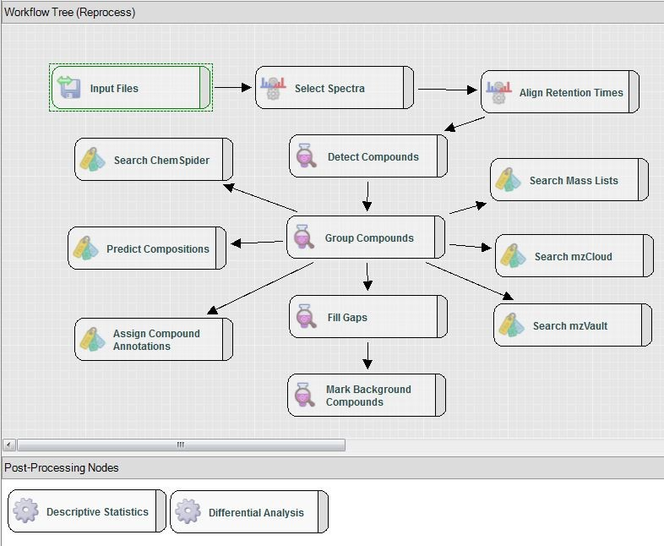

**Supplementary Figure 1**:Schematic of Compound Discoverer processing workflow for non-target approach. Each box represents a “node” that performs specific data processing operations. Detailed settings for the workflow used are provided in Table S4

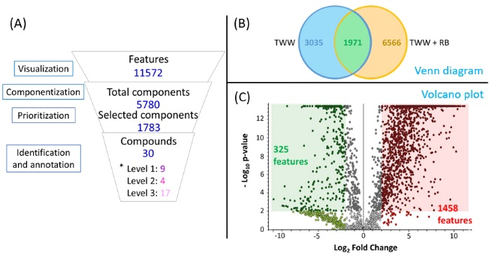

**Supplementary Figure 2**: Comprehensive analysis in negative mode: (A) Number of analytical signals (Venn Diagram), prioritized features (Vulcano plot) and annotated or identified compounds from non-target data analysis - *level inspired from Schymanski et al., 2014 and Alygizakis et al., 2023; (B) Venn diagram between TWW and TWW+RB; (C) Volcano plot representing the results of the ANOVA build on features

During componentization step, 5,780 components were found utilizing both retention time and peak shape of feature. Features were prioritized based on their statistically significance between the two studied conditions, resulting in reduction of features to 1,783 features (a 70% reduction). Finally, after verification of chromatogram and spectra qualities 30 compounds were identified or annotated (Figure S2A).

In the experiments under the TWW condition, 5,006 features were detected, whereas 8,537 features were exhibited in the TWW+RB condition. There are 3,035 specific features to TWW, 6,566 exclusive features to TWW+BR and 1,971 features found in both conditions (Figure S2B). After differential analysis, there are 325 features with -Log10 p-value equal or higher than 2 (p-value ≤ 0.01) and Log2 Fold Change equal or higher than 2 (area in TWW + RB four times lower than in TWW) and 1,458 features with -Log10 p-value equal or higher than 2 (p-value ≤ 0.01) and Log2 Fold Change equal or higher than 2 (area in TWW + RB four times higher than in TWW) (Figure S2C).

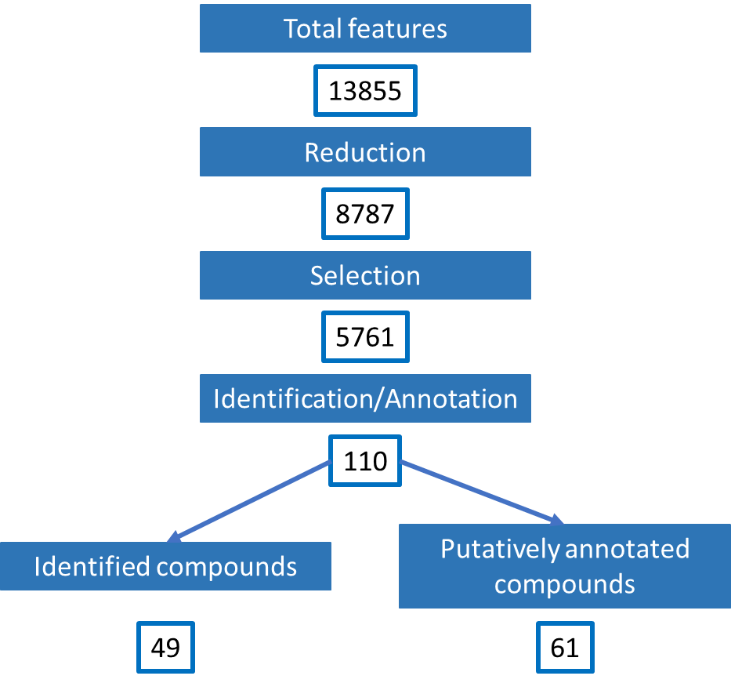

**Supplementary Figure 3**: Number of features at each stage of the prioritization workflow

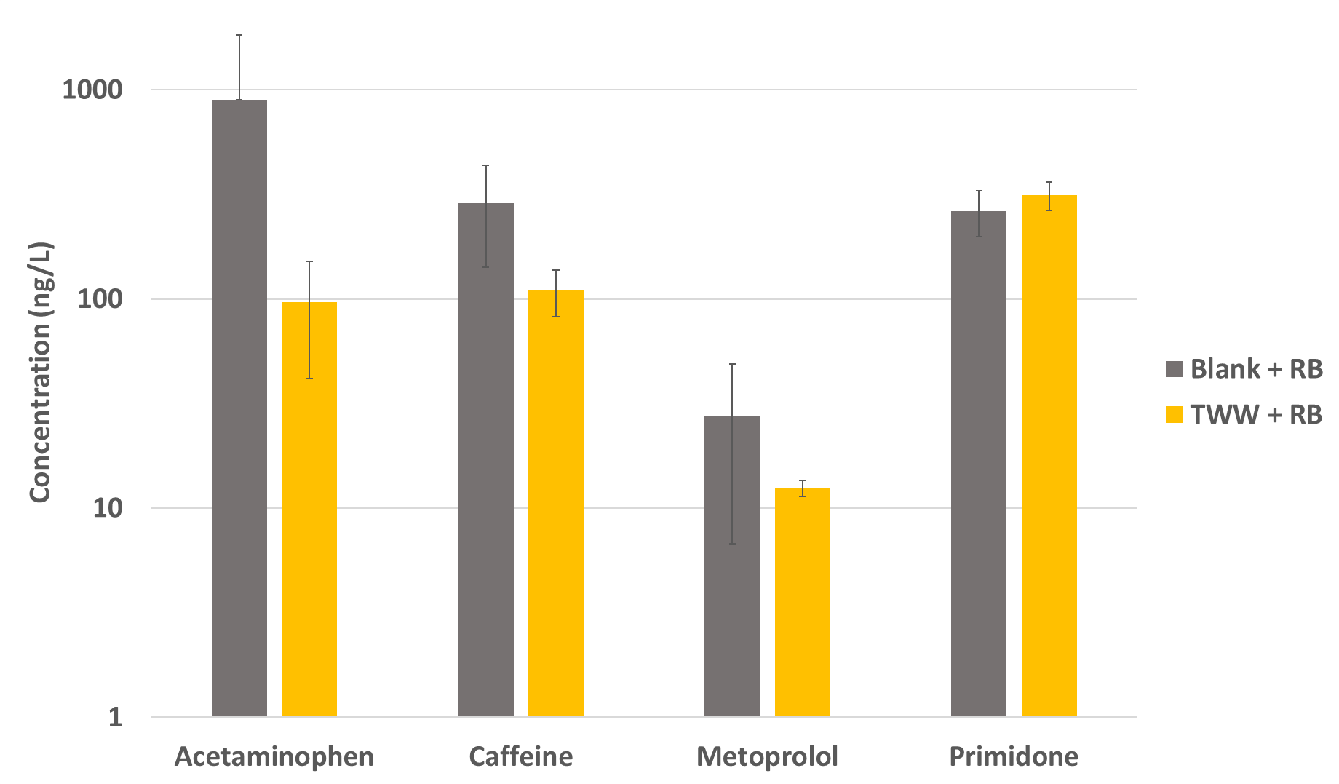

**Supplementary Figure 4**: Concentrations in ng/L of 4 pharmaceuticals found in blank after contact with reactive barrier (in grey) and in treated wastewater after contact with reactive barrier (in orange)

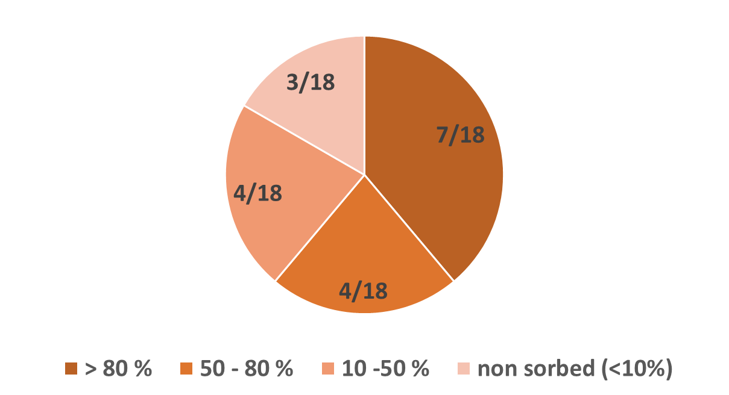

**Supplementary Figure 5**: Number of compounds of the total according to sorption on reactive barrier

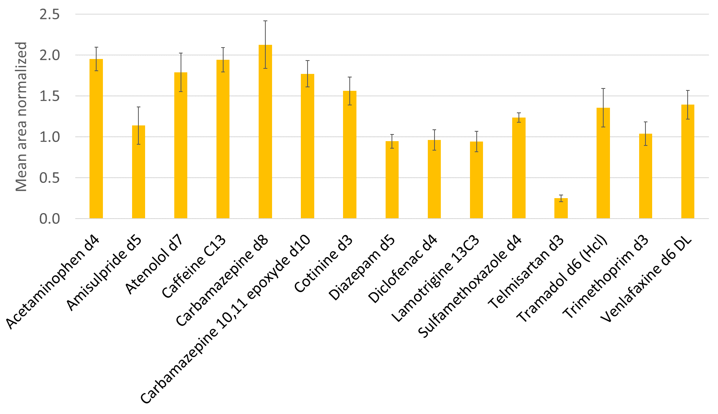

**Supplementary Figure 6**: Matrix effect on internal standards in TWW+RB compared to TWW

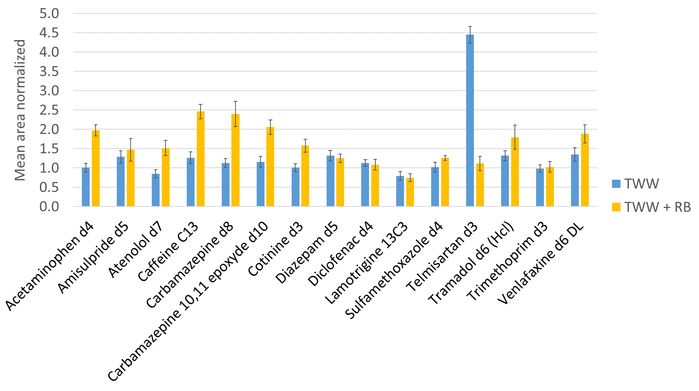

**Supplementary Figure 7**: Matrix effect on internal standards in TWW and in TWW+RB compared to ultra-pure water

## Supplementary Tables

**Supplementary Table** **1**: Pharmaceuticals compounds and associated deuterated internal standards

|  |  |
| --- | --- |
| **Compound** | **Internal standard** |
| Acetaminophen | Acetaminophen d4 |
| Amisulpride | Amisulpride d5 |
| Bezafibrate | Diclofenac d4 |
| Caffeine | Caffeine 13C |
| Carbamazepine | Carbamazepine d8 |
| Cetirizine | Carbamazepine 10,11 epoxide d10 |
| Climbazole | Diazepam d5 |
| Cocaine | Venlafaxine d6 |
| Crotamiton | Diazepam d5 |
| Diazepam | Diazepam d5 |
| Diclofenac | Diclofenac d4 |
| Diltiazem | Diazepam d5 |
| Fenofibric acid | Diclofenac d4 |
| Fluconazole | Amisulpride d5 |
| Irbesartan | Diazepam d5 |
| Ketoprofen | Diclofenac d4 |
| Lamotrigine | Lamotrigine 13C3 |
| Mefenamic acid | Carbamazepine d8 |
| Metoprolol | Venlafaxine d6 |
| Prednisolone | Diclofenac d4 |
| Primidone | Diclofenac d4 |
| Sotalol | Atenolol d7 |
| Sulfamethizole | Caffeine 13C |
| Sulfamethoxazole | Sulfamethoxazole d4 |
| Tramadol | Tramadol d6 |
| Trimethoprim | Trimethoprim d3 |
| Valsartan | Carbamazepine d8 |
| Venlafaxine | Venlafaxine d6 |

**Supplementary Table** **2**: Physicochemical properties of the materials (from Valhondo et al., 2023)

|  |  |  |  |  |  |
| --- | --- | --- | --- | --- | --- |
| **Material** | **% OM** | **%C total** | **pH** | **CEC (me/100g)** | **Reactive surface (m²/g)** |
| Clay | 3.11 | 0.92 | 8.7 | 20.4 | 23 |
| Sand | 0.73 | 0.72 | 8.5 | 2.3 | 3 |
| Compost | 21.03 | 14.93 | 7.8 | 43.9 | 5 |
| Woodships | 94.83 | 57.37 | 5.3 | 10.7 | - |

**Supplementary Table** **3**: pH and redox potentials of each replicas

|  |  |  |  |  |
| --- | --- | --- | --- | --- |
| **Replicas** | **pH initial** | **pH end** | **Redox potential (mV) initial** | **Redox potential (mV) end** |
| TWW 1 | 8.06 | 8.06 | 155 | 155 |
| TWW 2 | 8.06 | 8.06 | 155 | 155 |
| TWW 3 | 8.06 | 8.06 | 155 | 155 |
| TWW 4 | 8.06 | 8.06 | 155 | 155 |
| TWW 5 | 8.06 | 8.06 | 155 | 155 |
| TWW + RB 1 | 8.06 | 7.93 | 155 | 150 |
| TWW + RB 2 | 8.06 | 7.88 | 155 | 150 |
| TWW + RB 3 | 8.06 | 7.90 | 155 | 150 |
| TWW + RB 4 | 8.06 | 7.88 | 155 | 150 |
| TWW + RB 5 | 8.06 | 7.85 | 155 | 150 |

**Supplementary Table** **4**:Compound Discoverer 3.0 settings used in this study

|  |  |
| --- | --- |
| **Node** | **Settings** |
| Input Files | N/A |
| Select Spectra | *General Settings*   * Precursor Selection: Use MS(n-1) Precursor * Use Isotope Pattern in Precursor Re-evaluation: True * Provide Profile Spectra: Automatic * Store Chromatograms: False   *Spectrum Properties Filter*   * Lower RT Limit: 0 * Upper RT Limit: 0 * First Scan: 0 * Last Scan: 0 * Ignore Specified Scans: (not specified) * Lowest Charge State: 0 * Highest Charge State: 0 * Min. Precursor Mass: 0 Da * Max. Precursor Mass: 5000 Da * Total Intensity Threshold: 0 * Minimum Peak Count: 1   *Scan Event Filters*   * Mass Analyzer: Any * MS Order: Any * Activation Type: Any * Min. Collision Energy: 0 * Max. Collision Energy: 1000 * Scan Type: Any * Polarity Mode: Any * MS1 Mass Range: (not specified) * FAIMS CV: (not specified)   *Peak Filters*   * S/N Threshold (FT-only): 1.5   *Replacements for Unrecognized Properties*   * Unrecognized Charge Replacements: 1 * Unrecognized Mass Analyzer Replacements: ITMS * Unrecognized MS Order Replacements: MS2 * Unrecognized Activation Type Replacements: CID * Unrecognized Polarity Replacements: + or - * Unrecognized MS Resolution@200 Replacements: 60000 * Unrecognized MSn Resolution@200 Replacements: 30000 |
| Align Retention Times | * Alignment Model: Adaptive curve * Alignment Fallback: Use Linear Model * Maximum Shift [min]: 2 * Shift Reference File: True * Mass Tolerance: 5 ppm * Remove Outlier: True |
| Detect Compounds | *General Settings*   * Mass Tolerance [ppm]: 5 ppm * Min. Peak Intensity: 100 000 * Min. # Scans per Peak: 5 * Use Most Intense Isotope Only: True   *Trace Detection*   * Max. Number of Gaps to Correct: 2 * Min. Number of Adjacent Non-Zeros: 2 |

|  |  |
| --- | --- |
|  | *Peak Detection*   * Chromatographic S/N Threshold: 6 * Remove Baseline: False * Gap Ratio Threshold: 0.35 * Max. Peak Width [min]: 0.9 * Min. Relative Valley Depth: 0.1   *Isotope Pattern Detection*   * Group Isotopes for: Br; Cl * Use Peak Quality for Isotope Grouping: True * Filter out Features with Bad Peaks Only: True * Zig-Zag Index Threshold: 0.2 * Jaggedness Threshold: 0.4 * Modality Threshold: 0.9 * Remove Potentially False Positive Isotopes: True   *Compound Detection*   * Ions: [M+H]+, [M+K]+, [M+Na]+, [M+H]- * Base Ions: [M+H]+, [M+H]- * Remove Singlets: True   *AcquireX Settings*   * Detect Persistent Background Ions: False |
| Group Compounds | *General Settings*   * Mass Tolerance: 5ppm * RT Tolerance [min]: 0.2 * Align Peaks: False * Preferred Ions: [M+H]+,[M-H]− * Area Integration: Most Common Ion   *Peak Rating Contributions*   * Area Contribution: 3 * CV Contribution: 10 * FWHM to Base Contribution: 5 * Jaggedness Contribution: 5 * Modality Contribution: 5 * Zig-Zag Index Contribution: 5   *Peak Rating Filter*   * Peak Rating Threshold: 5 * Number of Files: 3 |
| Search ChemSpider | *Search Settings*   * Database(s): Chemical Biology Department, Max Planck Institute of Molecular Physiology; ChemicalProbes.org; Chemistry World from the Royal Society of Chemistry; Collaborative Drug Discovery; DrugBank; Guide to PHARMACOLOGY; Marine Drugs; Toxin, Toxin-Target Database * Search Mode: By Formula or Mass * Mass Tolerance: 5 ppm * Max. # of results per compound: 100 * Result Order (for Max. # of results per compound): Order By Reference Count (DESC) * Max. # of Predicted Compositions to be searched per Compound: 3   *Predicted Composition Annotation*   * Check All Predicted Compositions: False |
| Search MassLists | *Search Settings: MassLists*   * Mass Tolerance: 5ppm * Use Retention Time: True * RT Tolerance [min]: 1 |
| Assign Compound  Annotations | *General Settings*   * Mass Tolerance: 5 ppm   *Data Sources*   * Data Source #1: MassList Search * Data Source #2: mzVault Search * Data Source #3: mzCloud Search * Data Source #4: Predicted Compositions * Data Source #5: ChemSpider Search   *Scoring Rules*   * Use mzLogic: True * Use Spectral Distance: True * SFit Threshold: 20 * SFit Range: 20   *Reprocessing*  Clear Names: False |
| Predict Compositions | *Prediction Settings*   * MassTolerance: 5 ppm * Min. Element Counts: CH * Max. Element Counts: C90 H190 Br3 Cl6 F20 K2 N10 Na2 O18 P3 S5 * Min. RDBE: 0 * Max. RDBE: 40 * Min. H/C: 0.1 * Max. H/C: 3.5 * Max. # Candidates: 10 * Max. # Internal Candidates: 200   *Pattern Matching*   * Intensity Tolerance [%]: 30 * Intensity Threshold [%]: 0.1 * S/N Threshold: 3 * Min. Spectral Fit [%]: 30 * Min. Pattern Cov. [%]: 90 * Use Dynamic Recalibration: True   *Fragments Matching*   * Use Fragments Matching: True * Mass Tolerance: 5 ppm * S/N Threshold: 1.5 |
| Search mzVault | *Search Settings*   * mzVault Library: \MassBankTOT_05052022.db|\Base de données NEREIDE mzVault0.3_01092022.db * Compound Classes: All * Match Ion Activation Type: False * Match Ion Activation Energy: Any * Ion Activation Energy Tolerance: 60 * Match Ionization Method: False * Apply Intensity Threshold: True * Remove Precursor Ion: True * Precursor Mass Tolerance: 10 ppm * FT Fragment Mass Tolerance: 10 ppm * IT Fragment Mass Tolerance: 0.4Da * Match Analyser Type: False * Search Algorithm: HighChem HighRes * Match Factor Threshold: 50 * Max. # Results: 10 * RT Tolerance [min]: 2 * Use Retention Time: False |
| Search mzCloud | *General Settings*   * Compound Classes: All * Precursor Mass Tolerance: 10 ppm * FT Fragment Mass Tolerance: 10 ppm * IT Fragment Mass Tolerance: 0.4 Da * Library: Auto processed; Reference * Post Processing: Recalibrated * Max. # Results: 10 * Annotate Matching Fragments: False * Search MSn Tree: False   *DDA Search*   * Identity Search: HighChem HighRes * Match Activation Type: True * Match Activation Energy: Match with Tolerance * Activation Energy Tolerance: 20 * Apply Intensity Threshold: True * Similarity Search: None * Match Factor Threshold: 60   *DIA Search*   * Use DIA Scans for Search: False * Max. Isolation Width [Da]: 500 * Match Activation Type: False * Match Activation Energy: Any * Activation Energy Tolerance: 100 * Apply Intensity Threshold: False * Match Factor Threshold: 20 |
| Fill Gaps | * Mass Tolerance: 5 ppm * S/N Threshold: 1.5 * Use Real Peak Detection: True |
| Mark Background Compounds | *General Settings*   * Max. Sample/Blank: 5 * Max. Blank/Sample: 0 * Hide Background: True |
| Descriptive Statistics |  |
| Differential Analysis | *General Settings*   * Log10 Transform Values: True   *Peak Rating Contributions*   * Update Peak Rating: True * Area Contribution: 3 * CV Contribution: 10 * FWHM to Base Contribution: 5 * Jaggedness Contribution: 5 * Modality Contribution: 5 * Zig-Zag Index Contribution: 5 |

**Supplementary Table 5**: Analytical performance of compounds used in the quantification of pharmaceuticals residues: internal standard associated at each compound, m/z ratio (in positive mode), retention time (in min), real recovery and adjusted recovery (in %), and limit of quantification (LQ, in ng/L)

|  |  |  |  |  |  |  |
| --- | --- | --- | --- | --- | --- | --- |
| **Compound** | **Internal standard** | **m/z (+)** | **Retention time (min)** | **Real recovery (%)** | **Adjusted recovery (%)** | **LQ (ng/L)** |
| Acetaminophen | Acetaminophen d4 | 152.07060 | 1.28 | 84.7 ± 5.0 | 102.6 ± 6.7 | 5.0 |
| Amisulpride | Amisulpride d5 | 370.17950 | 8.71 | 45.1 ± 6.6 | 90.7 ± 13.4 | 0.1 |
| Bezafibrate | Diclofenac d4 | 362.11536 | 13.61 | 93.0 ± 2.5 | 102.4 ± 2.6 | 0.6 |
| Caffeine | Caffeine 13C | 195.08765 | 6.48 | 119.6 ± 3.3 | 104.0 ± 2.4 | 5.0 |
| Carbamazepine | Carbamazepine d8 | 237.10224 | 11.91 | 94.1 ± 5.6 | 94.4 ± 2.9 | 0.1 |
| Cetirizine | Carbamazepine 10,11 epoxide d10 | 389.16265 | 12.69 | 75.4 ± 2.9 | 87.9 ± 15.4 | 0.5 |
| Climbazole | Diazepam d5 | 293.10513 | 12.10 | 63.7 ± 3.3 | 44.2 ± 8.3 | 0.1 |
| Cocaine | Venlafaxine d6 | 304.15433 | 9.88 | 62.4 ± 5.0 | 108.2 ± 1.7 | 0.5 |
| Crotamiton | Diazepam d5 | 204.13829 | 13.12 | 55.4 ± 5.3 | 34.5 ± 2.5 | 0.6 |
| Diazepam | Diazepam d5 | 285.07892 | 13.72 | 75.1 ± 1.8 | 85.8 ± 7.8 | 0.1 |
| Diclofenac | Diclofenac d4 | 296.02396 | 15.35 | - | 137.1 ± 6.9 | 1.0 |
| Diltiazem | Diazepam d5 | 415.16860 | 12.09 | 28.2 ± 3.2 | 29.8 ± 10.0 | 0.5 |
| Fenofibric acid | Diclofenac d4 | 319.07316 | 15.12 | 49.7 ± 16.8 | 96.3 ± 1.6 | 1.0 |
| Fluconazole | Amisulpride d5 | 307.11134 | 8.60 | 61.0 ± 1.6 | 97.6 ± 5.7 | 0.5 |
| Irbesartan | Diazepam d5 | 429.23974 | 12.60 | 72.8 ± 3.5 | 84.9 ± 4.7 | 0.5 |
| Ketoprofen | Diclofenac d4 | 255.10157 | 13.48 | 104.3 ± 1.9 | 135.7 ± 4.3 | 5.0 |
| Lamotrigine | Lamotrigine 13C3 | 256.01513 | 8.50 | 87.1 ± 2.0 | 91.3 ± 7.4 | 0.5 |
| Mefenamic acid | Carbamazepine d8 | 242.11756 | 15.88 | 14.5 ± 4.0 | 73.5 ± 1.6 | 0.5 |
| Metoprolol | Venlafaxine d6 | 268.19072 | 8.57 | 67.5 ± 1.3 | 97.5 ± 13.7 | 0.1 |
| Prednisolone | Diclofenac d4 | 361.20095 | 11.00 | 84.1 ± 0.5 | 78.7 ± 7.8 | 1.0 |
| Primidone | Diclofenac d4 | 219.11280 | 7.81 | 94.2 ± 2.3 | 94.1 ± 3.4 | 1.0 |
| Sotalol | Atenolol d7 | 273.12674 | 1.15 | 90.5 ± 2.5 | 76.1 ± 0.8 | 0.6 |
| Sulfamethizole | Caffeine 13C | 271.03179 | 8.86 | 64.2 ± 4.4 | 77.9 ± 2.8 | 1.0 |
| Sulfamethoxazole | Sulfamethoxazole d4 | 254.05939 | 10.05 | 86.7 ± 1.3 | 93.1 ± 2.8 | 0.5 |
| Tramadol | Tramadol d6 | 264.19581 | 8.81 | 66.8 ± 2.3 | 87.2 ± 1.3 | 0.05 |
| Trimethoprim | Trimethoprim d3 | 291.14517 | 7.40 | 76.5 ± 5.1 | 94.0 ± 11.8 | 0.5 |
| Valsartan | Carbamazepine d8 | 436.23432 | 14.13 | 77.5 ± 3.3 | 87.7 ± 8.9 | 0.5 |
| Venlafaxine | Venlafaxine d6 | 278.21146 | 10.00 | 57.5 ± 0.6 | 93.7 ± 11.5 | 0.1 |

Real recovery corresponds to the recovery of the entire analytical protocol including SPE, evaporation and injection. Adjusted recovery is corrected recovery by labelled standard at the beginning of the analytical protocol to account for potential losses during sample preparation and analysis.

**Supplementary Table** **6**: Compounds identified and annotated with names, chemical formula, polarity, retention time (min), m/z, Δm (ppm), compound class, level (inspired from Schymanski et al., 2014 and Alygizakis et al., 2023), main fragments, presence in TWW, TWW+RB, variation after RB, Log2 FoldChange and presence in Blank+RB

See Supplementary Sheet Table S6.xlsx

**Supplementary Table** **7**: Natural products annotated with names, chemical formula, polarity, retention time (min), m/z, Δm (ppm), compound class, precisions on compound class with reference, level (inspired from Schymanski et al., 2014 and Alygizakis et al., 2023), main fragments, presence in TWW, TWW+RB, variation after RB, Log2 FoldChange and presence in Blank+RB

See Supplementary Sheet Table S7.xlsx

**References**

Al Omar, R., Micklewright, R., Masud, K., Naz, T., Vemulpad, S., and Jamie, J. (2022). The genus *Alphitonia* Reissek ex Endl. (Rhamnaceae): A review of its customary uses, phytochemistry and biological activities. *Journal of Ethnopharmacology* 294, 115168. doi: 10.1016/j.jep.2022.115168

Alygizakis, N., Lestremau, F., Gago-Ferrero, P., Gil-Solsona, R., Arturi, K., Hollender, J., et al. (2023). Towards a harmonized identification scoring system in LC-HRMS/MS based non-target screening (NTS) of emerging contaminants. *TrAC Trends in Analytical Chemistry* 159, 116944. doi: 10.1016/j.trac.2023.116944

Ashrafi, A. M., Bytešníková, Z., Cané, C., Richtera, L., and Vallejos, S. (2023). New trends in methyl salicylate sensing and their implications in agriculture. *Biosens Bioelectron* 223, 115008. doi: 10.1016/j.bios.2022.115008

Boonbangkeng, D., Treesubsuntorn, C., Krobthong, S., Yingchutrakul, Y., Pekkoh, J., and Thiravetyan, P. (2022). Using cell-free supernatant of *Bacillus* sp. AK3 in combination with *Chlorella* to remove harmful algal bloom species, TP, TN, and COD from water. *Journal of Environmental Chemical Engineering* 10, 108645. doi: 10.1016/j.jece.2022.108645

Carballeira, N. M., Reyes, M., Sostre, A., Huang, H., Verhagen, M. F., and Adams, M. W. (1997). Unusual fatty acid compositions of the hyperthermophilic archaeon Pyrococcus furiosus and the bacterium Thermotoga maritima. *Journal of Bacteriology* 179, 2766–2768. doi: 10.1128/jb.179.8.2766-2768.1997

Da Costa, M. V. J., Ramegowda, V., Ramakrishnan, P., Nataraja, K. N., and Sheshshayee, M. S. (2022). Comparative metabolite profiling of rice contrasts reveal combined drought and heat stress signatures in flag leaf and spikelets. *Plant Science* 320, 111262. doi: 10.1016/j.plantsci.2022.111262

Durazzo, A., Zaccaria, M., Polito, A., Maiani, G., and Carcea, M. (2013). Lignan Content in Cereals, Buckwheat and Derived Foods. *Foods* 2, 53–63. doi: 10.3390/foods2010053

Goswami, M. J., Dutta, U., Seema, T., Bharali, S. J., Yanka, H., Tag, H., et al. (2023). Antioxidant and Antidiabetic Properties of Extracts from Three Underutilized Food Plants of North East India. *Chemistry & Biodiversity* 20, e202200718. doi: 10.1002/cbdv.202200718

Hamrouni, H., Othman, K. B., Benmoussa, H., Idoudi, S., Najjaa, H., Neffati, M., et al. (2023). Phenolic Profiling, Antioxidant, and Antibacterial Activities of Selected Medicinal Plants from Tunisia. *Chemistry & Biodiversity* 20, e202300265. doi: 10.1002/cbdv.202300265

Inayama, S., Ohkura, T., Kawamata, T., and Yanagita, M. (1974). Ambrosic Acid, a New Irritant Principle from Ambrosia arthemisiifolia. *Chem. Pharm. Bull.* 22, 1435–1437. doi: 10.1248/cpb.22.1435

Liaqat, F., Xu, L., Khazi, M. I., Ali, S., Rahman, M. U., and Zhu, D. (2023). Extraction, purification, and applications of vanillin: A review of recent advances and challenges. *Industrial Crops and Products* 204, 117372. doi: 10.1016/j.indcrop.2023.117372

Liu, Y., Zhou, F., Shu, H.-Z., Lin, L.-G., and Zhang, Q.-W. (2023). Germacrane-type sesquiterpenoids from the flowers of Chrysanthemum indicum with hepatoprotective activity. *Food Chem Toxicol* 177, 113850. doi: 10.1016/j.fct.2023.113850

Matsushita, Y., Sugamoto, K., Iwakiri, Y., Yoshida, S., Chaen, T., and Matsui, T. (2010). Aerobic oxidation of 8,11,13-abietatrienes catalyzed by *N*-hydroxyphthalimide combined with 2,2′-azobis(4-methoxy-2,4-dimethylvaleronitrile) and its application to synthesis of naturally occurring diterpenes. *Tetrahedron Letters* 51, 3931–3934. doi: 10.1016/j.tetlet.2010.05.090

Okunishi, T., Takaku, N., Wattanawikkit, P., Sakakibara, N., Suzuki, S., Sakai, F., et al. (2002). Lignan production inDaphne odora cell cultures. *J Wood Sci* 48, 237–241. doi: 10.1007/BF00771374

Schymanski, E. L., Jeon, J., Gulde, R., Fenner, K., Ruff, M., Singer, H. P., et al. (2014). Identifying Small Molecules via High Resolution Mass Spectrometry: Communicating Confidence. *Environ. Sci. Technol.* 48, 2097–2098. doi: 10.1021/es5002105

Seetaha, S., Khamplong, P., Wanaragthai, P., Aiebchun, T., Ratanabunyong, S., Krobthong, S., et al. (2022). KERRA, Mixed Medicinal Plant Extracts, Inhibits SARS-CoV-2 Targets Enzymes and Feline Coronavirus. *COVID* 2, 621–632. doi: 10.3390/covid2050046

Truzzi, E., Marchetti, L., Gibertini, G., Benvenuti, S., Cappellozza, S., Giovannini, D., et al. (2024). Phytochemical and functional characterization of cultivated varieties of Morus alba L. fruits grown in Italy. *Food Chem* 431, 137113. doi: 10.1016/j.foodchem.2023.137113

Valhondo, C., Duporté, G., Cabaret, G., Rosain, D., Gomez, E., and Luquot, L. (2023). Assessing the Feasibility of Sustainable Materials to Boost the Sorption of Pharmaceutical Active Compounds When Included in Reactive Barriers in Soil Aquifer Treatment for Water Reuse. *Water* 15, 1393. doi: 10.3390/w15071393

Wu, C., Ichinose, K., Choi, Y. H., and van Wezel, G. P. (2017). Aromatic Polyketide GTRI-02 is a Previously Unidentified Product of the act Gene Cluster in Streptomyces coelicolor A3(2). *ChemBioChem* 18, 1428–1434. doi: 10.1002/cbic.201700107

Wu, T., Salim, A. A., Bernhardt, P. V., and Capon, R. J. (2022). Molecular Networking and Cultivation Profiling Reveals Diverse Natural Product Classes from an Australian Soil-Derived Fungus Aspergillus sp. CMB-MRF324. *Molecules* 27, 9066. doi: 10.3390/molecules27249066