Supplementary Information (SI)

Monitoring microplastics in the Seine River in the Greater Paris area.

Cleo N. Stratmann*, Rachid Dris*, Johnny Gasperi, Frans A. Buschman, Adriaan A. Markus, Sabrina Guerin, A. Dick Vethaak, Bruno Tassin

**\* Correspondence:** Cleo N. Stratmann ([Cleo.stratmann@enpc.fr](mailto:Cleo.stratmann@enpc.fr)), Rachid Dris (rachid.dris@u-pec.fr)

# Universal Filtration Object (UFO)

This plastic-free, stainless-steel, and volume-reducing microplastic (MP) sampling pump was developed by Aalborg University (Denmark).

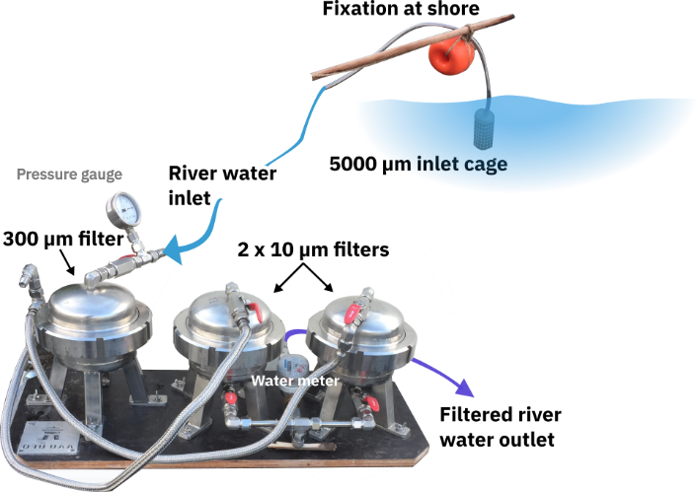

Figure S1 Set-up of the microplastic sampling with the UFO sampling pump.

# µ-FTIR information

Type: Nicolet iN10 (Thermofisher)   
Obtained spectra: Absorbance  
Mode: Transmission  
Detector: KBr imaging   
Collection time: 1 scan  
Spectral resolution: 8  
No. of detectors: 16  
Cell size: 25 x 25 µm  
Spectral range: 4,000-400 cm-1  
Filter method: Harris-Blackman   
Correction: Autobaseline  
Background sample: Yes, blank anodisc filter

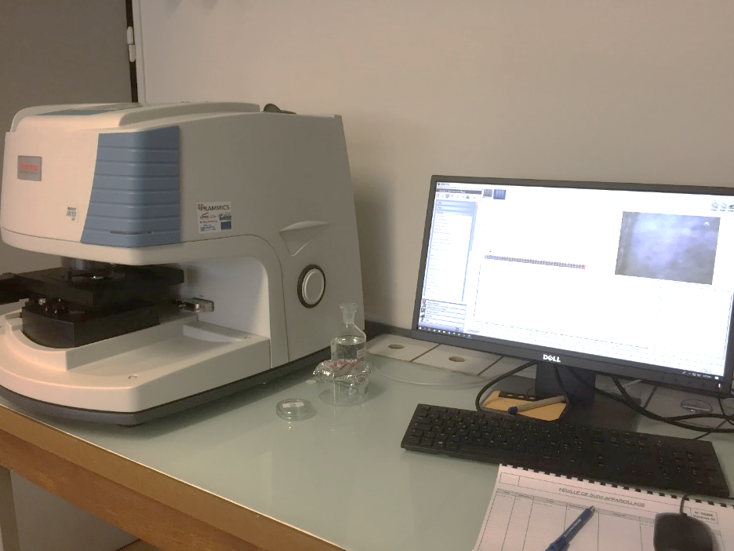

Figure S2 FTIR machine Nicolet iN10

# siMPle software information

Software version: 1.1.beta  
Spectra library version: MP_Library_Extended_Grouped_1_5

# Sample analysis process

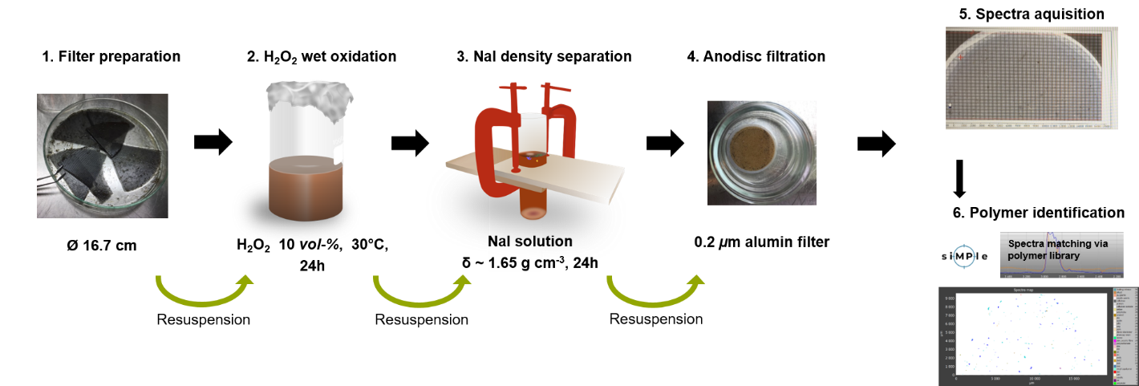

Figure S3 Visualization of the MP sample analysis process. H2O2=hydrogen peroxide, NaI=sodium-iodide, h=hours.

# Polymer type distribution

Sixteen identified polymer types: Acrylonitrile butadiene styrene, acrylic, acrylic paint, alkyd, cellulose acetate, epoxy, polyamide, polyethylene (PE), polyester incl. polyethylene terephthalate, polypropylene (PP), polystyrene (PS), polyurethane, polyvinyl acetate, polyvinyl chloride, styrene-butadiene rubber, vinyl copolymer.

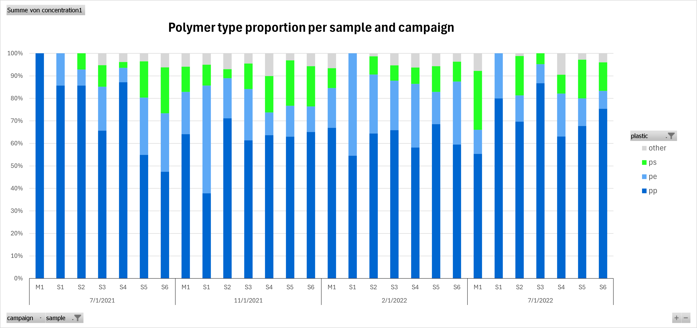

Figure S4 Polymer type proportions per sample and campaign with polypropylene (PP), polyethylene (PE), polystyrene (PS), and other polymer types aggregated (other). Campaigns named as 7/1/2021 for July 2021, 11/1/2021 for November 2021, 2/1/2022 for February 2022, and 7/1/2022 for July 2022.

# Polymer size distribution

Ein Bild, das Text, Screenshot, Diagramm, Design enthält.

**Figure S5** Minor and major microplastic particle dimensions and spearman rank correlation coefficient (rho) for all MP particles (A) and particles with major diameter <300 µm (B). Additional are histograms for minor and major particle dimension with a binwidth of 25 µm (B).

# Seine River water balances

Five water balances were developed to assess the distribution and dynamics of the Seine River water within the monitoring area around Greater Paris over time. Negative deviations in the water balances (Figures S5-S10) suggest a deficit of water volumes downstream, and positive deviations indicate a potential additional inflow of water (precipitation, other discharge, other small tributaries). The following points should be considered to cause unaccounted differences in discharge: Hydraulic residence time between hydro stations, precipitation (e.g., hydrologic lag time), evaporation, discharge input from other smaller tributaries that were not included in the water balance, discharge from other sources (e.g., CSO, WWTP effluent), measurement inaccuracies, retention, and intake due to sluices or floodplains.

For each balance, the discharge at the relevant hydrostation of the Seine River is represented as the sum of the the discharge of the previous upstream hydrostation in the Seine River plus any additional instreaming tributaries (Table S1). Five water balances were developed for the hydrostations (Table S2) related to the MP sampling sites (S1-S6) between 1 June 2021, and 1 August 2022. The locations, details, and discharge data for the hydrostations are present in the dataset (*Metadata* and *Water-balance*).

* Water balance 1 (7.1): La Seine à Bazoches-les-Bray (F2400001)
* Water balance 2 (7.2): La Seine Seine-St Fargeau (F4470003)
* Water balance 3 (7.3): La Seine à Alfortville et à Villeneuve-Saint-Georges et à Vitry-sur-Seine (F490 0001)
* Water balance 4 (7.4): La Seine à Paris (Austerlitz) (F700 0001)
* Water balance 5 (7.5): La Seine à Vernon (H3200 001).

Discharge of the Yonne (Table 2) would be the difference between F4000001 (La Seine à Montereau-Fault-Yonne) and F2400001 (La Seine à Bazoches-les-Bray), however this part was omited here.

A water balance (7.6) was also developed for sampling site S5 (Triel-sur-Seine). The sampling site is located downstream of station F7000001 La Seine à Austerlitz and after the confluent of the Oise River (H2080001 L'Oise à Creil). To account for this addition of water, the discharges from both hydrostations are added to obtain the best estimate of river discharge at sampling site S5.

Table S1 Seine River and tributaries visualization for the water balances. This includes the hydrostation measurement points relevant for sampling sites S1 (La Seine à Pont-sur-Seine) until S6 (La Seine à Vernon). Flow direction reads from top to bottom across the horizontal field boundaries.

|  |  |  |  |  |  |  |  |  |  |  |  |  |
| --- | --- | --- | --- | --- | --- | --- | --- | --- | --- | --- | --- | --- |
| **Seine** | **Tributaries** | | | | | | | | | | | |
| La Seine à Pont-sur-Seine | Ardusson | Voulzie | Yonne | Loing | Ru d'Ancoeur | Essonne | Orge | Yerres | Marne | Oise | Mauldre | Epte |
| La Seine à Vernon | | | | | | | | | | | | |

Table S2 Water balance visualization. The table lists the hydrostation-IDs and the names of the hydrostations which daily river discharge data was obtained from. Light blue cells refer to tributaries (see also Table S1), and blue cells refer to the Seine. The balance includes the points of hydrostation measurements relevant for sampling sites S1 (La Seine à Pont-sur-Seine) until S6 (La Seine à Vernon). Flow direction reads from top to bottom across the horizontal field boundaries. The numbers represent mean discharge over the whole period as reported in the dataset (1 June 2021 – 1 August 2022) in m3 s-1 for each hydrostation. Note that the Seine River discharge values relevant to the sampling sites (see dataset excel sheet *Data full* column W) differ up to 6-fold per site during MP samplings.

|  |  |  |  |  |  |  |  |  |  |  |  |  |
| --- | --- | --- | --- | --- | --- | --- | --- | --- | --- | --- | --- | --- |
| H1700010 La Seine à Pont-sur-Seine 56.9 | H1713010 L'Ardusson à Saint-Aubin 0.4 | F2320001 La Voulzie à Jutigny 1.9 |  | | | | | | | | | |
| F2400001 La Seine à Bazoches-les-Bray 50.7 | | | Yonne |  | | | | | | | | |
| F4000001 La Seine à Montereau-Fault-Yonne 130.7 | | | | F4390001 Le Loing à Épisy 16.6 | F4450001 Le ru d'Ancoeur à Blandy 0.5 |  | | | | | | |
| F4470003 La Seine Seine-St Fargeau 149.3 | | | | | | F4590001 L'Essonne à Ballancourt-sur-Essonne 7.7 | F4670001 L'Orge à Morsang-sur-Orge 3.8 | F4830002 L'Yerres à Boussy-Saint-Antoine 3.2 |  | | | |
| F4900001 La Seine à Alfortville 174.5 | | | | | | | | | F6640004 La Marne à Créteil 85.0 |  | | |
| F7000001 La Seine à Austerlitz 260.4 | | | | | | | | | | H2080001 L'Oise à Creil 96.1 | H3050004 La Mauldre à Aulnay-sur-Mauldre 1.7 | H3180410 L'Epte à Fourges 8.8 |
| H3200001 La Seine à Vernon 407.1 | | | | | | | | | | | | |

The following describes the hydrographs for the five different water balances. The absolute difference (orange lines) is calculated as the difference between the downstream discharge and the upstream discharge and any tributaries. The difference in river discharge would ideally be zero.

## Water balance 1: F2400001 La Seine à Bazoches-les-Bray

$Difference=Q_{F2400001}-Q_{H1700010}-Q_{F2320001}-Q_{H1713010}$ 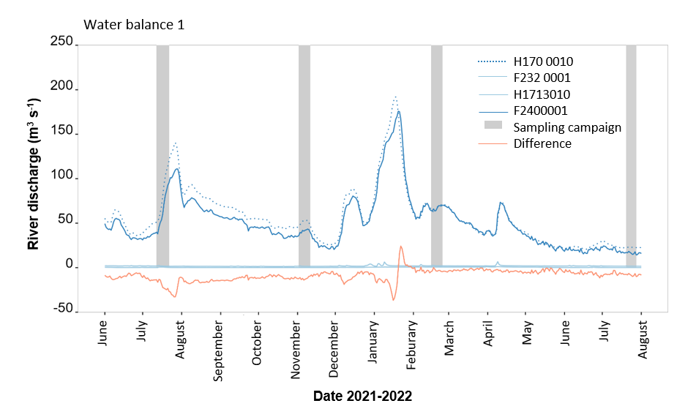

Figure S6 For sampling point S1, Marnay-sur-Seine, we consider the daily discharge from hydrostation H1700010, La Seine à Pont-sur-seine (dotted dark blue line). Tributaries La Voulzie (F2320001 – solid light blue line) and L’Ardusson (H1713010 – solid light blue line) are located downstream and discharges from both station are below ~10 m3 s-1. From station H1700010 until the next hydro station in the Seine river La Seine à Bazoches-les-Bray (F2400001 – solid dark blue line), the water balance results in discharge differences around zero, with values in the negative area, but with maximal deviances from zero of less than 50 m3 s-1.

## Water balance 2: F4470003 La Seine Seine-St Fargeau

$$Difference=Q_{F4470003}-Q_{F4000001}- Q_{F4390001}-Q_{F4450001}$$

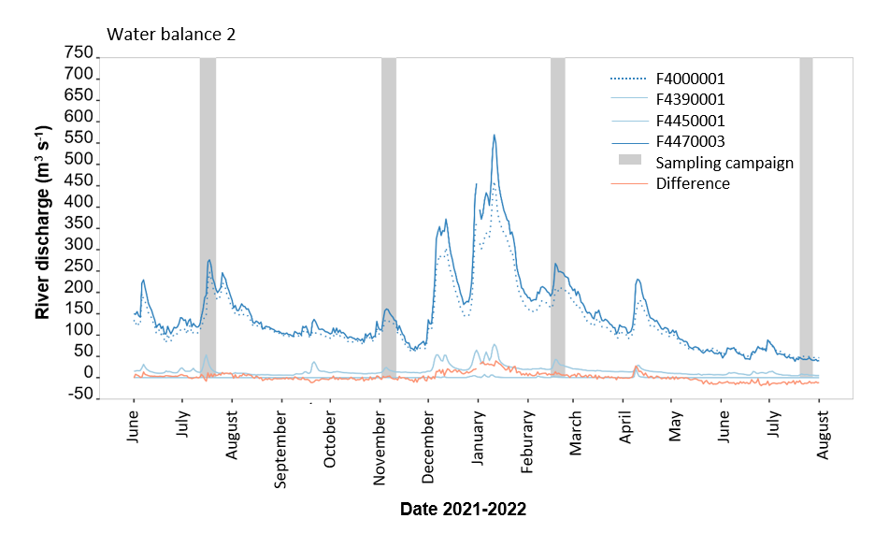

Figure S7 From station F4000001 La Seine à Montereau-Fault-Yonne until F4470003 La Seine Seine-St Fargeau the confluents Le ru d’Ancoeur à Blandy (F4390001) and Le Loing à Épisy (F4450001) join. Differences in discharge were slightly positive between December 2021 and February 2022 and more negative after May 2022.

## Water balance 3 : F4900001 La Seine à Alfortville

$${Difference=Q}_{F4900001}-Q_{F4470003 }- Q_{F4590001 }-Q_{F4670001 }-Q_{F4830002}$$

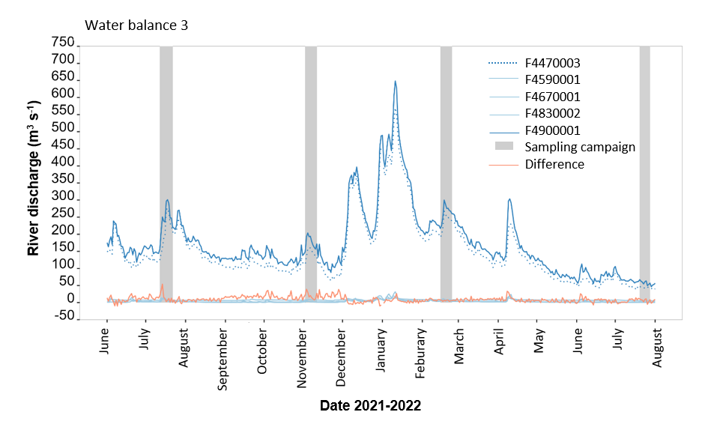

Figure S8 Between La Seine Seine-St Fargeau (F4470003) and La Seine à Alfortville (F4900001), the three confluents Essonne (F4590001), Orge (F4670001), and Yerres (F4830002) join. The balance exhibits only slight deviations.

## Water balance 4: F7000001 La Seine à Paris (Austerlitz)

$$Difference= Q_{F7000001 }-Q_{F4900001 }- Q_{F6640004 }$$

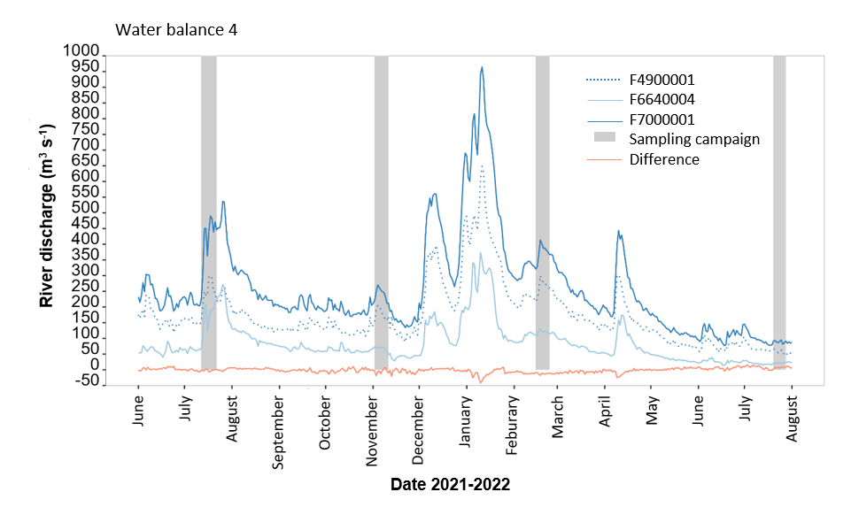

Figure S9 The water balance for station La Seine à Paris (F7000001) results from station La Seine à Alfortville (F4900001) and the confluent of the Marne (F6640004). Deviations are small.

## Water balance 5: H3200001 La Seine à Vernon

$${Difference=Q}_{H3200001 }-Q_{F7000001 }- Q_{H2080001 }-Q_{H3050004 }-Q_{H3180410 }$$

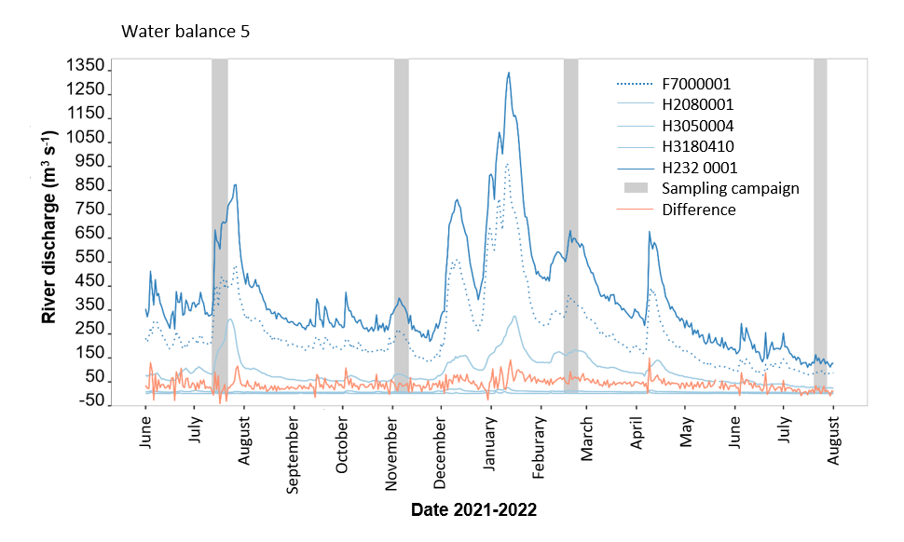

Figure S10 At station H3200001 (La Seine à Vernon), the discharge results from La Seine à Paris (F7000001) and three tributaries: Oise (H2080001), Mauldre (H3050004) and Epte (H3180410). Deviations are more often positive.

## Water balance for sampling site S5 La Seine à Triel-sur-Seine

The sampling site S5 (Triel-sur-Seine) is downstream of hydrostations La Seine à Paris (F7000001) and the Oise confluent (H2080001). Therefore, the discharges from both hydrostations were added and are included in the dataset (Excel table sheet *data full*) as column named “River discharge (Q) of the Seine for S5 (m3s-1)”. No graphic is intended.

$$Q_{Addition for S5 }=Q_{F7000001 }+ Q_{H2080001 }$$