**Supplementary Material**

*Factors for selecting focal species*

*Seasonal transitions:* Deploying ARUs during seasonal transitions is not recommended (i.e., end or beginning of breeding season or migration) to avoid overlapping with changes of occurrence and overall vocal activity that might introduce bias in the analysis (If the length of the breeding season is shorter than the ARU recording period, changes in species occurrence and vocal activity will most likely be driven by seasonal changes and not by any practice).

*Duty cycle:* In addition, some species, such as Sporophila seedeaters or Colinus quails, do not vocalize during the dawn and dusk chorus. These species use open habitats such as pastures and rice fields, and they begin their vocal activity after the dawn chorus (LS. pers. obs.). In coffee systems, species specialized in thickets that are often found next to coffee farms (e.g. White-faced ground sparrow *Melozone biarcuata* and Cabanis’ Ground-sparrow *M. cabanisi*) have been found to not vocalize in in the dawn or dusk chorus, and have been shown to vocalize randomly during the day (LS. unpub. data).

*Detectability:* The use of ARUs to detect habitat use of target species should focus on species with calls that can be easily differentiated from others, and care should be taken to avoid situations where non-target species mask target vocalizations. The species should be selected from a list of species detected on previous surveys or recordings in the area of interest. . There are other ways to reduce storage costs, by recording subsamples of vocal activity peaks using on-and-off recording periods (e.g., 10 s every minute, 5 min on and 5 min off). This subsampling approach yields a random sampling of vocal activity, and most vocal or common species are more likely to be detected.

*Factors for defining an optimal ARU recording protocol*

*When to record*: Birds generally have two vocal activity peaks (dawn and dusk chorus). Consequently, ARUs regularly are programmed to cover both peaks: dawn chorus is recorded for 3 hrs. (30 min before and 150 min after sunrise) and the dusk chorus is recorded for 2 h (90 min before and 30 min after sunrise). However, this recording schedule targets the bird community which vocalizes at these times, which may not include the activity peak of target species of interest.

*Duration of the recording:* How long to record vocalizations in ARUs is a very open question. If recording in the mornings only, the best approach is to record continuously 30 min before sunrise and 3 hrs. after, since the majority of species will vocalize during that period. When measuring the effect of farm management practices on avian habitat use, recorders should be set to record at least a week before and after the practice takes place. This, is to ensure that the variation in detections can be attributed to a specific practice instead of day-to-day variations in environmental conditions and to help control for other disturbances that may mask bird vocalizations (e.g. farm equipment).

*Acoustic data storage:* A high level of coordination is usually required among the different teams for fieldwork, data management, data annotation, and data analyses. Adopting best practices for data management from the onset can benefit the speed of transmission, integrity, security, backup, and the metadata of the collected audio files. In addition, an effective data storage and management strategy can enable efficient ways to increase the accessibility of audio files to different users for analysis or species annotation efforts. It is always advisable to have the data stored on at least two storage devices simultaneously in different locations, protected against humidity, extreme temperatures, and impacts. Storing data on a long-term cloud service, is recommended, when possible, although this can get costly depending on the amount of data. Research institutions, like universities, often have unlimited cloud storage services, and these should be leveraged when possible.

*Features of the Euphonia mobile app*

Euphonia is a mobile application developed to facilitate the annotation of spectrograms on iOS and Android devices. This tool is designed to engage the community in conservation and sustainability efforts through the application of bioacoustics. The app allows users to download audio files, listen to the sounds represented in the spectrograms by double-tapping, scroll through the spectrograms by sliding horizontally, draw selection boxes over signals of interest, select appropriate labels for these signals, and transmit the annotated data to a centralized server for further analysis by scientific teams. This design promotes effective collaboration between local experts, stakeholders, and scientists involved in passive acoustic monitoring projects.

We designed the Euphonia mobile to enable the annotation of spectrograms in a mobile device while reading the threshold for participation in annotation efforts for local stakeholder, as well as facilitating remote collaborations. We conducted usability tests of a beta version in a focus group and were able to qualitatively test if users were able to annotate spectrograms effectively in their phones. Portability and practicality were aspects that stood out in our tests. The Euphonia app was developed primarily for the experimental purpose of investigating the usability of a bioacoustics annotation mobile app and was not released commercially. Its current version is not maintained for production use, and the server that stored the data is no longer operational.

For further details on the project, including access to open-source code and insights into new bioacoustic app development inspired by this work, please visit the project page (<https://tropicodelabs.github.io/euphonia/>).

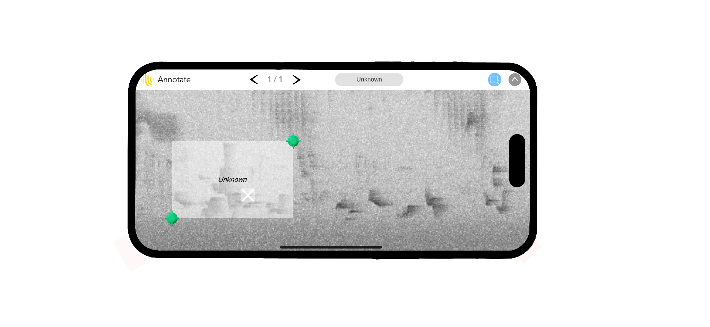

Supplementary Figure 1.

*Case study methods: Acoustic data storage*

Soxr not only assist in the compression process but also in the renaming of files. This ensures that the target FLAC file encapsulates all relevant information for identifying the file independently of the context of the directory tree, safeguarding the integrity of the information for any subsequent manipulation or analysis. After using soxr, the final data structure obtained is organized as follows: root data directory with the name of the deployment (e.g., Dep06), within this there are folders containing the information of the deployment id, site id, and recorder (e.g., Dep06_Site49_Recorder25), within each of these we had folders that contain the audios for each date recorded (e.g., 20230702). Moreover, the audios were renamed in such a way that they contain the following metadata fields joined by underscores: Deployment ID, Sample rate, Site ID, Recorder ID, date, time in UTC (e.g., Dep06_48K_Site49_Recorder25_20230702_113000Z.flac). This method ensures that there will be no data integrity issues at any time when analyzing or transferring data from one place to another, and its metadata is always easily available in a standard format.