Supplementary Material

Calculation of the carbon emission factor
(1) Direct carbon emission factor
In this study, the calculation of the direct carbon emission factor was performed based on the calculation method from the IPCC. The calculation process is shown in Equation (S1).
$$\begin{aligned}f_{i}=\frac{44}{12}×J_{i}×C_{i}×O_{i} \#\left(S1\right)\end{aligned}$$
where $f_{i}$ is the direct carbon emission factor from different energy sources; $J_{i}$ is the average minimum calorific value of energy j, obtained from the appendix of the China Energy Statistical Yearbook-2022${;C}_{i}$; and $O_{i}$ refers to the carbon content per unit calorific value and the energy oxidation rate of energy j, obtained from the Standard for Building Carbon Emission Calculation GB/T51366-2019.
Table S1. Decoupling results between PB’s carbon emissions and disposable income in 41cities in the YRD region
Energy types | Carbon emission coefficient
Raw Coal | 1.9003 kgCO₂/kg
Briquettes | 1.3178 kgCO₂/kg
Gasoline | 2.9251 kgCO₂/kg
Diesel Oil | 3.0959 kgCO₂/kg
LPG | 3.1013 kgCO₂/kg
Natural Gas | 2.1622 kg CO₂/m³
Fuel Oil | 3.1705 kgCO₂/kg
Kerosene | 3.0179 kgCO₂/kg

(2) Indirect carbon emission factor
Provincial electricity carbon emission factors, available only for 2010 and 2018, were released by the National Development and Reform Commission and the Ministry of Ecological Environment. Since electricity accounts for a relatively large proportion of the energy structure, the annual electricity carbon emission factor needs to be updated in the calculation. The electricity carbon emission factor is calculated by Eq. (S2).
$$\begin{aligned}f_{e}=\frac{C_{f}}{P_{f}+P_{r}} \#\left(S2\right)\end{aligned}$$
where $C_{f}$ is the carbon emissions from thermal power generation, $P_{f}$ is the thermal power generation, and $P_{r}$ is the renewable energy generation.
Figure A shows the values and trends of electrical carbon emission factors in various provinces and cities in the YRD region from 2005 to 2021. There has been a significant decrease in the electricity-related carbon emission factor due to technological advancements and energy structure adjustments.
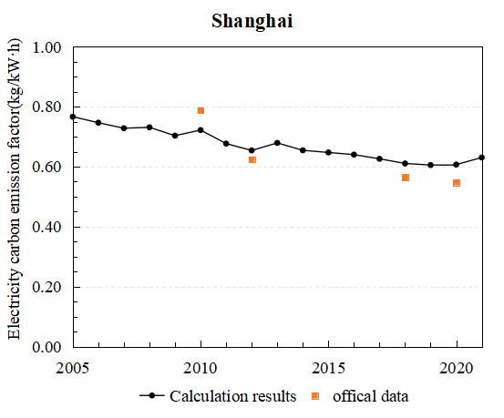 | 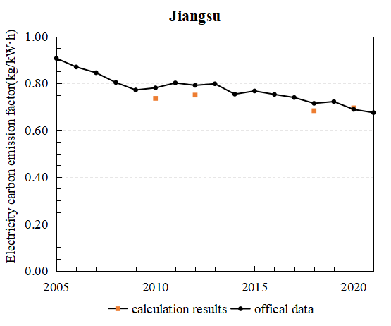
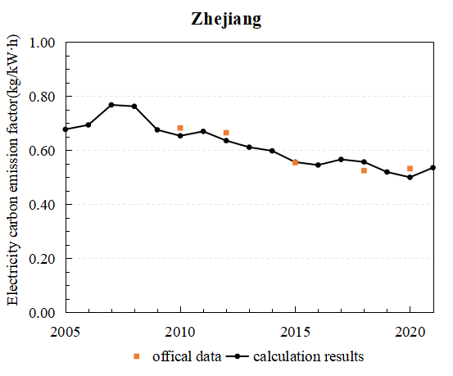 | 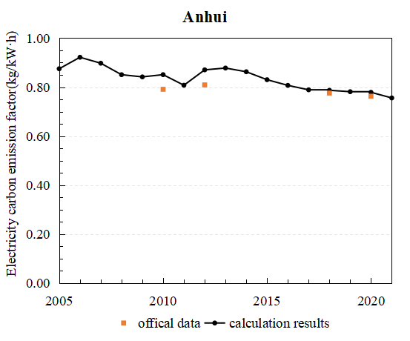
Figure S1. Electricity carbon emission factor in Shanghai, Jiangsu, Zhejiang, Anhui Province and

Decoupling results
Table S2. Decoupling results between PB’s carbon emissions and disposable income in 41cities in the YRD region
 | 2006-2011 |  | 2011-2016 |  | 2016-2021
 | φ | State | φ | State | φ | State
Shanghai | 1.48 | END | 0.90 | END | 0.66 | END
Nanjing | 2.44 | END | 1.65 | END | 2.52 | END
Wuxi | 2.80 | END | 1.09 | END | 1.91 | END
Xuzhou | 4.73 | END | 2.82 | END | 4.49 | END
Changzhou | 1.70 | END | 1.66 | END | 1.87 | END
Suuzhou | 1.71 | END | 1.58 | END | 1.98 | END
Nantong | 3.32 | END | 2.73 | END | 3.51 | END
Lianyungang | 3.74 | END | 2.26 | END | 4.21 | END
Huai’an | 4.33 | END | 2.38 | END | 5.61 | END
Yancheng | 6.79 | END | 2.74 | END | 5.72 | END
Yangzhou | 3.07 | END | 1.13 | END | 3.03 | END
Zhenjiang | 1.67 | END | 3.09 | END | 2.98 | END
Taizhou(JS) | 3.46 | END | 2.10 | END | 5.01 | END
Suqian | 5.21 | END | 3.42 | END | 4.26 | END
Hangzhou | 2.38 | END | 0.78 | END | 1.77 | END
Ningbo | 1.62 | END | 0.10 | END | 1.67 | END
Wenzhou | 3.49 | END | -0.52 | WD | 3.32 | END
Jiaxing | 3.90 | END | 0.16 | END | 1.49 | END
Huzhou | 0.11 | END | 0.62 | END | 3.87 | END
Shaoxing | 5.22 | END | 0.31 | END | 0.59 | END
Jinhua | 1.47 | END | 0.62 | END | 1.34 | END
Quzhou | -1.60 | SD | 0.50 | END | 4.97 | END
Zhoushan | 4.77 | END | 0.37 | END | 0.54 | END
Taizhou(ZJ) | 2.41 | END | 0.02 | END | 1.44 | END
Lishui | 4.06 | END | 0.44 | END | 1.42 | END
Hefei | 1.55 | END | 4.80 | END | 2.87 | END
Huaiben | 3.62 | END | 5.15 | END | 5.67 | END
Bozhou | 3.24 | END | 6.41 | END | 5.19 | END
Suzhou | 4.70 | END | 5.55 | END | 5.71 | END
Bengbu | 3.37 | END | 4.59 | END | 2.77 | END
Fuyang | 5.17 | END | 4.66 | END | 5.23 | END
Huainan | 3.74 | END | 2.67 | END | 6.55 | END
Chuzhou | 3.99 | END | 5.05 | END | 3.05 | END
Liuan | 3.69 | END | 10.79 | END | 5.39 | END
Maanshan | 1.22 | END | 5.04 | END | 3.32 | END
Wuhu | 1.46 | END | 4.59 | END | 1.82 | END
Xuancheng | 2.99 | END | 5.55 | END | 3.65 | END
Tongling | 2.25 | END | 1.39 | END | 4.63 | END
Chizhou | 3.39 | END | 5.17 | END | 3.27 | END
Anqing | 3.86 | END | 6.45 | END | 3.98 | END
Huangshan | 2.36 | END | 3.84 | END | 1.64 | END
Table S3. Decoupling results between UR’s carbon emissions and disposable income in 41cities in the YRD region
 | 2006-2011 |  | 2011-2016 |  | 2016-2021
 | φ | State | φ | State | φ | State
Shanghai | 0.03 | END | 0.95 | END | 1.48 | END
Nanjing | 0.71 | END | 1.46 | END | 1.56 | END
Wuxi | 0.74 | END | 1.24 | END | 1.36 | END
Xuzhou | 3.10 | END | 0.13 | END | 2.87 | END
Changzhou | 0.71 | END | 1.39 | END | 1.60 | END
Suuzhou | 1.18 | END | 2.02 | END | 1.10 | END
Nantong | 1.10 | END | 0.43 | END | 3.64 | END
Lianyungang | 2.04 | END | 1.73 | END | 4.97 | END
Huai’an | 0.28 | END | 3.22 | END | 3.70 | END
Yancheng | 2.43 | END | 1.83 | END | 6.02 | END
Yangzhou | 1.21 | END | 1.81 | END | 1.89 | END
Zhenjiang | 0.77 | END | 1.49 | END | 2.63 | END
Taizhou(JS) | 0.40 | END | 1.66 | END | 3.48 | END
Suqian | 2.42 | END | 2.32 | END | 3.61 | END
Hangzhou | 1.37 | END | 1.76 | END | 0.55 | END
Ningbo | -0.48 | WD | 1.24 | END | 0.86 | END
Wenzhou | 3.10 | END | -0.58 | WD | -1.35 | SD
Jiaxing | 2.47 | END | -0.20 | WD | 0.38 | END
Huzhou | 2.29 | END | 0.67 | END | 1.82 | END
Shaoxing | 3.35 | END | 0.86 | END | -0.73 | WD
Jinhua | 1.86 | END | 1.09 | END | 0.53 | END
Quzhou | 2.21 | END | 0.45 | END | 2.93 | END
Zhoushan | 3.75 | END | 0.85 | END | -0.54 | WD
Taizhou(ZJ) | 1.65 | END | 0.22 | END | -0.34 | WD
Lishui | 2.53 | END | 0.97 | END | 0.20 | END
Hefei | 1.73 | END | -0.48 | WD | 0.41 | END
Huaiben | -0.89 | WD | 0.10 | END | 1.74 | END
Bozhou | 0.57 | END | 0.89 | END | 1.53 | END
Suzhou | 0.08 | END | 3.42 | END | -0.01 | WD
Bengbu | 0.21 | END | 0.64 | END | -0.14 | WD
Fuyang | -0.64 | WD | 1.57 | END | 0.77 | END
Huainan | 0.65 | END | -1.52 | SD | -0.19 | WD
Chuzhou | -0.31 | WD | -0.36 | WD | 0.63 | END
Liuan | -1.41 | SD | 2.07 | END | 1.20 | END
Maanshan | 0.44 | END | 1.03 | END | 0.20 | END
Wuhu | 0.34 | END | 0.41 | END | 0.27 | END
Xuancheng | 0.92 | END | 2.06 | END | 0.83 | END
Tongling | 0.03 | END | 0.17 | END | 0.50 | END
Chizhou | 0.72 | END | 2.26 | END | -0.34 | WD
Anqing | -0.21 | WD | 0.68 | END | 0.56 | END
Huangshan | -0.37 | WD | 1.69 | END | 1.16 | END
Table S4. Decoupling results between RR’s carbon emissions and disposable income in 41cities in the YRD region
 | 2006-2011 |  | 2011-2016 |  | 2016-2021
 | φ | State | φ | State | φ | State
Shanghai | -1.20 | SD | -14.25 | SD | -1.62 | SD
Nanjing | 2.33 | END | 4.31 | END | 2.40 | END
Wuxi | 2.40 | END | 3.52 | END | 5.43 | END
Xuzhou | 6.00 | END | 10.59 | END | 1.33 | END
Changzhou | 2.27 | END | 5.19 | END | 2.29 | END
Suuzhou | 1.77 | END | 1.93 | END | 4.51 | END
Nantong | 5.95 | END | 6.38 | END | 4.36 | END
Lianyungang | 10.59 | END | 5.99 | END | 0.31 | END
Huai’an | 12.26 | END | 1.33 | END | -0.97 | WD
Yancheng | 7.81 | END | 5.71 | END | 1.18 | END
Yangzhou | 3.81 | END | 3.59 | END | 2.21 | END
Zhenjiang | 2.29 | END | 4.93 | END | -4.33 | SND
Taizhou(JS) | 5.89 | END | 4.15 | END | 2.49 | END
Suqian | 10.44 | END | 6.46 | END | 0.35 | END
Hangzhou | 3.08 | END | 0.87 | END | 10.11 | END
Ningbo | 0.83 | END | 0.82 | END | 8.06 | END
Wenzhou | 3.43 | END | -0.34 | WD | 15.35 | END
Jiaxing | 1.78 | END | -0.25 | WD | 12.05 | END
Huzhou | 3.10 | END | 1.61 | END | 5.08 | END
Shaoxing | 1.69 | END | 0.36 | END | 11.82 | END
Jinhua | 2.75 | END | 0.83 | END | 1.50 | END
Quzhou | 4.75 | END | 1.90 | END | 2.62 | END
Zhoushan | 3.62 | END | 0.86 | END | 4.11 | END
Taizhou(ZJ) | 3.68 | END | 0.38 | END | 1.95 | END
Lishui | 6.81 | END | 1.86 | END | -0.28 | WD
Hefei | 1.12 | END | 5.76 | END | -6.80 | SD
Huaiben | 0.48 | END | 8.36 | END | 4.42 | END
Bozhou | 0.64 | END | 4.93 | END | -0.32 | WD
Suzhou | 1.08 | END | 5.33 | END | -2.63 | SD
Bengbu | 0.83 | END | 6.43 | END | -2.02 | SD
Fuyang | 4.06 | END | 5.76 | END | 0.63 | END
Huainan | 0.37 | END | 4.46 | END | -1.01 | SD
Chuzhou | 1.18 | END | 7.28 | END | -2.57 | SD
Liuan | 0.75 | END | 12.92 | END | -2.35 | SD
Maanshan | -0.44 | WD | 6.00 | END | 0.67 | END
Wuhu | 1.56 | END | 6.16 | END | -0.36 | WD
Xuancheng | 2.25 | END | 6.65 | END | -2.31 | SD
Tongling | 1.22 | END | 2.56 | END | 2.78 | RD
Chizhou | 1.41 | END | 5.47 | END | -3.31 | SD
Anqing | -2.31 | SD | 13.63 | END | 1.03 | END
Huangshan | -1.24 | SD | 8.40 | END | 1.08 | END

