Appendix S1. Table of phytoplankton species identified in this study.

|  |
| --- |
| Species name |
| Microcystis aeruginosa |
| Chroococcus minutus |
| Chroococcus tenaax |
| Nostoc linckin |
| Aphanizomenon flos-aquae |
| Lyngbya limntica |
| Oscillatoria sp. |
| Phormidium tenue |
| Oscillatoria princeps |
| Phormidium sinense |
| Phormidium faveolarum |
| Phormidium corium |
| Phormidium tenue |
| Spirulina sp. |
| Spirulina platensis |
| Merismopedia minima |
| Merismopedia elegans |
| Merismopedia glauca |
| Aphanocapsa delicatissima |
| Raphidiopsis sp. |
| Merismopedia sinica |
| Raphidiopsis curvata |
| Cryptomonas sp. |
| Cryptomonas erosa |
| Chroomonas ovata |
| Chroomonas acuta |
| Melosira granulata |
| Melosira varians |
| Cyclotella sp. |
| Cyclotella comensis |
| Cyclotella meneghiniana |
| Asterionella formosa |
| Fragilaria sp. |
| Fragilaria virescens |
| Fragilaria capucina |
| Fragilaria intermedia |
| Synedra acus |
| Synedra ulna |
| Synedra ulua var.impressa |
| Achnanthes inflata |
| Achnanthes lanceolata |
| Achnanthes exigua |
| Achnanthes delicatula |
| Cocconeis placentula |
| Stauroneis sp. |
| Stauroneis anceps |
| Navicula sp. |
| Navicula simplex |
| Navicula capitata |
| Navicula exigua |
| Navicula radiosq |
| Navicula pupula |
| Navicula cryptocephala |
| Navicula rhynchocephala |
| Navicula minima |
| Navicula cuspidate |
| Navicula cincta |
| Navicula cuspidata |
| Pinnularia nobilis |
| Pinnularia undulate |
| Pinnularis viridis |
| Cymbella sp. |
| Cymbella affinis |
| Cymbella ventricosa |
| Cymbella tumida |
| Cymbella parua |
| Gomphonema sp. |
| Comphonema augur |
| Gomphonema constrictum |
| Gomphonema constrictum var.capitatum |
| Gomphonema angust- atum var. producta |
| Gomphonema turris |
| Gomphonema parvulum |
| Gomphonema gracile |
| Nitzschia sp. |
| Nitzschia acicularis |
| Nitzchia palea |
| Nitzschia amphibia |
| Nitzschia linearis |
| Surirella linenris |
| Surirella capronii |
| Surirella robusta |
| Hantzschia amphioxysf.capitata |
| Diploneis oualis |
| Amphora ovalis |
| Gyrosigma acuminatum |
| Diatoma vulgure |
| Frustulia vulgaris |
| Eunotia pectinnalis |
| Cymatopleura solea |
| Cymatopleura elliptica |
| Acanthosphaera zachariasi |
| Chlorella vulgaris |
| Chlamydomonas sp. |
| Chlamydomonas simplex |
| Chlamydomonas braunii |
| Chlamydomonas snowiae |
| Chlamydomonas debaryana |
| Chlamydomonas microsphaera |
| Chlorococcum sp. |
| Eudorina elegans |
| Pandorina morum |
| Sphaerocystis schroeteri |
| Schroederia sp. |
| Schroederia robusta |
| Schroederia nitzschioides |
| Carteria multifilis |
| Chodatella quadriseta |
| Chodatella wratislaviensis |
| Coelastrum microporum |
| Kirchneriella lunaris |
| Kirchneriella obesa |
| Krichneriella contorta |
| Oocystis sp. |
| Oocystis solitaria |
| Oocystis lacustris |
| Oocystis borgei |
| Selenastrum dibraianum |
| Selenastrum gracile |
| Dictyosphaerium sp. |
| Dictyosphaerium pulchellum |
| Tetraedron sp. |
| Tetraedron trigonum |
| Tetraedron minimum |
| Tetraedron candatum |
| Cosmarium sp. |
| Cosmarium laeve |
| Cosmarium formosulum |
| Arthrodesmas convergens |
| staurodesmus sp. |
| Scenedesmus sp. |
| Scenedesmus arcuatus |
| Scenedesmus quadricauda |
| Scenedesmus javaensis |
| Scenedesmus carinatus |
| Scenedesmus bicaudatus |
| Scenedesmus dimorphus |
| Scenedesmus denticulatus |
| Scenedesmus bijuga |
| Scenedesmus spinosus |
| Pediastrum |
| Pediastrum boryanum |
| Pediastrum simplex |
| Pediastrum duplex |
| Pediastrum tetras |
| Pediastrum biradiatum |
| Gonium sp. |
| Crucigenia tetrapedia |
| Crucigenia quadrata |
| Crucigenia lauterbonii |
| Micractinium sp. |
| Tetraspora sp. |
| Treubaria |
| Tetrastrum staurogeniaforme |
| Quadrigulachodatii |
| Chlorococcum sp. |
| Ankistrodesmus falcatus |
| Ankistrodesmus acicularis |
| Ankistrodesmus convolutus |
| Ankistrodesmus angustus |
| Closterium sp. |
| Closterium acerosum |
| Closterium gracile |
| Closterium intermedium |
| Closterium parvulum |
| Closterium kützingii |
| Monoraphidium contortum |
| Ulotrix osillarina |
| Pteromonasangulosa |
| Ochromonas mutabilis |
| Dinobryon sertularia |
| Dinobryon divergens |
| Glenodinium pulvisculus |
| Ceratium hirundinella |
| Ceratium hirundinella |
| Peridinium sp. |
| Prorocentrum minimum |
| Peridinium bipes Stein |
| Tribonema sp. |
| Tribonema minue |
| Euglena sanguinea |
| Euglena viridis |
| Euglena acus |
| Euglena oxyuris |
| Euglena caudata |
| Phacus sp. |
| Phacus longicauda |
| Phacus pyrum |
| Phacus ovalis |
| Trachelomonas sp. |
| Trachelomonasoblonga |
| Trachelomonas volvocina |
| Lepocinclis steinii |
| Strombomonas ensifera |
| Strombomonas fluviatilis |
| Khawkinea acutecouato |

Appendix S2. Table of zooplankton species identified in this study.

|  |
| --- |
| Species name |
| Vorticella campanula |
| Arcella arenaria |
| Arcella vulgaris |
| Arcella discoides |
| Difflugia auellana |
| Difflugia corona |
| Difflugia oblonga Ehrenberg |
| Difflugia qramen |
| Difflugia urceolata |
| paramecium |
| Tintinnopsis wangi |
| Tintinnopsis sinensis |
| Epistylis rotans |
| Colepidae |
| Actinosphaerium eichhorni |
| actinophrys |
| Chilodonella |
| Didinium balbianii |
| Didinium balbianii nanum |
| Brachionus sp. |
| Brachionus diversicornis |
| Brachionus calyciflorus Pallas |
| Brachionus leydigi |
| Brachionus quadridentatus |
| Brachionus urceus |
| Brachionus angularis |
| Brachionus caudatus |
| Brachionus forficula |
| Brachionus budapestinensis |
| Keratella sp. |
| Keratella valga |
| Keratella cochlearis |
| Keratella quadrala |
| Keratella ticinensis |
| Filinia longisela |
| Synchacta tremula |
| Synchaeta stylata |
| Polyarthra trigla |
| Polyarthra dolichoptera |
| Monostyla lunaris |
| Monostyla bulla Gosse |
| Monostyla pyriformis |
| Monostyla unguitata |
| Monostyla cornuta |
| Colurella uncinata |
| Pedalia sp. |
| Asplanchna brightwelli |
| Asplanchna priodonta |
| Asplanchna girodi |
| Rotifer sp. |
| Lecane sp. |
| Lecane ungulata |
| Epiphanes senta |
| Lepadella patella |
| Notholon labis |
| Notholon sqwmoda |
| Keratella quadrata |
| Conochilus unicornis |
| Trichocerca pusilla |
| Trichocerca bicrislata |
| Trichocerca rousseleti |
| D icranophorus cauda tus |
| Euchlanis dilatata |
| Pompholyx complanata |
| Diurella stylata |
| Diurella weberi Jennings |
| Alona guttataSars |
| Moina weismanni |
| Moina micrura |
| Moina macrocopa |
| Daphnia carinata |
| Diaphanosoma leuchtenbergianum |
| Diaphanosoma brachyurum |
| Bosmina longirostris |
| Simocephalus vetulus |
| Copepodid larva |
| Eucylops serrulatus |
| Thermocyclops sp. |
| Eucylops serrulatus |
| Mesocyclops leuckarti |
| Calanus sinicus |
| Nauplius |
| Harpacticoida |

Appendix S*3*. Pearson correlation matrix between environmental parameters and phytoplankton diversity indices

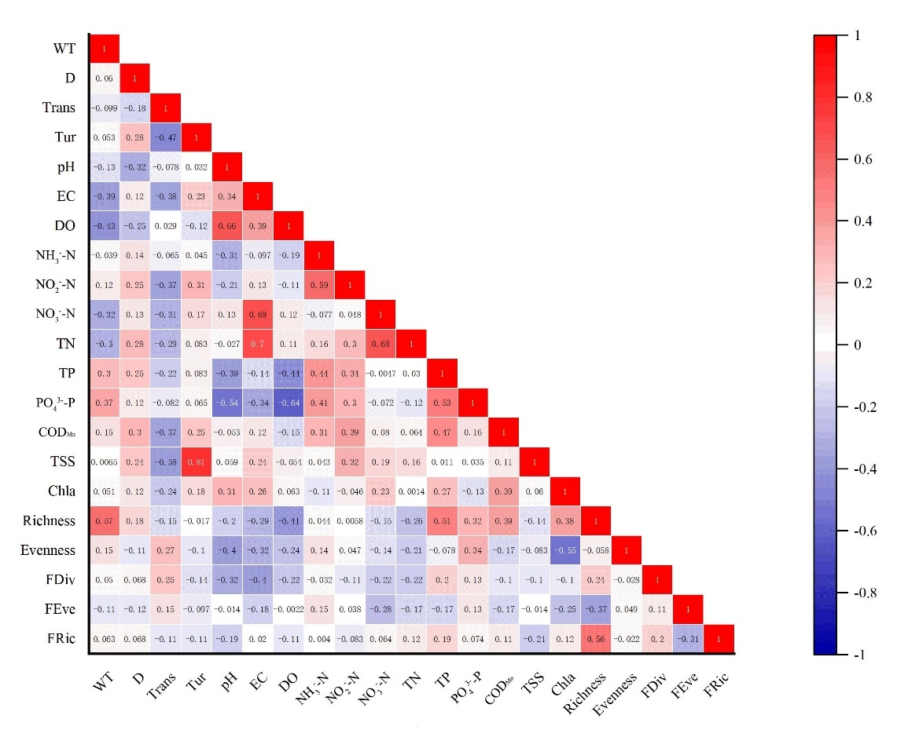

This figure shows the correlation between variables such as water environment parameters and phytoplankton diversity indicators. The color depth indicates the magnitude of the Pearson correlation coefficients, with red representing positive correlations and blue representing negative correlations. The correlation coefficients range from -1 to +1. (WT: water temperature; D: water depth; Trans: transparency; Tur: turbidity; pH: pH; EC: electrical conductivity; DO: dissolved oxygen; NH3--N: ammonia nitrogen; NO2–-N: nitrite nitrogen; NO3–-N: nitrate nitrogen; TN: total nitrogen; TP: total phosphorus; PO43–-P: phosphate; CODMn: permanganate index; TSS: suspended solids; Chl-a: chlorophyll-a; Richness: species richness; Evenness: evenness; FDiv: functional divergence; FEve: functional evenness; FRic: functional richness)