**Supplementary Figures**

**Supplementary Figure 1**.Pearson’s correlation among traits recorded from dry (_d) and fresh (_f) spikes. Correlation plot for F19 (A), F20 (B), F21 (C), P20(D) and for multi-environment (E) are reported. The traits are denoted as: FRT, total floret number; NFRT, net floret number; SPK, total spikelet number; NSPK, net spikelet number.

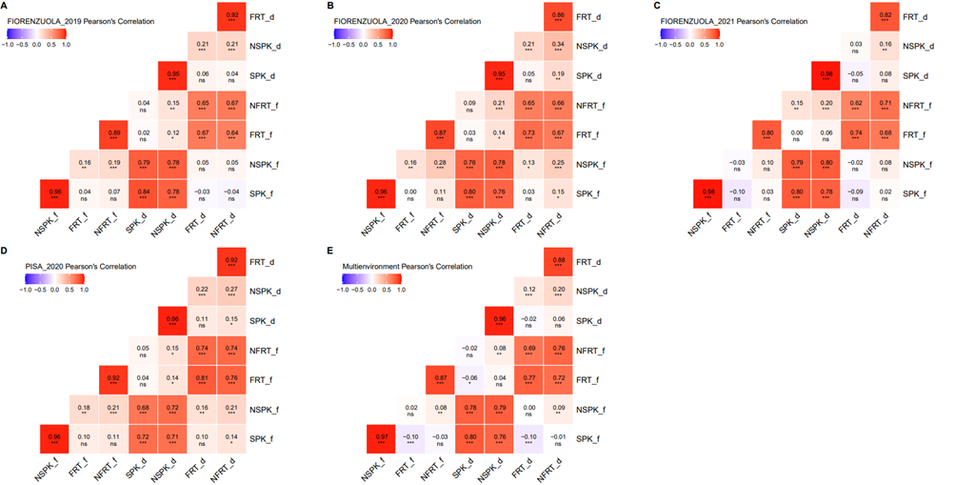

* Significance level at *p*<0.05, **significance level at *p* <0.01, ***significance level at *p* <0.001 and ns for non-significant.

**Supplementary Figure 2.** Pearson’s correlation among all traits in each environment. Correlation plot for F19 (A), F20 (B), P20 (C) and F21(D) are reported.

* Significance level at *p* <0.05, **significance level at *p* <0.01, ***significance level at *p*<0.001 and ns for non-significant.

The traits are denoted as: FRT, total floret number; NFRT, net floret number; SPK, total spikelet number; NSPK, net spikelet number.

**Supplementary Figure 3.** A) Principal component analysis of multi-environment BLUP for all traits; dots are coloured according heading date. B) Correlation of the principal components with all targeted traits.

The traits are denoted as: FRT, total floret number; NFRT, net floret number; SPK, total spikelet number; NSPK, net spikelet number.