Supplementary Material

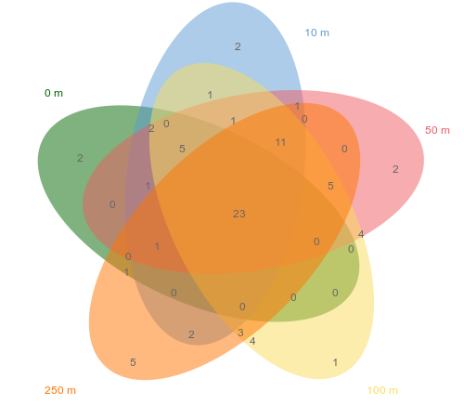
Supplementary Figures

Supplementary Figure 1 Petal Venn diagram of plant compositions at different distances from the highway.

