Supplementary Material

Supplementary Figures

Supplementary Figure 1. Mechanical tests on a hexagonal patch of membrane. (A) uniaxial stretching. (B) shearing, after Závodszky et al. (2017) under CC-BY 4.0 license.
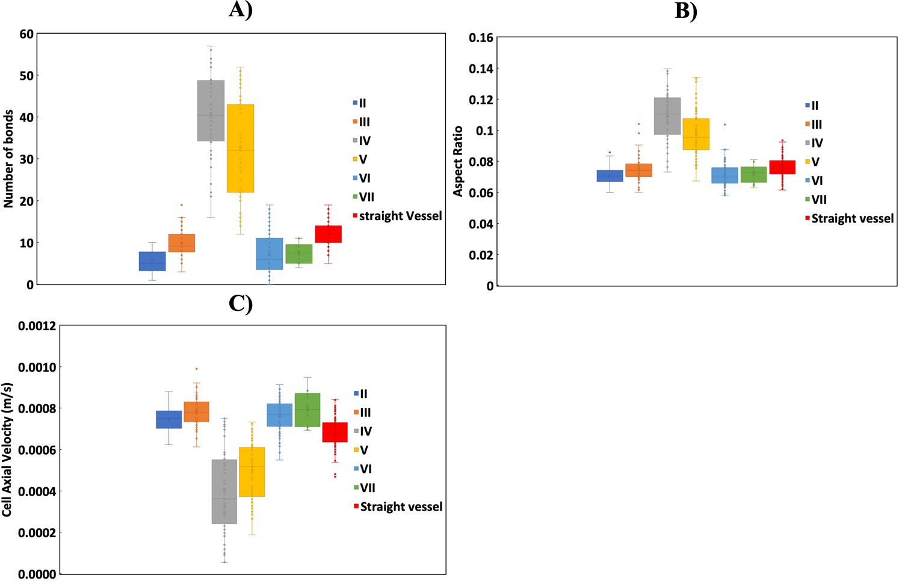
Supplementary Figure 2. Comparison of the behaviour of CTCs in the straight vessel with that in the regions of the curved vessel in terms of (A) the number of adhesion bonds, (B) aspect ratio, and (C) cell axial velocity.
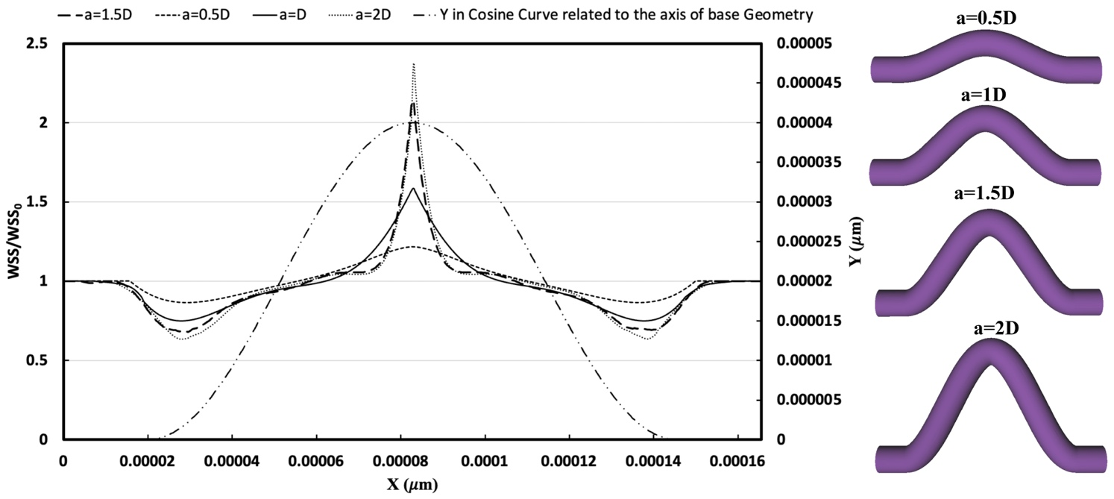
Supplementary Figure 3. Spatial distribution WSS ratio on the inferior curvature in the curved vessel with various amplitude magnitudes (a) relative to a straight one considering pure blood flow without any cell with the same Reynolds number. Various geometries of the curved vessel related to different amplitudes are depicted on the right.

Supplementary Table
Supplementary Table 1 Parameters used in the model.
Parameter | Definition | Physical value | References
$$T$$ | Absolute temperature | $$310 K$$ | (Chang and Hammer, 1996)
$$k_{f}^{0}$$ | Unstressed forward reaction rate | $$750 s^{-1}$$ | (Zhang et al., 2018)
P_{off} | Power parameter for modulating the effect of shear stress on the rate of bond rupture | -3 | (Yan et al., 2012)
P_{on} | Power parameter for modulating the effect of shear stress on the rate of bond formation | 1 | (Yan et al., 2012)
$$k_{r}^{0}$$ | Unstressed reverse reaction rate | $$20 s^{-1}$$ | (Zhang et al., 2018)
$$k_{l_{CTC}}$$ | Link force coefficient (equivalent to G=90μN/m) | 150 | (Lenarda et al., 2019)
$$k_{b_{CTC}}$$ | Bending force modulus | 600 $K_{B}T$ | (Cui et al., 2021)
$$k_{a_{CTC}}$$ | Local area conservation coefficient (equivalent to Poisson's Ratio of 1/3) | 250 | (Tan, 2015)
$$k_{v_{CTC}}$$ | Volume conservation coefficient¹ | 600 | -
$$σ_{ts}$$ | Transition state spring constant | $${2×10}^{-6}N/m$$ | (Zhang et al., 2018)
$$σ_{b}$$ | Bond spring constant | $${10}^{-4 }N/m$$ | (Zhang et al., 2018)
$$l_{0}$$ | Equilibrium bond length in adhesive dynamics model | $$0.5 μm$$ | (Dabagh et al., 2020)
$$H_{c}$$ | Cut-off length for bond formation | $$1 μm$$ | (Dabagh et al., 2020)
$$K_{B}$$ | Boltzmann constant | $$1.38× {10}^{-23} J/K$$ | (Dabagh et al., 2020)
$$∆t$$ | Time interval | $${10}^{-7} s$$ | (Wang et al., 2013; Wu and Qi, 2019)
$$\dot{γ}$$ | Fluid Average Shear rate (${U_{max}}/D$) | 200 | (Zhang et al., 2018; Dabagh et al., 2020)
$$∆x$$ | Fluid lattice resolution | $$0.5 μm$$ | (Lenarda et al., 2019)
$$D_{cp}$$ | Microvessel diameter | $$20 μm$$ | (Lenarda et al., 2019)
$$L_{cp}$$ | Length of the periodic microvessel domain | $$165 μm$$ | -
$$ν$$ | Kinematic viscosity of plasma | $$1.2× {10}^{-6} {m^{2}}/s$$ | (Dabagh and Randles 2019)
$$μ$$ | Dynamic viscosity of plasma | $$1.2 mPa.s$$ | (Dabagh and Randles 2019)
$$r_{CTC}$$ | CTC baseline radius | $$4 μm$$ | (Suresh 2007; Anvari et al.2021)
- Volume modulus is chosen to be large but numerically stable (Závodszky et al., 2017).

References
Anvari, S., Osei, E., and Maftoon, N. (n.d.). Interactions of Platelets with Circulating Tumor Cells Contribute to Cancer Metastasis. Sci Rep.
Chang, K.-C., and Hammer, D. A. (1996). Influence of Direction and Type of Applied Force on the Detachment of Macromolecularly-Bound Particles from Surfaces. Langmuir 12, 2271–2282. doi: 10.1021/la950690y
Cui, J., Liu, Y., Xiao, L., Chen, S., and Fu, B. M. (2021). Numerical study on the adhesion of a circulating tumor cell in a curved microvessel. Biomech Model Mechanobiol 20, 243–254. doi: 10.1007/s10237-020-01380-x
Dabagh, M., Gounley, J., and Randles, A. (2020). Localization of Rolling and Firm-Adhesive Interactions Between Circulating Tumor Cells and the Microvasculature Wall. Cel. Mol. Bioeng. 13, 141–154. doi: 10.1007/s12195-020-00610-7
Dabagh, M., and Randles, A. (2019). Role of deformable cancer cells on wall shear stress-associated-VEGF secretion by endothelium in microvasculature. PLOS ONE 14, e0211418. doi: 10.1371/journal.pone.0211418
Késmárky, G., Kenyeres, P., Rábai, M., and Tóth, K. (2008). Plasma viscosity: A forgotten variable. Clinical Hemorheology and Microcirculation 39, 243–246. doi: 10.3233/CH-2008-1088
Lenarda, P., Coclite, A., and Decuzzi, P. (2019). Unraveling the Vascular Fate of Deformable Circulating Tumor Cells Via a Hierarchical Computational Model. Cel. Mol. Bioeng. 12, 543–558. doi: 10.1007/s12195-019-00587-y
Suresh, S. (2007). Biomechanics and biophysics of cancer cells. Acta Biomaterialia 3, 413–438. doi: 10.1016/j.actbio.2007.04.002
Tan, J. (2015). Lattice Boltzmann Method and Its Applications in Soft Matter. 166.
Wang, W., Mody, N. A., and King, M. R. (2013). Multiscale model of platelet translocation and collision. Journal of Computational Physics 244, 223–235. doi: 10.1016/j.jcp.2012.08.014
Wu, T.-H., and Qi, D. (2019). Investigation of shear rates of rolling adhesion on leukocytes with bending of microvilli. Phys. Rev. Fluids 4, 063101. doi: 10.1103/PhysRevFluids.4.063101
Yan, W. W., Cai, B., Liu, Y., and Fu, B. M. (2012). Effects of wall shear stress and its gradient on tumor cell adhesion in curved microvessels. Biomech Model Mechanobiol 11, 641–653. doi: 10.1007/s10237-011-0339-6
Závodszky, G., van Rooij, B., Azizi, V., and Hoekstra, A. (2017). Cellular Level In-silico Modeling of Blood Rheology with An Improved Material Model for Red Blood Cells. Front. Physiol. 8, 563. doi: 10.3389/fphys.2017.00563
Zhang, Z., Du, J., Wei, Z., Wang, Z., and Li, M. (2018). Effects of membrane deformability and bond formation/dissociation rates on adhesion dynamics of a spherical capsule in shear flow. Biomech Model Mechanobiol 17, 223–234. doi: 10.1007/s10237-017-0956-9

