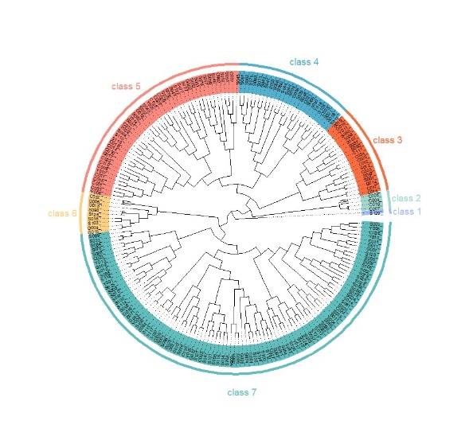

Figure S1. Cluster analysis of 240 germplasm resources

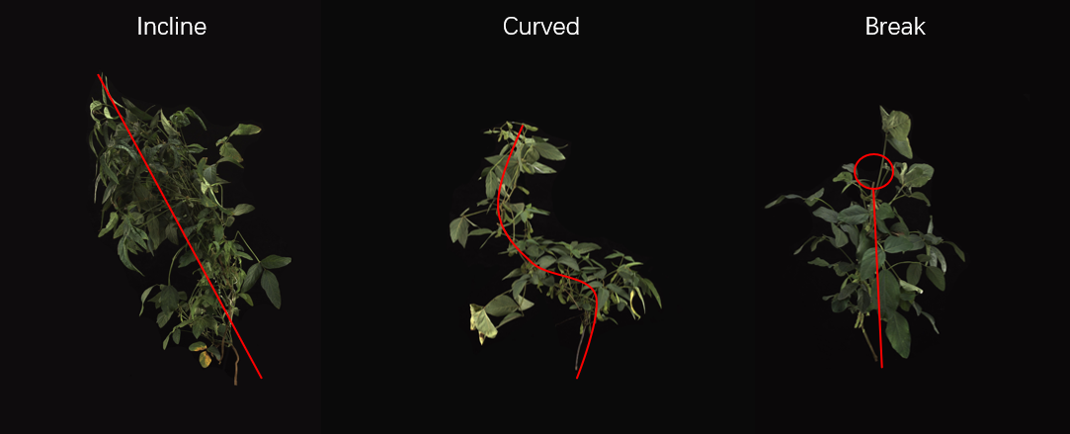

Figure S2. Diagram of extreme material field growth.