**Table S1**

China 's total output of aquatic products in 2020.

|  |  |  |
| --- | --- | --- |
| Index | Production(104t) | Aquaculture production(104t) |
| Pisces | 3752.69 | 2761.36 |
| Crustaceans | 800.56 | 603.29 |
| Shellfish | 1552.04 | 1498.71 |
| Alga | 264.34 | 262.14 |
| Cephalopods | 56.49 | 0 |
| Miscellaneous | 122.91 | 98.70 |
| Sum | 6549.02 | 5224.20 |

**Table S2**

The discovery of red tide in Fujian sea area in 2021.

|  |  |  |  |  |  |
| --- | --- | --- | --- | --- | --- |
| Region | Time | Days | Sea area | Maximal area(km2) | Dominant species |
| Fuzhou | May 10 th~11th | 2 | The sea area near Houwan Village, Lianjiang County | 1.0 | Noctiluca scintillans |
| September 30th~October 6th | 7 | Huangqi bay | 8.0 | Akashiwo sanguinea |
| Pingtan | May 26 th~27th | 2 | The sea area near Su 'ao Town, Pingtan County | 0.5 | Noctiluca scintillans |
| Ningde | June 7th~10th | 4 | The sea area near Yujing Village, Xiamen Township, Fuding City | 3.0 | Prorocentrum donghaiense |

**Table S3**

Indicator grading criteria for ecosystem health evaluation in Sansha Bay.

| Indicator | Excellent | Good | Fair | Poor | Very poor |
| --- | --- | --- | --- | --- | --- |
| The comprehensive disturbance index of sea use(P1) | 0＜P1≤0.17 | 0.17＜P1≤0.23 | 0.23＜P1≤0.6 | 0.6＜P1≤0.8 | 0.8＜P1＜1 |
| Assignment Score | [80,100) | [60,80) | [40,60) | [20,40) | [0,20) |
| The proportion of industrial discharge outlets(P2) | The assignment method of P2 is：The minimum value of P2 ( 0 ) corresponds to the assignment of 100, and the maximum value of P2 (14.19 %) corresponds to the assignment of 0. According to the linear relationship, the assignment calculation formula is: ${P2}_{(A)}=100-705×P2$. | | | | |
| Assignment Score | [80,100) | [60,80) | [40,60) | [20,40) | [0,20) |
| The density of total discharge outlets(P3) | The assignment method of P3 is：The minimum value of P3 ( 0 ) corresponds to the assignment of 100, and the maximum value of P3 (4 ) corresponds to the assignment of 0. According to the linear relationship, the assignment calculation formula is: ${P3}_{(A)}=100-25×P3$*.* | | | | |
| Assignment Score | [80,100) | [60,80) | [40,60) | [20,40) | [0,20) |
| The regional environmental risk index(P4) | P4=0 | 0＜P4<1 | 1≤P4<10 | 10≤P4<100 | P4≥100 |
| Assignment Score | 100 | (75,100） | (50,75] | (25,50] | [0,25] |
| The phosphorus-to-nitrogen molar ratio(S1) | 8≤S1≤32 | — | 4≤S1<8  or  32<S1≤64 | — | S1<4  or  S1 >64 |
| Assignment Score | [80,100] | — | [60,80) | — | [0,60) |
| The dissolved oxygen saturation index(S2) | 95%≤S1≤110% | — | 80%≤S1<95% or 110%<S1≤120% | — | S1<80% or  S1>120% |
| Assignment Score | [100,80] | — | [60,80) | — | [0,60) |
| The comprehensive water heavy metal pollution index(S3) | 0≤S3＜1.0 | 1.0≤S3＜4.2 | 4.2≤S3＜8.4 | 8.4≤S3＜37 | 37≤S3 |
| Assignment Score | [80,100] | [60,80) | [40,60) | (0,40) | 0 |
| The aquatic product quality index(S4) | 0≤S4<0.2 | 0.2≤S4<0.6 | 0.6≤S4<1 | 1≤S4 | — |
| Assignment Score | (80,100] | (60,80] | [40,60] | [0,40] | — |
| The phytoplankton species diversity index(S5) | 3.8≤S5 | 2.5≤S5<3.8 | 1.8≤S5<2.5 | 0.9≤S5<1.8 | 0≤S5<0.9 |
| Assignment Score | 100 | [75,100) | [50,75) | [25,50) | [0,25) |
| The zooplankton species diversity index(S6) | 4.0≤S6 | 2.4≤S6<4.0 | 1.5≤S6<2.4 | 0.9≤S6<1.5 | 0≤S6<0.9 |
| Assignment Score | 100 | [75,100) | [50,75) | [25,50) | [0,25) |
| The red tide risk index(S7) | 0≤S7≤1.0 | — | 1.0≤S7<2.5 | — | S7≥2.5 |
| Assignment Score | [80,100] | — | [60,80) | — | [0,60) |
| The ratio of filter-feeding shellfish and macroalgae cultivation area to the total aquaculture area(R1) | R1≥15% | — | 5%≤R1＜15% | — | R1＜5% |
| Assignment Score | [80,100] | — | [60,80) | — | [0,60) |
| The expanse of nature reserves(R2) | R2≥38% | — | 10%＜R2＜38% | — | R2≤10% |
| Assignment Score | [80,100] | — | (60,80) | — | [0,60] |
| The duration of the fishing moratorium(R3) | Comply with policy requirements. | — | — | — | Non-compliance with policy requirements |
| Assignment Score | 100 | — | — | — | 0 |

**Table S4**

The Calculation method, Value, Assignment Score , and Health State of each indicator.

|  |  |  |  |  |  |
| --- | --- | --- | --- | --- | --- |
| Indicator | Equation | Zoning | Values of Indexes | Assignment Scores | Health State |
| P1 | $$P1=\sum{\frac{A_{i}}{A}×F }$$ Where A*i* is different sea area, km2; A is the area of the zoning, km2; F is the assignment of different sea area. (The assignments are as follows: 0.98 for sea use of the port, 0.99 for industrial and urban sea area, 0.63 for sea use of cage culture, and 0.99 for sea use of tourism and leisure entertainment.) | 1 | 0.90 | 10 | Very poor |
| 2 | 0.90 | 10 | Very poor |
| 3 | 0.74 | 26 | Poor |
| 4 | 0.99 | 1 | Very poor |
| P2 | $P2=\frac{B}{C}$; $P2_{A}=100-705×$ P2  Where B is the number of industrial discharge outlets; C is the total number of discharge outlets; P2A is the assignment of the proportion of industrial discharge outlets in the zoning. | 1 | 4.12 | 71 | Good |
| 2 | 14.19 | 0 | Very poor |
| 3 | 11.25 | 21 | Poor |
| 4 | 0 | 100 | Excellent |
| P3 | $P3=\frac{D}{E}$; $P3_{A}=100-25×P3$ Where D is the number of discharge outlets in the zoning; E is the area of the zoning, km2; P3A is the assignment of the density of total discharge outlets in the zoning. | 1 | 3.85 | 0 | Very poor |
| 2 | 0.92 | 75 | Good |
| 3 | 2.20 | 50 | Fair |
| 4 | 0.35 | 100 | Excellent |
| P4 | $$P4=\frac{q_{1}}{Q_{1}}+\frac{q_{2}}{Q_{2}}+\frac{q_{3}}{Q_{3}}+…\frac{q_{n}}{Q_{n}}$$ Where q1, q2,..... qn is the maximum total amount of each hazardous substance,t; Q1, Q2... Qn The critical amount of each dangerous substance, t. | 1 | 13738.58 | 0 | Very poor |
| 2 | 0 | 100 | Excellent |
| 3 | 0 | 100 | Excellent |
| 4 | 0 | 100 | Excellent |
| S1 | $$S1={\frac{C_{IN}}{M_{N}}}/{\frac{C_{P}}{M_{P}}}$$ Where CIN is the concentration of inorganic nitrogen (mg/L) in the surface seawater of a sampling sites; CP is the concentration of active phosphate (mg/L) in the surface seawater of a sampling sites; MN is the molar mass of nitrogen (g/mol); MP is the molar mass of phosphorus (g/mol). | 1 | 23 | 95 | Excellent |
| 2 | 18 | 97 | Excellent |
| 3 | 14 | 90 | Excellent |
| 4 | 22 | 97 | Excellent |
| S2 | $S2=\frac{P_{O_{2}}}{P_{{O'}_{2}}}×1$ 00%  Where PO2 is the measured oxygen content, mg/L; PO’2 is the saturation concentration of oxygen in seawater at field water temperature and salinity, mg/L. | 1 | 81 | 61 | Fair |
| 2 | 82 | 63 | Fair |
| 3 | 81 | 61 | Fair |
| 4 | 86 | 68 | Fair |
| S3 | $$S_{j}=\frac{C_{i}}{C_{o}}; S3=\sqrt{\frac{S_{j,max}^{2}+{\overline{S}}_{j}^{2}}{2}}$$ Where Sj is the single factor pollution index of heavy metals at station j; Ci is the measured concentration of heavy metals; Co is the evaluation standard of heavy metals; Sj,max is the largest single factor index in station j; j is the average value of each single factor index. | 1 | 0.078 | 98 | Excellent |
| 2 | 0.067 | 99 | Excellent |
| 3 | 0.053 | 99 | Excellent |
| 4 | 0.052 | 99 | Excellent |
| S4 | $P_{n}=C_{i}/C_{io}$; $S4=\sqrt[n]{P_{1}×P_{2}×⋯P_{n}}$ Where Pn is the pollution index of a pollution factor; Ci is the measured concentration of a pollution factor; Cio is the evaluation standard of a pollution factor. | 1 | 0.31 | 75 | Good |
| 2 | 0.21 | 80 | Good |
| 3 | 0.21 | 80 | Good |
| 4 | 0.10 | 90 | Excellent |
| S5 | $S5=-\sum{P_{i}lnP_{i}}$; $P_{i}=\frac{N_{i}}{N}$ Where Pi is the ratio of the number of i individuals to the total number of individuals in the survey station; Ni is the number of individuals of species i; N is the number of all individuals in the survey station. | 1 | 2.27 | 67 | Fair |
| 2 | 2.81 | 81 | Good |
| 3 | 2.54 | 76 | Good |
| 4 | 2.54 | 76 | Good |
| S6 | $S6=-\sum{P_{i}lnP_{i}}$; $P_{i}=\frac{N_{i}}{N}$ Where Pi is the ratio of the number of i individuals to the total number of individuals in the survey station; Ni is the number of individuals of species i; N is the number of all individuals in the survey station. | 1 | 2.55 | 77 | Good |
| 2 | 2.93 | 83 | Good |
| 3 | 2.74 | 80 | Good |
| 4 | 2.74 | 80 | Good |
| S7 | $$S7=\sum_{i=1}^{n}{\left[T_{i}×\log{(S_{i}×D_{i}}\right]}$$ Where n is the number of red tides in the region; Ti is the toxicity of the dominant species of red tide, and the T value is 1 when the dominant species is toxic red tide; The T value was 0.67 when the dominant species was harmful red tide organisms; The T value was 0.33 when the dominant species was non-toxic red tide organisms; Si is the maximum area of red tide (km2); Di is the number of days the red tide lasts. | 1 | 0 | 100 | Excellent |
| 2 | 0 | 100 | Excellent |
| 3 | 0 | 100 | Excellent |
| 4 | 0 | 100 | Excellent |
| R1 | $$R1=\frac{E}{F}$$ Where E is the filter-feeding shellfish and macroalgae cultivation area; F is the total sea area of each evaluation unit. | 1 | 10.08 | 70 | Fair |
| 2 | 16.00 | 82 | Excellent |
| 3 | 32.32 | 100 | Excellent |
| 4 | 0.17 | 2 | Very poor |
| R2 | $$R2=\frac{G}{F}$$ Where G is the nature reserve area; F is the total sea area of each evaluation unit. | 1 | 0 | 0 | Very poor |
| 2 | 26.58 | 72 | Fair |
| 3 | 0 | 0 | Very poor |
| 4 | 45.80 | 86 | Excellent |
| R3 | The fishing moratorium in 2020 ranged from May 1st to September 16th within Sansha Bay. | 1 | 138 | 100 | Excellent |
| 2 | 138 | 100 | Excellent |
| 3 | 138 | 100 | Excellent |
| 4 | 138 | 100 | Excellent |

**Table S5**

The calculation process of entropy weight method

| Target layer | Criterion layers | Index | Values of Information entropy value (e) | Values of Information utility(d) | Weight (%) |
| --- | --- | --- | --- | --- | --- |
| Health level of aquaculture ecosystem | Pressure  （27.96%） | P1 | 0.69 | 0.31 | 8.04 |
| P2 | 0.68 | 0.31 | 8.27 |
| P3 | 0.76 | 0.24 | 6.19 |
| P4 | 0.79 | 0.21 | 5.47 |
| State  （50.52%） | S1 | 0.75 | 0.24 | 6.46 |
| S2 | 0.33 | 0.67 | 17.78 |
| S3 | 0.76 | 0.24 | 6.43 |
| S4 | 0.75 | 0.25 | 6.72 |
| S5 | 0.75 | 0.25 | 6.57 |
| S6 | 0.75 | 0.25 | 6.57 |
| S7 | 1 | 0 | 0 |
| Response  （21.52%） | R1 | 0.71 | 0.29 | 7.66 |
| R2 | 0.47 | 0.53 | 13.86 |
| R3 | 1 | 0 | 0 |

**Table S6**

The calculation process of analytical hierarchy process method

| Criterion layer | Pressure | State | Response | Eigenvector | Weight  (%) | Maximum eigenvalue | CI | RI | CR | Consistency Test |
| --- | --- | --- | --- | --- | --- | --- | --- | --- | --- | --- |
| Pressure | 1 | 9/34 | 8/17 | 0.413 | 13.763 | 3.041 | 0.020 | 0.520 | 0.039 | Pass |
| State | 34/9 | 1 | 13/4 | 1.872 | 62.391 |
| Response | 17/8 | 4/13 | 1 | 0.715 | 23.846 |

**Table S7**

The calculation process of the index layer of analytical hierarchy process method

| Index  layer | P1 | P2 | P3 | P4 | S1 | S2 | S3 | S4 | S5 | S6 | S7 | R1 | R2 | R3 | Eigenvector | Weight  (%) | Maximum eigenvalue | CI | RI | CR | Consistency Test |
| --- | --- | --- | --- | --- | --- | --- | --- | --- | --- | --- | --- | --- | --- | --- | --- | --- | --- | --- | --- | --- | --- |
| P1 | 1 | 7/18 | 2/7 | 1/4 |  |  |  |  |  |  |  |  |  |  | 0.339 | 8.471 | 4.142 | 0.047 | 0.890 | 0.053 | Pass |
| P2 | 18/7 | 1 | 1/2 | 6/23 |  |  |  |  |  |  |  |  |  |  | 0.615 | 15.370 |
| P3 | 7/2 | 2 | 1 | 7/22 |  |  |  |  |  |  |  |  |  |  | 0.970 | 24.248 |
| P4 | 4 | 23/6 | 22/7 | 1 |  |  |  |  |  |  |  |  |  |  | 2.076 | 51.912 |
| S1 |  |  |  |  | 1 | 1/2 | 7/23 | 4/15 | 9/35 | 9/34 | 9/26 |  |  |  | 0.313 | 4.477 | 7.591 | 0.098 | 1.360 | 0.072 | Pass |
| S2 |  |  |  |  | 2 | 1 | 8/21 | 8/29 | 10/37 | 5/16 | 4/15 |  |  |  | 0.401 | 5.724 |
| S3 |  |  |  |  | 23/7 | 21/8 | 1 | 9/23 | 7/31 | 7/30 | 4/13 |  |  |  | 0.571 | 8.164 |
| S4 |  |  |  |  | 15/4 | 29/8 | 23/9 | 1 | 7/22 | 7/18 | 7/22 |  |  |  | 0.872 | 12.453 |
| S5 |  |  |  |  | 35/9 | 37/10 | 31/7 | 22/7 | 1 | 1 | 5/3 |  |  |  | 1.746 | 24.945 |
| S6 |  |  |  |  | 34/9 | 16/5 | 30/7 | 18/7 | 1 | 1 | 16/5 |  |  |  | 1.868 | 26.680 |
| S7 |  |  |  |  | 26/9 | 15/4 | 13/4 | 22/7 | 3/5 | 5/16 | 1 |  |  |  | 1.229 | 17.558 |
| R1 |  |  |  |  |  |  |  |  |  |  |  | 1 | 7/24 | 7/24 | 0.379 | 12.642 | 3.043 | 0.021 | 0.520 | 0.041 | Pass |
| R2 |  |  |  |  |  |  |  |  |  |  |  | 24/7 | 1 | 7/13 | 1.048 | 34.939 |
| R3 |  |  |  |  |  |  |  |  |  |  |  | 24/7 | 13/7 | 1 | 1.573 | 52.419 |

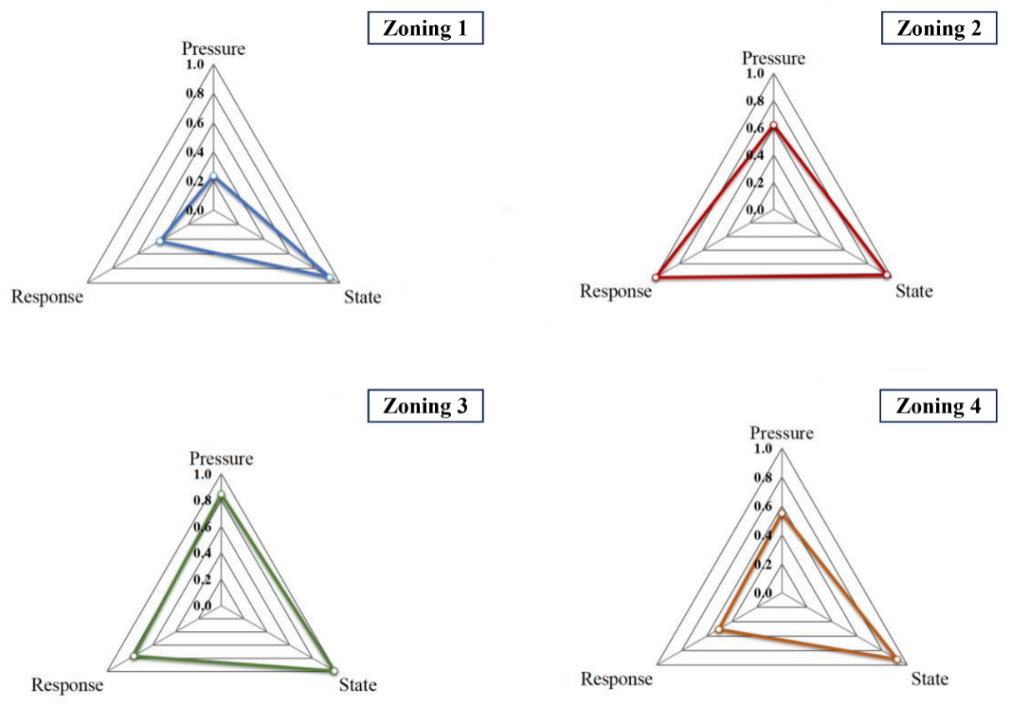

**Fig. S1.** Composite index of pressure, state and response layers in each sub-region of Sansha Bay

`