Supplementary Material

**Supplementary Figures:**

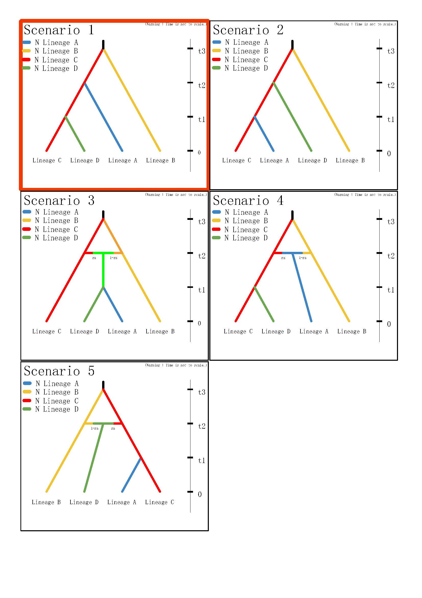

Figure S1. Alternative demographic scenarios of four lineages of *Nerita yoldii* analyzed by DIY-ABC, the most likely scenario is highlighting with red border

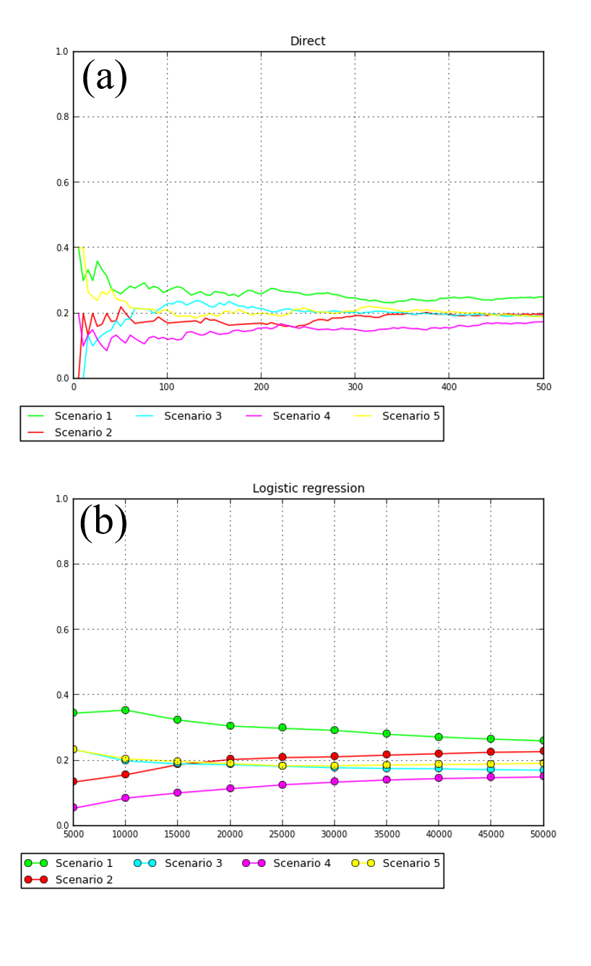

Figure S2. Posterior probabilities of the five scenarios obtained by (a) direct estimate and (b) logistic regression

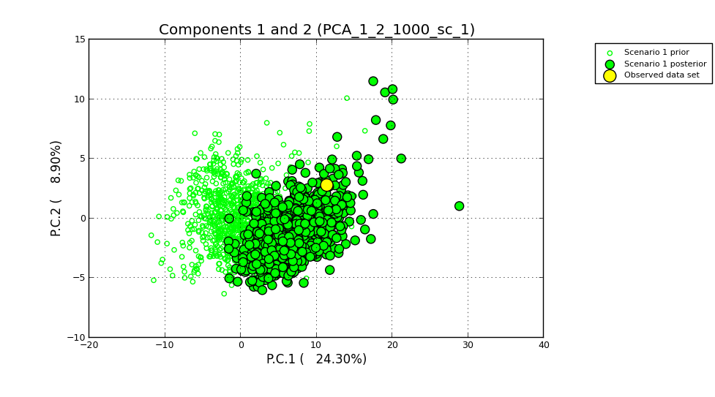

Figure S3. Principal component analysis of test parameters when processing model checking for scenario 1

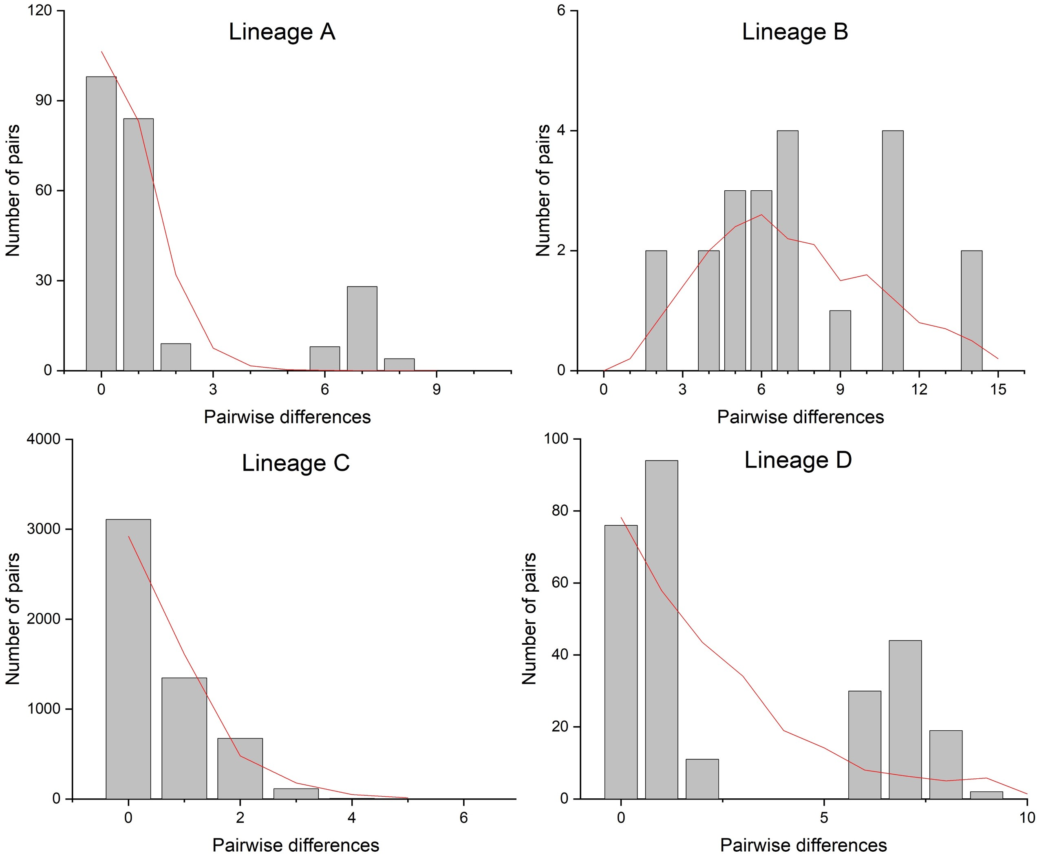

Figure S4. Observed pairwise differences (bar) and expected mismatch distributions (line) of the four lineages of *Nerita yoldii*

**Supplementary Tables:**

**Table S1.** Traces of the extended Bayesian Skyline analysis for each lineage. ESS (effective sample size) is an estimate of how many effectively independent draws from the marginal posterior distribution the MCMC is equivalent to. ESS > 200 assures that the MCMC simulation provides a very good estimate of the posterior distribution

|  |  |  |  |  |  |  |  |  |
| --- | --- | --- | --- | --- | --- | --- | --- | --- |
| Statistic | Lineage A | | Lineage B | | Lineage C | | Lineage D | |
| Mean | ESS | Mean | ESS | Mean | ESS | Mean | ESS |
| posterior | -811.506 | 1764 | -730.914 | 564 | -985.131 | 425 | -799.362 | 2090 |
| likelihood | -780.744 | 3968 | -764.549 | 3379 | -805.483 | 282 | -763.981 | 4587 |
| prior | -30.763 | 1826 | 33.635 | 540 | -179.648 | 371 | -35.381 | 2027 |
| treeLikelihood | -780.744 | 3968 | -764.549 | 3379 | -805.483 | 282 | -763.981 | 4587 |
| TreeHeight | 2.117 | 7515 | 0.117 | 4030 | 0.548 | 6366 | 2.352 | 6552 |
| kappa | 25.948 | 2636 | 14.379 | 2855 | 29.569 | 3638 | 14.291 | 3276 |
| ExtendedBayesianSkyline | -12.685 | 1449 | 50.435 | 472 | -116.588 | 308 | -17.239 | 1694 |
| indicators.alltrees.1 | 1.866E-2 | 7783 | 9.155E-2 | 1441 | 2.222E-4 | 9001 | 1.522E-2 | 6340 |
| indicators.alltrees.2 | 1.966E-2 | 8326 | 9.099E-2 | 1970 | 2.222E-4 | 9001 | 1.455E-2 | 7553 |
| indicators.alltrees.3 | 1.989E-2 | 5512 | 9.966E-2 | 1964 | 1.111E-4 | 9001 | 1.555E-2 | 7700 |
| indicators.alltrees.4 | 2.333E-2 | 5793 | 8.488E-2 | 2571 | 3.333E-4 | 5404 | 1.378E-2 | 7448 |
| indicators.alltrees.5 | 2.155E-2 | 7851 | 9.277E-2 | 1408 | 2.222E-4 | 9001 | 1.422E-2 | 5822 |
| indicators.alltrees.6 | 1.866E-2 | 7964 | 8.255E-2 | 1753 | 2.222E-4 | 9001 | 1.611E-2 | 7495 |
| indicators.alltrees.7 | 2.255E-2 | 5917 | 7.31E-2 | 1090 | 6.666E-4 | 5408 | 1.5E-2 | 7728 |
| indicators.alltrees.8 | 2.222E-2 | 7789 | 6.099E-2 | 2090 | 1.222E-3 | 1681 | 1.544E-2 | 5829 |
| indicators.alltrees.9 | 2.144E-2 | 8343 | 4.877E-2 | 2794 | 1.778E-3 | 729 | 1.589E-2 | 6192 |
| indicators.alltrees.10 | 1.989E-2 | 6248 | 4.599E-2 | 2179 | 1.111E-4 | 9001 | 1.955E-2 | 5759 |
| populationMean.alltrees | 1.008 | 9001 | 0.992 | 9001 | 1.024 | 6802 | 1.011 | 8908 |
| popSizes.alltrees.1 | 1.645 | 3934 | 1.043 | 1039 | 0.513 | 3761 | 1.812 | 3846 |
| popSizes.alltrees.2 | 0.517 | 8258 | 0.475 | 6267 | 0.508 | 3607 | 0.51 | 8150 |
| popSizes.alltrees.3 | 0.522 | 8045 | 0.468 | 6512 | 0.511 | 3545 | 0.513 | 8205 |
| popSizes.alltrees.4 | 0.517 | 8518 | 0.464 | 7158 | 0.515 | 3281 | 0.523 | 8468 |
| popSizes.alltrees.5 | 0.511 | 8057 | 0.471 | 7481 | 0.51 | 3720 | 0.533 | 7200 |
| popSizes.alltrees.6 | 0.524 | 8493 | 0.462 | 6860 | 0.507 | 3572 | 0.517 | 8137 |
| popSizes.alltrees.7 | 0.524 | 8180 | 0.471 | 6710 | 0.5 | 4059 | 0.517 | 8129 |
| popSizes.alltrees.8 | 0.511 | 8532 | 0.472 | 6102 | 0.533 | 3095 | 0.517 | 8479 |
| popSizes.alltrees.9 | 0.527 | 8295 | 0.47 | 6593 | 0.526 | 3250 | 0.519 | 8423 |
| popSizes.alltrees.10 | 0.517 | 7996 | 0.478 | 7768 | 0.515 | 2163 | 0.513 | 8715 |
| sum(indicators.alltrees) | 0.461 | 2677 | 1.194 | 856 | 0.511 | 3581 | 0.374 | 2312 |