Supplementary Materials

Table 1: Symptom category co-occurrence matrix.

|  |  |  |  |  |  |  |  |  |  |  |  |  |  |
| --- | --- | --- | --- | --- | --- | --- | --- | --- | --- | --- | --- | --- | --- |
|  | Thinking, concentration, and decisions | Interest and Motivation | Physical: sleep | Physical: fatigue | Physical: appetite | Physical: movement | Substance use | PHQ-9-suicidal tendencies | PHQ-9-emotional: depressed and sadness | PHQ-9-emotional: worthlessness and worry | Physical: pains | Social | Mental health-related issues |
| Thinking, concentration, and decisions | 1022 | 16 | 19 | 10 | 4 | 1 | 3 | 7 | 15 | 24 | 4 | 11 | 6 |
| Interest and Motivation | 16 | 370 | 12 | 10 | 4 | 24 | 0 | 2 | 2 | 9 | 2 | 8 | 1 |
| Physical: sleep | 19 | 12 | 872 | 10 | 14 | 4 | 2 | 1 | 9 | 10 | 6 | 4 | 5 |
| Physical: fatigue | 10 | 10 | 10 | 725 | 3 | 5 | 1 | 6 | 32 | 9 | 3 | 12 | 5 |
| Physical: appetite | 4 | 4 | 14 | 3 | 695 | 6 | 7 | 2 | 8 | 5 | 2 | 6 | 1 |
| Physical: movement | 1 | 24 | 4 | 5 | 6 | 104 | 0 | 2 | 3 | 0 | 2 | 1 | 1 |
| Substance use | 3 | 0 | 2 | 1 | 7 | 0 | 185 | 0 | 4 | 0 | 0 | 0 | 2 |
| PHQ-9-suicidal tendencies | 7 | 2 | 1 | 6 | 2 | 2 | 0 | 294 | 11 | 12 | 1 | 3 | 0 |
| PHQ-9-emotional: depressed and sadness | 15 | 2 | 9 | 32 | 8 | 3 | 4 | 11 | 1612 | 32 | 12 | 14 | 20 |
| PHQ-9-emotional: worthlessness and worry | 24 | 9 | 10 | 9 | 5 | 0 | 0 | 12 | 32 | 1896 | 17 | 22 | 22 |
| Physical: pains | 4 | 2 | 6 | 3 | 2 | 2 | 0 | 1 | 12 | 17 | 377 | 1 | 5 |
| Social | 11 | 8 | 4 | 12 | 6 | 1 | 0 | 3 | 14 | 22 | 1 | 3555 | 17 |
| Mental health-related issues | 6 | 1 | 5 | 5 | 1 | 1 | 2 | 0 | 20 | 22 | 5 | 17 | 716 |

Table 1 shows the symptoms and the number of occurrences of being tagged together in an individual Tweet with other symptoms for all depression symptom annotated Tweets in data set 2.

Table 2: Summary of classifier configurations.

|  |  |  |  |
| --- | --- | --- | --- |
| Classifier | Binary Classifier  (2 labels) | Multi-class classifier  (6 labels) | Configuration |
| Naïve Bayes | Test size = 0.2 | Test size = 0.2 |  |
| Random Forest | Estimators = 600 Criterion = Entropy | Estimators = 600 Criterion = Entropy | Embedding layer word2vec Test size = 0.2 |
| Convolutional Neural Network (CNN) | ConvID (Filters = 100, Kernel size = 3) MaxPoolID (Pool size=2, strides=2) Flatten Dropout = 0.5 Dense = 10 units Dropout = 0.5 2 units output (sigmoid) Loss = Binary cross entropy | ConvID (Filters = 100, Kernel size = 3) MaxPoolID (Pool size=2, strides=2) Flatten Dropout = 0.5 Dense = 10 units Dropout = 0.5 6 units output (softmax) Loss = Categorical cross entropy | Batch 1 input layer: Embedding layer word2vec  Batch 2 input layers: Embedding layer word2vec + user behavior features + linguistic features  Test size = 0.2 Epochs = 20 Number of runs = 3 Batch size = 128 Optimizer = Adam |
| Bidirectional Long-Short Term Memory (LSTM) | Bidirectional LSTM units = 128 Bidirectional LSTM units = 128 2 units output (sigmoid) Loss = Binary crossentropy | Bidirectional LSTM units = 128 Bidirectional LSTM units = 128 6 units output (softmax) Loss = Categorical crossentropy |
| Bidirectional Long-Short Term Memory (LSTM w/ Dropout) | Bidirectional LSTM units = 128 Dropout = 0.4 Bidirectional LSTM units = 128 Dropout = 0.4 2 units output (sigmoid) Loss = Binary cross entropy | Bidirectional LSTM units = 128 Dropout = 0.4 Bidirectional LSTM units = 128 Dropout = 0.4 6 units output (softmax) Loss = Categorical cross entropy |
| Gated Recurrent Unit (GRU) | Bidirectional GRU units = 128 Dropout = 0.5 Bidirectional GRU units = 128 Dropout = 0.5 2 units output (sigmoid) Loss = Binary cross entropy | Bidirectional GRU units = 128 Dropout = 0.5 Bidirectional GRU units = 128 Dropout = 0.5 6 units output (softmax) Loss = Categorical cross entropy |

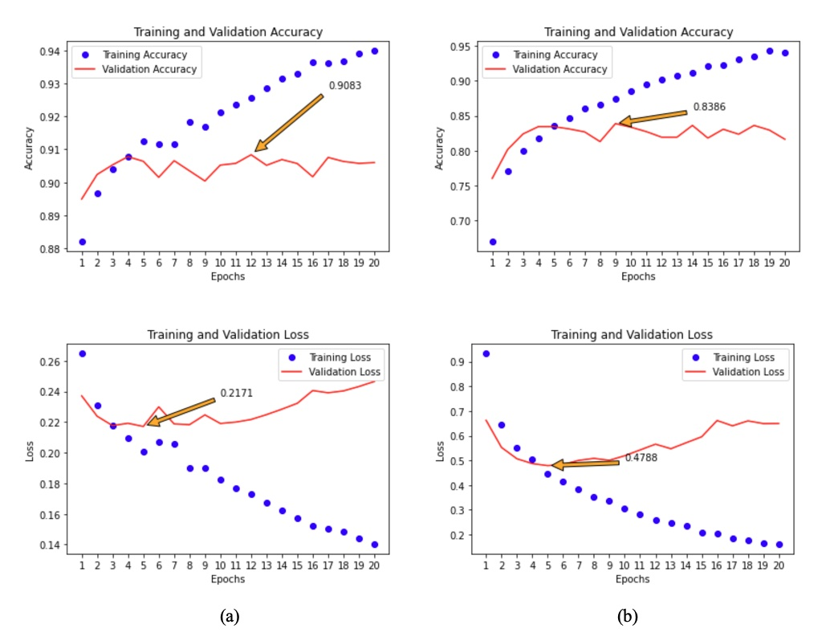

**Figure 1.** (a) Final model stage 1 loss and accuracy metrics. As the training run progresses, the validation accuracy is not improving, which means that 20 epochs is enough number of runs to get the highest validation accuracy. The training accuracy will improve, but the validation accuracy will not. We get the validation accuracy for this run at 0.9064 at epoch 5, which has the lowest validation loss. (b) Final model stage 2 loss and accuracy metrics. Same as with the stage 1 model, as the training run progresses, the validation accuracy is not improving, and we get the validation accuracy for this run at 0.8344 at epoch 5, with the lowest validation loss.