**Numerical modeling** **the impacts of increasing groundwater pumping upon discharge decline of the BL Spring located in Xilin Gol League in east Inner Mongolia, China**

Han Xiao1,2,*, Yu Yang1,2, Qiyuan Liu1,2, Yongge Zang1,2, Xinying Lian1,2, Fu Xia1,2, Yonghai Jiang1,2

1. State Key Laboratory of Environmental Criteria and Risk Assessment, Chinese Research Academy of Environmental Sciences, Beijing 100012, China
2. State Environmental Protection Key Laboratory of Simulation and Control of Groundwater Pollution, Chinese Research Academy of Environmental Sciences, Beijing, 100012, China

*Corresponds to Han Xiao (hxiao0716@163.com)

**1 Supplementary Figures and Tables**

**1.1 Supplementary Figures**

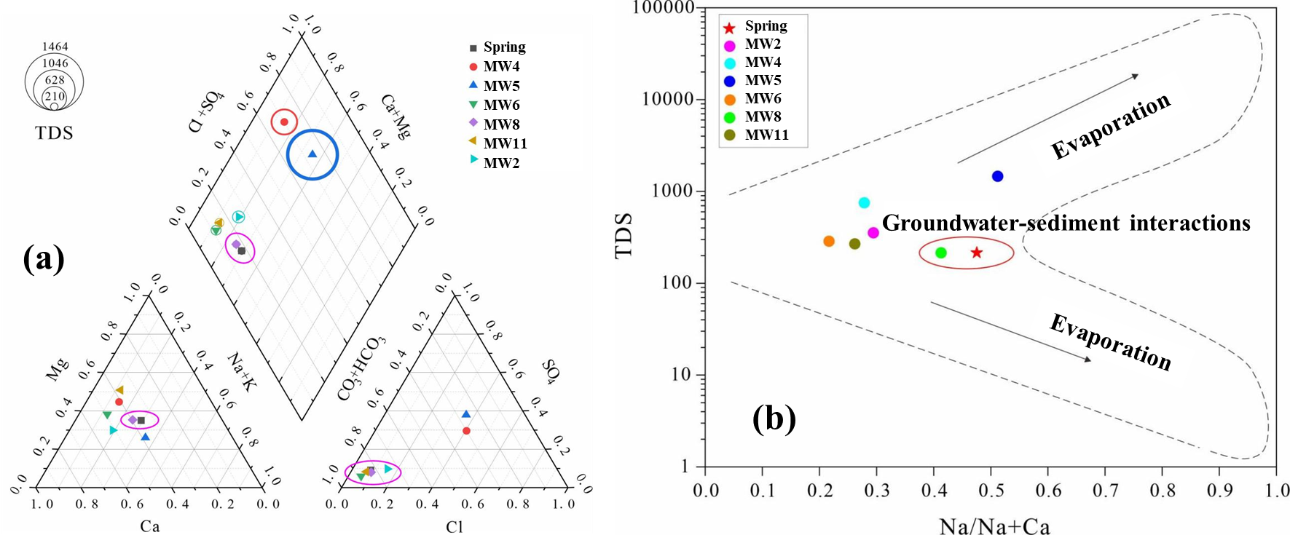

**Supplementary Figure 1** (a) Piper Diagram; and (b) Gibbs Diagram

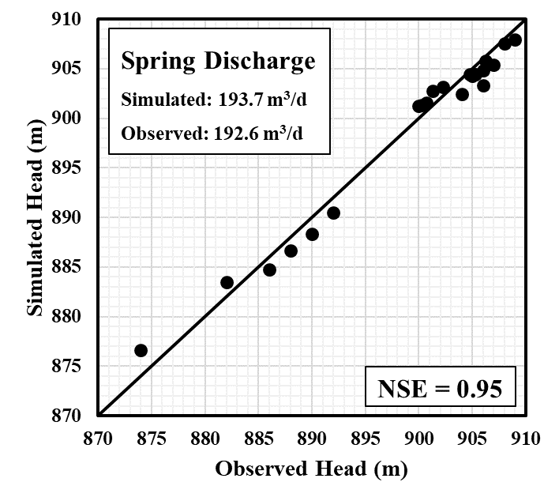

**Supplementary Figure 2** Scatter diagram showing the goodness of fit between the simulate and observed groundwater levels during calibration period

**1.2 Supplementary Tables**

**Supplementary Table 1** Hydrogeological parameters of each layer

|  |  |  |  |
| --- | --- | --- | --- |
| Parameter | Silty sand layer | Clay layer | Fine sand layer |
| Hydraulic conductivity (m/d) | 3.5-6.0 | 0.0001-0.0006 | 0.5-6.0 |
| Porosity (-) | 0.35 | 0.4 | 0.3 |
| Specific yield (-) | 0.004-0.01 | - | - |
| Specific storage (-) | - | - | 0.001-0.005 |

**Supplementary Table 2** Water quality of spring discharge and monitoring wells (unit: mg/L)

|  |  |  |  |  |  |  |  |
| --- | --- | --- | --- | --- | --- | --- | --- |
| c (mg/L) | Spring | MW2 | MW4 | MW5 | MW6 | MW8 | MW11 |
| K+ | 26.1 | 36.9 | 36.8 | 13.9 | 24 | 14.6 | 26.4 |
| Na+ | 26.1 | 26.4 | 190 | 189 | 13.9 | 24 | 14.6 |
| Ca2+ | 28.8 | 63.2 | 95.5 | 180 | 50.2 | 34.1 | 41.1 |
| Mg2+ | 16.8 | 22.1 | 62.5 | 72.6 | 23.4 | 18.3 | 33.9 |
| CO32- + HCO3- | 189 | 278 | 166 | 380 | 298 | 186 | 276 |
| Cl- | 11.2 | 33 | 130 | 308 | 11.1 | 14 | 12.9 |
| SO42- | 16.4 | 28.6 | 129 | 435 | 15.8 | 16.6 | 21.2 |
| NO3- | 2.35 | 7.63 | 43.6 | 5.13 | 2.01 | 0.849 | 1.54 |
| TDS | 215 | 354 | 751 | 1462 | 286 | 214 | 268 |

**Supplementary Table 3** Descriptions of eight pumping scenarios and simulation results

|  |  |  |  |  |  |  |
| --- | --- | --- | --- | --- | --- | --- |
| Scenario | Active well | Inactive well | Pumping rate (m3/d) | Spring discharge (m3/d) | Spring discharge decline (m3/d) | Reduction ratio (%) |
| 0 | None | #1, #2, #3, #4, #5, #6, #7 | 0 | 201.4 | - | - |
| 1 | #1 | #2, #3, #4, #5, #6, #7 | 6.54 | 200.0 | 1.4 | 0.70 |
| 2 | #2 | #1, #3, #4, #5, #6, #7 | 6.54 | 198.4 | 3.0 | 1.49 |
| 3 | #3 | #1, #2, #4, #5, #6, #7 | 6.54 | 200.4 | 1.0 | 0.50 |
| 4 | #4 | #1, #2, #3, #5, #6, #7 | 6.54 | 201.4 | 0 | 0 |
| 5 | #5 | #1, #2, #3, #4, #6, #7 | 6.54 | 200.9 | 0.5 | 0.25 |
| 6 | #6 | #1, #2, #3, #4, #5, #7 | 6.54 | 200.7 | 0.7 | 0.35 |
| 7 | #7 | #1, #2, #3, #4, #5, #6 | 6.54 | 200.6 | 0.8 | 0.40 |
| 8 | #1, #2, #3, #4, #5, #6, #7 | None | 45.8 | 193.7 | 7.7 | 3.80 |

**Supplementary Table 4** Descriptions of twelve pumping scenarios and simulation results

|  |  |  |  |  |
| --- | --- | --- | --- | --- |
| Scenario | Total pumping rate (m3/d) | Spring discharge (m3/d) | Spring discharge decline (m3/d) | Reduction ratio (%) |
| 0 | 0 | 201.4 | - | - |
| 8 | 45.8 | 193.7 | 7.7 | 3.8 |
| 9 | 91.6 | 185.9 | 15.5 | 7.7 |
| 10 | 183.2 | 170.2 | 31.2 | 15.5 |
| 11 | 274.8 | 154.5 | 46.9 | 23.3 |
| 12 | 297.7 | 151.1 | 50.3 | 25.0 |
| 13 | 366.4 | 138.9 | 62.5 | 31.0 |
| 14 | 458 | 123.2 | 78.2 | 38.8 |
| 15 | 586.2 | 100.7 | 100.7 | 50.0 |
| 16 | 687 | 84.0 | 117.4 | 58.3 |
| 17 | 888.5 | 50.4 | 151 | 75.0 |
| 18 | 916 | 45.0 | 156.4 | 77.7 |
| 19 | 1145 | 5.8 | 195.6 | 97.1 |
| 20 | 1176 | 0.0 | 201.4 | 100 |