Supplementary Material

Supplementary Figures and Tables

Supplementary Figures
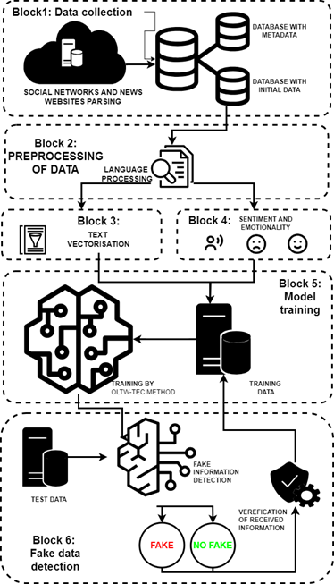
Supplementary Figure 1. Structure of the intelligent method for online disinformation detection

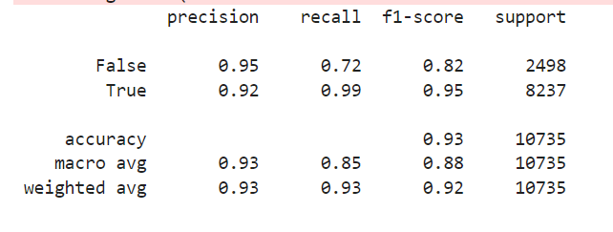 | 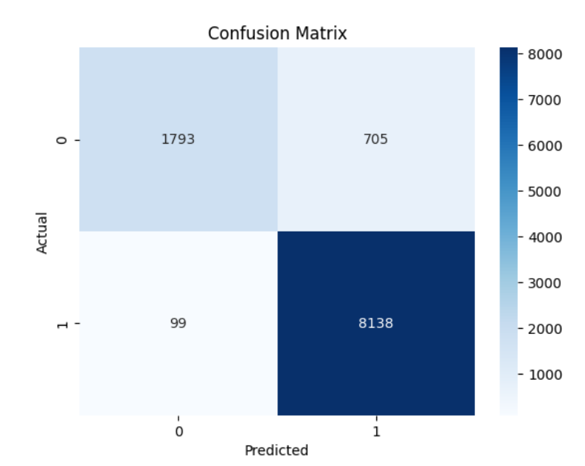
A | B
Supplementary Figure 2. Evaluation results

Supplementary Tables
Table 1. Comparison of similar studies.
Authors | Dateset | Model | Accuracy (Acc.) | Labguage | Approach
Chang, Q., Li, X., Duan, Z.[11] | Politifact | GCN-GANM | 0.8602 | English | Deep Learning
 | Gossipcop |  | 0.9825 | English
 | Weibo |  | 0.9804 | Chinese
Peng, L., Jian, S., Kan, Z., Qiao, L., Li, D.[12] | Weibo | CSFND | 0.895 | Chinese | Contextual Semantic Representation
 | Twitter |  | 0.833 | English
Ahammad, T.[13] | COVID-19 News Headlines | LDA, VADER | Not specified | English | Sentiment Analysis and Topic Modeling
Qu, Z., Meng, Y., Muhammad, G., Tiwari, P.[14] | Gossip | QMFND | 0.879 | English | Quantum Multimodal Fusion
 | Politifact |  | 0.846
Farhangian, F., Cruz, R. M. O., Cavalcanti, G. D. C.[15] | Liar | Різні (включаючи SVM, LR, KNN, NB, RF, AdaBoost, XGBoost, MLP, CNN, BiLSTM, трансформерні моделі) | SVM з LLaMA - 0.266 | English | Comprehensive Analysis and Comparison of Various Approaches to Fake News Detection
 | ISOT |  | This is achieved by BiLSTM or CNN with methods such as BERT, DistilBERT, BART, RoBERTa, LLaMA, and Falcon, reaching up to 100% F1-score.
 | COVID |  | BiLSTM з Falcon - 95%
 | GM |  | BiLSTM з Falcon - 99.3%
Fang, X., Wu, H., Jing, J., Meng, Y., Yu, B., Yu, H., & Zhang, H.[16] | Chinese | NSEP | 86.8% Chinese in dataset | Chinese | Detection of Fake News through Perception of News Semantic Environment (NSEP)
Soga, K., Yoshida, S., & Muneyasu, M.[17] | Custom (Twitter), | Graph Transformers | 86.41% на Custom, | English | Detection of Fake News Using Positional Similarity and Graph Neural Networks
 | FibVID |  | 79.80% на FibVID
Yang, H., Zhang, J., Zhang, L., Cheng, X., & Hu, Z.[18] | Weibo, | MRAN | 90.3% на Weibo, | Chinese, | Multimodal Analysis with Consideration of Interconnections
 | Twitter, |  | 85.5% на Twitter, | English
 | Pheme |  | 87.0% на Pheme | English
Raja, E., Soni, B., Lalrempuii, C., & Borgohain, S. K.[19] | Dravidian_Fake | Hybrid model DTCN_BiLSTM_CAM | 93.97% | Dravidian languages | Hybrid Approach with DTCN, BiLSTM, CAM
Luvembe, A. M., Li, W., Li, S., Liu, F., & Wu, X.[20] | GossipCO, | CAF-ODNN | GossipCO Dataset: 86.3% | English | Multimodal Approach with Complementary Attention and Optimized Deep Neural Network
 | PolitiFact, |  | PolitiFact Dataset: 88.9%
 | Fakeddit, |  | Fakeddit Dataset: 90.0%
 | Pheme |  | Pheme Dataset:: 87.9%
Jiang, Y., Yu, X., Wang, Y., Xu, X., Song, X., & Maynard, D.[21] | PolitiFact | SAMPLE (D-SAMPLE, C-SAMPLE, M-SAMPLE) | F1/Acc: 0.81/0.82 (PolitiFact, M-SAMPLE, Data rich) | English | Multimodal Learning Using Query Templates
 | GossipCop |  | F1/Acc: 0.58/0.62 (GossipCop, M-SAMPLE, Data rich)
Syed, L., Alsaeedi, A., Alhuri, L. A., & Aljohani, H. R.[22] | Twitter (195,943 tweets) | Bi-LSTM, Bi-GRU, SVM (Weakly Supervised) | Bi-LSTM: 89.95, Bi-GRU: 89.60 | English | Hybrid Approach with Weakly Supervised Learning and Deep Learning
Xie, B., & Li, Q.[23] | Twitter, Weibo | RNN-Based Gatekeepers' Behavioral Model (RGBM) | Accuracy: 98.5, Відгук: 97.8, F1: 97.6, Loss: 0.058 | English, Chinese | Detection of Fake News Using Gatekeepers' Behavioral Model
Přibáň, P., Hercig, T., & Steinberger, J.[24] | Czech | Logistic regression | Unbalanced (2 classes): Accuracy - 0.35 / 0.82 | Czech, | Machine Learning, 10-Fold Cross-Validation
 | Polish language |  | Unbalanced (2 classes): Accuracy - 0.34 / 0.73 | Polish,
 | Czech |  | Unbalanced (2 classes): Accuracy - 0.35 / 0.82 | Czech,
Bucos, M., & Drăgulescu, B.[25] | Factual.ro | Extra Trees Classifier, Random Forest Classifier, Support Vector Machine, Logistic Regression | Acc: 0. 0.8075, Pre: 0.8548, Rec: 0.8217, F1: 0.8084, AUC: 0.8451, Kappa: 0.6012 | Romanian | Using Transformer Models for Back Translation (BT), including mBART and Google Translate, to Improve Fake News Detection.
Afanasieva, I., Golian, N., Golian, V., Khovrat, A., & Onyshchenko, K.[26] | Data on the U.S. presidential elections and Russia's invasion into Ukraine | CNN, RNN | CNN: 93-94% (war), 94% (elections); RNN: 94% (war), 96% (elections) | English, russian | Using Neural Networks for Fake News Detection
Table 2. Comparison with the Developed Method
Model | Precision (False) | Precision (True) | Recall (False) | Recall (True) | F1-score (False) | F1-score (True) | Accuracy | Confusion Matrix (False, True)
Logistic Regression | 0.96 | 0.85 | 0.44 | 0.99 | 0.60 | 0.92 | 86.42% | (1091, 1407), (51, 8186)
SVM | 0.90 | 0.93 | 0.75 | 0.99 | 0.85 | 0.96 | 90.61% | (1680, 818), (68, 8169)
Random Forest | 0.88 | 0.95 | 0.81 | 1.00 | 0.89 | 0.97 | 90.31% | (2026, 472), (31, 8206)
Gradient Boosting | 0.94 | 0.86 | 0.48 | 0.99 | 0.64 | 0.92 | 87.31% | (1209, 1289), (73, 8164)
KNN | 0.91 | 0.87 | 0.51 | 0.99 | 0.66 | 0.92 | 87.57% | (1285, 1213), (121, 8116)
Decision Tree | 0.81 | 0.95 | 0.83 | 0.94 | 0.82 | 0.94 | 91.45% | (2077, 421), (497, 7740)
XGBoost | 0.89 | 0.89 | 0.61 | 0.98 | 0.73 | 0.93 | 89.19% | (1533, 965), (195, 8042)
AdaBoost | 0.88 | 0.87 | 0.50 | 0.98 | 0.64 | 0.92 | 86.92% | (1259, 1239), (165, 8072)
OLTW-TEC | 0.95 | 0.92 | 0.72 | 0.99 | 0.82 | 0.95 | 93% | (1793, 705), (99, 8138)

