Supplementary Figures

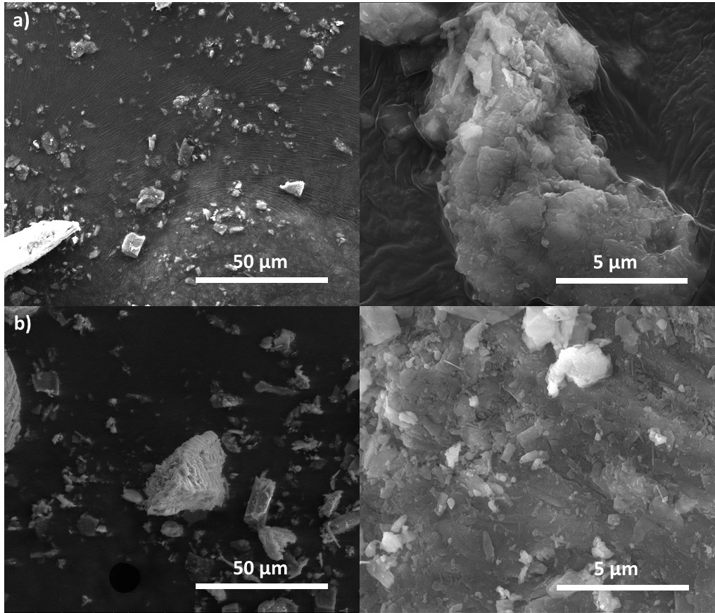
Fig. S1. SEM images of serpentinite, a) before and b) after, thermal treatment, in H₂/N₂ atmosphere at 800ºC for one hour.

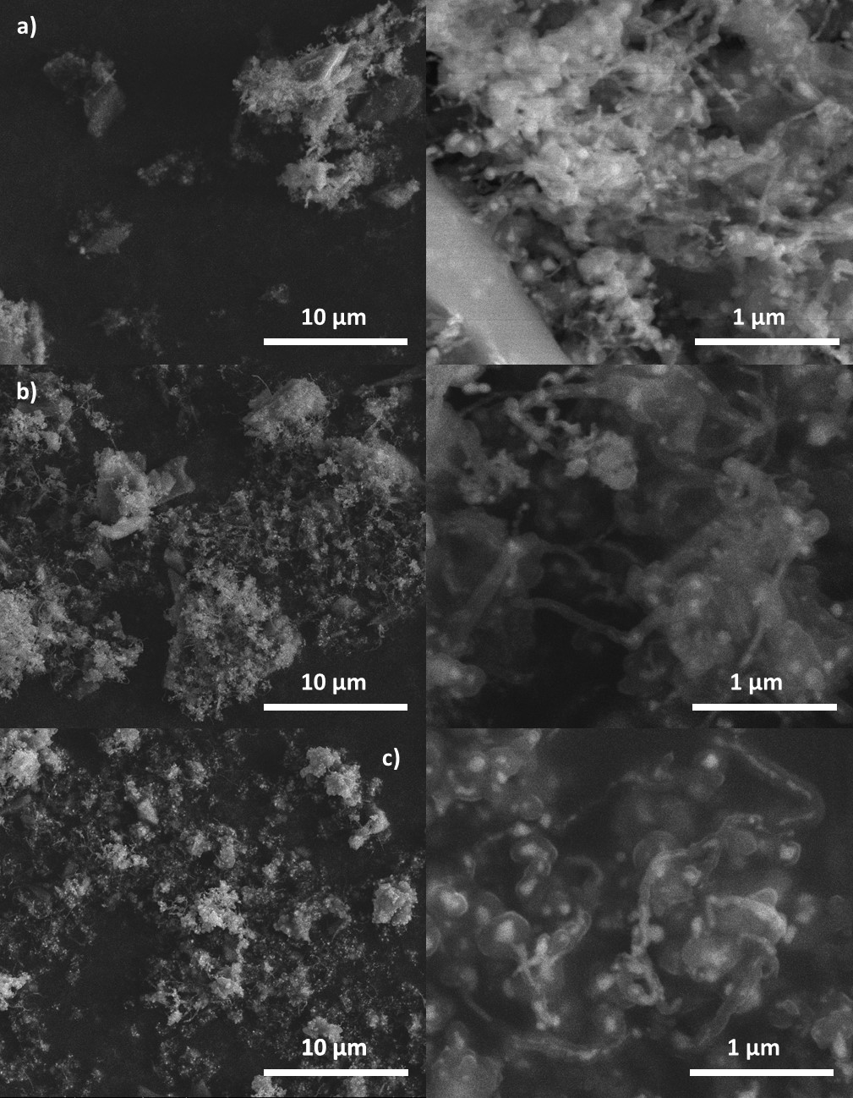
Fig. S2. SEM images of of serpentinite with 5 (a), 10 (b) and 20 (c) %wt of Co, after CVD process (methane 1 h).

Fig. S3. Chromatograms obtained for reactions at different pH values. Retention time for the sulfentrazone = 4.84 min; retention time for the degradation product = 3.75.¹

1. Nascimento, M. A.; Lopes, R. P.; Cruz, J. C.; Silva, A. A.; Lima, C. F., Sulfentrazone dechlorination by iron-nickel bimetallic nanoparticles. Environ. Pollut. 2016, 211, 406-413.

