Supplementary Material

# Appendix 1. Operational definition of variables used in this study.

|  |  |  |
| --- | --- | --- |
| Variables | | Definition |
| Input-related risks | Delayed input supply | Late delivery of essential inputs like seeds, pesticides, and fertilizers |
| Escalating input costs | Rising prices for essential resources like seeds, fertilizers, and labor |
| Fluctuating interest rates | Unpredictable changes in borrowing costs |
| Lack of private capital | Insufficient investment funds from private sources |
| Reliable quality | Difficulty in consistently meeting desired grain standards |
| Market-related risks | Price volatility | Unpredictable fluctuations in market prices |
| Limited market information | Insufficient access to crucial data |
| Market dishonesty | Deceptive practices or misinformation in trade transactions |
| Uncertain foreign markets/policies | Instability in overseas markets and trade policies |
| Middleman exploitation | Intermediaries taking advantage of farmers |
| Resource-related risks | River and groundwater drying | Potential depletion of water sources essential for irrigation |
| Water management | Challenges associated with efficiently allocating, distributing, and conserving water resources for irrigation |
| Water infrastructure | Potential shortcomings or failures in irrigation systems and facilities |
| Insufficient Machinery | Inadequate availability or functionality of rice farming equipment |
| Insufficient family labor | Lack of available family members or household labor to adequately support rice farming tasks |
| External environmental risks | Environmental calamities | Sudden and severe natural disasters or events such as floods, droughts, or storms |
| Intense weather conditions | Extreme or erratic weather events such as heavy rainfall, droughts, or heatwaves |
| Abundant precipitation | Excessive rainfall or moisture levels |
| Pest and disease | The threat posed by insects, pathogens, and other biological agents that can damage rice crops |
| Policy and support-related risks | Limited extension services | Insufficient access to agricultural education, training, and support for rice farmers |
| Absence of contract farming | Lack of formal agreements between rice farmers and buyers |
| Shifts in local agricultural policies | Sudden changes or alterations in government regulations or initiatives related to rice farming |
| Absence of farmer cooperatives | Lack of organized collective groups |
| Insufficient farm record-keeping | Inadequate documentation and tracking of farming activities, inputs, and outcomes |

**Appendix 2.**

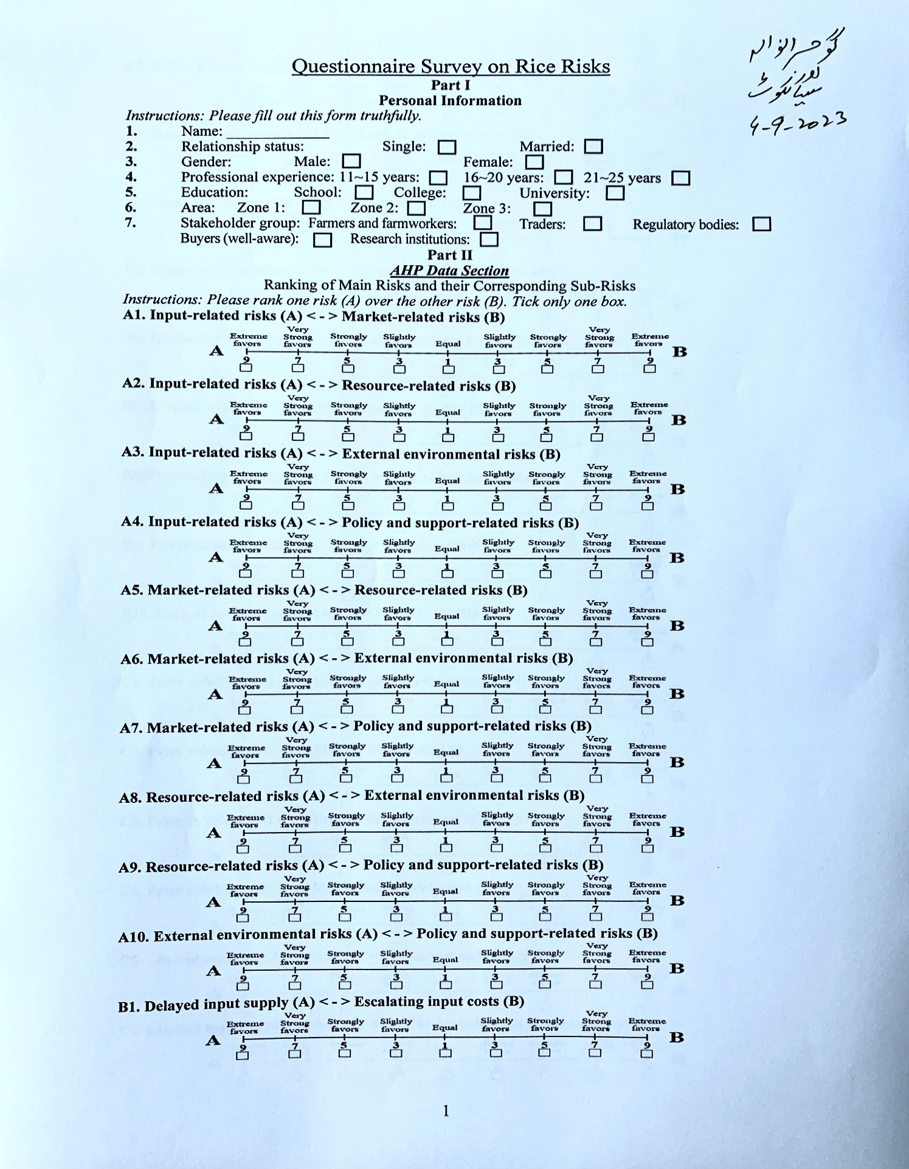

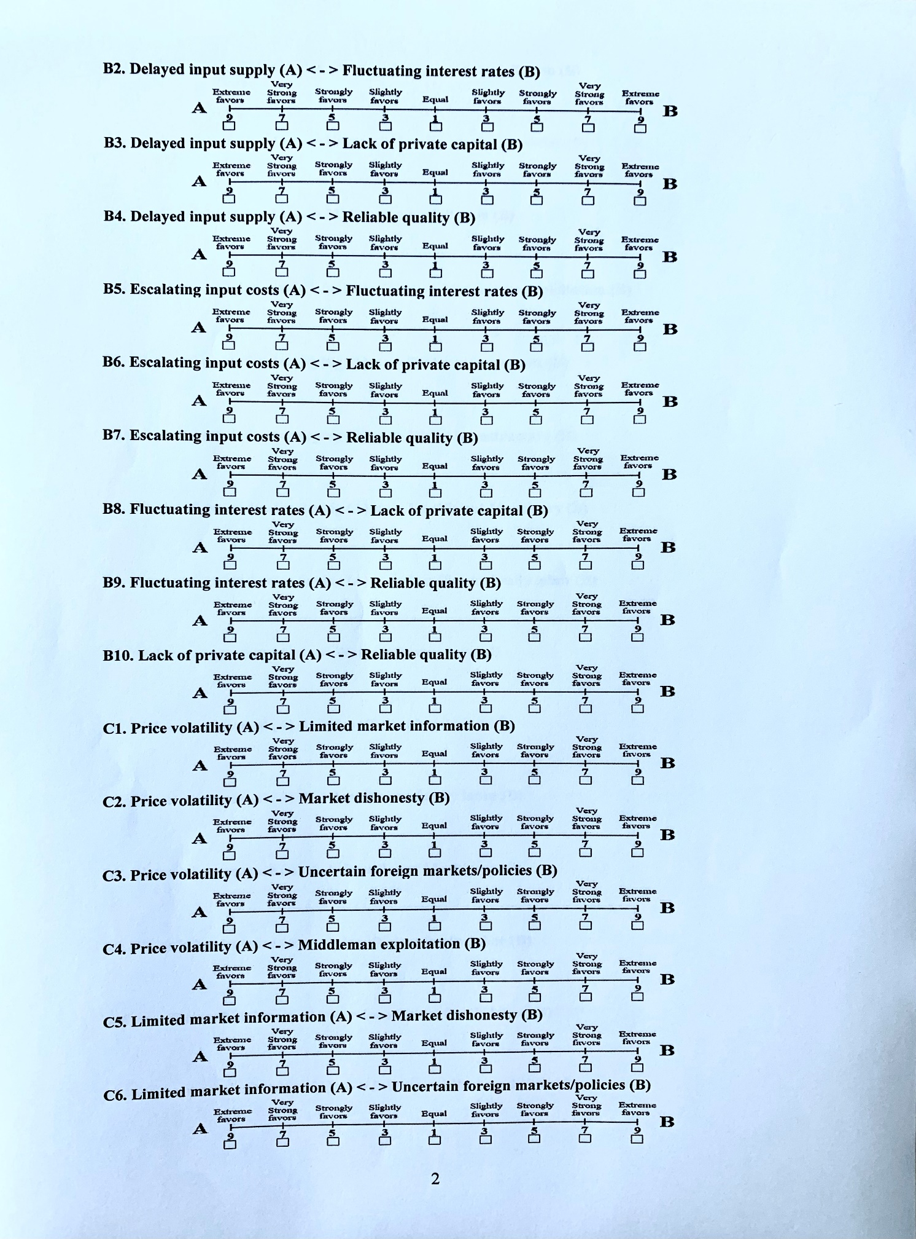

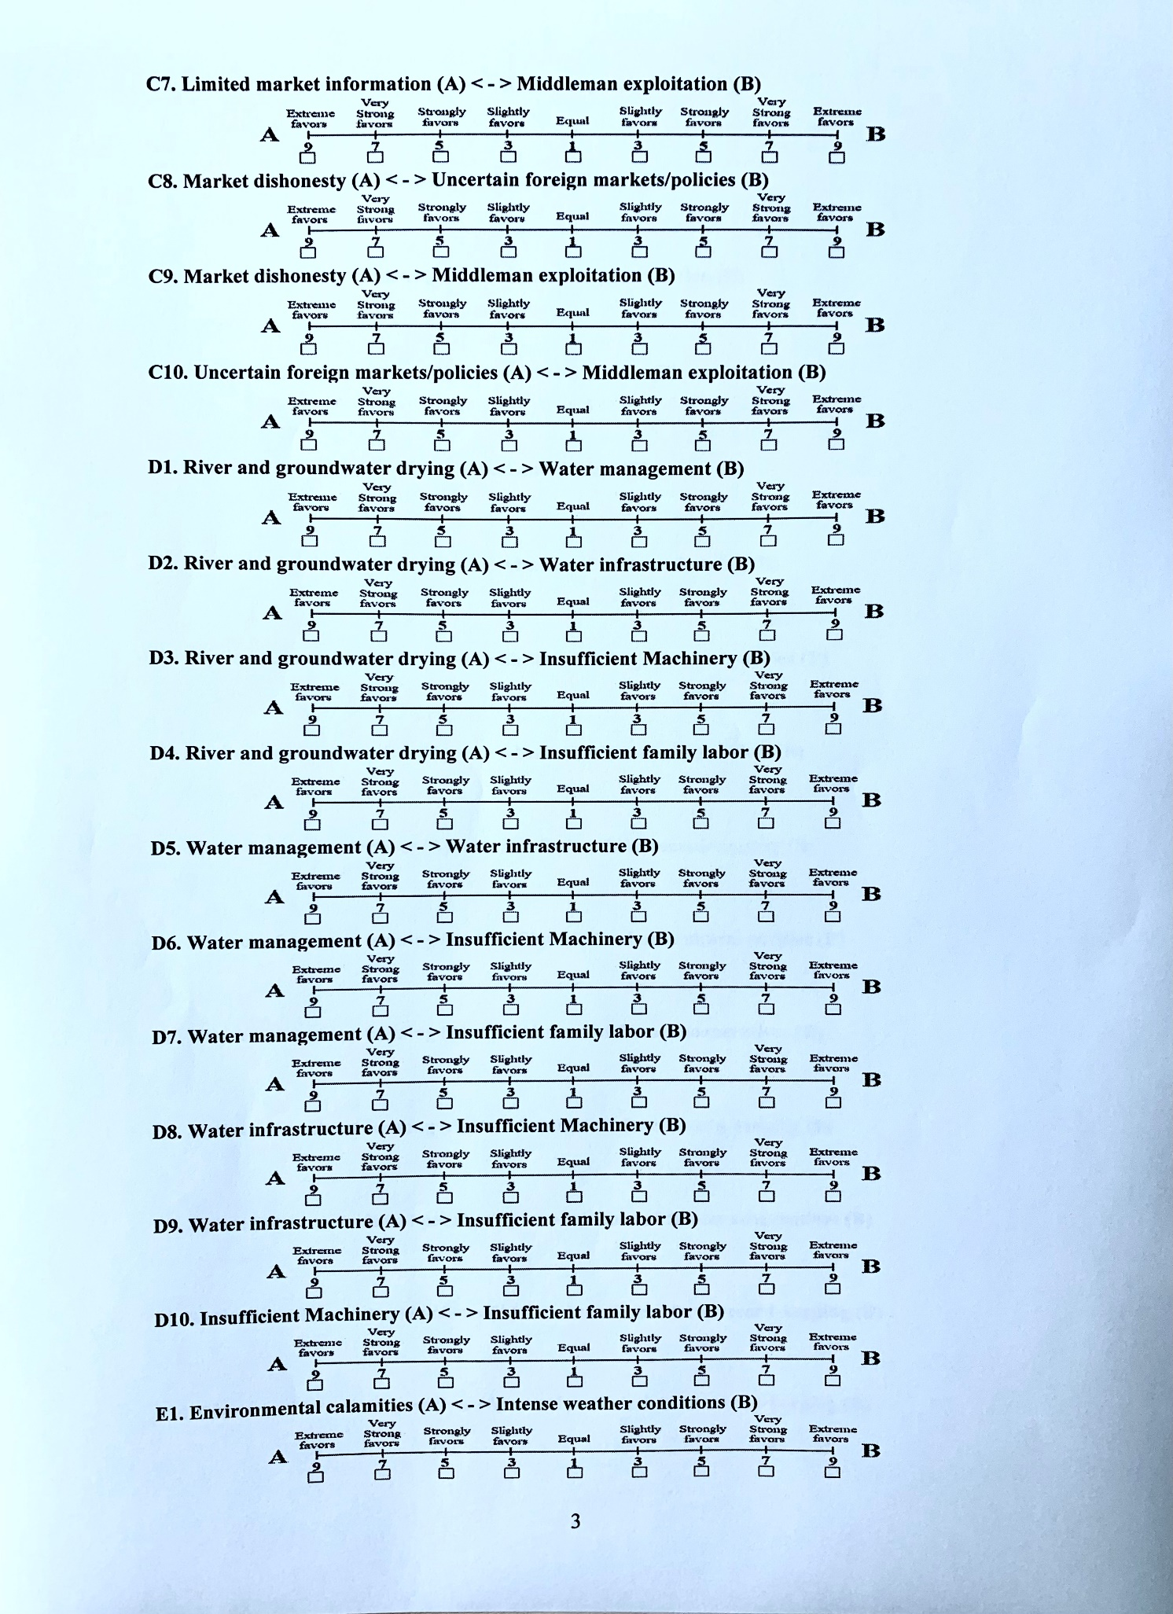

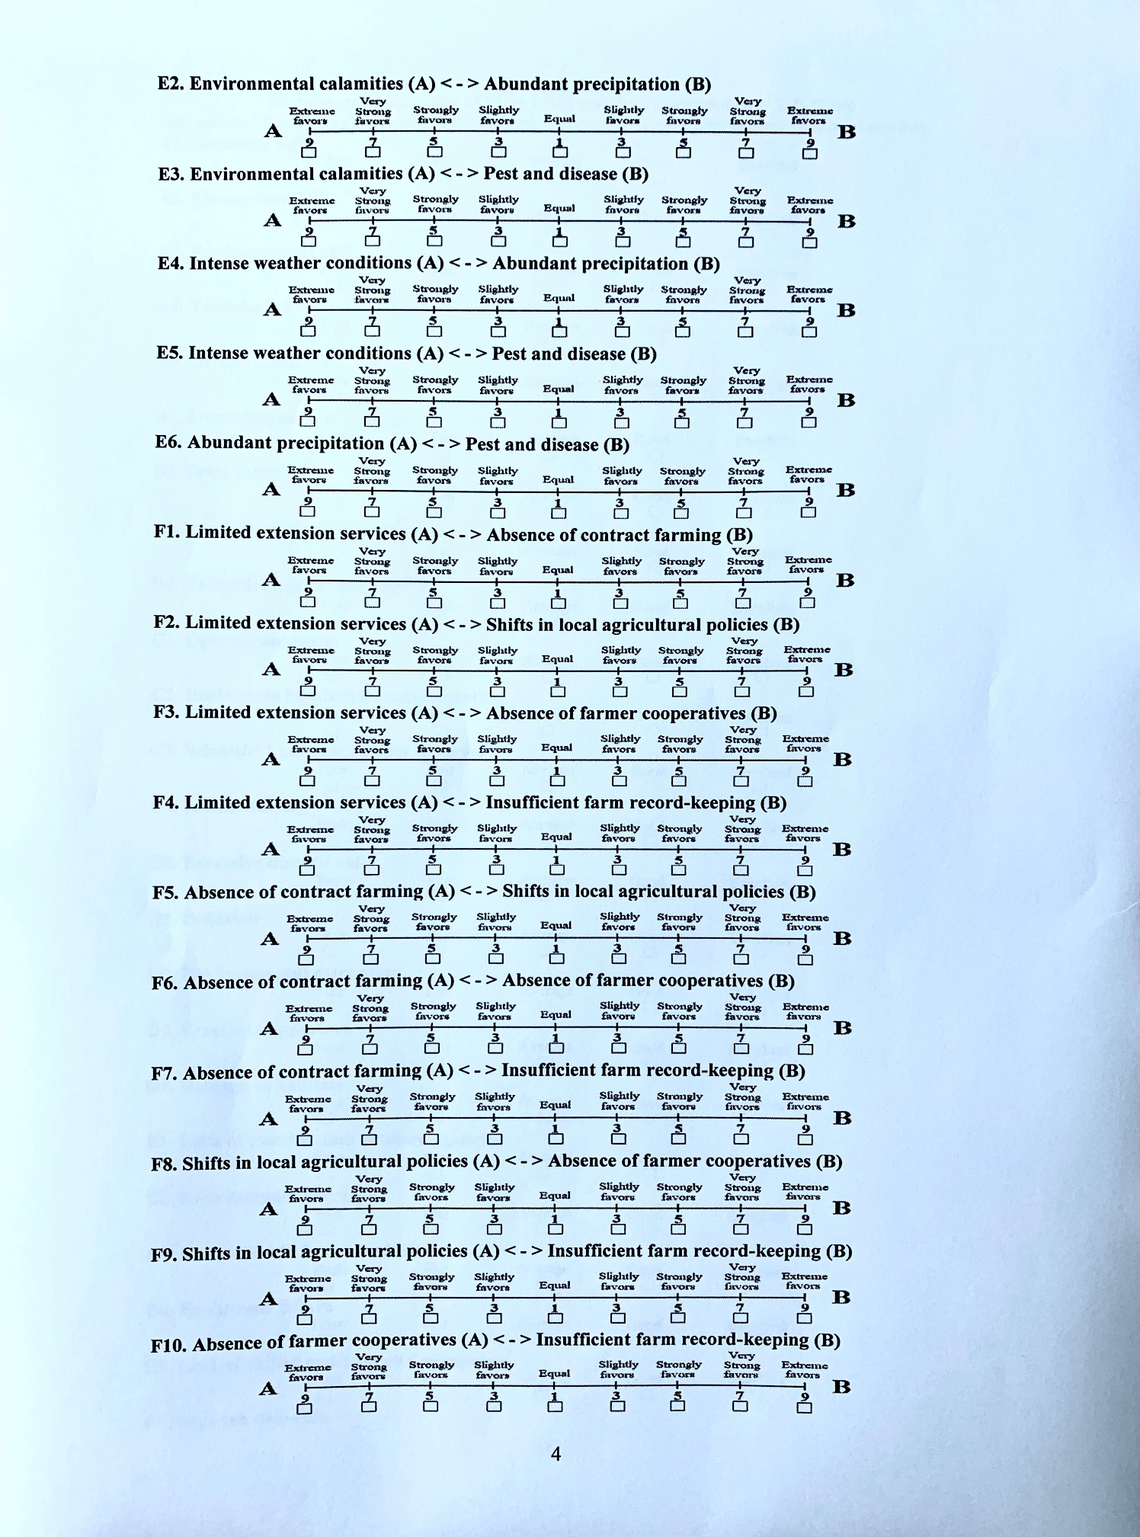

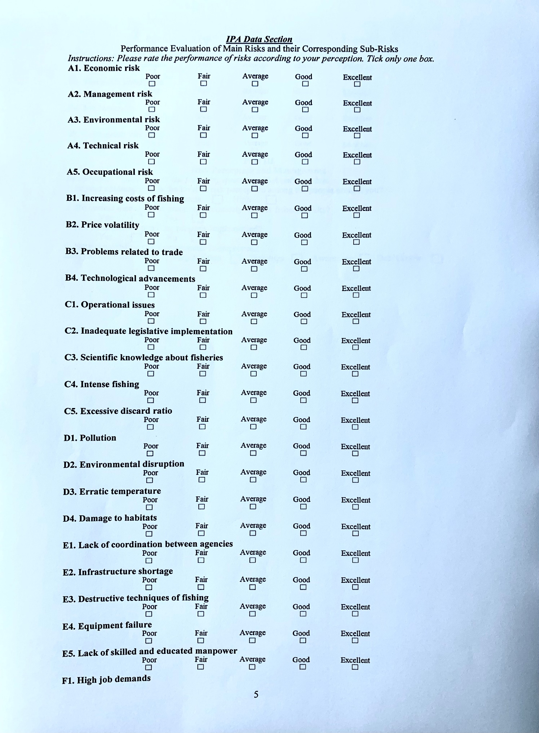

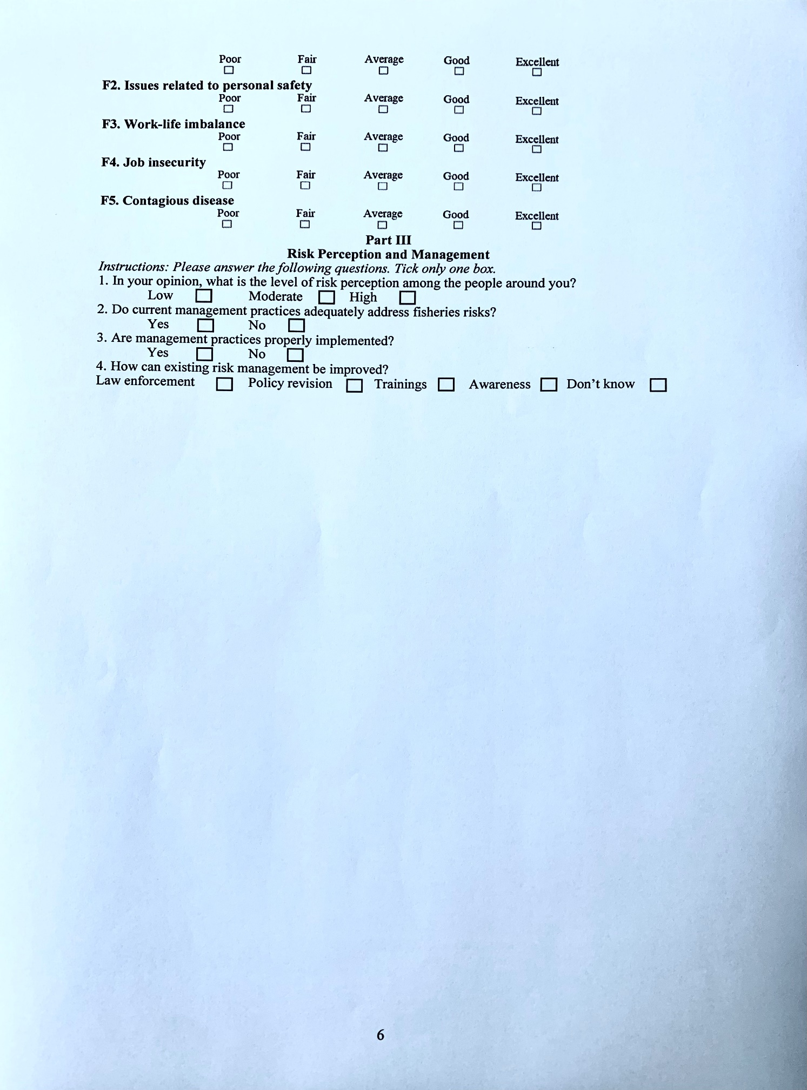

# Appendix 3. Values of a*ij* (*i* as a substitute of *j*) and their corresponding interpretation.

|  |  |
| --- | --- |
| Scale | Interpretation |
| 1 | Strongly preferred |
| 2 | Equal to moderately preferred |
| 3 | Moderately preferred |
| 4 | Moderately to strongly preferred |
| 5 | Strongly preferred |
| 6 | Strongly to very strongly preferred |
| 7 | Strongly preferred |
| 8 | Very strongly to extremely preferred |
| 9 | Extremely preferred |

Note: Adopted from Saaty, 2005.

**Appendix 4. Matrix values and associated RCI scores.**

|  |  |  |  |  |  |  |  |  |  |  |
| --- | --- | --- | --- | --- | --- | --- | --- | --- | --- | --- |
| Matrix value | 1 | 2 | 3 | 4 | 5 | 6 | 7 | 8 | 9 | 10 |
| RCI | 0.00 | 0.00 | 0.58 | 0.90 | 1.12 | 1.24 | 1.32 | 1.41 | 1.45 | 1.49 |

Note: Adopted from Saaty, 2005.