Sensitivity Analysis
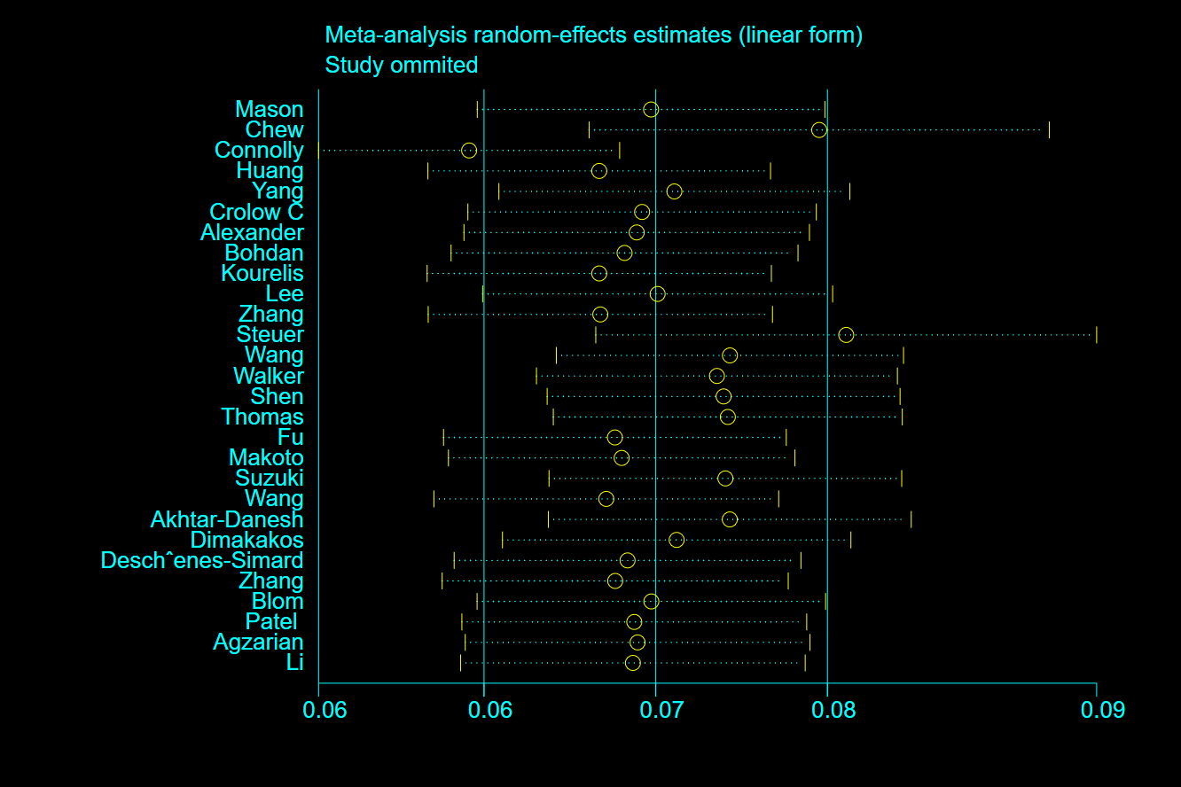
Figure 1 –Sensitivity analysis showing the prevalence of VTE in patients with lung cancer
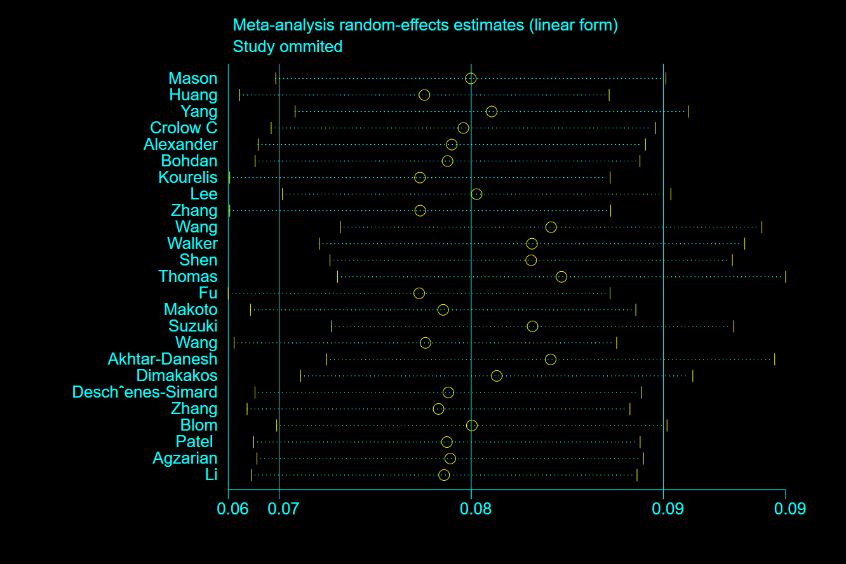
Figure 1 –Sensitivity analysis showing the prevalence of VTE in patients with lung cancer after removing three studies

