

Supplementary figure 01: the flow chart including patients and study process

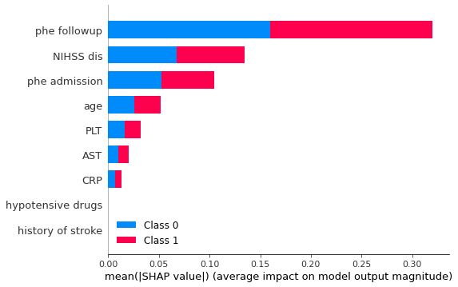

Supplementary figure 02: The importance of feature plot of random forest model.



Supplementary figure 03: The ROC and Precision plot of the basic model for external validation. a-1: ROC of logistic regression model; a-2 Precision of logistic regression model; b-1 ROC of support vector machine model; b-2 Precision of support vector machine model; c-1 ROC of decision trees model; c-2 Precision of decision trees model.



Supplementary figure 04: The ROC and Precision plot of the integrated model for external validation. a-1: ROC of random forest model; a-2 Precision of random forest model; b-1 ROC of XGBoost model; b-2 Precision of XGBoost model.