SUPPLEMENTARY MATERIAL

Table S1 | Age data from literature or from online (ITRDB) databases.

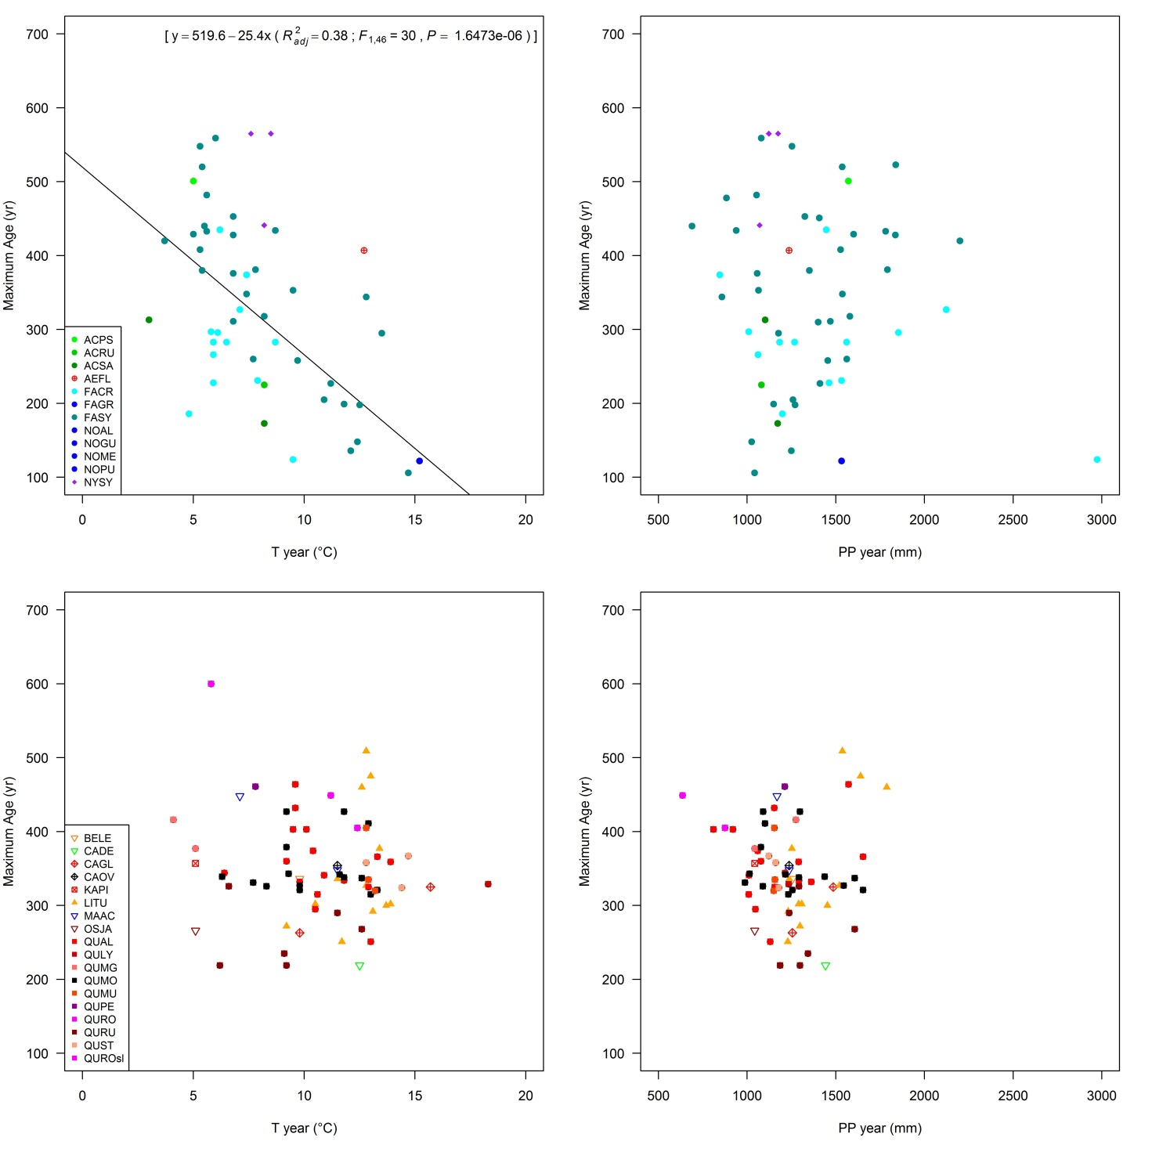
Figure S1 | Relationships between the age of the oldest tree within each old-growth forest and the mean annual temperature and precipitation. The regressions are calculated separately for shade-tolerant (above) and shade-intolerant or intermediate (below) species (see Table 1), and considering the most represented genera only (within parentheses: R²_{adj}, adjusted R²; F, value of the F statistic; P, significance of the F-test). Only significant regressions are represented.

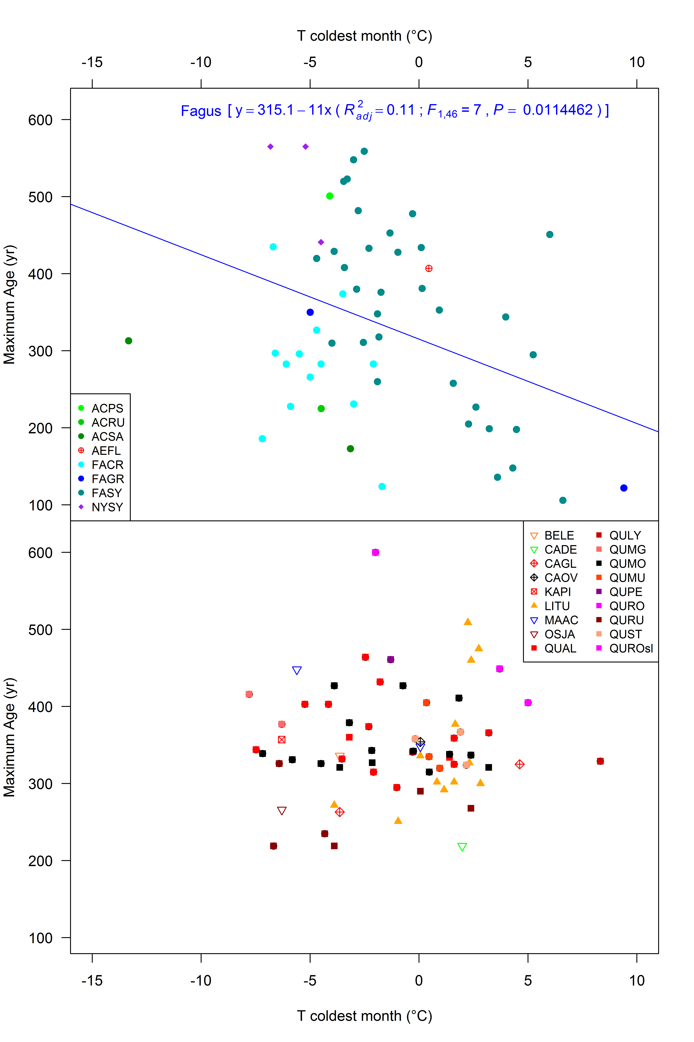
Figure S2 | Relationships between the age of the oldest tree within each old-growth forest and the mean temperature of the coldest month. The regressions are calculated separately for shade-tolerant (above) and shade-intolerant or intermediate (below) species (see Table 1), and considering the most represented genera only (within parentheses: R²_{adj}, adjusted R²; F, value of the F statistic; P, significance of the F-test). Only significant regressions are represented.

References
Abrams, M. D., Copenheaver, C. A., Black, B. A., and Van de Gevel, S. (2001). Dendroecology and climatic impacts for a relict, old-growth, bog forest in the Ridge and Valley Province of central Pennsylvania, U.S.A. Can. J. Bot. 79, 58-69. doi: 10.1139/cjb-79-1-58.
Abrams, M. D., and Copenheaver C. A. (1999). Temporal variation in species recruitment and dendroecology of an old-growth white oak forest in the Virginia Piedmont, USA. For. Ecol. Manage. 124, 275-284.
Abrams, M. D., Copenheaver, C. A., Terazawa, K., Umeki, K., Takiya, M., and Akashi, N. (1999). A 370-year dendroecological history of an old-growth Abies–Acer–Quercus forest in Hokkaido, northern Japan. Can. J. For. Res. 29, 1891-1899.
Abrams, M. D., Ruffner, C. M., and DeMeo, T. E. (1998). Dendroecology and species co-existence in an old-growth Quercus–Acer–Tilia talus slope forest in the central Appalachians, USA. For. Ecol. Manage. 106, 9-18.
Abrams, M. D., Orwig, D. A., and DeMeo, T. E. (1995). Dendroecological analysis of successional dynamics for a presettlement-origin white-pine-mixed-oak forest in the southern Appalachians, USA. J. Ecol. 83, 123-133.
Biondi, F. (1992). Development of a tree-ring network for the Italian Peninsula. Tree-ring Bull. 52, 15-29.
Bourquin-Mignot, C., and Girardclos, O. (2001). Construction d'une longue chronologie de hetres au Pays basque. La forst d'lraty et le Petit Age glaciaire, Sud-Ouest european. Revue de Geographie des Pyrenees et du Sud-Ouest 11, 59-71.
Butler, S.M. (2006). Disturbance History and Stand Dynamics of the Coweeta Basin, Western North Carolina. PhD Thesis. The University of Maine.
Castagneri, D., Nola, P., Motta, R., and Carrer, M. (2014). Summer climate variability over the last 250 years differently affected tree species radial growth in a mesic Fagus–Abies–Picea old-growth forest. For. Ecol. Manage. 320, 21-29. doi:10.1016/j.foreco.2014.02.023.
Chokkalingam, U., and White, A. (2000). Structure and spatial patterns of trees in old-growth northern hardwood and mixed forests of northern Maine. Plant Ecol. 156, 139-160.
Copenheaver, C. A., Seiler, J. R., Peterson, J. A., Evans, A. M., McVay, J. L., and White, J. H. (2014). Stadium Woods: a dendroecological analysis of an old-growth forest fragment on a university campus. Dendrochronologia 32, 62-70. doi: 10.1016/j.dendro.2013.09.001.
Drobyshev, I., and Niklasson, M. (2010). How old are the largest southern Swedish oaks? A dendrochronological analysis. Ecol. Bull. 53, 155-163.
Fonti, P., Treydte, K., Osenstetter, S., Frank, D., and Esper, J. (2009). Frequency-dependent signals in multi-centennial oak vessel data. Palaeogeogr. Palaeoclimatol. Palaeoecol. 275, 92-99. doi: 10.1016/j.palaeo.2009.02.021.
Hagiwara, S. (1988). The diameter growth rate of Japanese beech Fagus crenata Blume, in their northern limit, Hokkaido beech forest, Japan. Memoirs of the National Science Museum 21, 99-106. (In Japanese with English summary)
Hiura, T. (1990). Stand structure and development in a primary beech forest around the northern boundary. Transactions of the Meeting in Hokkaido Branch of the Japanese Forestry Society 38, 82-84. (In Japanese)
Huber, B., von Jazewitsch, W., John, A., and Wellenhofer, W. (1949). Jahrringchronologie der Spessarteichen. Forstwissenschaftliches Centralblatt 68, 706-715.
Kitamura, K., Kobayashi, M., Kawahara, T. (2007). Age structure of wind-fall canopy trees for Siebold’s beech (Fagus crenata) in the northernmost population in Kariba-yama, Hokkaido. J. For. Res. 12, 467-472.
Kose, N., and Guner, H. T. (2012). The effect of temperature and precipitation on the intra-annual radial growth of Fagus orientalis Lipsky in Artvin, Turkey. Turk. J. Agric. For. 36, 501-509. doi:10.3906/tar-1109-4.
Labuhn, I., Daux, V., Pierre, M., Stievenard, M., Girardclos, O., Féron, A., et al. (2013). Tree age, site and climate controls on tree ring cellulose δ¹⁸O: A case study on oak trees from south-western France. Dendrochronologia in press. doi: 10.1016/j.dendro.2013.11.001.
McCarthy, B. C., Small, C. J., and Rubino, D. L. (2001). Composition, structure and dynamics of Dysart Woods, an old-growth mixed mesophytic forest of southeastern Ohio. For. Ecol. Manage. 140, 193-213.
Nagano Regional Forest Office (1989). Forest management by the natural regeneration of beech. Fujiwara Insatsu KK, Matsumoto, Japan. (In Japanese)
Nagel, T. A., Levanic, T., and Diaci, J. (2007). A dendroecological reconstruction of disturbance in an old-growth Fagus-Abies forest in Slovenia. Ann. For. Sci. 64, 891-897. doi: 10.1051/forest:2007067.
Nobori, Y., Takahashi, N., Ogata, T. (1998). The environmental factors affecting the tree ring fluctuation of Fagus crenata (I) – Making of tree ring index curve from 8 regions in northern Japan and the relationships between meteorological factors and tree ring. Transactions of the Japanese Forestry Society 109, 317-320. (In Japanese)
Pederson, N., Bell, A. R., Cook, E. R., Lall, U., Devineni, N., Seager, R., et al. (2013). Is an epic pluvial masking the water insecurity of the greater New York City region? J. Clim. 26, 1339-1354. doi: 10.1175/JCLI-D-11-00723.1.
Poulson, T. L., and Platt, W. J. (1996). Replacement patterns of beech and sugar maple in Warren Woods, Michigan. Ecology 77(4), 1234-1253.
Ruffner, C. M., and Abrams, M. D. (1998). Relating land-use history and climate to the dendroecology of a 326-year-old Quercus prinus talus slope forest. Can. J. For. Res. 28, 347-358.
Sperduto, D. D., Nichols, W. F., Crowley, K. F., and Bechtel, D. A. (2000). Black gum (Nyssa sylvatica Marsh) in New Hampshire. NH Natural Heritage Inventory, Department of Resources and Economic Development, Concord.
Splechtna, B. E., Gratzer, G., and Black, B. A. (2005). Disturbance history of a European old-growth mixed-species forest – A spatial dendro-ecological analysis. J. Veg. Sci. 16, 511-522.
Williams-Linera, G., Devall, M. S., and Alvarez-Aquino, C. (2000). A relict population of Fagus grandifolia var. mexicana at the Acatlan Volcano, Mexico: structure, litterfall, phenology and dendroecology. J. Biogeogr. 27, 1297-1309.

