Supplementary Material

Radial and axial pseudo-diffusion coefficients

Figure 1. Boxplots of ROI-averaged D_{xy}*, D_{z}* and comparison with global D* in the multifidus (top row) and erector spinae (bottom row) muscles of the three cohorts analyzed in this work. * indicates the p-values, where significant, between indicated cohorts.

Dixon measurements
Table 1a. Parameters of the 2-point Dixon clinical acquisition. TR stands for repetition time, TE for echo time and TA for acquisition time. VIBE stands for Volumetric interpolated breath-hold examination.
 | VIBE Dixon
TR [ms] | 6.1
TE [ms] | 2.46, 3.69
Voxel [mm³] | 1.5$×$1.5×3
Averages | -
Slices | 40
TA | 2 min

Table 2a. Values of fat fraction calculated from the Dixon approach. MF — M. multifidus; ES — M. erector spinae.

Cohort | Fat fraction  Dixon  (%)  MF | Fat fraction  Dixon  (%)  ES
Control | 5 ± 3 | 3 ± 2
Endurance | 0.7 ± 0.3 | 1.1 ± 0.2
Strength | 1.05 ± 0.03 | 1.03 ± 0.02

- Fat fraction (Dixon) results for multifidus muscle
Kruskal-Wallis p-value=8 e-10
 | Control | Endurance | Strength
Control | 1 | 4.4e-10 | 6e-6
Endurance | 4.4e-10 | 1 | 0.45
Strength | 6e-6 | 0.45 | 1

- Fat fraction (Dixon) for erector spinae muscle
Kruskal-Wallis p-value=1.5 e-06
 | Control | Endurance | Strength
Control | 1 | 1.1e-04 | 5e-06
Endurance | 1.1e-04 | 1 | 0.99
Strength | 5e-06 | 0.99 | 1

Illustration of all the muscles
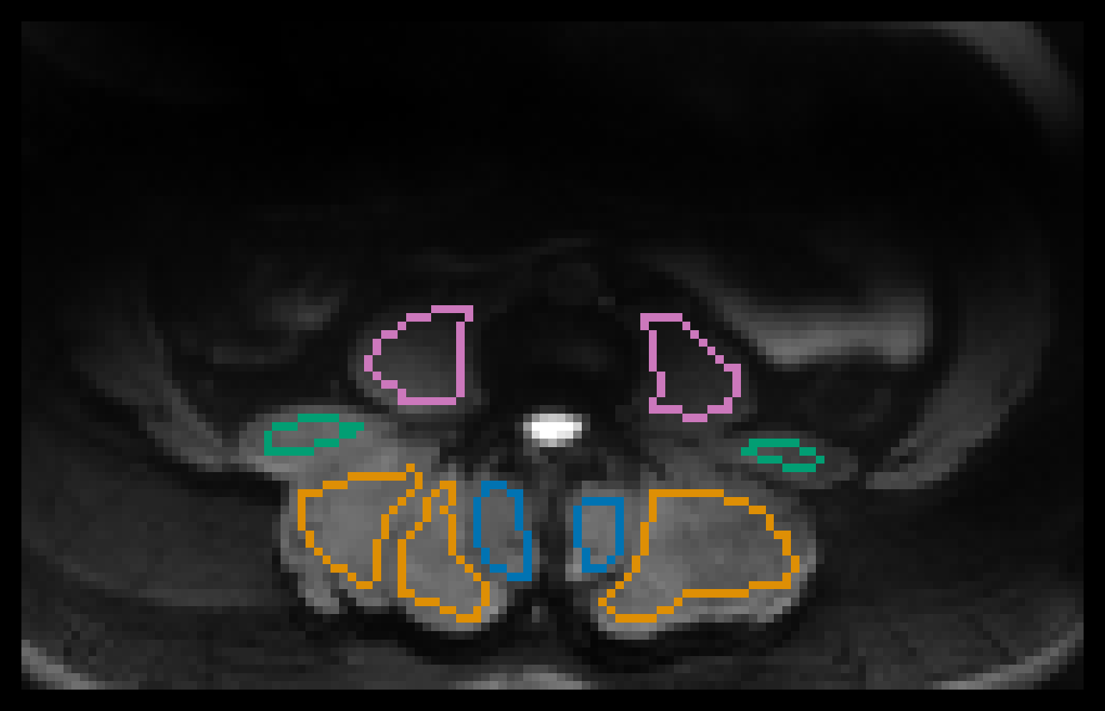
Figure 2.DWI signal (b=0) for a representative subject of the strength cohort. Note the significant drop of signal in the psoas major muscles (color coded in pink), tangentially affecting the quadratus lumborum, (color coded in green). Multifidus is indicated in blue and erector spinae in orange as in the manuscript text.
Additionally, the small number of voxels associated with the segmentation of the quadratus lumborum complicates consistent evaluation of this muscle across different cohorts.

Representative maps for one subject of the strength and control group

Figure 3. Below example parameter maps for one strength and control group subject, respectively are shown. The grouping of the maps, indicated by the frame color, represents the acquisition from which they originate (VFA, TSE, or IVIM). Maps sharing a color bar are windowed identically. In the corrected T₁ relaxation time map, the successful B₁-field inhomogeneity correction is visible compared to the uncorrected map (a). Section (b) shows the water T₂ and fat fraction maps extracted from the EPG. Section (c) shows the maps of the diffusion coefficients $D_{xy}$, D_{z}, the pseudo-diffusion coefficient D*, and the perfusion fraction f. Additionally, the ROIs used for quantitative analysis are outlined on top of the map of S₀ (multifidus in blue and erector spinae in orange).

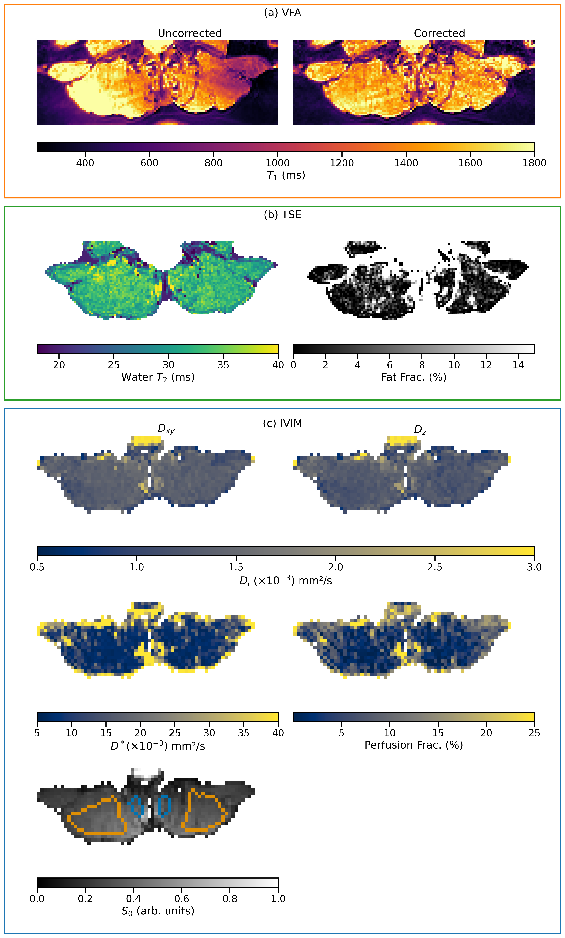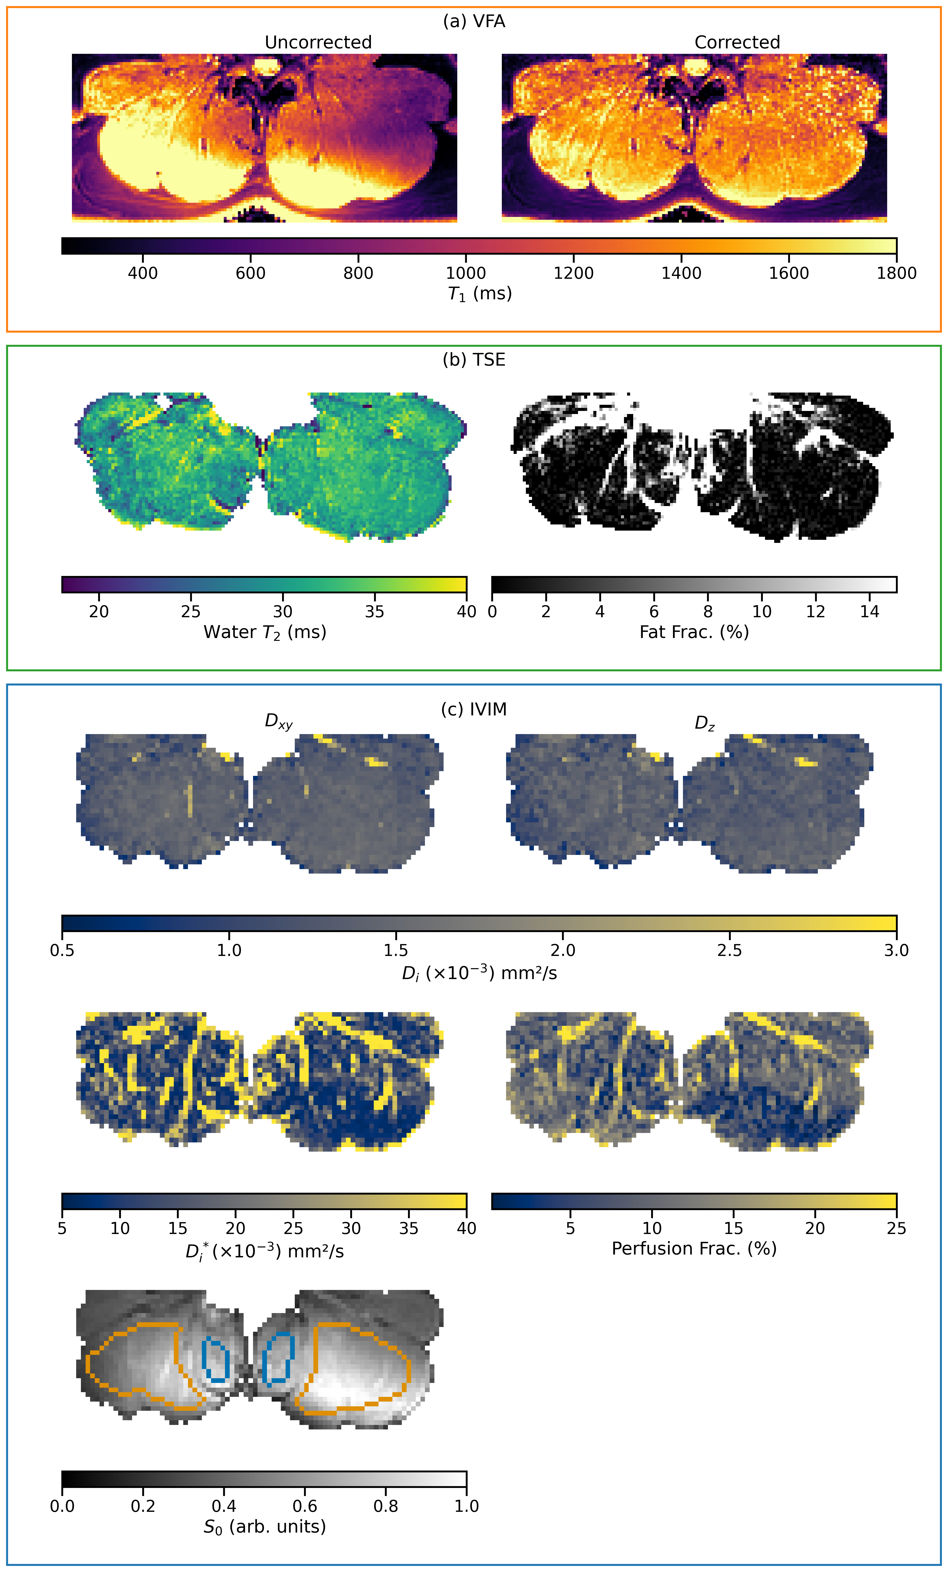

Results from Kruskal-Wallis and Dunn’s post hoc comparison

- T₂ results for multifidus muscle
Kruskal-Wallis p-value=0.020
 | Control | Endurance | Strength
Control | 1 | 0.012 | 0.025
Endurance | 0.012 | 1 | 0.845
Strength | 0.025 | 0.845 | 1

- T₂ results for erector spinae muscle
Kruskal-Wallis p-value=0.021
 | Control | Endurance | Strength
Control | 1 | 0.018 | 0.017
Endurance | 0.018 | 1 | 0.929
Strength | 0.017 | 0.929 | 1

- Fat fraction results for multifidus muscle
Kruskal-Wallis p-value=2.5 e-07
 | Control | Endurance | Strength
Control | 1 | 1.8e-04 | 1.1e-07
Endurance | 1.8e-04 | 1 | 0.813
Strength | 1.1e-07 | 0.813 | 1

- Fat fraction for erector spinae muscle
Kruskal-Wallis p-value=2.2 e-07
 | Control | Endurance | Strength
Control | 1 | 3e-06 | 2e-06
Endurance | 3e-06 | 1 | 0.986
Strength | 2e-06 | 0.986 | 1

- T₁ results for multifidus muscle
Kruskal-Wallis p-value=0. 290
- T₁ results for erector spinae muscle
Kruskal-Wallis p-value= 0.796
- Perfusion fraction results for multifidus muscle
Kruskal-Wallis p-value=0.284
- Perfusion fraction results for erector spinae muscle
Kruskal-Wallis p-value=0.088
- Radial diffusion results for multifidus muscle
Kruskal-Wallis p-value=0.049
 | Control | Endurance | Strength
Control | 1 | 0.063 | 0.001
Endurance | 0.063 | 1 | 0.100
Strength | 0.001 | 0.100 | 1
- Radial diffusion results for erector spinae muscle
Kruskal-Wallis p-value=0.025
 | Control | Endurance | Strength
Control | 1 | 0.710 | 0.011
Endurance | 0.710 | 1 | 0.058
Strength | 0.011 | 0.058 | 1

- Axial diffusion results for multifidus muscle
Kruskal-Wallis p-value=0.047
 | Control | Endurance | Strength
Control | 1 | 0.024 | 0.100
Endurance | 0.024 | 1 | 0.001
Strength | 0.100 | 0.001 | 1

- Axial diffusion results for erector spinae muscle
Kruskal-Wallis p-value=0.045
 | Control | Endurance | Strength
Control | 1 | 0.044 | 0.381
Endurance | 0.044 | 1 | 0.026
Strength | 0.381 | 0.026 | 1

- Pseudo-diffusion results for multifidus muscle
Kruskal-Wallis p-value=0.136
- Pseudo-diffusion results for erector spinae muscle
Kruskal-Wallis p-value=0.050
 | Control | Endurance | Strength
Control | 1 | 0.201 | 0.020
Endurance | 0.201 | 1 | 0.323
Strength | 0.020 | 0.323 | 1

- Age
Kruskal-Wallis p-value=0.097
- BMI
Kruskal-Wallis p-value=0.001
 | Control | Endurance | Strength
Control | 1 | 0.0535 | 0.0044
Endurance | 0.0535 | 1 | 0.0002
Strength | 0.0044 | 0.0002 | 1

