Supplementary Material

# Supplementary Figures and Tables

## Supplementary Figure 1.

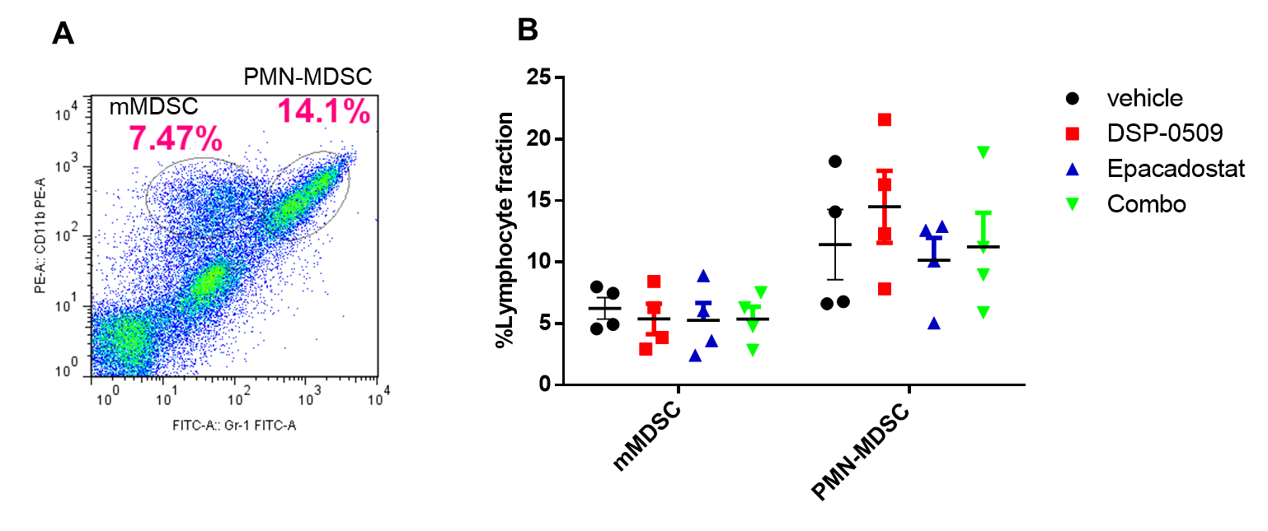

**Supplementary Figure 1.** MDSC infiltration in HM-1 tumor analyzed by flow cytometry. HM-1 tumors treated with each treatment were collected at day21. **A**. Representative histogram of MDSCs. Monocytic MDSC (mMDSC) and PMN-MDSC were defined as the CD11b+Gr-1mid and CD11b+Gr-1high respectively. **B**. The ratio of MDSCs in TILs in HM-1 tumor. n= 4 / group.

## Supplementary Figure 2

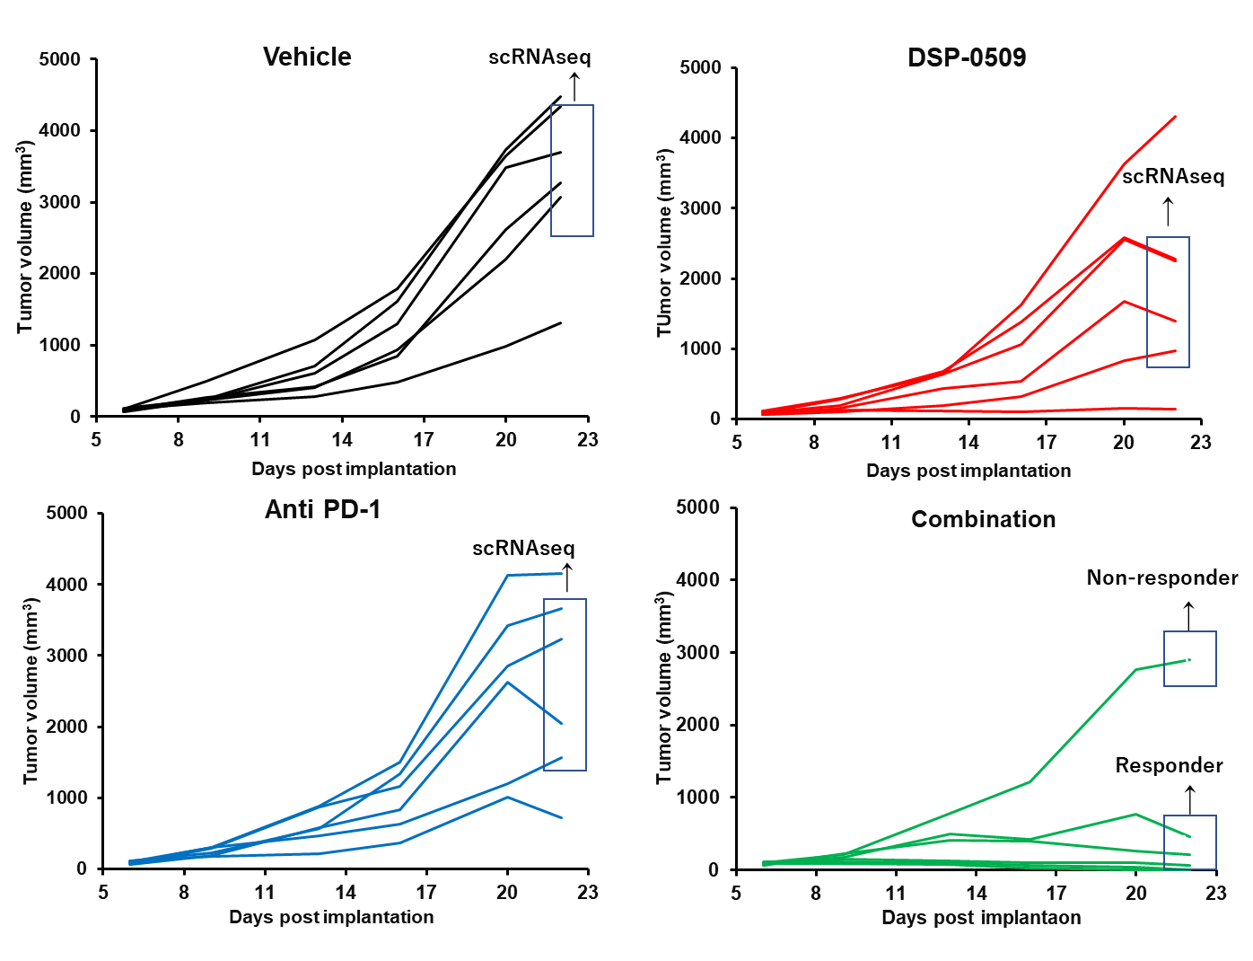

**Supplementary Figure 2.** Individual tumor growth in Fig. 3A. In vehicle, DSP-0509 and anti PD-1 group, TILs derived from 4 mice as indicated in figure above were pooled and used for scRNAseq. In combination group, TILs derived from 3 mice as indicated in figure above were pooled and used as responder. TILs derived from 1 mouse as indicated in figure above were used as non-responder.