Supplementary Material

**Supplementary Figure 1**. Longer exposure of SH-SY5Y cell line to PrP106-126. The proliferation rate was assessed at different time points; 12, 24, and 48 hr using CCK8 assay. The results showed that cells exposed to PrP106-126 (100 and 200 μM) have similar effects at 12, 24, and 48 hrs. Thus, 24 hr time point treatment has been selected.

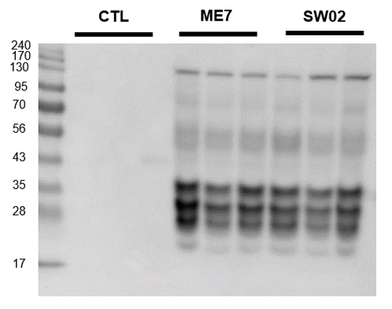

**Supplementary Figure 2.** Evaluation of the protective effects of SW02 on PrPSc accumulation expression in the ME7 scrapie-infected mice at the terminal stage based on western blotting.