Supplementary Material

Oligodendrocyte precursor cell-derived exosomes combined with cell therapy promote clinical recovery by immunomodulation and gliosis attenuation

Sarah Ingrid Pinto Santos1, Santiago Jose Ortiz Peñuela2, Alessandro de Paula Filho1, Ana Laura Midori Rossi Tomiyama2, Lilian de Oliveira Coser2, Juliano Coelho da Silveira1, Daniele dos Santos Martins1, Adriano Polican Ciena3, Alexandre Leite Rodrigues de Oliveira2, Carlos Eduardo Ambrósio1

1Faculty of Animal Science and Food Engineering, University of São Paulo (FZEA/USP), Brazil

2Institute of Biology, University of Campinas (IB/UNICAMP), Brazil

3Institute of Biosciences, São Paulo State University, Campus Rio Claro (IB/Unesp), Brazil

**\* Correspondence:**Corresponding Author  
sarahingridpsantos@gmail.com

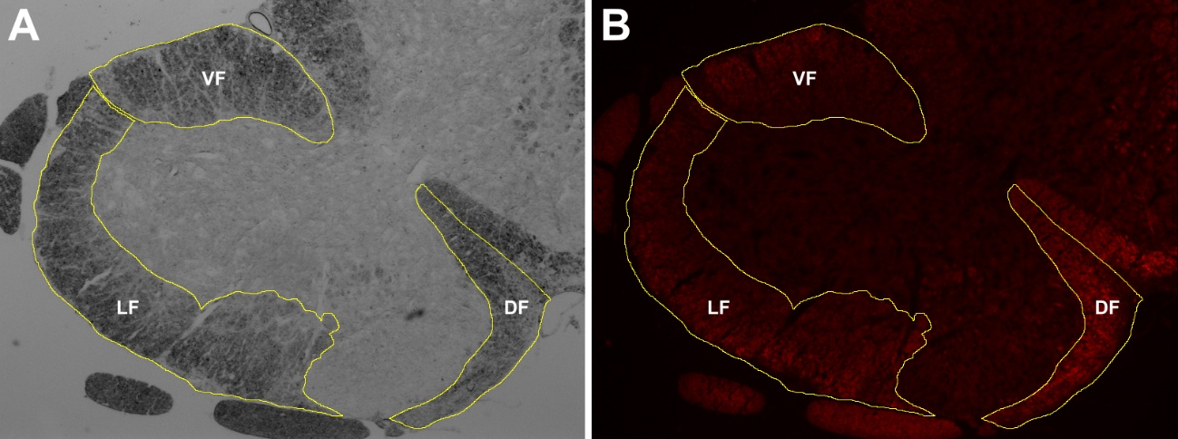

**Supplementary figure 1.** Analysis of areas of demyelination in the spinal cord. The area of white matter is initially delineated in the light microscopy image (A) and transferred to the FluoroMyelin-labeled fluorescence image of the spinal cord (B) for subsequent quantification of the integrated pixel density per funiculus.

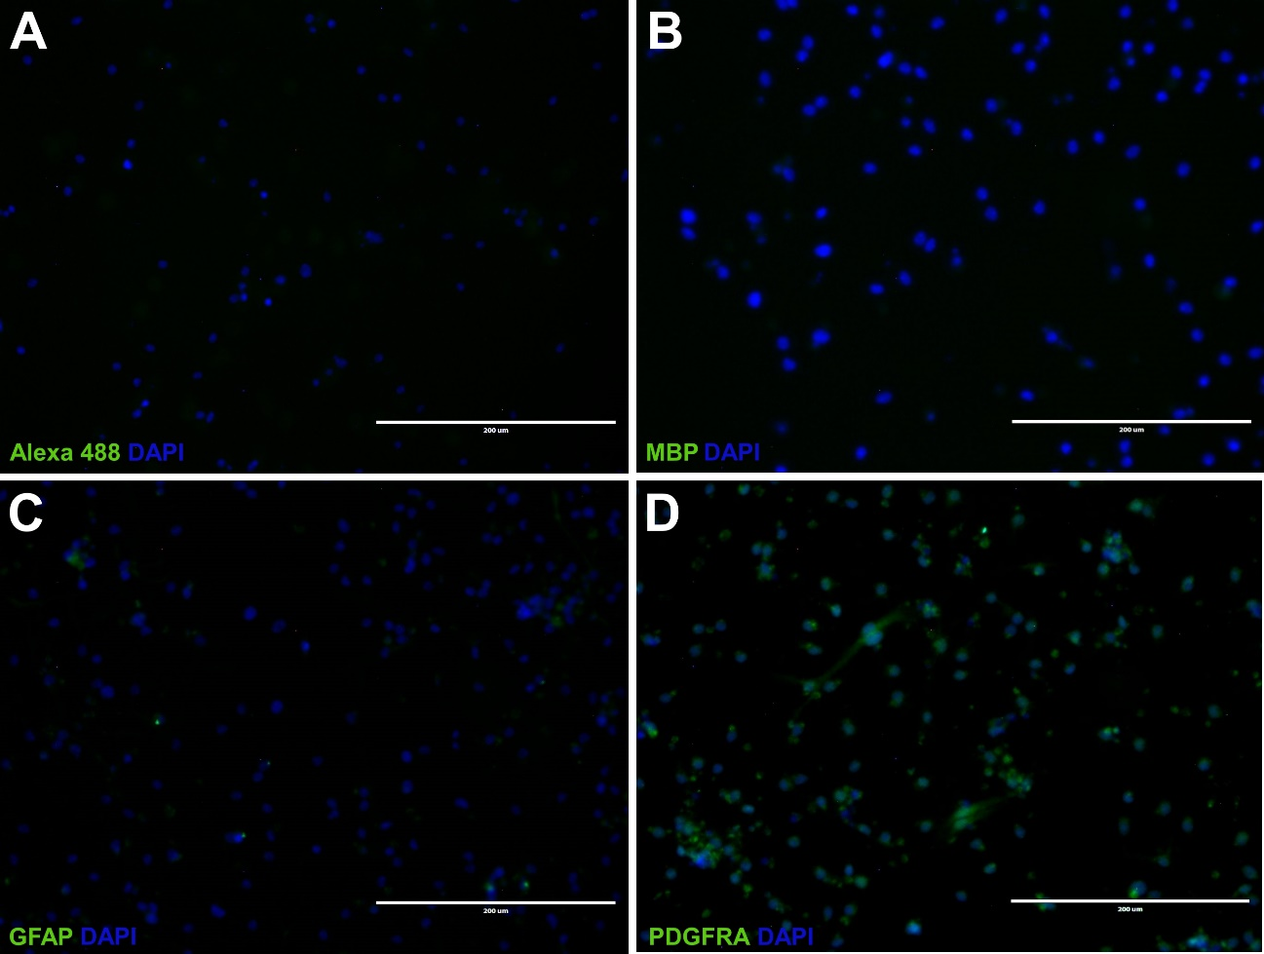

**Supplementary figure 2.** Immunocytochemical of differentiated oligodendrocyte precursor cells revealing no labeling in the control cells for the secondary antibody **(A)** and the maturation marker MBP **(B)**. A few cells showed some GFAP labeling **(C)**, while practically the entire population was immunopositive for PDGFRA **(D)**.